Supplementary Materials

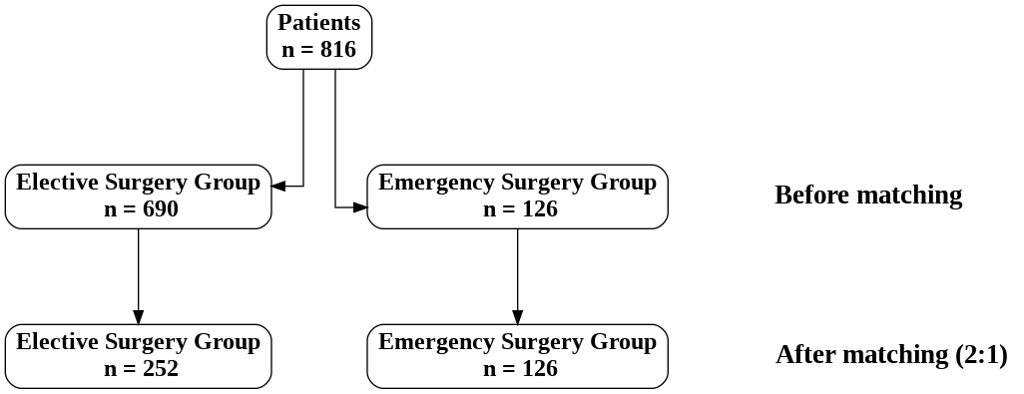

Figure S1: Study flow chart - Co-variables for propensity score matching were Sex, Age, BMI, Hemoglobin level, Leukocyte count, ASA score and Total points nutritional status.
Table S1: Postoperative Complications (after 2:1 matching)
Variable | sub-category | Elective Surgery [N=252] | Emergency Surgery [N=126] | p-value
Anastomotic leakage |  |  |  | 0.645
 | No | N=240(95.2%) | N=123(97.6%)
 | Yes, drained percutaneously | N=1(0.4%)
 | Yes, radiological diagnosis with no intervention | N=1(0.4%)
 | Yes, reoperated | N=10(4.0%) | N=3(2.4%)
Complication after surgery (Pulmonary) |  |  |  | 1.000
 | No | N=235(93.3%) | N=117(92.9%)
 | Yes | N=17(6.7%) | N=9(7.1%)
Complication after surgery (Cardial) |  |  |  | 0.449
 | No | N=248(98.4%) | N=122(96.8%)
 | Yes | N=4(1.6%) | N=4(3.2%)
Complication after surgery (Gastrointestinal) |  |  |  | 0.745
 | No | N=221(87.7%) | N=109(86.5%)
 | Yes | N=31(12.3%) | N=17(13.5%)
Complication after surgery (Kidneys) |  |  |  | 0.730
 | No | N=248(98.4%) | N=125(99.2%)
 | Yes, oliguria | N=1(0.4%)
 | Yes, renal failure | N=3(1.2%) | N=1(0.8%)
Complication after surgery (Urogenital) |  |  |  | 0.554
 | No | N=250(99.2%) | N=126(100.0%)
 | Yes | N=2(0.8%)
Complication after surgery (Central nervous system) |  |  |  | 1.000
 | No | N=251(99.6%) | N=126(100.0%)
 | Yes | N=1(0.4%)
Complication after surgery (Wound Complications) |  |  |  | 1.000
 | No | N=247(98.0%) | N=123(97.6%)
 | Yes | N=5(2.0%) | N=3(2.4%)
Complication after surgery (Thromboembolic) |  |  |  | 1.000
 | No | N=251(99.6%) | N=126(100.0%)
 | Yes | N=1(0.4%)
Complication after surgery ((central) line associated bloodstream) |  |  |  | 1.000
 | No | N=251(99.6%) | N=126(100.0%)
 | Yes | N=1(0.4%)
Complication after surgery (Anaesthetic) |  |  |  | 1.000
 | No | N=251(99.6%) | N=126(100.0%)
 | Yes | N=1(0.4%)
Complication after surgery (Gastrointestinal haemorrhage) |  |  |  | 1.000
 | No | N=251(99.6%) | N=125(99.2%)
 | Yes | N=1(0.4%) | N=1(0.8%)
Complication after surgery (Infectious complications) |  |  |  | 0.853
 | No | N=227(90.1%) | N=115(91.3%)
 | Yes | N=25(9.9%) | N=11(8.7%)
Complication after surgery (Mechanical bowel obstruction) |  |  |  | 0.669
 | No | N=248(98.4%) | N=125(99.2%)
 | Yes | N=4(1.6%) | N=1(0.8%)
Complication after surgery (Nausea or vomiting) |  |  |  | 0.847
 | No | N=230(91.3%) | N=116(92.1%)
 | Yes | N=22(8.7%) | N=10(7.9%)
Complication after surgery (Obstipation or diarrhoea) |  |  |  | 0.669
 | No | N=248(98.4%) | N=125(99.2%)
 | Yes | N=4(1.6%) | N=1(0.8%)
Complication after surgery (Pain) |  |  |  | 0.191
 | No | N=247(98.0%) | N=120(95.2%)
 | Yes | N=5(2.0%) | N=6(4.8%)
Complication after surgery (Postoperative excessive haemorrhage) |  |  |  | 1.000
 | No | N=247(98.0%) | N=124(98.4%)
 | Yes | N=5(2.0%) | N=2(1.6%)
Complication after surgery (Postoperative paralytic ileus) |  |  |  | 0.833
 | No | N=234(92.9%) | N=118(93.7%)
 | Yes | N=18(7.1%) | N=8(6.3%)
Complication after surgery (Prolonged postoperative sedation) |  |  |  | N/A
 | No | N=252(100.0%) | N=126(100.0%)
Complication after surgery (Surgical complications) |  |  |  | 0.138
 | No | N=206(81.7%) | N=111(88.1%)
 | Yes | N=46(18.3%) | N=15(11.9%)

