Distribution of tumor size in the open and laparoscopic gastrectomy groups

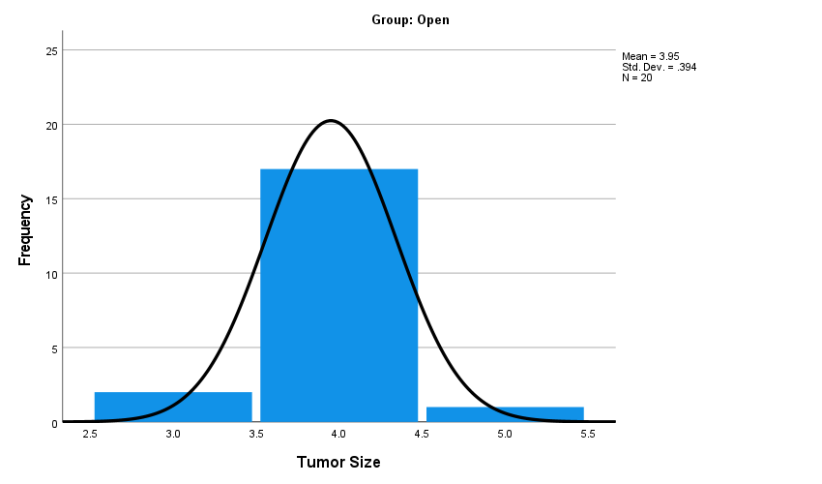
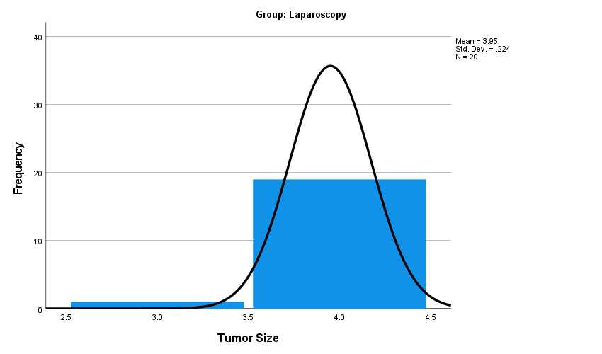
Distribution of dissected lymph node counts in the open and laparoscopic gastrectomy groups
