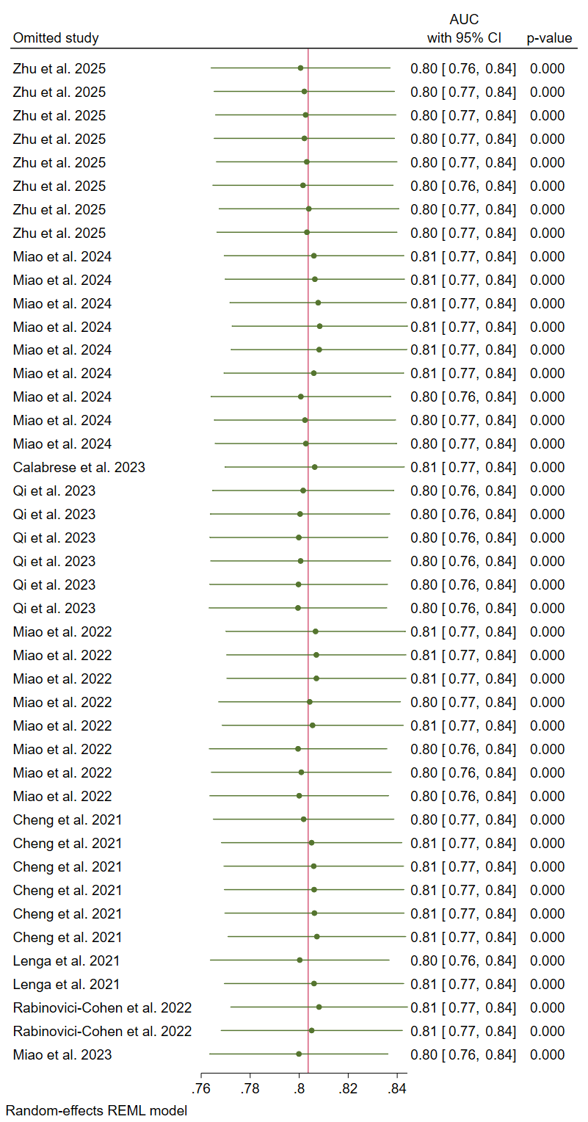
Figure S1. Sensitivity analysis of all included studies
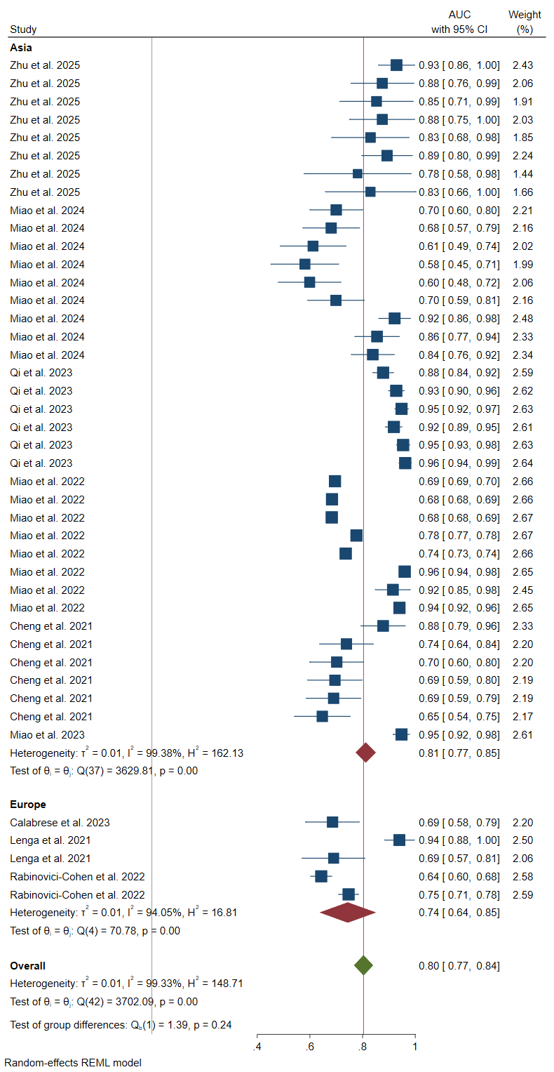
Figure S2. Subgroup meta-analysis of all included studies based on the region of the study.

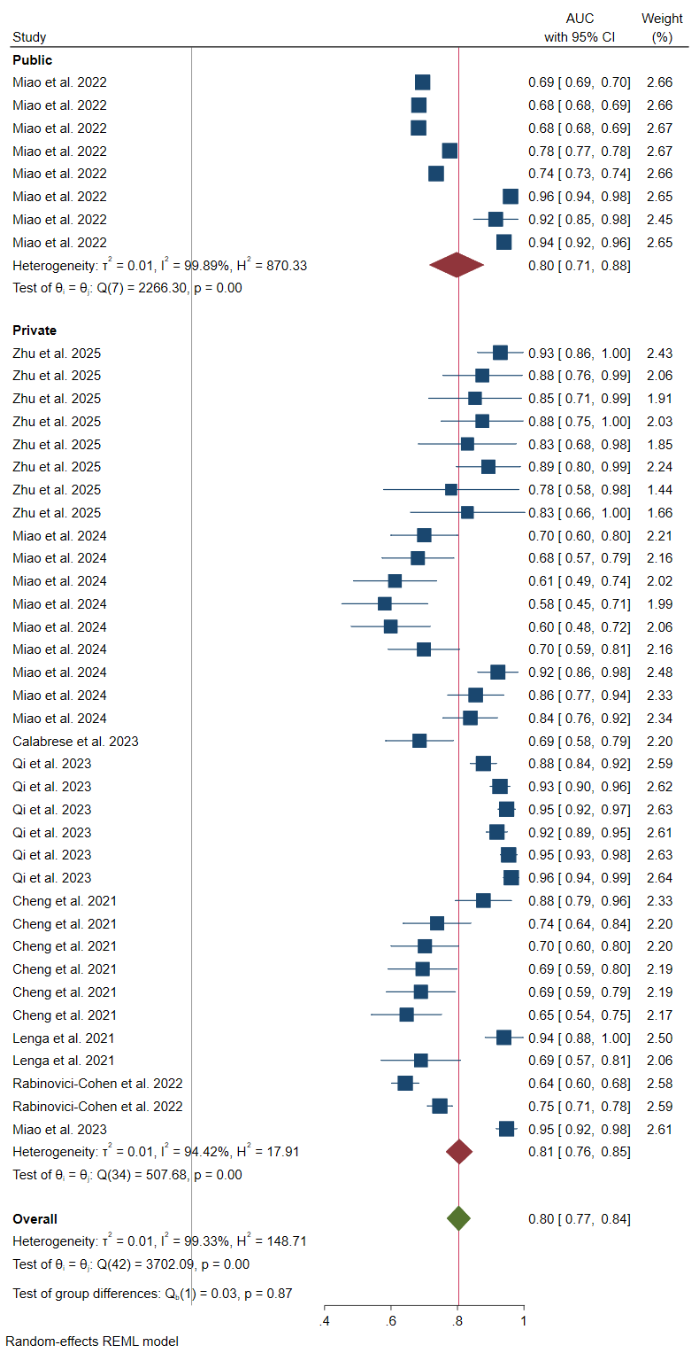
Figure S3. Subgroup meta-analysis of all included studies based on data availability status.
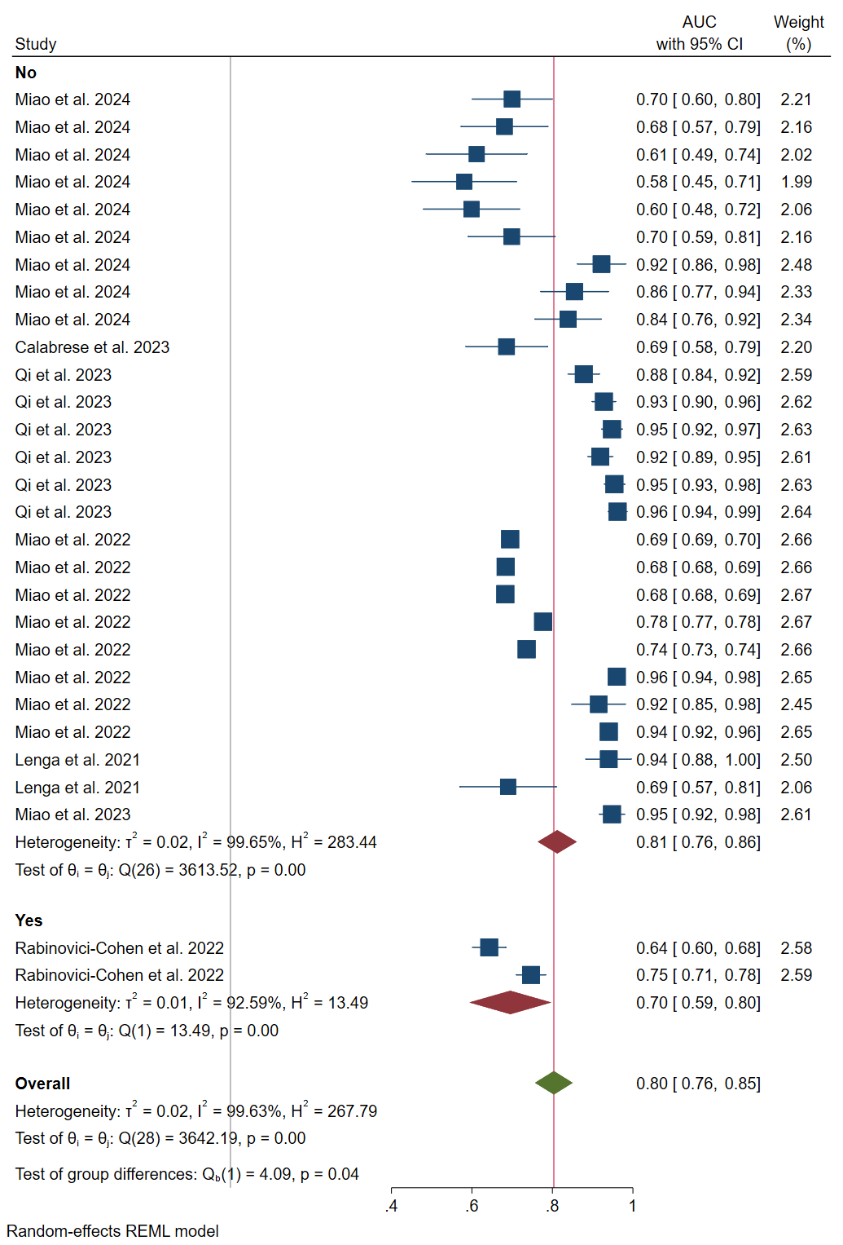
Figure S4. Subgroup meta-analysis of all included study for AUC of ROC curve based on the region
of the data availability.

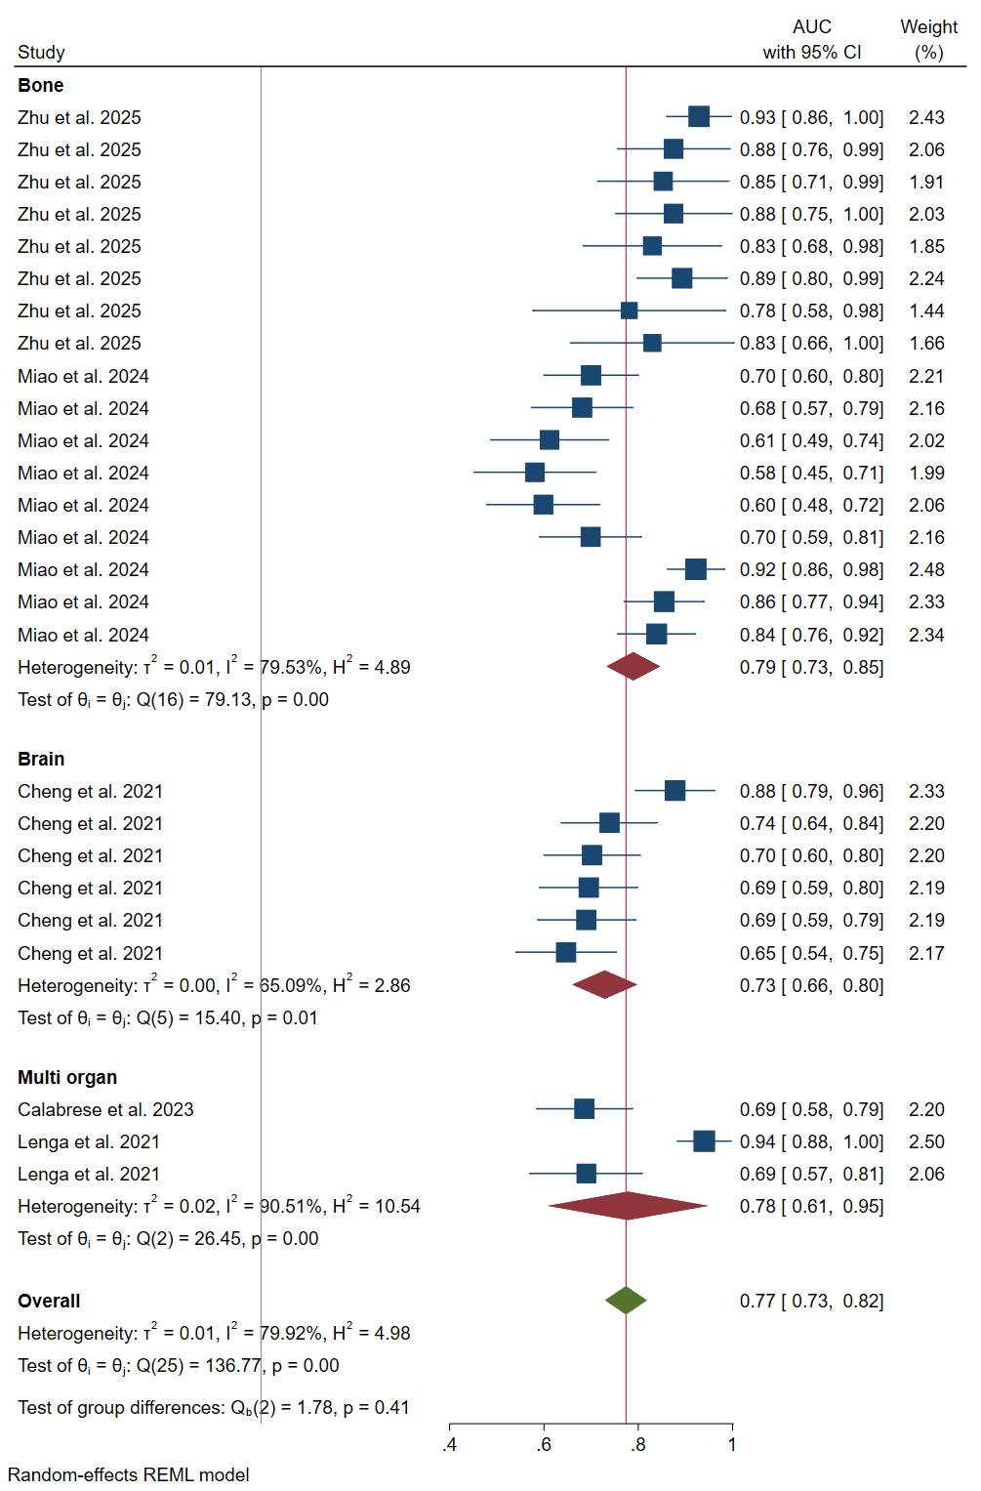
Figure S5. Subgroup meta-analysis of all included study-model pairs based on site of distant metastasis.
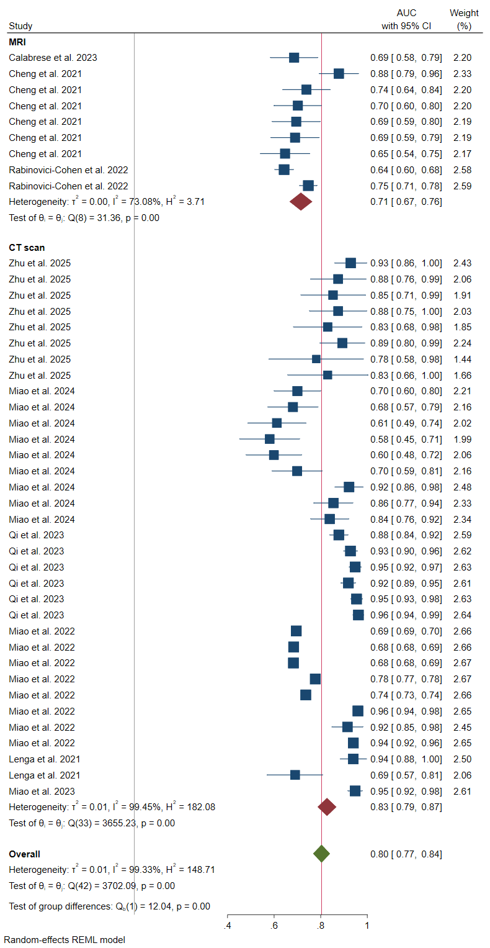
Figure S6. Subgroup meta-analysis of all included study-model pairs based on the imaging modality.

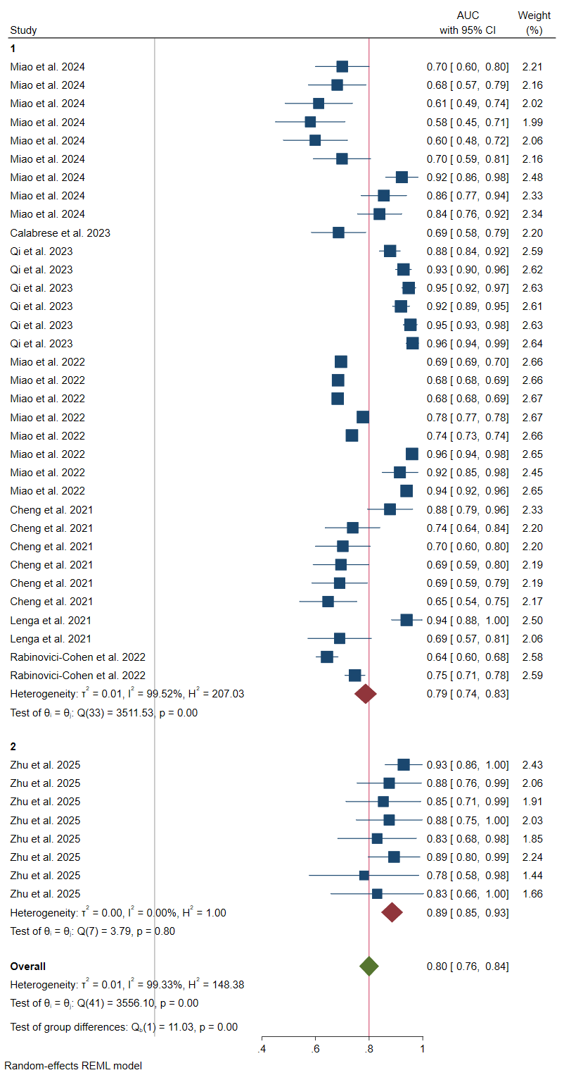
Figure S7. Subgroup meta-analysis of all included study-model pairs based on the number of centers from which training/test data were collected. The encoded variable 2 indicates multi-center (more than one center) study.

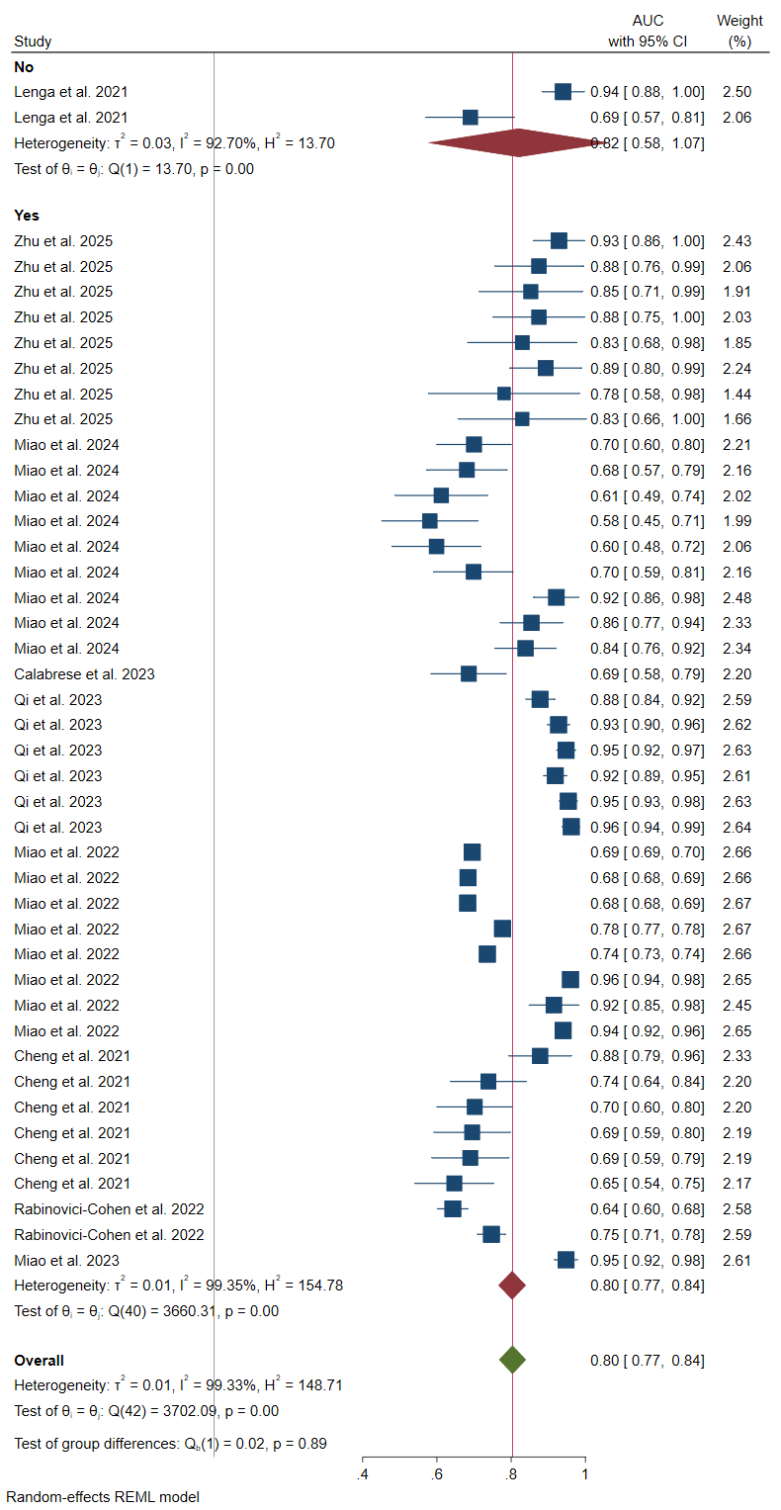
Figure S8. Subgroup meta-analysis of all included study-model pairs based on the feature selection report.

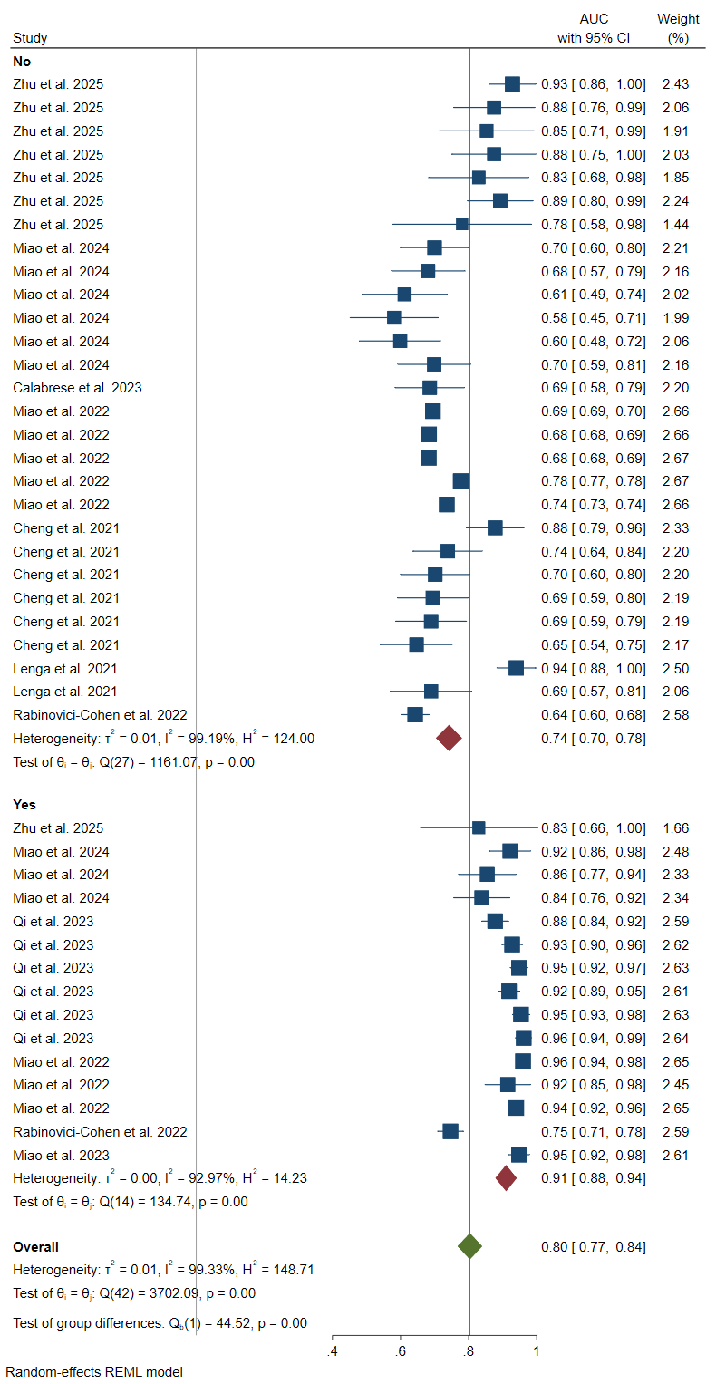
Figure S9. Subgroup meta-analysis of all included study-model pairs based on the inclusion of clinical/pathological features in the model (Pure imaging vs combined models). Yes indicates that the model was indeed trained on both imaging and clinic-pathological data.
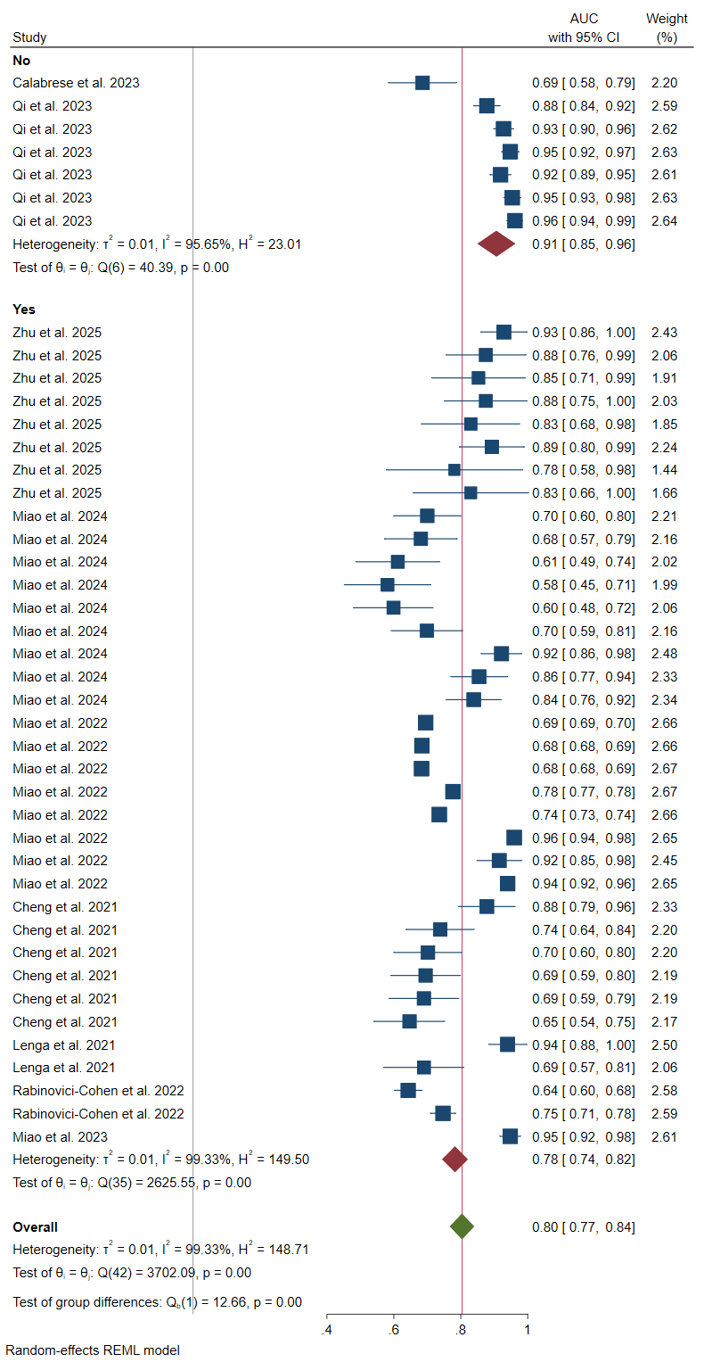
Figure S10. Subgroup meta-analysis of all included study-model pairs based on the use of radiomics. Yes indicates that the study did use radiomics analysis for model development.
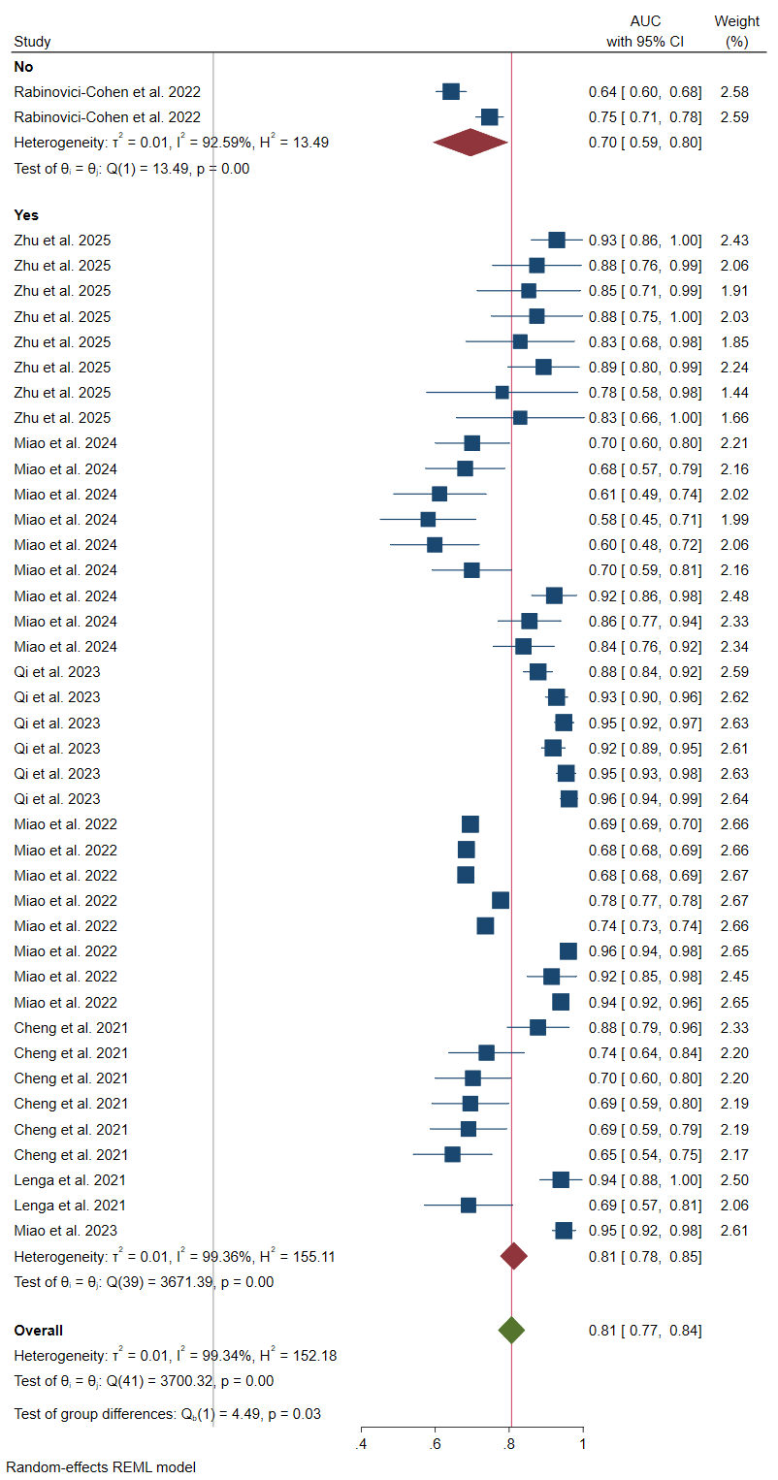
Figure S11. Subgroup meta-analysis of all included study-model pairs based on prior feature selection status. Yes indicates that a sort of feature selection process, whether manual or data-driven, was performed prior to training the model.
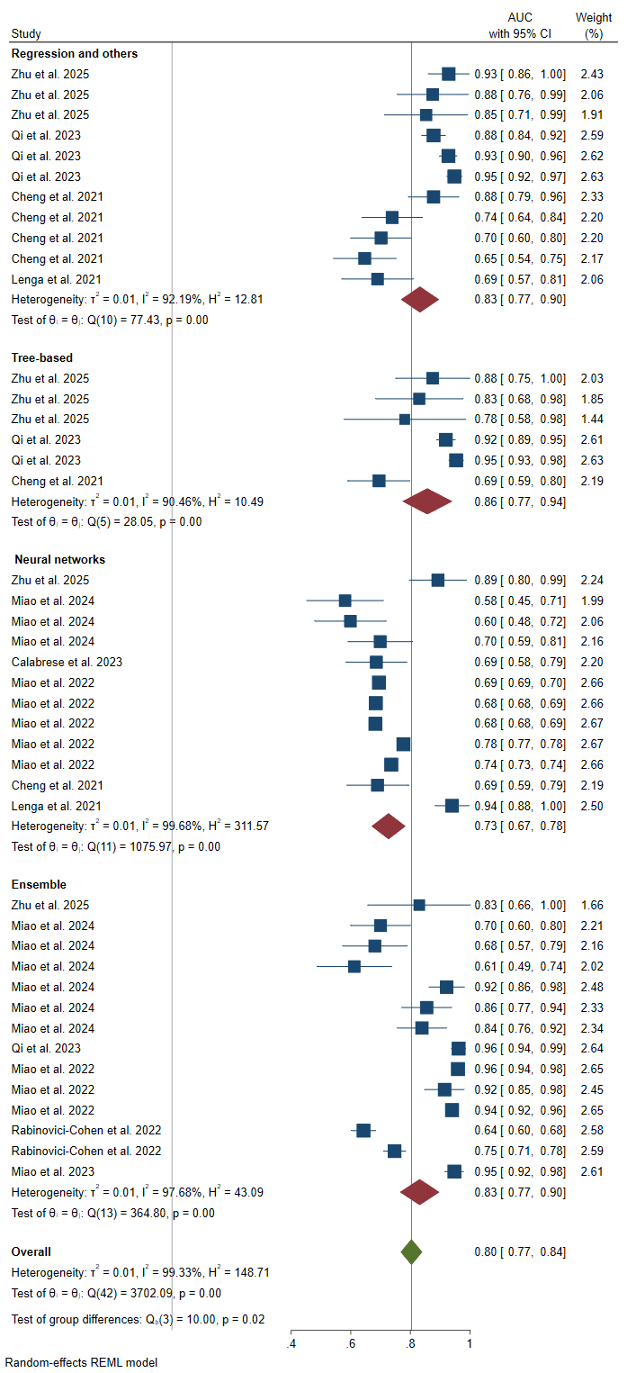
Figure S12. Subgroup meta-analysis of all included study-model pairs based on the model type.

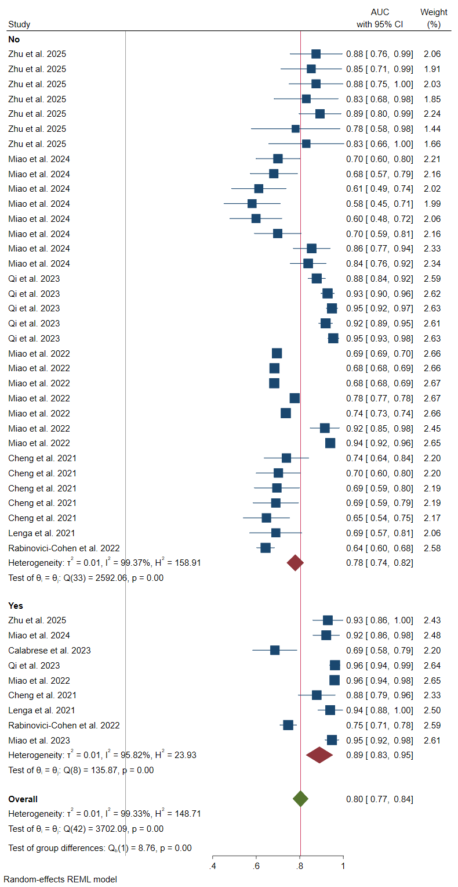
Figure S13. Subgroup meta-analysis of all included study-model pairs based on the best performing model(per study) performance. Yes indicates that the model was the best-performing one within the study from which it originates.
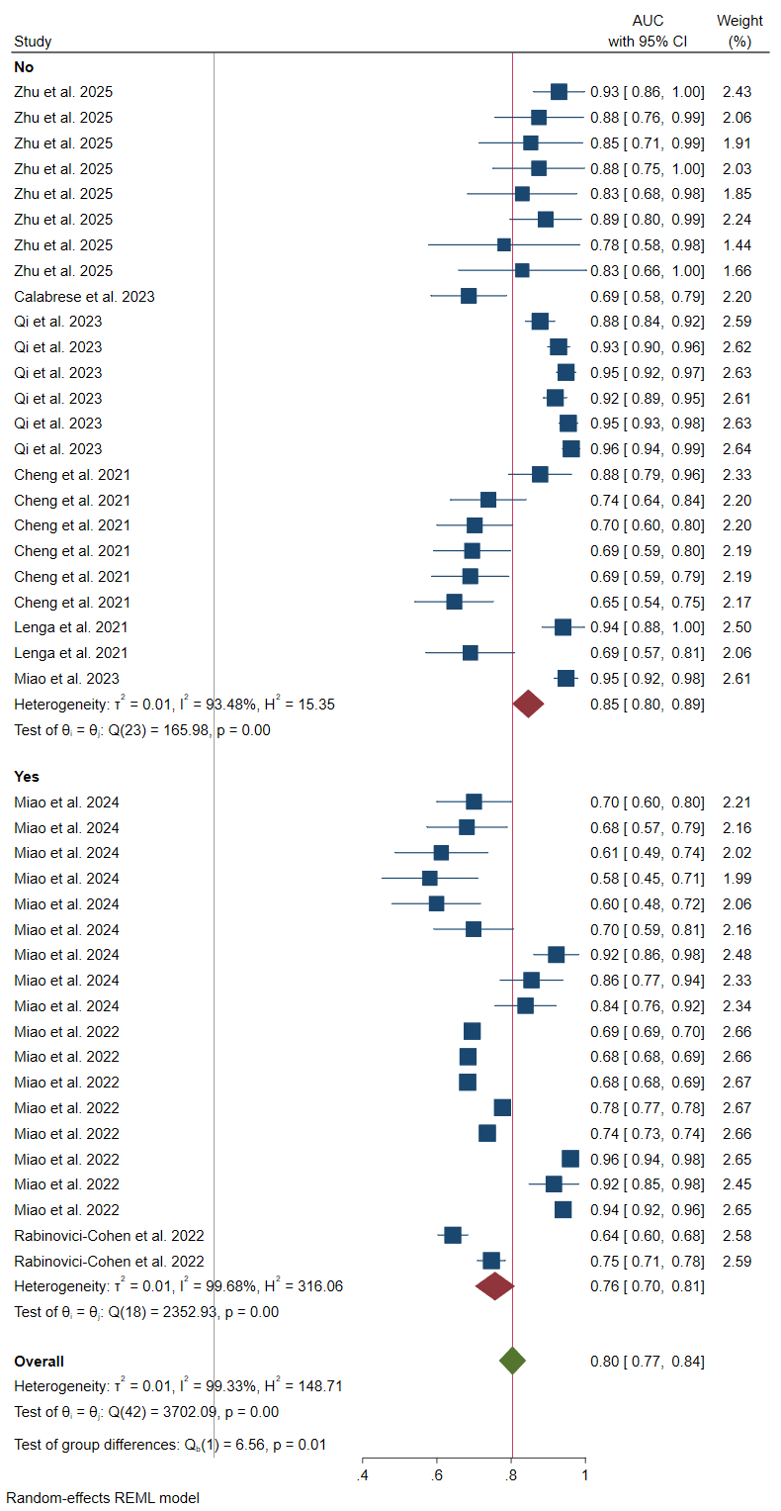
Figure S14. Subgroup meta-analysis of all included study-model pairs based on the code availability status.
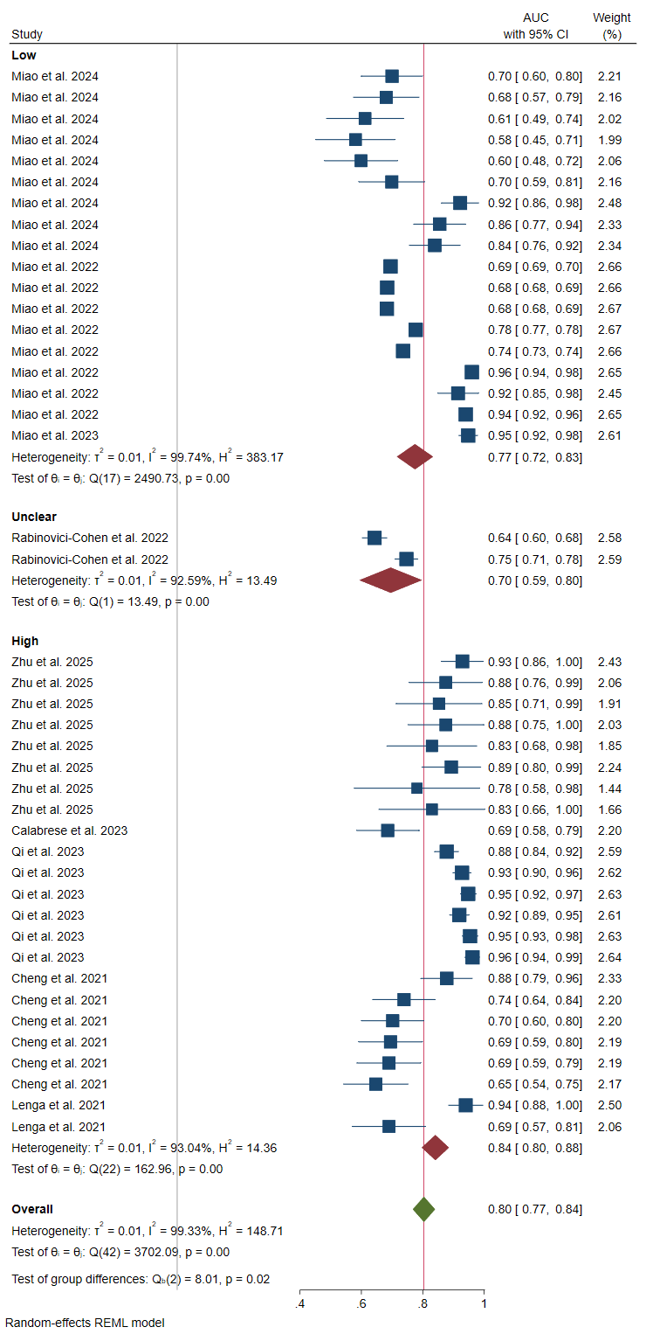
Figure S14. Subgroup meta-analysis of all included study-model pairs based on the ROB assessment.

