SUPPLEMENTAL MATERIAL
TRPM4 specific blocking antibody attenuates reperfusion injury in a rat model of stroke
Cover Title: TRPM4 blocking antibody in stroke

Bo Chen¹* PhD, Yahui Gao¹* BA, Shunhui Wei¹* PhD, See Wee Low¹ BA, Gandi Ng¹ BA, Dejie Yu² BA, Tian Ming Tu³ MD, PhD, Tuck Wah Soong² PhD, Bernd Nilius⁴ MD, PhD, Ping Liao^{1,5,6†} MD, PhD

¹Calcium Signalling Laboratory, Department of Research, National Neuroscience Institute, Singapore, ²Department of Physiology, Yong Loo Lin School of Medicine, National University of Singapore, ³Department of Neurology, National Neuroscience Institute, Singapore, ⁴Department of Cellular and Molecular Medicine, KU Leuven, Leuven, Belgium, ⁵Duke-NUS Medical School, Singapore, ⁶Health and Social Sciences, Singapore Institute of Technology, Singapore.
* These authors contribute equally in this study.

† Correspondence to Ping Liao, MD, PhD. Calcium Signalling Lab, National Neuroscience Institute, 11 Jalan Tan Tock Seng, Singapore 308433. E-mail: ping_liao@nni.com.sg Fax: (65) 6256 9178; Tel: (65) 6357 7611.

Supplemental

Figure I
a
QDRSSNCSAERGSWAHPEGPVAGSCVSQ
LPSILRRVFYRPYLQIFGQIPQEEMDVALMNP
*

b

Rattus norvegicus E G I L R P Q D R S L P S I L R R V F Y R P Y L Q
Mus musculus E G I L R P Q D R S L P S I L R R V F Y R P Y L Q
Homo sapiens E G L L R P R D S D F P S I L R R V F Y R P Y L Q

Rattus norvegicus I F G Q I P Q E E M D V A L M N P S N C S A E R G
Mus musculus I F G Q I P Q E E M D V A L M I P G N C S M E R G
Homo sapiens I F G Q I P Q E D M D V A L M E H S N C S S E P G

Rattus norvegicus S W A H P E G P V A G S C V S Q Y A N W
Mus musculus S W A H P E G P V A G S C V S Q Y A N W
Homo sapiens F W A H P P G A Q A G T C V S Q Y A N W

*

c

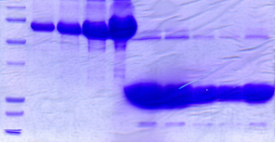
1
BSA (µg)
2
5
GST-M4P elution
10
GST-M4P
75
MW
(kDa)
50
37
25
1
2
3
4
5

M
M

M

Supplemental Fig. I Generation and characterization of antibody M4P (a) A 28-amino acid polypeptide between transmembrane segment 5 and 6 from the rat TRPM4 channel was synthesized for M4P production. The 32-amino acid hydrophobic polypeptide spanning across the pore lining sequence was excluded. Asterisk: N-glycosylation site. Channel pore: boxed in green. (b) Alignment of the linker sequences between transmembrane segments 5 and 6 of TRPM4 from Rattus norvegicus, Mus musculus, and Homo sapiens. The rat 28 amino acid sequences for generating M4P were circled with boxes. The pore loops were labelled in filled grey boxes. Asterisk: N-glycosylation site. (c) Coomassie Blue Staining of a SDS-PAGE gel showing the expression of GST-fused 28 amino acid rat TRPM4 polypeptide for immunization.

Supplemental Figure II

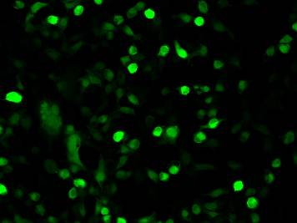
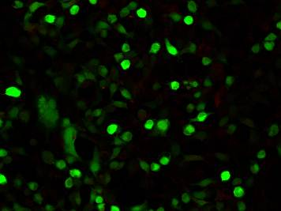
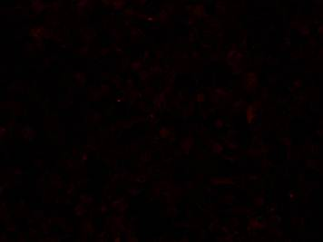
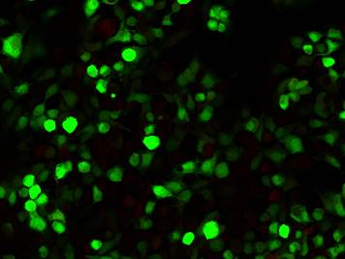
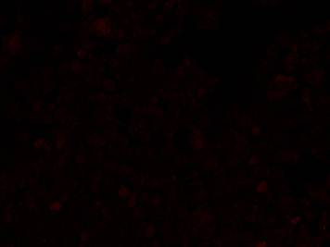
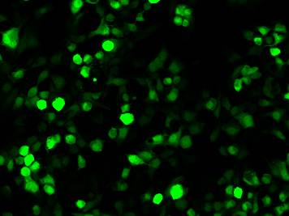
2º Ab
IgG
TRPM4
TRPM4
Merge
Merge

Supplemental Fig. II Both secondary antibody alone treatment and rabbit IgG treatment fail to stain TRPM4 channels. HEK 293 cells transfected with TRPM4 were incubated with secondary antibody (upper panel) or rabbit IgG (lower panel) for 6 hrs. The cells were then fixed and processed for immunostaining. Scale bar: 50 µm

Supplemental Figure III

a
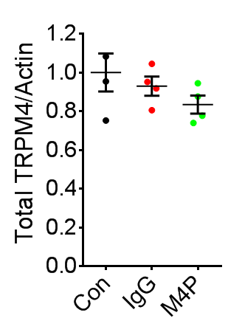

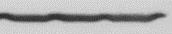
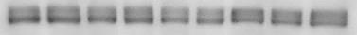
Actin
Total
TRPM4_H
TRPM4_L
Con
IgG
M4P

b
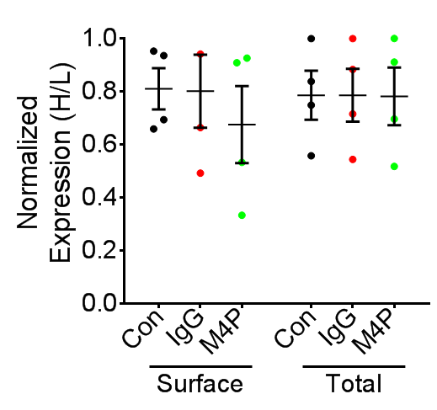

Supplemental Fig. III M4P treatment does not change total glycosylated TRPM4 (a) Detection and quantification of total TRPM4 channel expression. (b) Quantification of ratio of fully glycosylated TRPM4 (TRPM4_H) fractions to core glycosylated TRPM4 (TRPM4_L) fractions. TRPM4_H indicated protein fully glycosylation. TRPM4_L indicated core glycosylation. TfR: transferrin receptor. TRPM4 transfected HEK 293 cells were incubated with rabbit IgG (1.3 µg/ml) and M4P (1.3 µg/ml) for 6 hrs. Con: control group received no treatment. n=4 experiments for (a), (b), and statistical analysis was performed by One Way ANOVA with Bonferroni’s post hoc analysis. In (a), F (2,9) = 1.464, p = 0.2815. In (b), surface ratio, p = 0.7005; total ratio, p = 0.9993.

Supplemental Figure IV

a
Rat TRPM4 E G I L R P Q D R S L P S I L R R V F Y R P Y L Q
Rat TRPM5 Q A L L H P H D G R L E W I F R R V L Y R P Y L Q

Rat TRPM4 I F G Q I P Q E E M D V A L M N P S N C S A E R G
Rat TRPM5 I F G Q I P L D E I D E A R V - - - N C S - - - -

Rat TRPM4 S W A H P - E G P V A G S C V S Q Y A N W
Rat TRPM5 - - L H P L L L D S S A S C P N L Y A N W

*

MW
(kDa)
TRPM5
GFP
c
b
GFP
NT

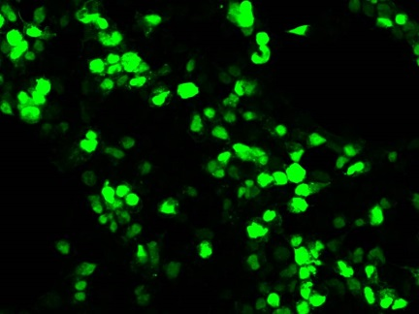
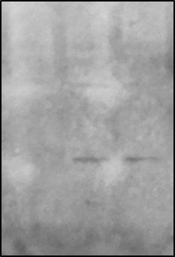
TRPM5/M4P
150

75
M4P
50

37

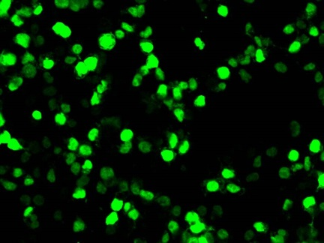
GFP

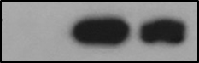
GFP

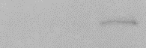
TRPM5

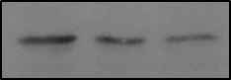
Actin

Supplemental Fig. IV M4P does not bind to TRPM5 channel (a) Alignment of the linker sequences between transmembrane segments 5 and 6 of TRPM4 from Rattus norvegicus TRPM4 channel (NP_001129701.1) and TRPM5 channel (NP_001178825.1). Asterisk: N-glycosylation site. The polypeptides used for generating M4P were circled with boxes, and TRPM4 and TRPM5 share only 24% homology (7/29). The pore loops were labelled in filled grey boxes, and TRPM4 and TRPM5 share 62% homology (13/21) in this region. (b) HEK 293 cells were transfected with pIRES EGFP/TRPM5 and pEGFP. M4P could not detect TRPM5 channel (upper panel). (c) Western blot using M4P could not detect TRPM5 channel which is around 130 kD. Control GFP protein and TRPM5 protein were successfully detected by commercial antibodies. NT: non-transfected.

Supplemental Figure V
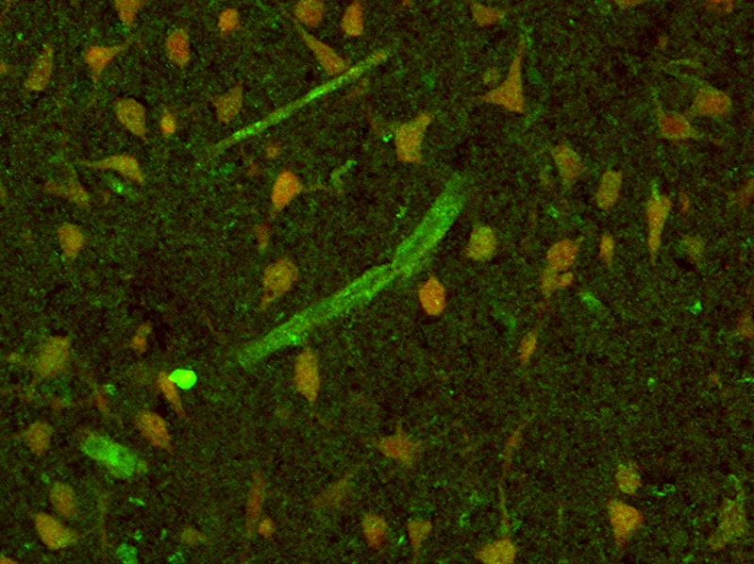
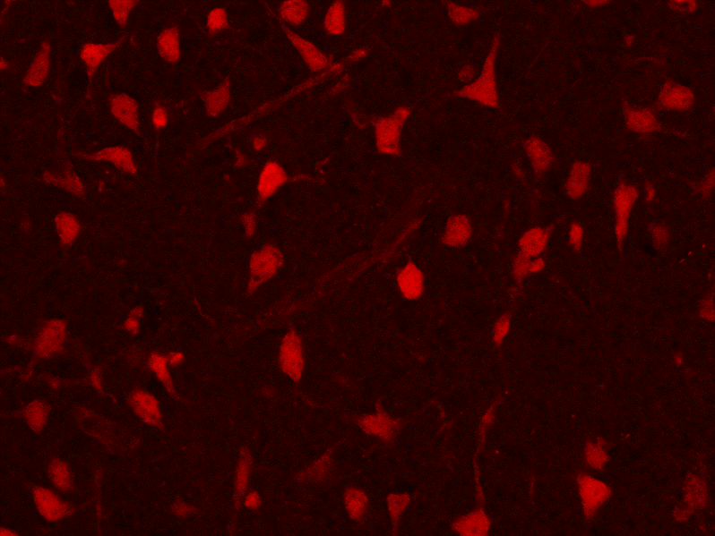
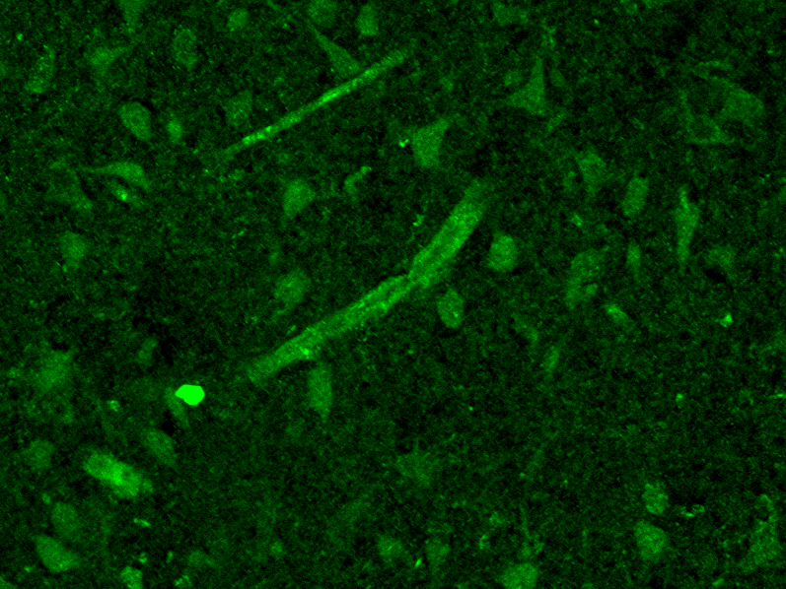
NeuN
M4P
Merge

Supplemental Fig. V M4P stain with NeuN in penumbra region of ipsilateral hemisphere. Co-staining of TRPM4 using M4P antibody with anti-NeuN in ipsilateral hemisphere of rat brains 1 day after MCAO. Scale bar: 50 µm.

Supplemental Figure VI

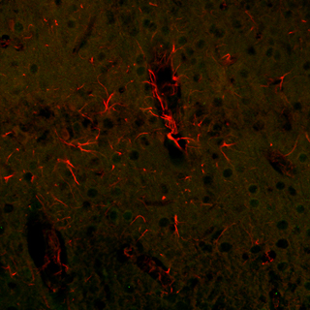
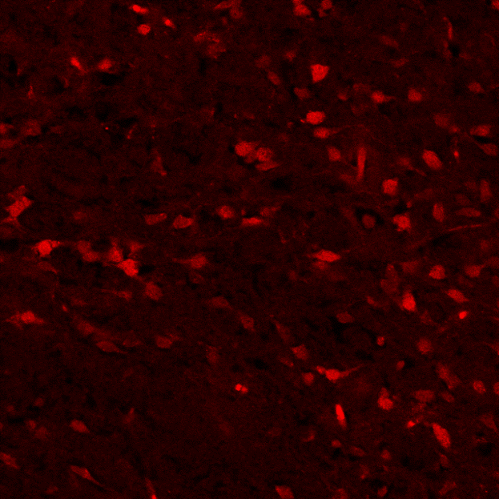
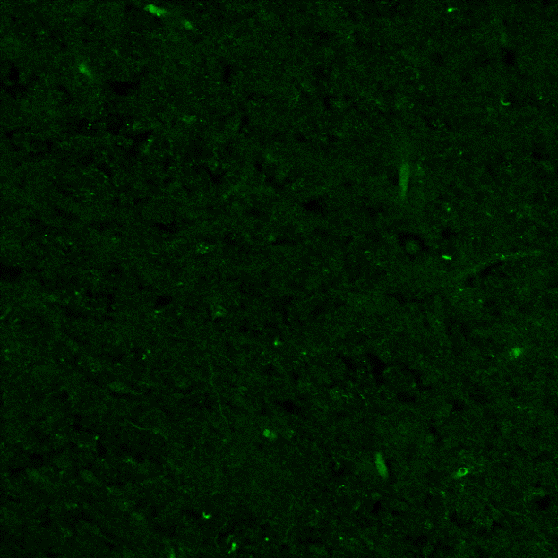
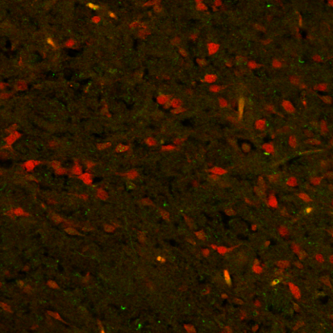
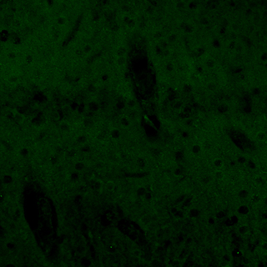
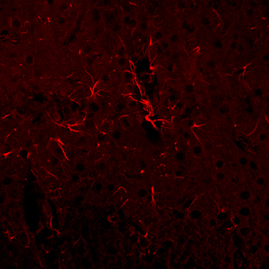
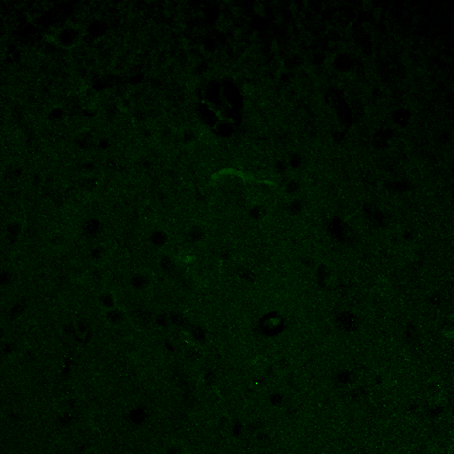
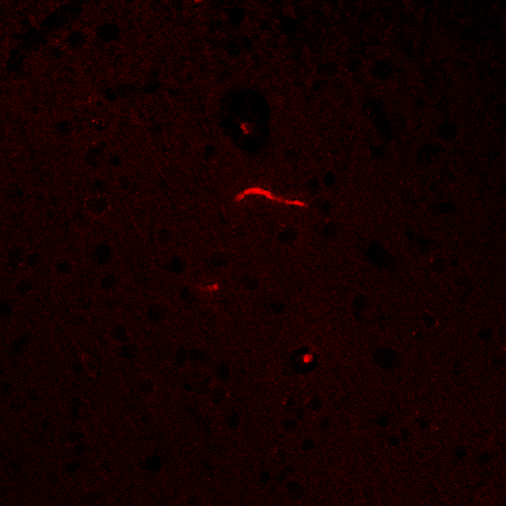
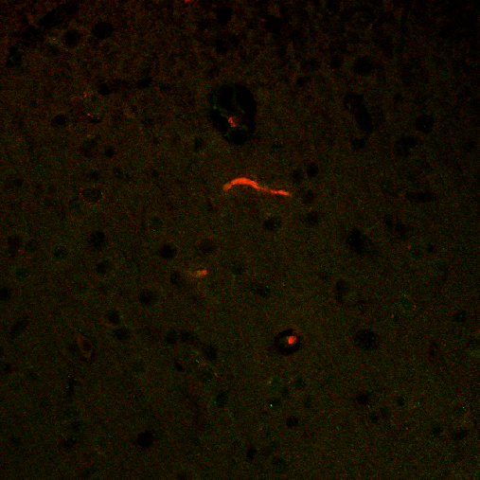
M4P
Merge
GFAP
NeuN
M4P
Merge
vWF
M4P
Merge

Supplemental Fig. VI M4P does not stain astrocytes and most neurons in contralateral hemisphere. Co-staining of TRPM4 using M4P antibody with anti-vWF, anti-NeuN and anti-GFAP in contralateral hemisphere of rat brains 1 day after MCAO. Arrows: co-localization of M4P with NeuN in neurons. Scale bar: 50 µm.

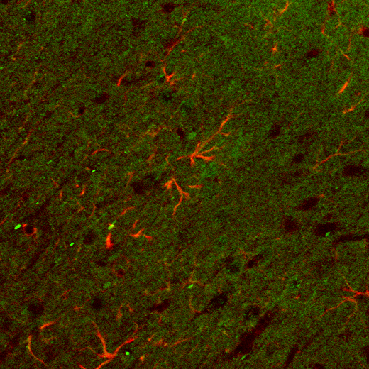
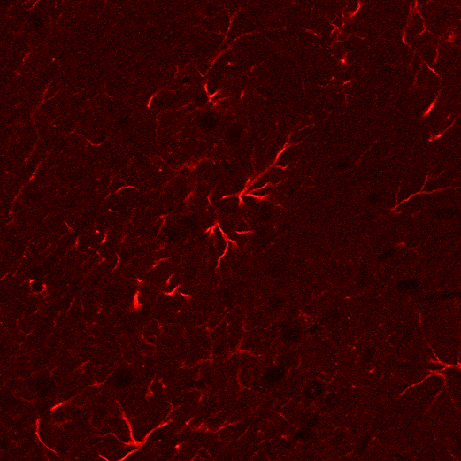
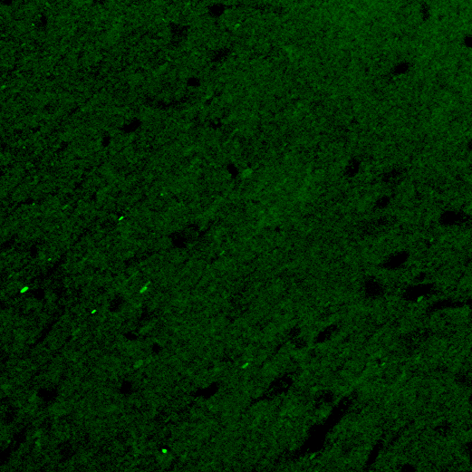
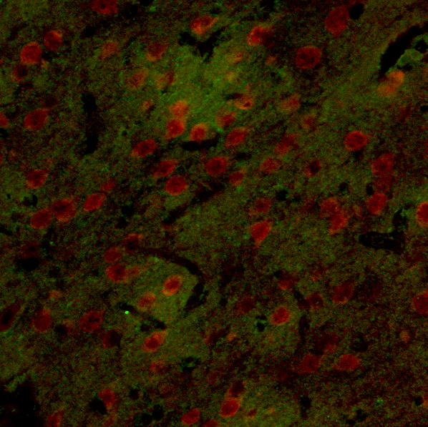
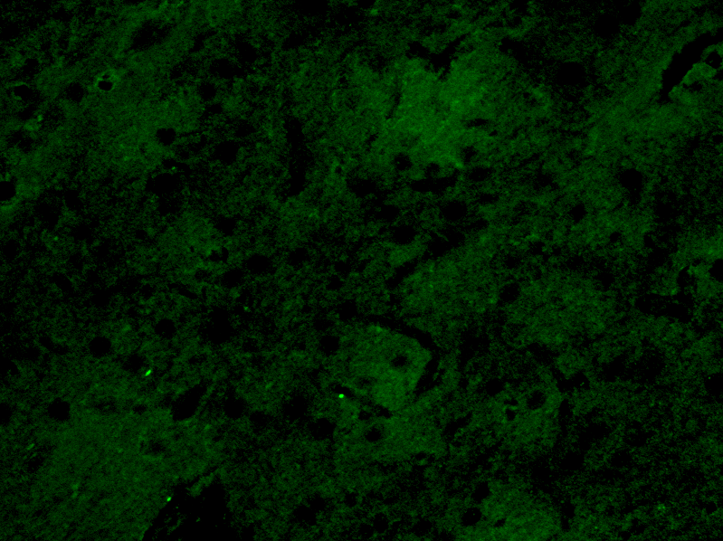
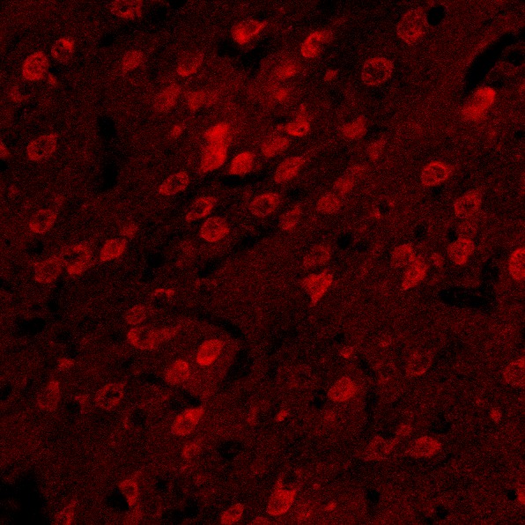
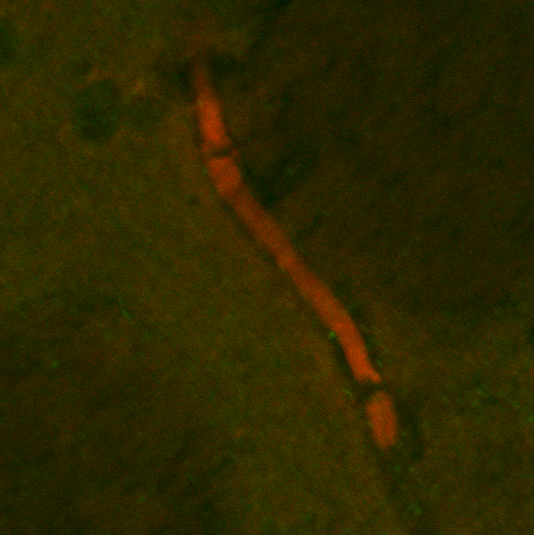
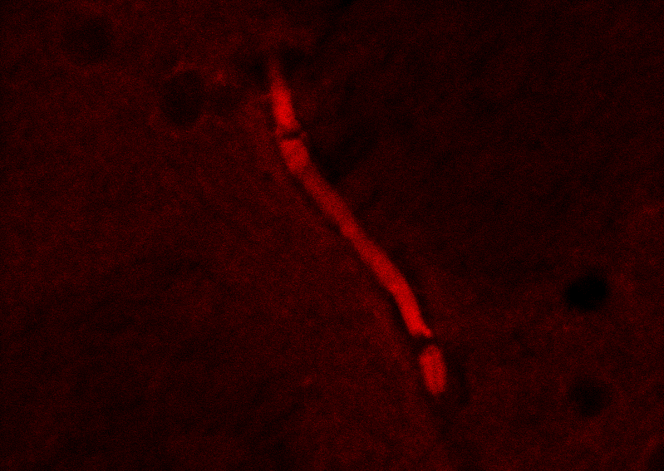
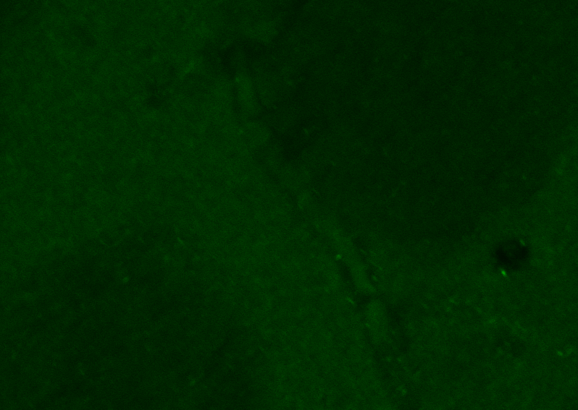
Supplemental Figure VII
GFAP
M4P
Merge
M4P
Merge
NeuN
vWF
M4P
Merge

Supplemental Fig. VII Immunostaining using M4P in sham-operated rat brain. Co-staining of TRPM4 using M4P antibody with anti-vWF, anti-NeuN and anti-GFAP in same regions as Fig. VI in sham-operated rat brains. Scale bar: 50 µm.

