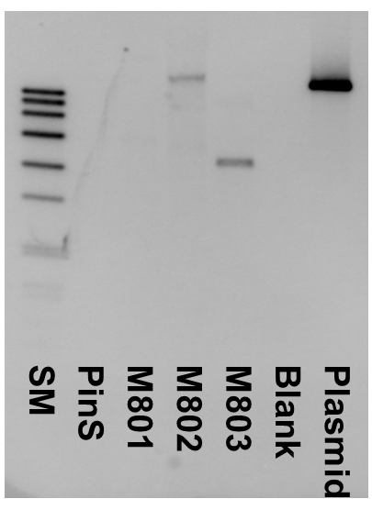
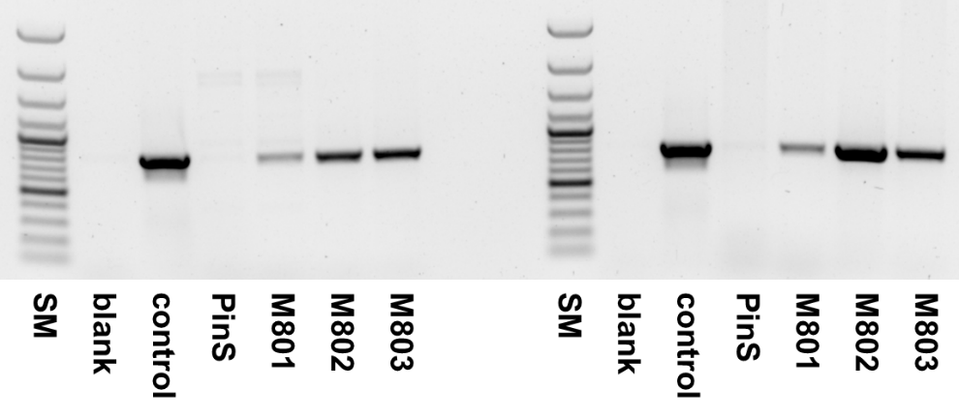
Supplementary Figure S1 Molecular evaluation of the three transgenic CsCH3H apple lines in comparison to the PinS control. a: PCR-based detection of the nptII selection; left PCR with genomic DNA, right RT-PCR with cDNA from leaves. b: Detection of integrated T-DNA copies in DNA of the CsCH3H transgenic apple lines by Southern hybridization. abbrev: SM: Size marker

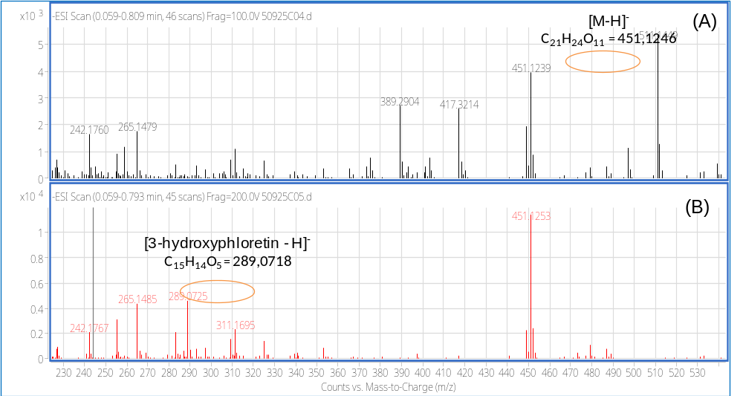
289.0718
451.1246

Supplementary Figure S2 Mass spectra of 3-hydroxyphloridzin showing (A) the accurate mass of the compound and (B) the loss of a hexose and 3-hydroxyphloretin pseudomolecular ion

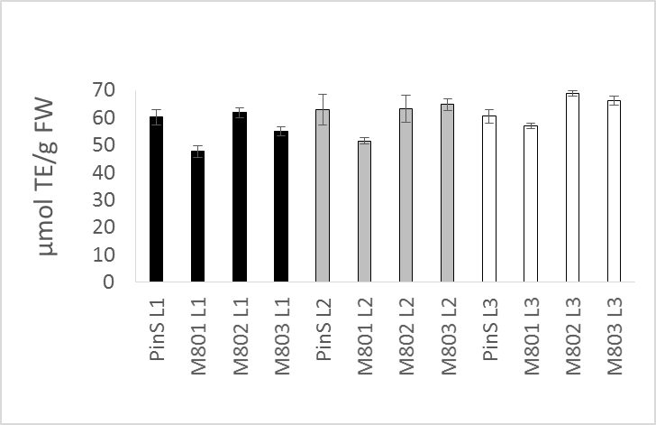
Supplementary Figure S3 Antiradical power (µmol TE/g FW) determined by the DPPH method in extracts of the first (L1, black), second (L2, grey) and third (L3, white) leaves of three transgenic CsCH3H apple lines (M801, M802, M803) in comparison to the PinS parent line

Supplementary Figure S4 Expression of elongation factor normalized against the housekeeping gene glycerinaldehyde 3-phosphate dehydrogenase in transgenic CsCH3H apple trees in comparison to the parent line PinS (expression ratio 1) in the first (L1, black), second (L2, grey) and third (L3, white) leaves

Supplementary Table S1 List of primers used
Primer ID | Sequence (5´>3´direction) | T_{m} (°C) | Size (bp) | Source  (Acc. no./pub.)
Mal.EF.F | TACTGGAACATCACAGGCTGAC | 60.3 | 308 | Vanblaere et al. (2011)
Mal.EF.R | TGGACCTCTCATCATGTTGT | 55.3 | 308 | Vanblaere et al. (2011)
Mal.ANS.F | GTCATGCACATTGGGGATACACTT | 61.0 | 102 | AF117269
Mal.ANS.R | CCATGAAATCCTCACCTTTTCCTTG | 61.3 | 102 | AF117269
Mal.ANR.F | TTTTGGCTGAGAAAGAATCTGCATC | 59.7 | 100 | DQ099803
Mal.ANR.R | TGGGGGTATCTTTTGTTGAGGAACT | 61.3 | 100 | DQ099803
Mal.FGT.F | TGTACATAAGCTTCGGGACAGTG | 60.6 | 102 | DQ156906
Mal.FGT..R | TGATAGACCACAAGAAGGGTGCT | 60.6 | 102 | DQ156906
Mal.GAPDH.F | CACCACCGACTACATGACCTA | 62.5 | 99 | MDC007381
Mal.GAPDH.R | AAGAGAAGGGTCTTGGAGTCCT | 63.3 | 99 | MDC007381
SpeCH3H* | CCCTCACTAGTCCCAACAACTCTTACTA | 65.1 | 1639 | p9u10-35S::CH3H
CH3HMlu* | CCTTACGCGTTGAAACAGGAACTCAG | 64.8 | 1639 | p9u10-35S::CH3H
nptII_F | ACAAGATGGATTGCACGCAGG | 59.8 | 780 | Flachowsky et al. 2007
nptII_R | AACTCGTCAAGAAGGCGATAG | 57.9 |  | Flachowsky et al. 2007
* restriction sites for SpeI and MluI which were used for cloning the CH3H cDNA into p9u10-35S are written in bold and underlined

Supplementary Table S2 Conversion rates of recombinant CH3H and F3'H using the 6'-deoxychalcone isoliquiritigenin, the flavanone naringenin and the dihydrochalcone phloretin as substrates
 | % Conversion rate with
Recombinant enzyme | isoliquiritigenin | naringenin | phloretin
CH3H (NCBI FJ216429) | 92.5±2 | 40.6±4 | 30.2±2
F3'H (NCBI FJ216426) | - | 45.6±3 | 10.4±3

Supplementary Table S4 m/z contained in fractionated sample detected with a ToF-MS in negative ionization mode. Deviation to the calculated molecular weight prior (100 V fragmentor voltage) and after fragmentation (200 V) is given in ppm
 | Detected m/z | Calculated m/z | ppm
[Phloridzin-H]⁻ | 451.1239 | 451.1246 (C₂₁H₂₄O₁₁) | 1.55
[3-hydroxyphloretin-H]⁻  (200 V fragmentor voltage) | 289.0725 | 289.0718 (C₁₅H₁₄O₅) | -2.42

Supplementary Table S3 Overview of the polyphenol composition in the first (L1), second (L2) and third (L3) leaves
in three transgenic CsCH3H apple lines (M801, M802, M803) in comparison to the PinS parent line.

mg/g DW
Sample |  | Total polyphenols | Total dihydro-  chalcones | phloridzin | phloretin | 3-Hydroxy-  phloridzin | Total flavonols | Hydroxycinnamic acids | Flavan 3-ols | Epicatechin | Catechin | Procyanidin B2 | Procyanidin B5 | Procyanidin E-B5
Leaf 1 | PinS | 329 ± 16 | 305 ± 15 | 293 ± 15 | 1.5 ±0.2 | 4.5±0.5 | 20.4 ± 1 | 3.3 ± 0.3 | 1.2 ± 0.2 | 0.18 ± 0.02 | 0.06 ± 0.01 | 0.04 ± 0.01 | 0.8 ± 0.04 | 0.31 ± 0.02
Leaf 1 | M801 | 120 ± 6 | 105 ± 5 | 99 ± 5 | 0.6 ±0.1 | 3.0 ±0.2 | 12.2 ± 0.6 | 1.9 ± 0.2 | 0.2 ± 0.05 | 0.12 ± 0.01 | 0.05 ± 0.01 | 0.02 ± 0.00 | 0.15 ± 0.01 | 0.05 ± 0.01
Leaf 1 | M802 | 226 ± 11 | 203 ± 10 | 187 ± 9 | 0.8±0.1 | 10.9±1 | 19.6 ± 1 | 2.9 ± 0.3 | 0.4 ± 0.05 | 0.18 ± 0.01 | 0.08 ± 0.02 | 0.03 ± 0.01 | 0.28 ± 0.01 | 0.05 ± 0.01
Leaf 1 | M803 | 329 ± 16 | 305 ± 15 | 289 ± 14 | 1.1±0.2 | 10.4 ±1 | 19.4 ± 1 | 2.8 ± 0.3 | 0.7 ± 0.05 | 0.24 ± 0.03 | 0.12 ± 0.02 | 0.06 ± 0.01 | 0.51 ± 0.01 | 0.15 ± 0.01
Leaf 2 | PinS | 352 ± 18 | 327 ± 16 | 312±16 | 2.1±0.2 | 7.0 ±0.7 | 19.5 ± 1 | 3.5 ± 0.3 | 1.3 ± 0.05 | 0.21 ± 0.03 | 0.05 ± 0.01 | 0.05 ± 0.01 | 0.98 ± 0.02 | 0.30 ± 0.01
Leaf 2 | M801 | 239 ± 12 | 212 ± 11 | 199 ± 10 | 1.6±0.2 | 7.2±0.8 | 23.5 ± 1 | 2.7 ± 0.3 | 0.6 ± 0.05 | 0.35 ± 0.03 | 0.11 ± 0.02 | 0.07 ± 0.02 | 0.42 ± 0.01 | 0.11 ± 0.01
Leaf 2 | M802 | 190 ± 10 | 165 ± 8 | 148 ± 7 | 1.8±0.2 | 11.4 ±1 | 21.6 ± 1 | 2.4 ± 0.3 | 0.5 ± 0.05 | 0.29 ± 0.03 | 0.10 ± 0.02 | 0.07 ± 0.02 | 0.40 ± 0.01 | 0.09 ± 0.01
Leaf 2 | M803 | 184 ± 9 | 160 ± 8 | 144 ± 7 | 1.2±0.1 | 10.9 ±1 | 21.3 ± 1 | 2.4 ± 0.3 | 0.4 ± 0.05 | 0.21 ± 0.03 | 0.09 ± 0.01 | 0.04 ± 0.01 | 0.29 ± 0.01 | 0.07 ± 0.00
Leaf 3 | PinS | 217 ± 11 | 190 ± 10 | 179 ±9 | 0.6±0.1 | 5.1±0.5 | 22.7 ± 1 | 3.5 ± 0.4 | 1.2 ± 0.1 | 0.16 ± 0.01 | 0.03 ± 0.01 | 0.06 ± 0.01 | 0.89 ± 0.02 | 0.22 ± 0.01
Leaf 3 | M801 | 180 ± 9 | 152 ± 8 | 143 ± 7 | 0.9±0.1 | 5.1±0.5 | 24.4 ± 1 | 2.6 ± 0.3 | 0.6 ± 0.05 | 0.43 ± 0.04 | 0.11 ± 0.02 | 0.11 ± 0.02 | 0.36 ± 0.01 | 0.12 ± 0.01
Leaf 3 | M802 | 142 ± 7 | 117 ± 6 | 98 ± 5 | 1.8±0.2 | 13.4±1 | 21.6 ± 1 | 2.4 ± 0.3 | 0.6 ± 0.05 | 0.36 ± 0.04 | 0.10 ± 0.03 | 0.11 ± 0.02 | 0.37 ± 0.01 | 0.08 ± 0.01
Leaf 3 | M803 | 147 ± 7 | 119 ± 6 | 102 ± 5 | 1.1±0.2 | 12.6±1 | 24.0 ± 1 | 2.4 ± 0.3 | 0.6 ± 0.05 | 0.36 ± 0.04 | 0.09 ± 0.03 | 0.11 ± 0.02 | 0.36 ± 0.01 | 0.13 ± 0.02

