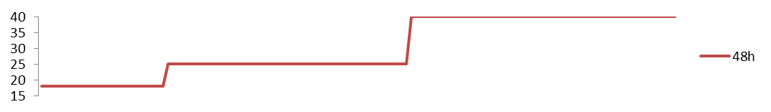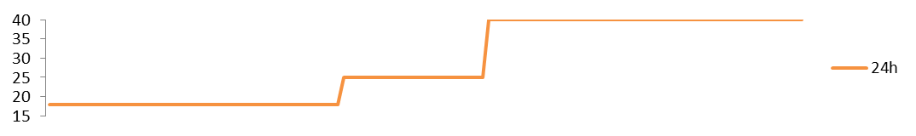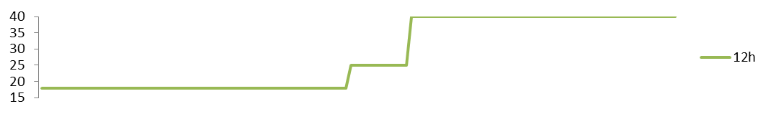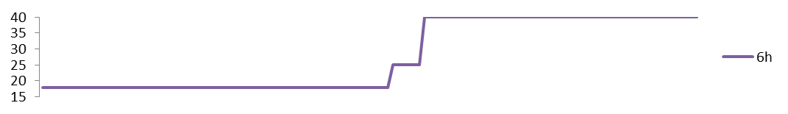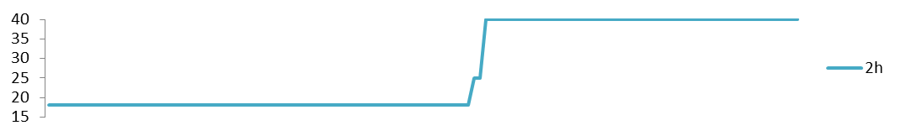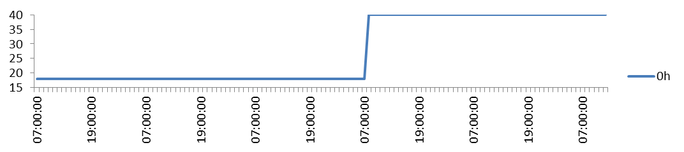
Temperature °C
*
*
*
*
*
*
*
*
*
Watering
Lights off

Heat Stress 40 ⁰C
*

Online Resource S1 a Thermotolerance assay – timecourse experiments. Prior to acclimation treatment, plants were moved to a growth chamber maintained at 18°C, 12h day length, for one week. To induce thermotolerance, plants were then transferred to 25 °C (acclimation treatment) under constant light for different periods of time (0, 2, 6, 12, 24 or 48 h), prior to heat stress at 40 °C.

Temperature °C
Onlilne Resource S1 b Standard thermotolerance assay. Prior to acclimation treatment, plants were moved to a growth chamber maintained at 18°C, 12h day length, for one week. To induce thermotolerance, plants were then transferred to 25 °C (acclimation treatment – control plants were left at 18°C) under constant light, prior to heat stress at 40 °C.
Planta
A reversible light and genotype dependent acquired thermotolerance response protects the potato plant from excessive temperature
Almudena Trapero-Mozos^{1*}, Laurence JM Ducreux^{2*}, Craita E Bita^{2*}, Wayne Morris², Cosima Wiese³, Jenny A Morris², Christy Paterson², Peter E Hedley², Robert D Hancock^{2*}, Mark Taylor^{2*}

Corresponding author: mark.taylor@hutton.ac.uk

Cell & Molecular Sciences, The James Hutton Institute, Invergowrie, Dundee DD2 5DA, United Kingdom.

*
Watering
Lights off
*
*
*
*
*
*
*
*
Heat Stress 40 ⁰C
*

