Supplementary Fig. S2Phylogenetic relationships of the putative A. fatua ACC oxidases, AfACO1 and AfACO5 with ACO proteins from other species. The unrooted phylogenetic tree based on deduced amino acid sequences of unigenes from NGS RNA-seqAvena fatua database. It was constructed in Geneious 6.1. software with the neighbor-joining method and Jukes-Cantor genetic distance model.

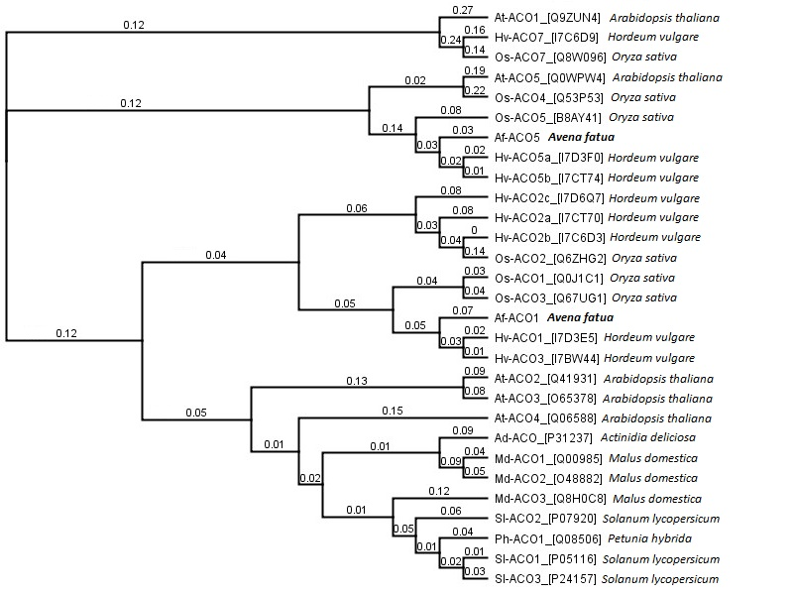

Involvement of ethylene biosynthesis and perception during germination of dormant Avena fatua L. caryopses induced by KAR₁ or GA₃
Izabela Ruduś, Danuta Cembrowska-Lech, Anna Jaworska, Jan Kępczyński*
Department of Plant Physiology and Genetic Engineering, Faculty of Biology, University of Szczecin, Wąska 13, 71-415 Szczecin, Poland
*Corresponding author: Jan Kępczyński, jankepcz@wp.pl, jan.kepczynski@usz.edu.pl

