Supplementary Information
Supplementary Fig. S1 Arrangement of seeds (Cameor) in water loss experiment.
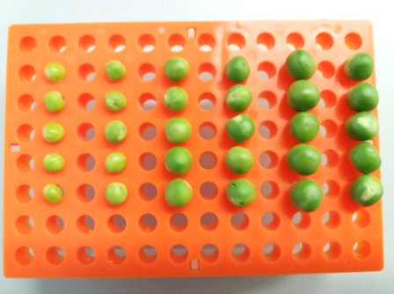

Supplementary Fig. S2The dry mature seeds of Cameor (a), JI92 (b) and JI1794 (c). The images were captured using the digital microscope VHX-7000 (Keyence). Scale bar = 2 mm (a) or 1mm (b, c).

Supplementary Fig. S3 Summary of statistical analysis of water loss during the development of Cameor, JI92 and JI64 seeds shown in Fig. 9. Different letters indicate significant differences (P = 0.05) by Kruskal-Wallis test with the following non-parametric multiple comparison test.

