Raman developmental markers in root cell walls are associated with lodging tendency in tef

Sabrina Diehn¹, Noa Kirby¹, Shiran Ben-Zeev¹, Muluken Demelie Alemu^{1,2}, Yehoshua Saranga¹, Rivka Elbaum¹
¹The Robert H. Smith Institute of Plant Sciences and Genetics in Agriculture, The Hebrew University of Jerusalem, Rehovot 7610001, Israel
²Ethiopian Institute of Agricultural Research, Ethiopia

Supporting table and figures

Table S1: Days to flowering (DTF) and lodging indices at week 8, 9, and 10 (LI8, LI9, and LI10, respectively) of the four tef genotypes (RTC-157, RTC-275, RTC-392, RTC-400) in a field experiment, Shiller Farm 2021. Data are means of two six plots (2 irrigation regimes X 3 replicates). Different letters (a,b,c) indicate significant difference according to Tukey HSD test (P<0.05), *, ** and *** indicate significant F ratios at P<0.05, 0.01 and 0.001, respectively. Data adapted from Demelie Alemu and Ben-Zeev (pers. communication, Hebrew University of Jerusalem, 2023).
Effect of genotypes |  | DTF | LI8 | LI9 | LI10
RTC-157 |  | 81.2 a | 37 b | 285 b | 387 c
RTC-275 |  | 54.2 b | 183 b | 417 b | 550 b
RTC-392 |  | 43.7 c | 117 b | 450 b | 667 ab
RTC-400 |  | 57.2 b | 450 a | 833 a | 783 a
Source | DF | F Ratio | F Ratio | F Ratio | F Ratio
ENV | 1 | 126 | 2.69 | 21.97 *** | 122.47 ***
Geno | 3 | 4519.1 *** | 10.72*** | 9.59 ** | 26.00 ***
ENV*Geno | 3 | 353.8 * | 1.45 | 1.82 | 13.8 ***
Block | 2 | 35.6 | 2.21 | 0.24 | 0.81

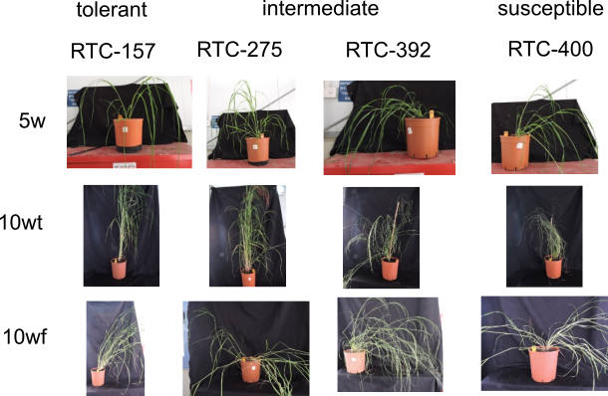

Fig. S1 Photographs of plants that were used in this study, including (from left to right) RTC-157, RTC-275, RTC-392, and RTC-400 genotypes of plants of (top to bottom) 5-week-old (5w), supported 10-week-old (10wt), and non-supported 10-week-old (10wf).

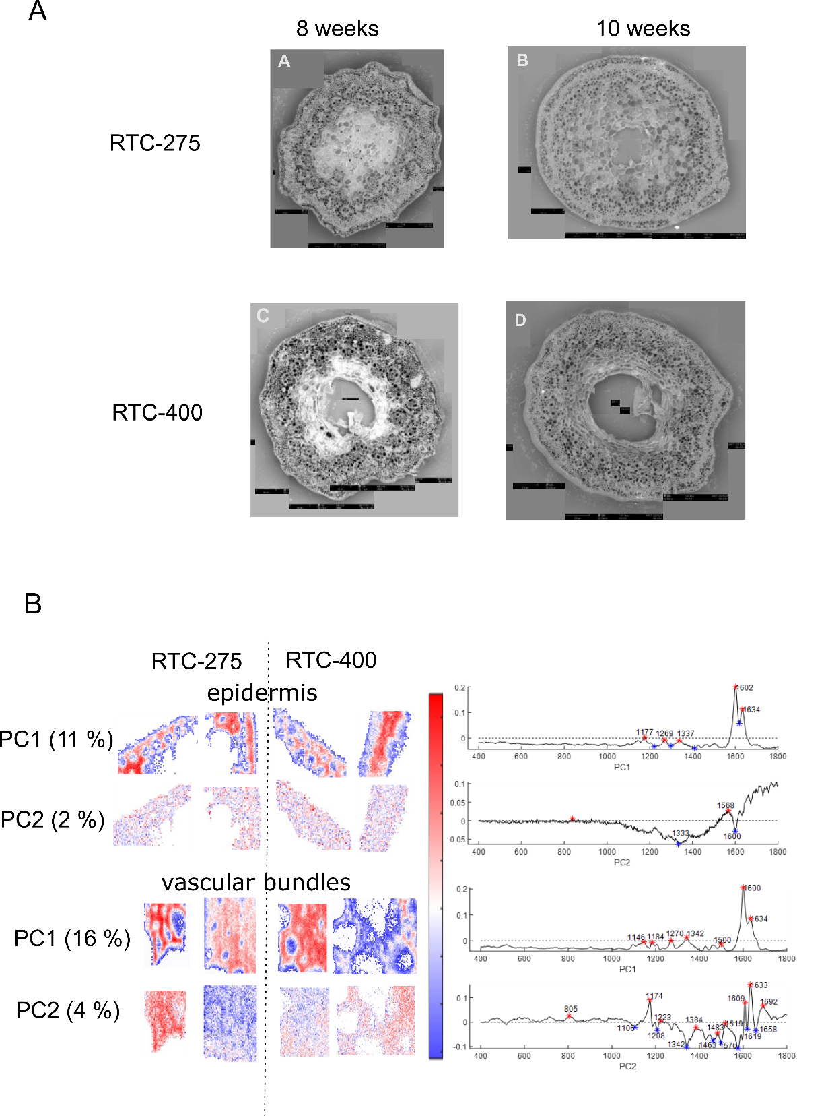
Fig. S2 A. SEM mosaic images of cross sections from the first internodes of the two genotypes RTC-375 (intermediate lodging tolerant) and RTC-400 (lodging susceptible) at 8 weeks and 10 weeks after emergence. B. PCA images of PC1 and PC2 of internode cross sections focusing on epidermis and vascular bundles. These preliminary observations indicated a faster development of a hollow stem in the lodging susceptible genotype. Nonetheless, we could not detect consistent chemical variation linked to lodging tendencies by Raman microspectroscopy.

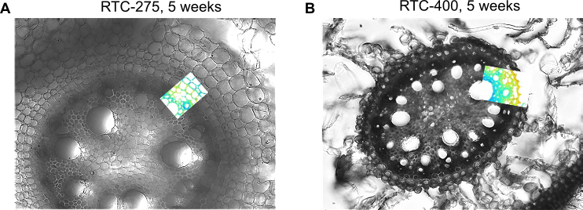
Fig. S3 Crown root cross sections from a line with intermediate (A, RTC-275) and with high (B, RTC-400) lodging tendencies of five weeks old (5w) tef plants. The images present an overlay of bright-field images and Raman intensity maps at 1144 cm⁻¹, which is tentatively associated with suberin. The endodermis inner tangential wall exhibits high suberin levels, mostly in RTC-400.

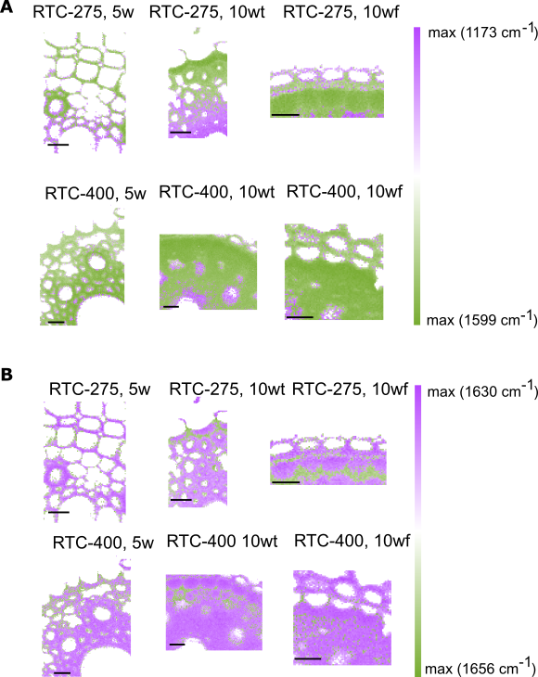
Fig. S4 Overlays of the intensity maps of (A) 1173 and 1599 cm⁻¹, as well as of (B) 1630 and 1656 cm⁻¹ from 5 weeks (5w), 10 weeks trellised (10wt) and 10 weeks non-trellised (10wf) plants from the two genotypes RTC-275 and RTC-400. One can appreciate that on a cell level, the bands at 1173 and 1599 cm⁻¹ and at 1630 and 1656 cm⁻¹ complement each other. All scale bars represent 20 µm.

