Supplementary materials

Table S1. List of primers used for qPCR analysis.
Target | T2T accession | Primer sequence (5’-3’) |  | Amplicon length
VvNCED6 | Vitvi05_01chr02g19450 | F | CTGGGAAGGAGAACACGGTA | 101 bp
VvNCED6 | Vitvi05_01chr02g19450 | R | TTGGTTACCTCTCCGGTCAC | 101 bp
VvSVP2 | Vitvi05_01chr18g07640 | F | CGGCTAATGACTATGGAATCGG | 130 bp
VvSVP2 | Vitvi05_01chr18g07640 | R | GCTTGAGAGATGTGTCAGAGC | 130 bp
VvDRM1 | Vitvi05_01chr10g08760 | F | CTATGACTCCCACCACTCCC | 174 bp
VvDRM1 | Vitvi05_01chr10g08760 | R | GGAGATGAACAGGCGTAGGT | 174 bp
VvFT | Vitvi05_01chr08g17740 | F | AGAAACGCAGACAGACGGTT | 128 bp
VvFT | Vitvi05_01chr08g17740 | R | AGCTGTTTCTCGCTGAGCAT | 128 bp

Table S2. Detailed phenotypic data on Chardonnay (CH) and Cabernet Sauvignon (CS) single-node cuttings in forcing conditions classified as per BBCH scale. DOE = day of experiment.
 | 0 DOE |  | 3 DOE |  | 4 DOE |  | 7 DOE |  | 10 DOE
 | CH | CS | CH | CS | CH | CS | CH | CS | CH | CS
BBCH 00 | 100% | 100% | 0% | 40% | 0% | 0% | 0% | 0% | 0% | 0%
BBCH 01 – 03 | 0% | 0% | 80% | 60% | 80% | 100% | 20% | 100% | 20% | 20%
BBCH 04 – 06 | 0% | 0% | 20% | 0% | 20% | 0% | 80% | 0% | 20% | 80%
BBCH 07 – 09 | 0% | 0% | 0% | 0% | 0% | 0% | 0% | 0% | 40% | 0%
BBCH 10 | 0% | 0% | 0% | 0% | 0% | 0% | 0% | 0% | 20% | 0%

Table S3. Loadings extracted from PCA analyses. Loading threshold was set at |loading| > 0.2.
 | T2T accession | Annotation
0 DOE included | Vitvi05_01chr04g19030 | VviDHN1 (Dehydrin 1)
0 DOE included | Vitvi05_01chr07g05590 | VviSUSY3 (Sucrose Synthase 3)
0 DOE included | Vitvi05_01chr08g06180 | Pyruvate decarboxylase
0 DOE included | Vitvi05_01chr01g20950 | VviGAPC1 (Glyceraldehyde-3-Phosphate Dehydrogenase)
0 DOE included | Vitvi05_01chr04g24030 | VviADH1 (Alcohol Dehydrogenase)
0 DOE included | Vitvi05_01chr19g01900 | D-Mannose Binding Lectin Protein
0 DOE included | Vitvi05_01chr19g01920 | Mannose Binding Lectin1
0 DOE included | Vitvi05_01chr19g09420 | Glycine rich protein family
0 DOE excluded | Vitvi05_01chr05g10840 | Unknown
0 DOE excluded | Vitvi05_01chr08g13760 | Metallothionein
0 DOE excluded | Vitvi05_01chr11g00510 | VviSUSY4 (Sucrose Synthase 4)
0 DOE excluded | Vitvi05_01chr19g09420 | Glycine rich protein family

Table S6. Total number of genes included in each cluster group.
Cluster | Chardonnay | Cabernet Sauvignon
Group 1 | 7213 | 5186
Group 2 | 523 | 1797
Group 3 | 723 | 1340

Table S7. Total number of genes included in each cluster group. CS = Cabernet Sauvignon; CH = Chardonnay. G1 = group 1; G2 = group 2; G3 = group 3.
Comparison | Intersection | Union | (Intersection/Union)*100
CS G1 v CH G1 | 4757 | 7642 | 62%
CS G2 v CH G1 | 1256 | 7754 | 16%
CS G3 v CH G3 | 667 | 1396 | 48%
CS G3 v CH G1 | 639 | 7914 | 8%
CS G2 v CH G2 | 464 | 1856 | 25%

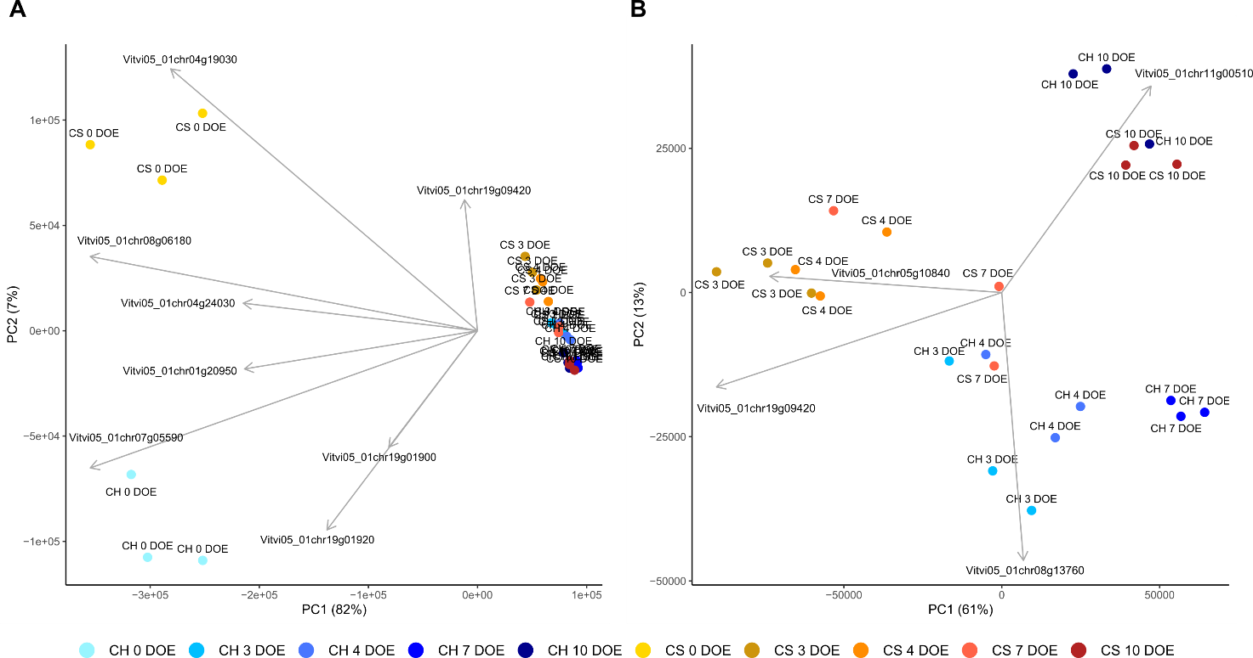
Figure S1. Principal Component Analysis of RNA-seq data of Chardonnay (CH) and Cabernet Sauvignon (CS) single-node cuttings throughout the experiment (A). To improve sample segregation, PCA analysis was also performed excluding 0 DOE samples (B). Loadings were extracted with a | loading | > 0.2 threshold. DOE = day of experiment.

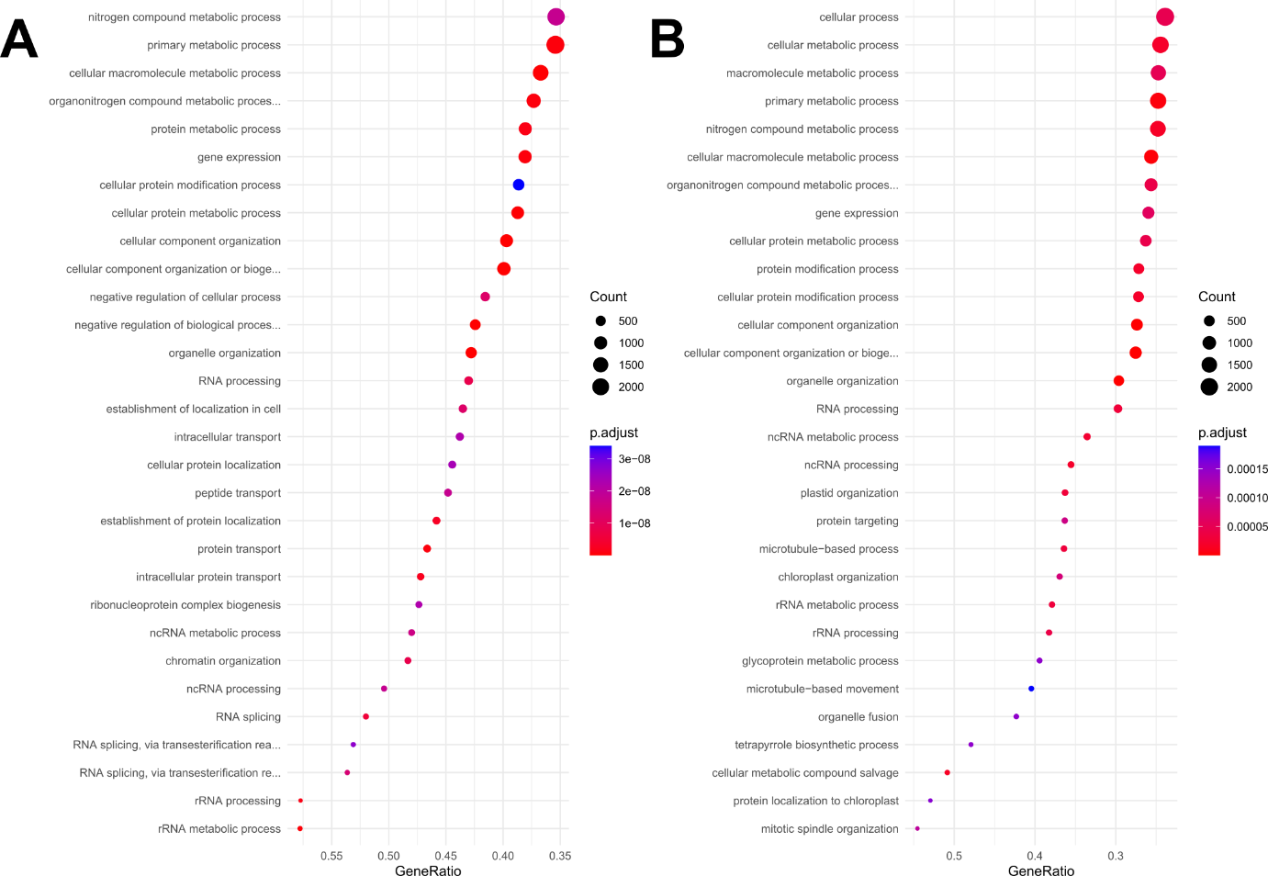
Figure S2. Gene Ontology enrichment analysis of biological processes taking place in Chardonnay and Cabernet Sauvignon single-node cuttings throughout the experiment. A = Chardonnay group 1, B = Cabernet Sauvignon group 1.
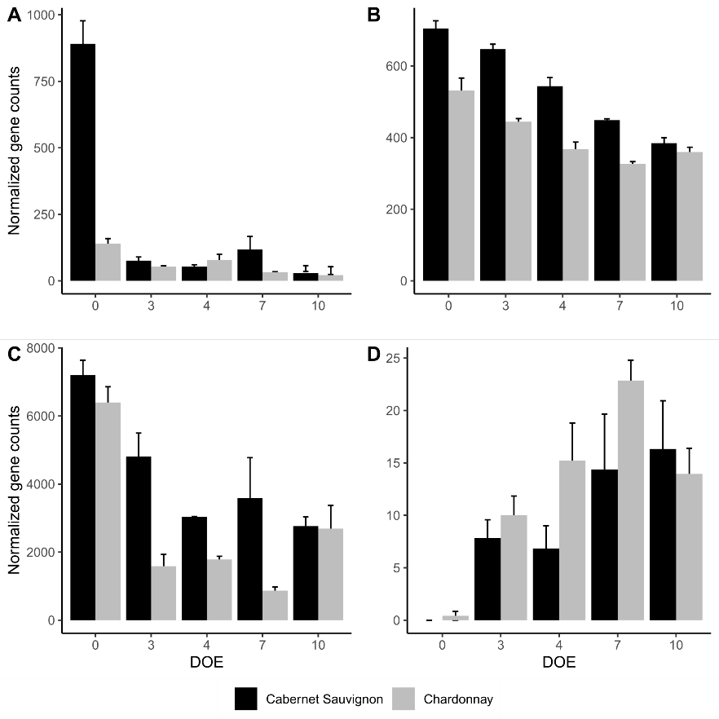
Figure S3. DESeq2 normalized gene counts of genes VvNCED6 (A), VviSVP2 (B), VviDRM1 (C), VviFT (D) in cv. Cabernet Sauvignon (black bars) and cv. Chardonnay (grey bars) throughout the experiment. DOE = day of experiment. Results are expressed as mean of 3 biological replicates ± standard error.

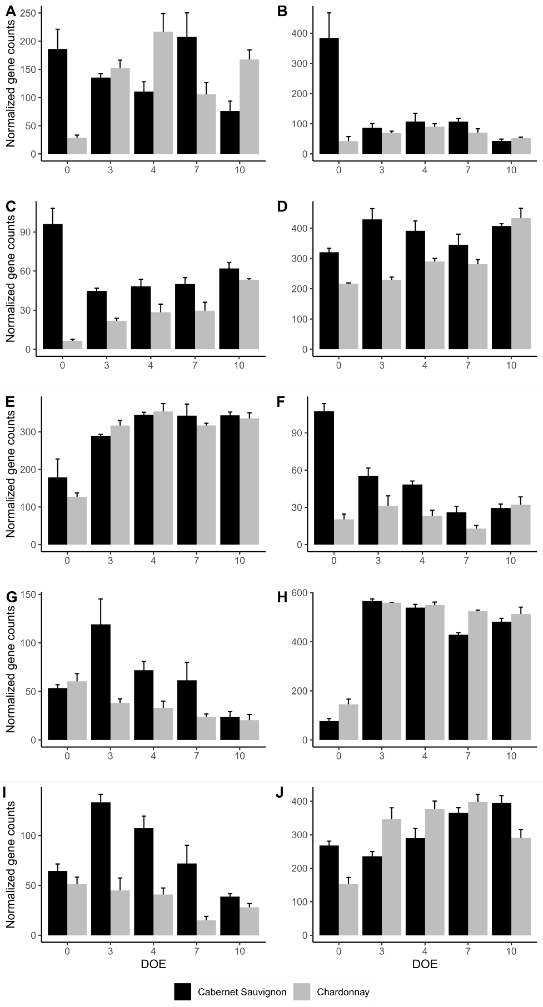
Figure S4. DESeq2 normalized gene counts of genes VviNCED3 (A), VviNCED4 (B), VviNCED5 (C), VviZEP1 (D), VviZEP2 (E), VviZEP3 (F), Absicic Aldehyde Oxidase (AAO) homologs (G to I) and VviABA2 (J) in cv. Cabernet Sauvignon (black bars) and cv. Chardonnay (grey bars) throughout the experiment. DOE = day of experiment. Results are expressed as mean of 3 biological replicates ± standard error. VviNCED3 = Vitvi05_01chr19g16940; VviNCED4 = Vitvi05_01chr02g19450; VviNCED5 = Vitvi05_01chr10g14230; VviZEP1 = Vitvi05_01chr07g28260; VviZEP2 = Vitvi05_01chr13g28160; VviZEP3 = Vitvi05_01chr02g08870; VviAAOs = Vitvi05_01chr18g32800, Vitvi05_01chr06g13810, Vitvi05_01chr18g32770; VviABA2 = Vitvi05_01chr13g23670.

