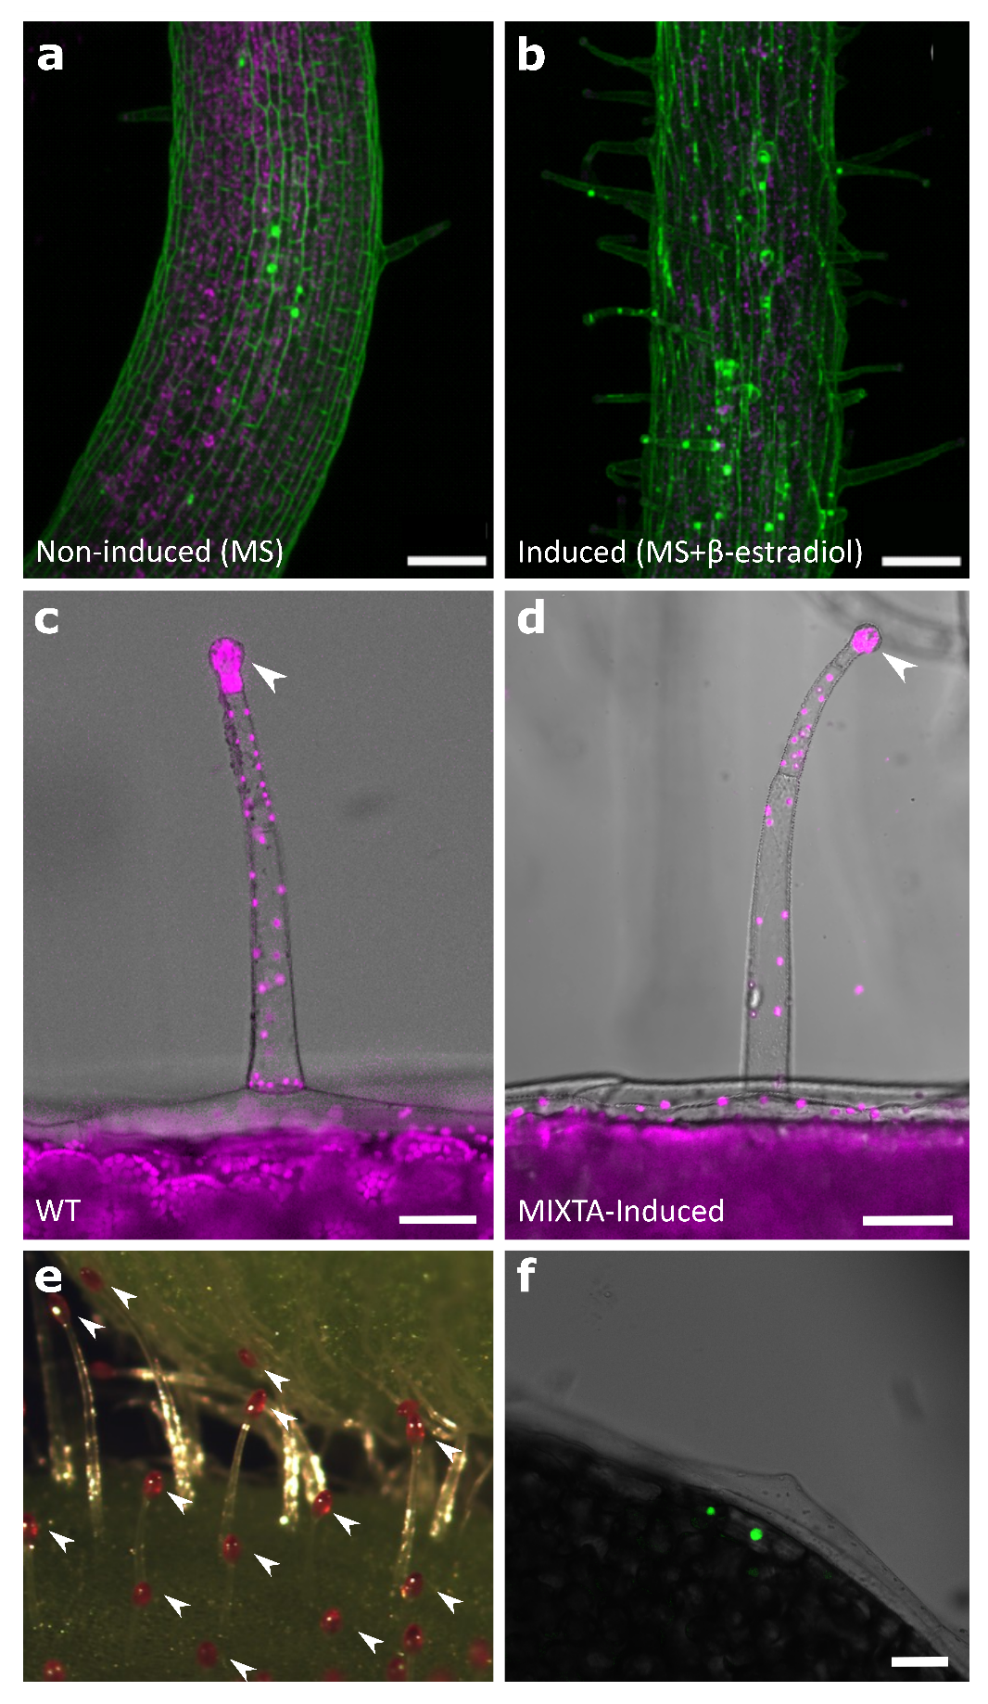
Fig. S1 a, b Hypocotyls. Detailed phenotypic differences in pEST::AmMIXTA transgenic plants. Ten-day-old pEST::AmMIXTA seedlings were germinated on non-inducing medium (1/2 MS medium) (a) and inducing medium (1/2 MS medium supplemented with 5 μM β-estradiol) (b). Magenta represents autofluorescence; green indicates propidium iodide staining. Scale bar: 100 μm. c, d Chlorophyll autofluorescence in the trichome heads of (c) a leaf from a wild-type plant and (d) a cotyledon from a ten-day-old induced pEST::AmMIXTA seedling. White arrowheads point to chlorophyll autofluorescence in the glandular heads. Scale bar: 50 μm. e Induced ten-day-old pEST::AmMIXTA seedlings stained with rhodamine B, an acylsugar dye that stains the trichome heads red, confirming the full development of trichomes in the induced line. White arrowheads point to stained trichome heads. f The nuclear localization of VENUS-tagged MIXTA under the same inducible promoter in inducible conditions is displayed. VENUS-tagged MIXTA is shown in green. The scale bar is 50 μm.

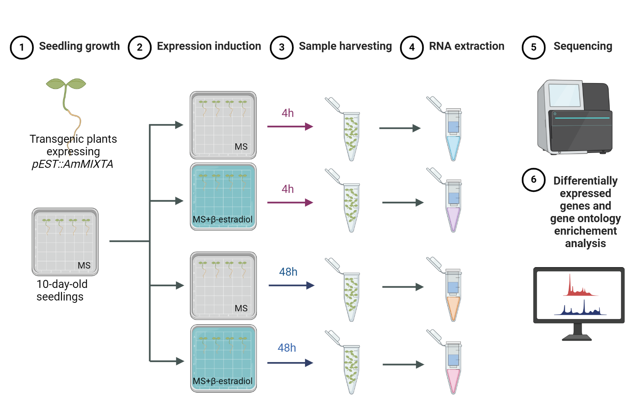
Fig. S2 Utilization of AmMIXTA as a tool for identifying genes involved in the early stages of trichome development: experimental scheme. This Fig. outlines the step-by-step experimental approach employed to elucidate the role of AmMIXTA in the initiation and early development of trichomes. Initially, pEST::AmMIXTA transgenic plants were cultivated under inducing conditions to induce the expression of AmMIXTA, the same line was grown in non-inducing conditions as a control. Subsequent stages involved the collection of samples at critical early developmental stages, followed by RNA extraction and high-throughput sequencing to identify differentially expressed genes. The schematic representation includes key experimental steps such as treatment conditions, sample collection time points, and the analytical methods used to dissect the genetic pathways activated by AmMIXTA in trichome development.

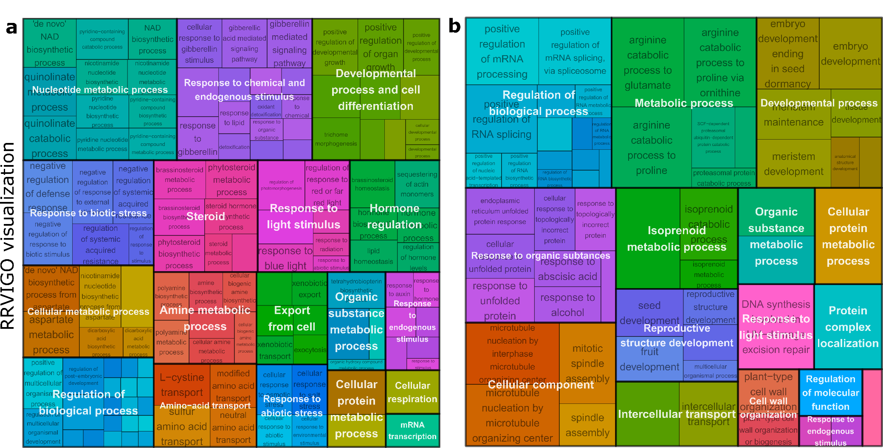
Fig. S3 GO term enrichment visualization with Rrvigo
Utilizing Rrvigo, a tool designed to visualize enriched GO terms, upregulated GO terms identified in Fig. 3 at 4 h (a) and 48 h (b) following pEST::AmMIXTA induction were categorized into subgroups. This visualization facilitates the understanding of the functional significance of genes upregulated in response to pEST::AmMIXTA induction, by grouping similar GO terms together and highlighting the primary biological processes involved.

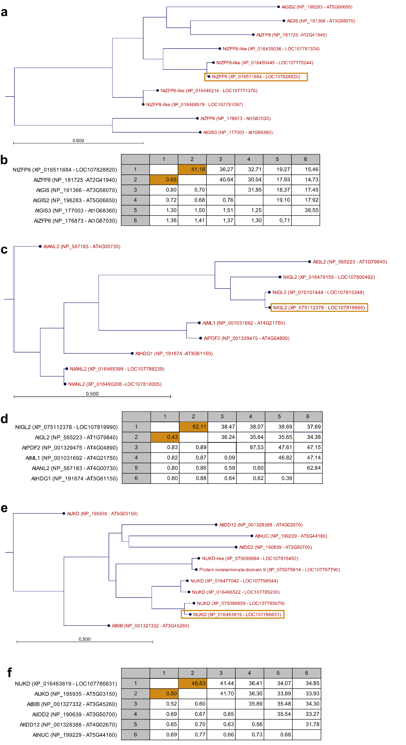
Fig. S4 Phylogenetic analysis of NtZFP8, NtGL2, and NtJACKDAW. a, c, e Phylogenetic trees of NtZFP8 (LOC107828820; a), NtGL2 (LOC107819990; c), and NtJACKDAW (LOC107786831; e), showing their relationships with the five closest homologs in Nicotiana tabacum and Arabidopsis thaliana, as identified by NCBI BLAST. Trees were constructed using CLC Workbench (Qiagen) with bootstrap values based on 1,000 replicates. The number of base pair substitutions per site is indicated along each branch. b, d, f Pairwise comparison tables corresponding to each tree, showing percentage identity above the diagonal and evolutionary distance below the diagonal for each protein pair. In each case, the N. tabacum ortholog used in this study is the closest homolog to the A. thaliana ortholog bearing a similar gene name (NtZFP8/AtZFP8, NtGL2/AtGL2, NtJACKDAW/AtJACKDAW).

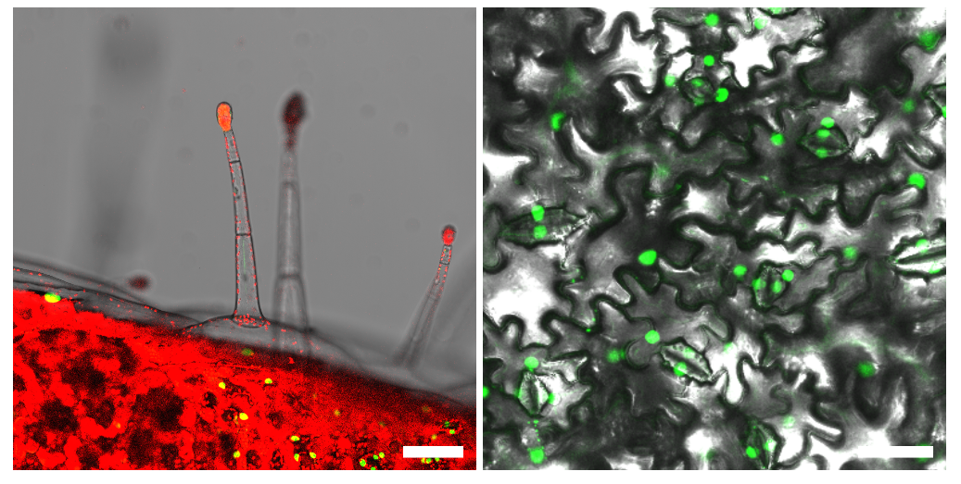
Fig. S5 NtZFP8 expression pattern in 6-week-old leaves. Transgenic plants expressing pZFP8::nlsGFP-GUS in larger leaves (15 cm) of 6 week-old plants. Left panel shows a trichome (note that mature glandular trichomes are not labelled); right panel shows the epidermal cell layer. Scale bars represent 100 μm; green indicates nlsGFP; red denotes chlorophyll autofluorescence.

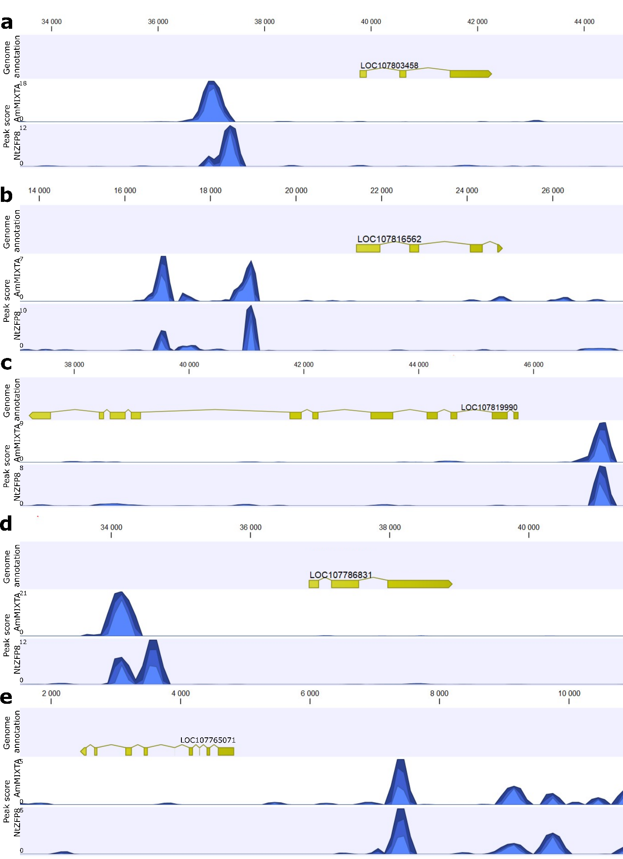
Fig. S6 Top 5 binding sites of NtZFP8 and AmMIXTA identified by DAP-seq. DAP-seq analysis identified genes whose promoters are targeted by both AmMIXTA and NtZFP8. a LOC107803458, NtMYB6. b LOC107816562, NtCONSTANS-like 10. c LOC107819990, NtGLABRA2. d LOC107786831, NtJACKDAW. e LOC107765071, NtAGL66. In each panel, the upper track displays the gene annotation and its position on the contig, while the lower track shows the DAP-seq peak shape score and the peak's localization. The analysis and creation of this figure were performed using CLC Genomics

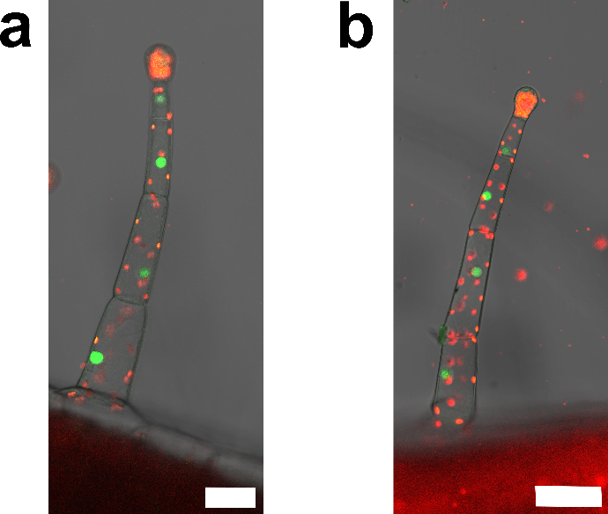
Fig. S7 NtGL2 and NtJACKDAW expression pattern in 6-week-old leaves.
Transgenic plants expressing pNtGL2::nlsGFP-GUS (a) and pNtJACKDAW::nlsGFP-GUS (b) in expending leaves (±5 cm) of 6-week-old plants. Scale bars represent 50 μm; green indicates nlsGFP; red denotes chlorophyll autofluorescence.

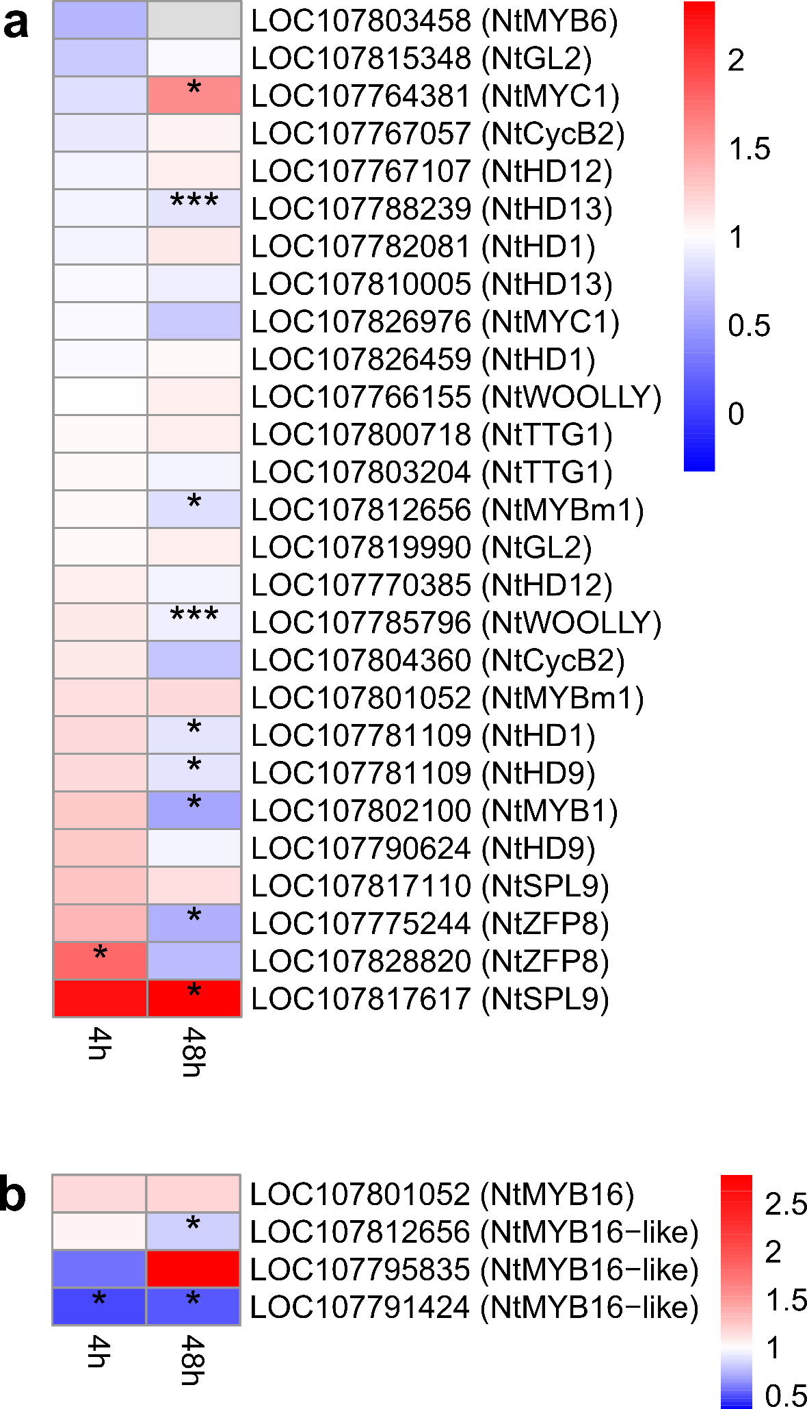
Fig. S8 Representation of a subset of genes of interest. Heatmap of differentially expressed trichome development-related genes (a) and AmMIXTA homologs (b). Scale represent the fold change (FC): white is FC=1 (no change of expression), red means upregulated (FC>1), blue downregulated (FC<1). *, P <0.05; **, P <0.01; ***, P <0.001

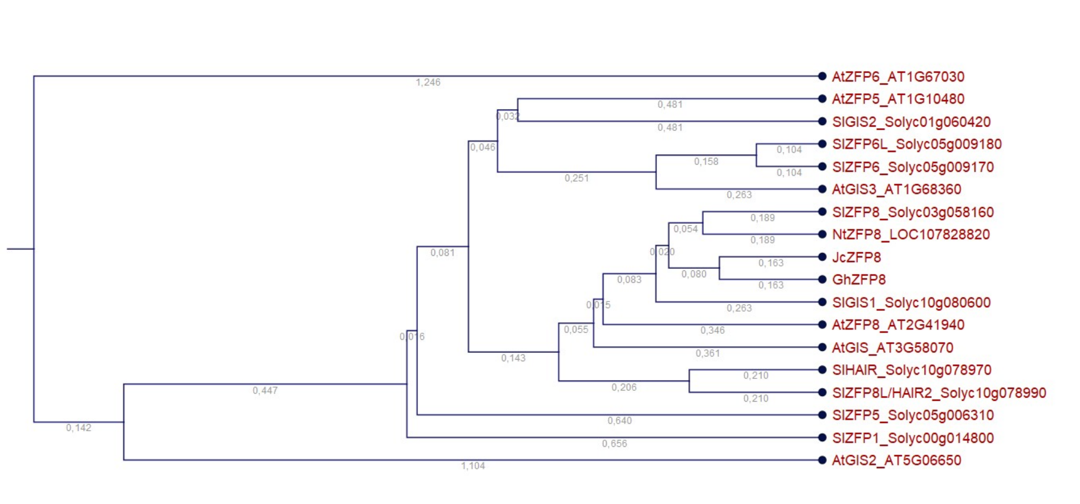
Fig. S9 Phylogenic tree of ZINC-FINGER proteins. Phylogenic relationship of ZINC-FINGER proteins in tomato, Arabidopsis, coton and Jatropha curcas. Bootstrap analysis was based on 1,000 replicates (CLC workbench, Qiagen). The number of base pair substitutions/sites is indicated at each branch.

Table S1 PCR primers used in this study

Table S2 Exonic read mapping to the N.tabacum genome before and after trimming steps

Table S3 DAP-seq Read mapping to the N.tabacum genome before and after trimming steps

Table S4 Upregulated DEGs at 4 h and 48 h post-induction of AmMIXTA

Table S5 GO term enrichment analysis at 4 h and 48 h post-induction of AmMIXTA

Table S6 DAP-seq table for AmMIXTA binding sites

Table S7 DAP-seq table for NtZFP8 binding sites

