Supplementary Information
Comparison of single and combined salt and cold stress effects and their challenges for hyperspectral measurements of different Capsicum species
Franziska Genzel^{1,2}, Anika Wiese-Klinkenberg^{1,2}
¹Institute of Bio- and Geosciences, Bioinformatics (IBG-4) and Plant Sciences (IBG-2), Forschungszentrum Jülich GmbH, 52425 Jülich, Germany,
²Bioeconomy Science Center (BioSC), Forschungszentrum Jülich GmbH, 52425 Jülich, Germany

Table S1 Management of temperature and light regime in growth chamber
Parameter | Time | Set
Parameter | Time | Control | Cold | Salt | Cold+Salt
Temperature | 00:00 | 18 | 12 | 18 | 12
Temperature | 05:30 | 18 | 12 | 18 | 12
Temperature | 06:00 | 24 | 18 | 24 | 18
Temperature | 16:00 | 24 | 18 | 24 | 18
Temperature | 16:30 | 18 | 12 | 18 | 12
Temperature | 23:59 | 18 | 12 | 18 | 12
Lamps | 00:00 | off | off | off | off
Lamps | 06:00 | on | on | on | on
Lamps | 16:01 | off | off | off | off
Lamps | 23:59 | off | off | off | off

Fig. S1 Positions used for spectral reflectance measurement with the spectroradiometer.

Fig. S2 Dry weight (DW, mg) of C. annuum (a) and C. chinense plants (b) shown for control, cold, salt, and cold plus salt 1, 7, and 14 days after start of stress treatment. Data show means ± standard deviations (n = 4 plants). Different letters indicate significant differences between treatments (control, cold, salt, cold plus salt) per species within each time point (P ≤ 0.05)

Table S2 Foliar concentration of chlorophyll a and chlorophyll b of C. annuum and C. chinense grown under different conditions (control, cold, salt, cold plus salt) after 1, 7, and 14 days. Data show means ± standard deviations (n = 4 plants). Significant differences between treatments within each time point are indicated by different letters (P ≤ 0.05)
Pigment concentration (mg/g DW) | Day | Control | Cold | Salt | Cold+Salt
C. annuum
Chlorophyll a | 1 | 14.0 ± 0.8 a | 12.5 ± 0.8 ab | 16.7 ± 1.6 b | 13.8 ± 1.7 ab
Chlorophyll a | 7 | 13.0 ± 0.3 a | 7.9 ± 0.6 b | 16.2 ± 1.8 c | 11.4 ± 0.9 a
Chlorophyll a | 14 | 11.5 ± 0.8 ac | 6.7 ± 0.4 b | 14.4 ± 1.4 c | 9.9 ± 2.2 ab
Chlorophyll b | 1 | 2.2 ± 0.2 | 1.8 ± 0.2 | 2.6 ± 0.5 | 2.1 ± 0.4
Chlorophyll b | 7 | 1.6 ± 0.05 ac | 1.0 ± 0.2 b | 2.2 ± 0.4 a | 1.4 ± 0.1 bc
Chlorophyll b | 14 | 1.9 ± 0.1 ac | 0.8 ± 0.04 b | 2.2 ± 0.4 c | 1.4 ± 0.4 ab
C. chinense
Chlorophyll a | 1 | 9.4 ± 1.00 | 8.7 ± 1.0 | 9.4 ± 1.2 | 8.4 ± 1.0
Chlorophyll a | 7 | 9.7 ± 0.8 a | 6.1 ± 1.0 b | 9.4 ± 1.5 a | 7.5 ± 0.7 ab
Chlorophyll a | 14 | 9.5 ± 0.6 a | 5.2 ± 0.4 b | 8.5 ± 1.6 ac | 6.4 ± 0.4 bc
Chlorophyll b | 1 | 1.2 ± 0.1 | 1.1 ± 0.2 | 1.2 ± 0.2 | 1.0 ± 0.1
Chlorophyll b | 7 | 1.2 ± 0.1 a | 0.6 ± 0.1 b | 1.2 ± 0.3 a | 0.9 ± 0.2 ab
Chlorophyll b | 14 | 1.4 ± 0.1 a | 0.6 ± 0.1 b | 1.2 ± 0.2 a | 0.8 ± 0.1 b

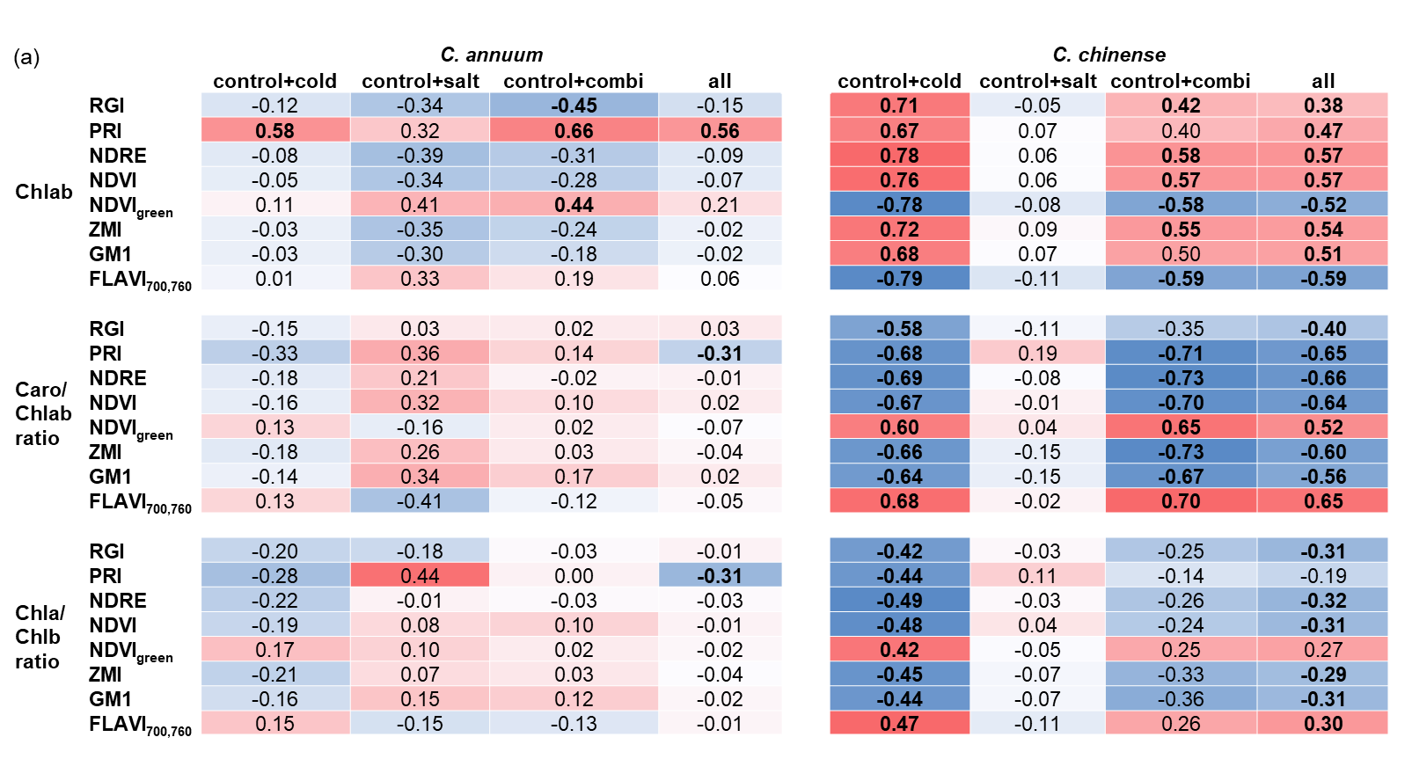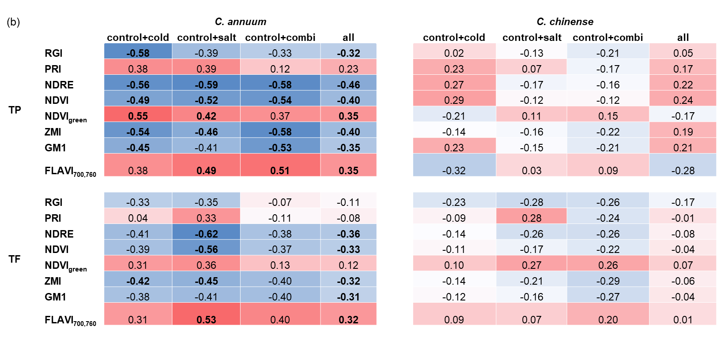
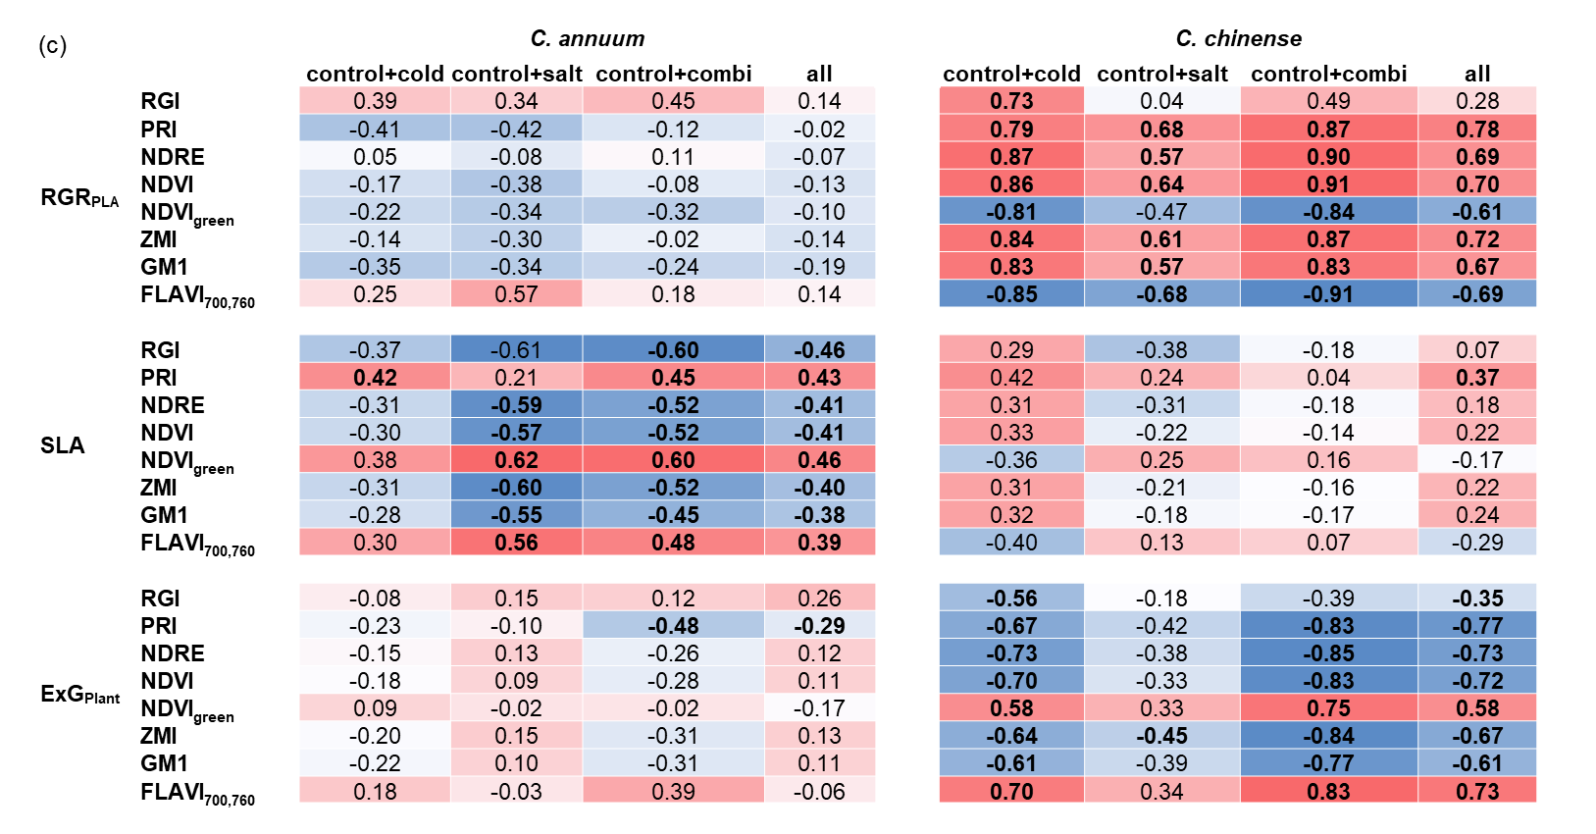
Fig. S3 Results of Pearson correlation conducted separately for the respective treatments (control and cold, control and salt, control and combination, all together). Shown is the coefficient (R, Pearson) of determination of relationships between reflectance indices and stress indicators [(a) chlorophyll ab (Chlab, mg/g DW), carotenoids (Caro, mg/g DW), the ratio of carotenoids to chlorophyll ab (Caro/Chl ratio), the ratio of chlorophyll a to b (Chl a/b ratio), (b) total phenolics (TP, mg/g DW), total flavonoids (TF, mg/g DW), (c) relative growth rate (RGR_{PLA}, %/day), specific leaf area (SLA, cm²/mg), and Excess Greenness Index (ExG_{plant})] of C. annuum and C. chinense including data from 1,7,and 14 days after start of stress treatment. Significance (P ≤ 0.05) is indicated in bold

