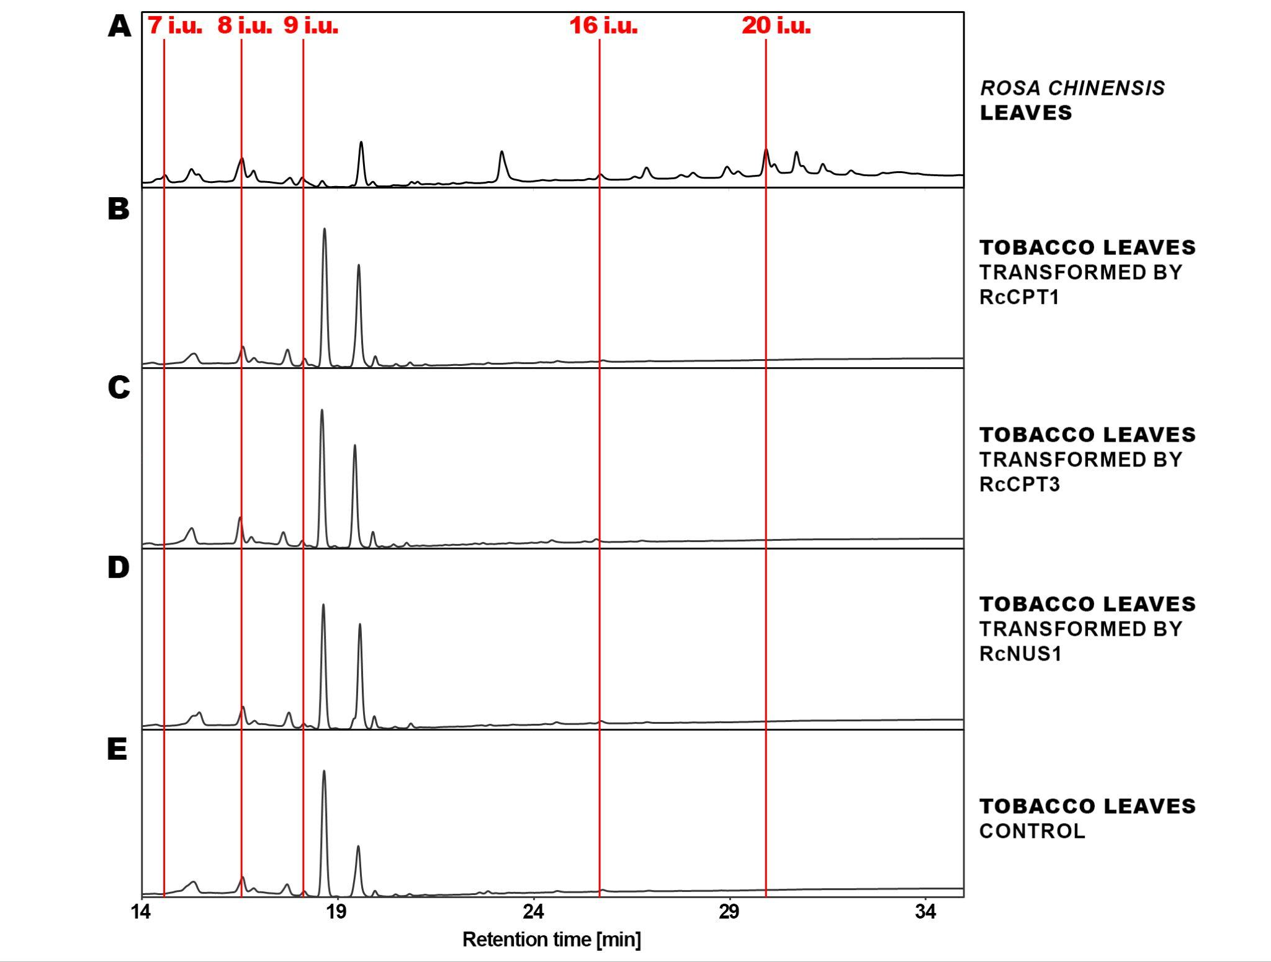
Suppl. Fig. 1 Polyisoprenoids extracted from the R. chinensis leaves and tobacco leaves transiently transformed by R. chinensis CPTs and NUS1. HPLC/UV method for shorter compounds identification was used. Representative HPLC/UV chromatograms are presented and the main polyprenols are indicated.

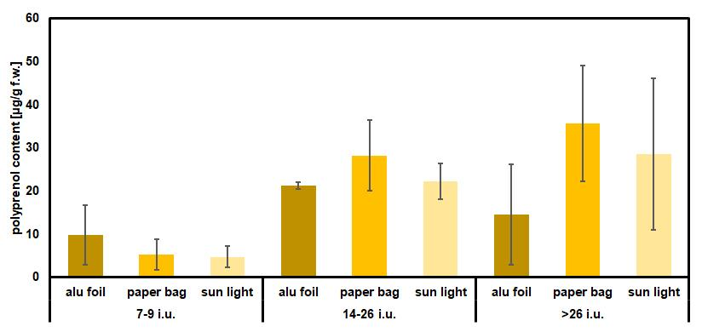
Suppl. Fig. 2 Polyisoprenoid length 7-9 i.u., 14-26 i.u., and longer than 26 i.u. content in English shrub rose “Abraham Darby” leaves grow in the sun light as a control conditions or exposed to dark (alu foil) or partial darkening (paper bag) for 72 hours. All leaves were treated and collected from the same bush growing in the natural environment. All values are presented as mean ± SD (n = 3).

Primer name | Primer sequence (5’-3’)
Cloning into pENTR and ImpGWB vectors
RcCPT1_F | CACCATGGAGAAAAGAAATGGC
RcCPT1_R_STOP | TTATGACTGTTTCTTTTTTC
RcCPT1_R_bSTOP | TGACTGTTTCTTTTTTCTT
RcCPT2_F | CACCATGCTATCCCTGCGAT
RcCPT2_R_STOP | CTATAAATCTCGTCTACCATAACGTC
RcCPT2_R_bSTOP | TAAATCTCGTCTACCATAACGTCT
RcCPT3_F | CACCATGGGGTCGCGAATTCTGGTCT
RcCPT3_R_STOP | TTATGCCTGCTTCTTTTTCTTCTCCA
RcCPT3_R_bSTOP | TGCCTGCTTCTTTTTCTTCTCC
RcNUS1_F | CACCATGGATTTGAAGATTCAAATGCAG
RcNUS1_R_STOP | TCATTTACCATAGTTTTGGCGCACAG
RcNUS1_R_bSTOP | TTTACCATAGTTTTGGCGCACAG
Real-time PCR analysis of RcCPTs
RcCPT1_RT_F | AGTGGAGCTGGGTATGGTCT
RcCPT1_RT_R | GCACGGAGGGACAGTACAAA
RcCPT2_RT_F | GTGTCTCCAGCTCACTCCAC
RcCPT2_RT_R | TTCCCGTCCATGATAACCGC
RcCPT3_RT_F | CCAGTTGGGGAAGGACACAA
RcCPT3_RT_R | TTTCAGCAGCAACCCTGACA
RcNUS1_RT_F | CGGTACCTGGCGATTGTAGT
RcNUS1_RT_R | AGCCACTGCAGAAGCTCAAT
Suppl. Table 1 List of primers used in this work.

