SUPPLEMENTARY MATERIAL

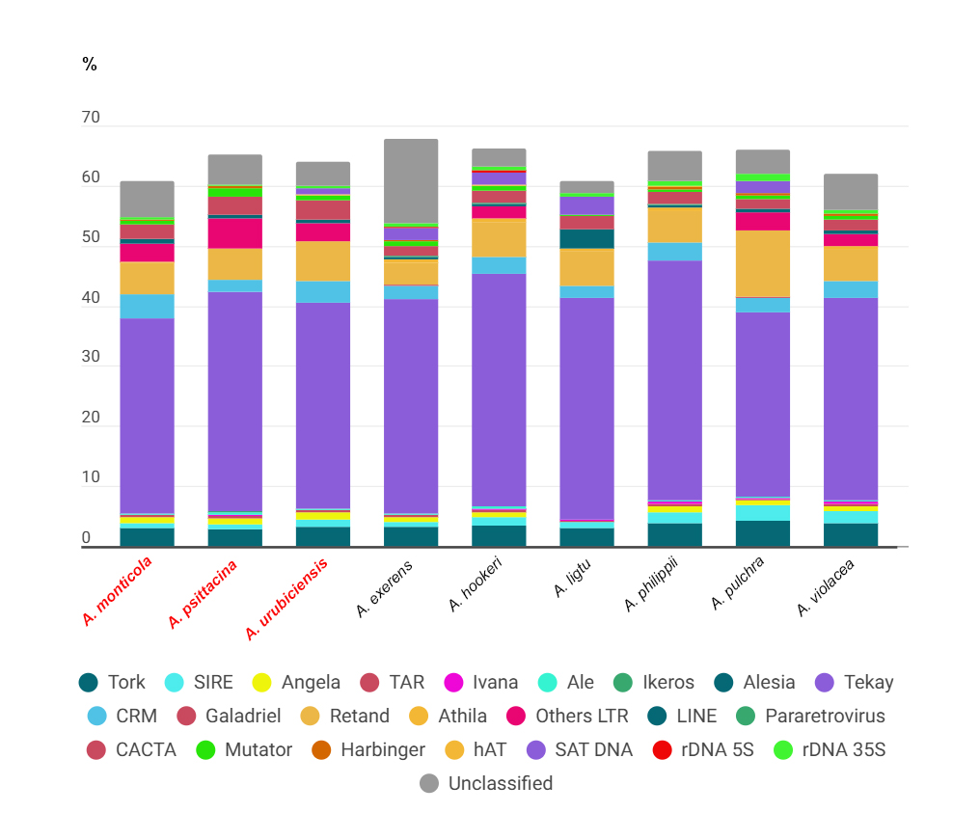
Supplementary Figure 1. Proportions of repeats in Alstroemeria species after individual analysis with RepeatExplorer. The first four species are Brazilian.

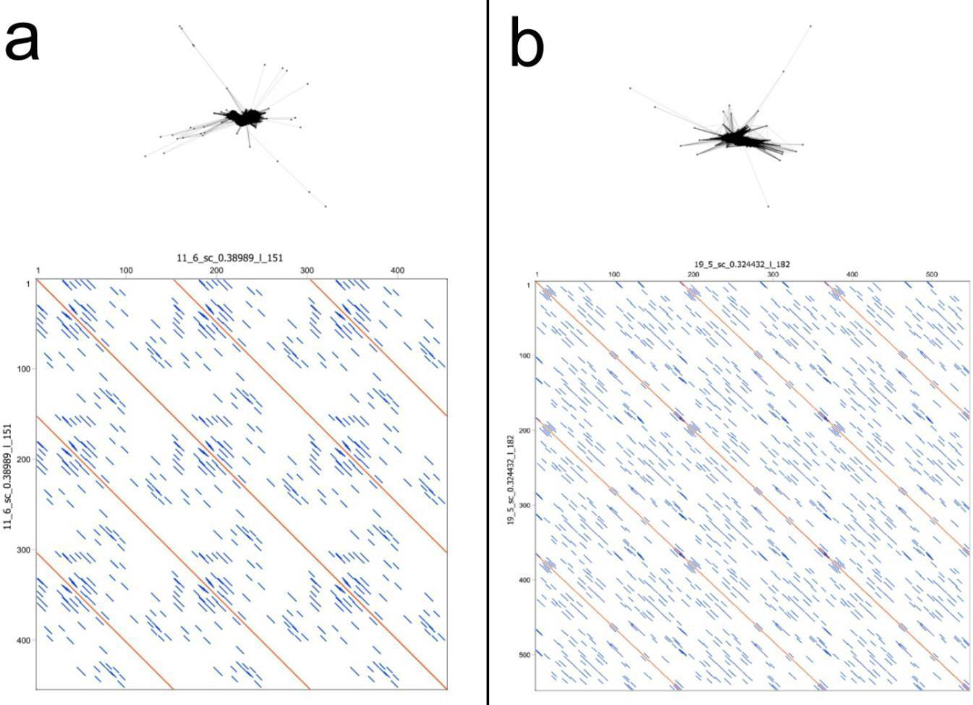

Supplementary Figure 2. TAREAN graph and dotplot of new Alstroemeria satellite DNAs selected for chromosomal mapping. In a, AhoSAT2-361 of A. hookeri and in b, AliSAT1-285 of A. ligtu.

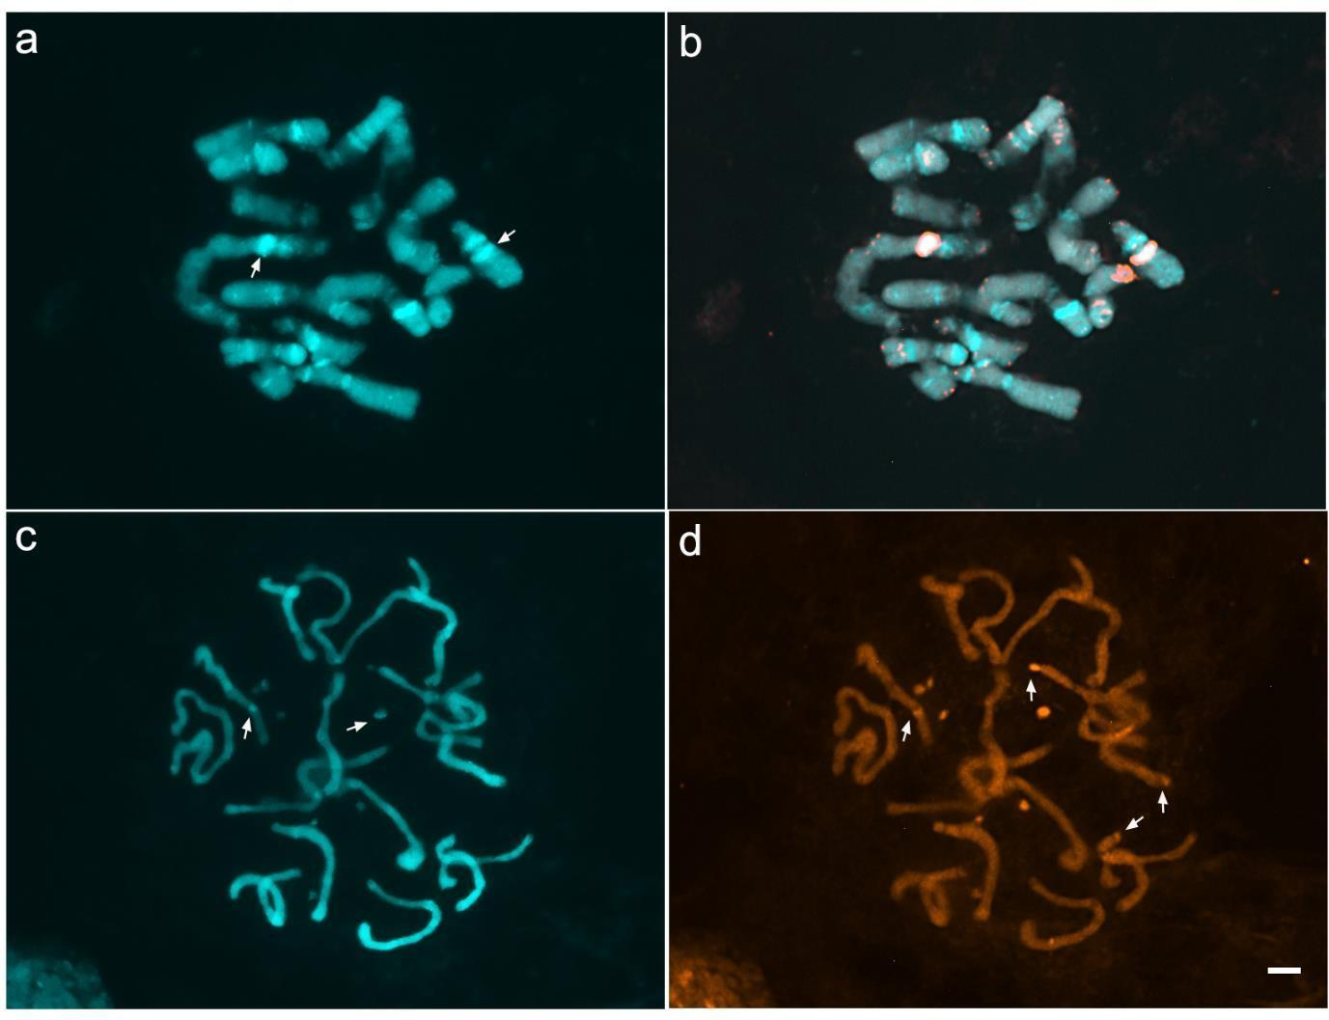
Supplementary Figure 3. Fluorescent in situ hybridization of satDNAs in Chilean Alstroemeria species. a-b) AhoSAT2-361 in A. ligtu. c-d) AliSAT1-285 in A. hookeri. White arrows in a and c show DAPI blocks co-located with satellites. White arrows in d show weak satellite signals. Bar = 10µ.

Supplementary Table 1. Genomic proportions (%) of repetitive sequences identified in species of Alstroemeria after comparative RepeatExplorer analysis.

 | A.  exerens | A.  hookeri | A.  ligtu | A. longistaminea | A. monticola | A.  philippii | A.  psittacina | A.  pulchra | A.  violacea | A.  urubiciensis
Genome size (1C) | - | 26.00 pg –  25.42 Gb | 34.70 pg –  33.94 Gb | 26.37 pg – 25.8  Gb | 26.55 pg – 25,97 Gb* | 20.75 pg –  20.29 Gb | 24.95 pg –  24.40 Gb | 20.05 pg –  19.61 GB | 29.15 – 28.51  Gb* | 26.48 pg –  25,90 Gb*
HKL (μm) | - | - | - | - | - | - |  | - | 118.25 μm | -
Comparative clustering reads | 622.730 | 607.382 | 608.328 | 649.280 | 557.148 | 606.124 | 724.394 | 539.346 | 611.498 | 558.864
Coverage | - | 0.004x | 0.003x | 0.004x | 0.003x | 0.004x | 0.004x | 0.004x | 0.003x | 0.003x
Repetitive elements |  |  |  |  | Genome proportion (%)
Class I
LTR-retrotransposon
Ty1/copia
Tork | 3.60 | 3.25 | 3.21 | 2.96 | 3.23 | 3.63 | 3.01 | 4.10 | 3.72 | 3.27
SIRE | 0.61 | 0.88 | 0.81 | 0.78 | 0.70 | 1.12 | 0.68 | 1.34 | 1.14 | 0.68
Angela | 0.84 | 0.84 | 0.59 | 1.29 | 1.08 | 0.97 | 1.05 | 0.65 | 0.91 | 1.04
TAR | 0.22 | 0.21 | 0.19 | 0.16 | 0.21 | 0.20 | 0.2 | 0.18 | 0.20 | 0.21
Ivana | 0.43 | 0.76 | 0.62 | 0.29 | 0.34 | 0.85 | 0.35 | 1.09 | 1.0 | 0.38
Ale | 0.20 | 0.22 | 0.15 | 0.17 | 0.18 | 0.22 | 0.21 | 0.22 | 0.21 | 0.20
Ty3/gypsy
Chromovirus
Tekay | 34.14 | 33.55 | 31.40 | 35.60 | 35.64 | 33.14 | 37.00 | 27.22 | 30.21 | 36.07

CRM | 2.31 | 2.33 | 2.19 | 2.05 | 1.83 | 2.24 | 1.84 | 2.24 | 2.40 | 1.79
Galadriel | 0.07 | 0.07 | 0.07 | 0.06 | 0.07 | 0.07 | 0.08 | 0.08 | 0.1 | 0.07
Non-chromovirus
Retand | 3.77 | 4.85 | 4.73 | 4.46 | 4.43 | 4.35 | 3.97 | 9.89 | 5.03 | 4.65
Athila | 0.05 | 0.03 | 0.04 | 0.03 | 0.03 | 0.03 | 0.04 | 0.03 | 0.04 | 0.04
Others LTRs | 5.44 | 4.83 | 4.53 | 5.42 | 5.21 | 5.30 | 5.55 | 3.87 | 5.21 | 5.10
Non-LTR
LINE | 0.30 | 0.26 | 0.35 | 0.38 | 0.41 | 0.30 | 0.36 | 0.36 | 0.30 | 0.42
Pararetrovirus | 0.03 | 0.03 | 0.02 | 0.06 | 0.06 | 0.08 | 0.05 | 0.01 | 0.05 | 0.05
Class II
CACTA | 1.81 | 1.84 | 1.90 | 2.53 | 2.37 | 1.76 | 2.44 | 1.51 | 1.34 | 2.43
Mutator | 0.47 | 0.41 | 0.37 | 0.47 | 0.52 | 0.49 | 0.55 | 0.45 | 0.48 | 0.52
Harbinger | 0.25 | 0.29 | 0.22 | 0.29 | 0.29 | 0.26 | 0.25 | 0.30 | 0.31 | 0.25
hAT | 0.09 | 0.07 | 0.08 | 0.08 | 0.1 | 0.09 | 0.1 | 0.10 | 0.12 | 0.10
SatDNA | 2.44 | 3.06 | 5.9 | 1.72 | 1.50 | 1.33 | 1.51 | 1.67 | 1.40 | 1.83
rDNA
5S | 0.09 | 0.42 | 0.09 | 0.06 | 0.05 | 0.02 | 0.05 | 0.03 | 0.02 | 0.06
35S | 0.92 | 0.70 | 3.20 | 0.42 | 0.30 | 0.89 | 0.19 | 1.27 | 0.63 | 0.45
Unclassifield repeats | 6.8 | 5.62 | 5.72 | 5.25 | 7.20 | 6.30 | 5.73 | 6.51 | 6.11 | 6.00
Total | 64.88 | 64.52 | 66.38 | 64.52 | 65.75 | 63.64 | 65.21 | 63.11 | 61.15 | 65.61

References of the 2C value in picograms: Buitendijk et al. 1997, Nascimento et al. 2021a.
*Genomes sizes estimated in this present work.

Supplementary Table 2. Consensus sequences by TAREAN and primers used for amplification of satellites of A. ligtu and A. hookeri.

> AliSAT1-285
Consensus | CCAATGACAACAACGACAACGCATGGCGATGCCAAGTACCACGCCGGACAGTGCCAAGCGCAATGCCGGACGGTACCAAGC ACCGTCACGGGTGGTGGGGCCAAATTCCGTCGCACGTGGGGTGGGGCCAAACAACGCCGCGCGCGGTGGTCGGGGGGCC AAATTCCGCCGCACGCGGTGGTCGGGCCAAACAAGCACCATGCCGGAAGGTGCAAAGTGCCGTGCCGGAGGGGGCCAAGC  ACTATGCCGGAAGGTGCAAAGCACCGCCGAGCGGCGCGCGGGGC
Primer sequence (5’🡪3’)
AliSAT1 F | GGCCCAATGACAACAACGAC
AliSAt1 R | CTTTGCACCTTCCGGCATAG
> AhoSAT2-361
Consensus | CGTTCGCGTCGAAAAGATCTACGTTTTGACAGGTCATTCGCCCAATTCCAACGGTCGGATCGAAAGTTAGGCCGTTTCCGGG AAACCCTAGAGATTTGGGTGGTAAAATGAACCCTTGACCCTGAAATCGAAACCCTGGACCCTAAACTCGTAACCCAGAACACT AAACCATGAACCCTAAACCCTAAACCTTAAACTCGAAACCCTAACCCTAAACTCGTGACCCGAAACCCTAAAATCGTGACCCT AAACCCTAAACTCGTGACCCCAAACCCTAAAGTCGTGACCCTAAACCCTAAACTCGGAACCCTAAACCCTGAACTCGTGACCC  TAAACCCTAAACCCTAAACCCTGTATCG
Primer sequence (5’🡪3’)
AhoSAT2 F | CGGATCGAAAGTTATGGCCG
AhoSAT2 R | CCGTTGGAATTGGGCGAATG

Supplementary Table 3. Proportion of the main satellite DNAs identified in Alstroemeria species by comparative analyses.

 |  | CG  content (%) |  |  |  |  | Abundance (%)
SatDNA | Monomer size (bp) | CG  content (%) | Brazilian species |  |  |  |  |  | Chilean species
SatDNA | Monomer size (bp) | CG  content (%) | A.  urubuciensis | A.  longistaminea | A.  monticola | A.  psittacina | A.  exerens | A.  hookeri |  | A.  philippii | A.  pulchra
 |  |  |  |  |  |  |  |  | A. ligtu | A.  philippii | A.  pulchra | A.violacea
AliSAT1 | 774 | 43.8% | 0.045441 | 0.03931 | 0.033 | 0.041342 | 0.058209 | 0.060432 | 4.668378 | 0.081152 | 0.052819 | 0.053116
AurSAT3 | 226 | 50.0% | 0.450741 | 0.593174 | 0.550582 | 0.382175 | 0.01146 | 0.030136 | 0.049368 | 0.065609 | 0.021592 | 0.07055
AviSAT2 | 103 | 70.9% | 0 | 0 | 0 | 0 | 0.186088 | 0.304563 | 0.305614 | 0.196827 | 0.703244 | 0.208716
Other 1 | 1614 | 33.3% | 0.189105 | 0.172641 | 0.184057 | 0.181962 | 0.128788 | 0.185943 | 0.113156 | 0.191264 | 0.127587 | 0.215722
AviSAT3 | 6124 | 40.0% | 0.074104 | 0.137343 | 0.018882 | 0.136333 | 0.518244 | 0.343354 | 0.109394 | 0.149052 | 0.153996 | 0.140447
ApuSAT6 | 3596 | 42.1% | 0.160267 | 0.151623 | 0.145234 | 0.171038 | 0.209007 | 0.166227 | 0.199825 | 0.160669 | 0.143825 | 0.175641
AexSAT5 | 138 | 47.8% | 0.158345 | 0.170716 | 0.148763 | 0.162051 | 0.144432 | 0.150518 | 0.118171 | 0.154779 | 0.132226 | 0.174989
AliSAT8 | 318 | 43.1% | 0.232624 | 0.176813 | 0.260467 | 0.242109 | 0.105868 | 0.094575 | 0.079146 | 0.103895 | 0.074054 | 0.118615
AexSAT1 | 22 | 59.1% | 0 | 0 | 0.000353 | 0 | 0.830573 | 0.691357 | 0 | 0 | 0 | 0.000652
AhoSAT5 | 1129 | 34.0% | 0.363878 | 0.145526 | 0.018 | 0.033461 | 0.003274 | 0.284846 | 0.004232 | 0.016689 | 0.074054 | 0.013523
AexSAT6 | 163 | 52.8% | 0.040023 | 0.033373 | 0.040588 | 0.052957 | 0.097864 | 0.079667 | 0.076169 | 0.082952 | 0.063883 | 0.090264
Other 2 | 885 | 38.95 | 0.076726 | 0.073164 | 0.070234 | 0.064848 | 0.048386 | 0.060432 | 0.035106 | 0.05252 | 0.04122 | 0.048717
AhoSAT2 | 361 | 47.6% | 0.00035 | 0 | 0 | 0.000138 | 0.000546 | 0.502849 | 0 | 0.000164 | 0.000178 | 0
Other 3 | 212 | 46.75 | 0.022895 | 0.021821 | 0.019941 | 0.020602 | 0.047113 | 0.038952 | 0.037457 | 0.044339 | 0.031584 | 0.047087
AhoSAT10 | 154 | 48.7% | 0 | 0.000321 | 0 | 0 | 0.030924 | 0.036868 | 0.091528 | 0.012762 | 0.044075 | 0.010916
Other 4 | 832 | 24.9% | 0.012234 | 0.007381 | 0.013412 | 0.017698 | 0.017099 | 0.029975 | 0.011911 | 0.012762 | 0.006424 | 0.013849

