Rootstock genotype shapes vine functional traits and associated microbiomes, with predominant shifts in the phyllosphere
Ginevra Canavera^{1,2,3}, Filippo Vaccari¹, Matteo Gatti², Edoardo Puglisi^{1,3}*, Tommaso Frioni^{2,3}
¹Department for Sustainable Food Process, Università Cattolica del Sacro Cuore, Via Emilia Parmense 84, 29122 Piacenza, Italy
²Department of Sustainable Crop Production, Università Cattolica del Sacro Cuore, Via Emilia Parmense 84, 29122 Piacenza, Italy
³National Research Centre for Agricultural Technologies (Agritech Foundation, PNRR M4C2), Naples, Italy
*Corresponding: edoardo.puglisi@unicatt.it

Supplementary Information 1
LEFSE analysis of phyllosphere and rhizosphere of bacterial and fungal communities in 2023 and 2024 and PCA of predicted bacterial functional pathways in the phyllosphere at veraison in 2023 and 2024

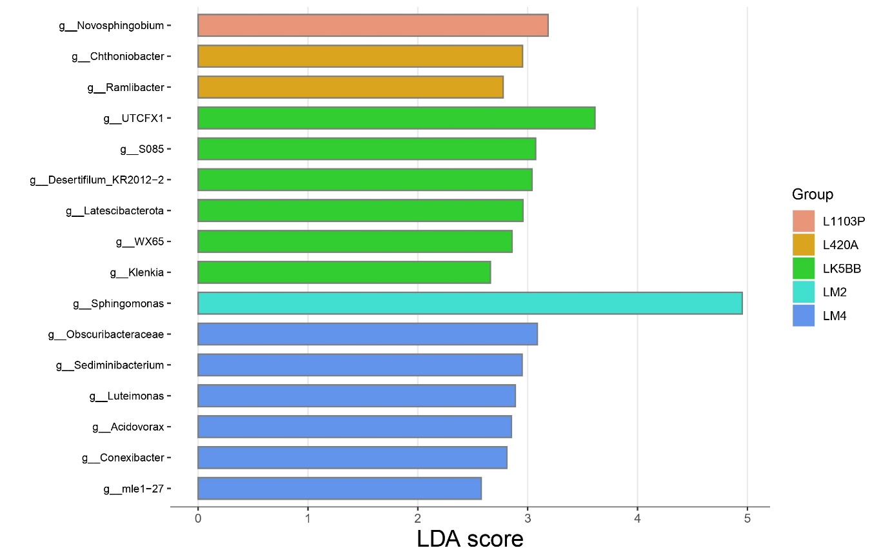
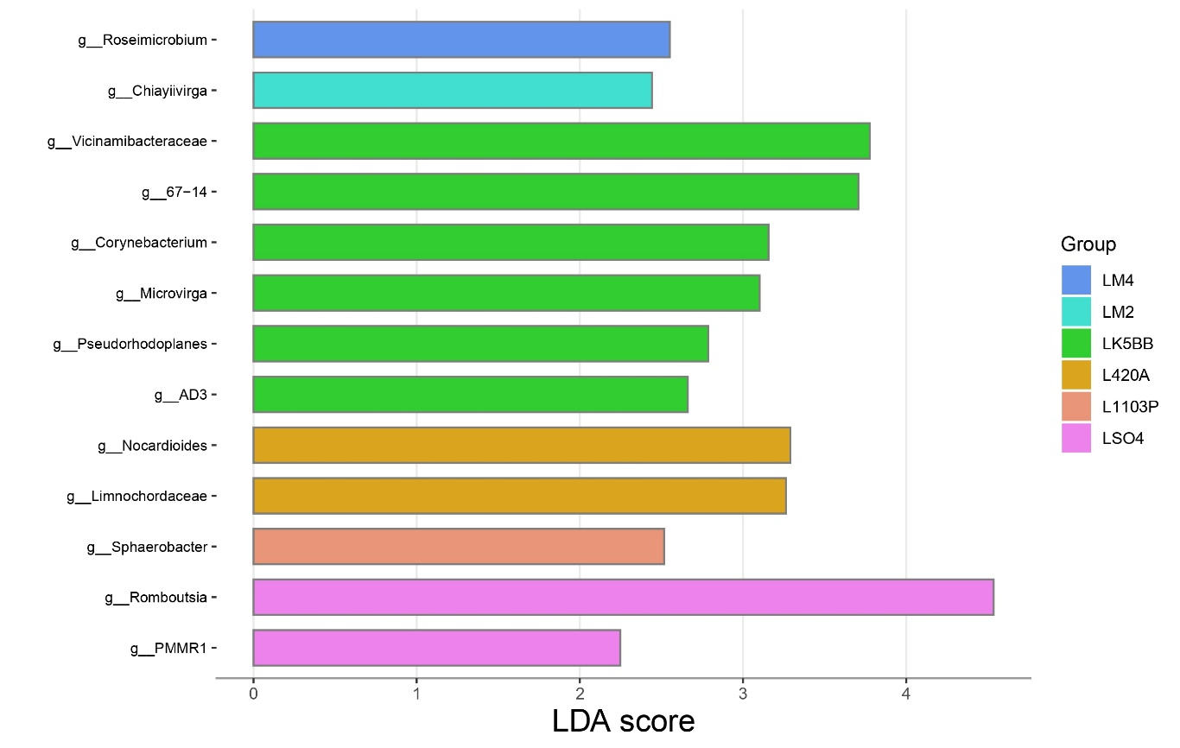
Fig. S1 LEfSe analysis of phyllosphere bacterial communities at flowering in 2023
Treatment
Treatment
Fig. S2 LEfSe analysis of phyllosphere bacterial communities at veraison in 2023

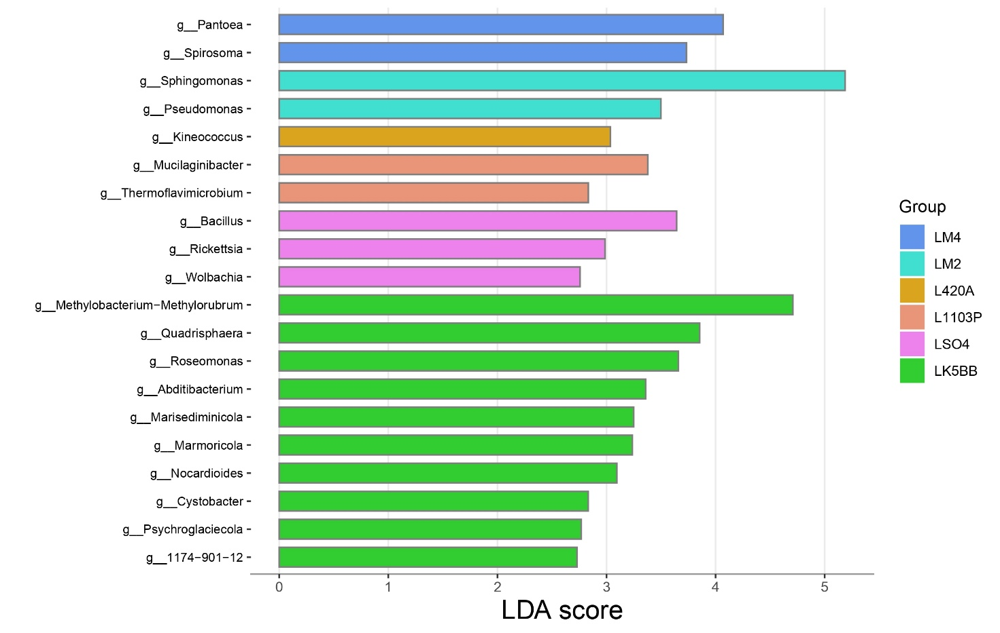
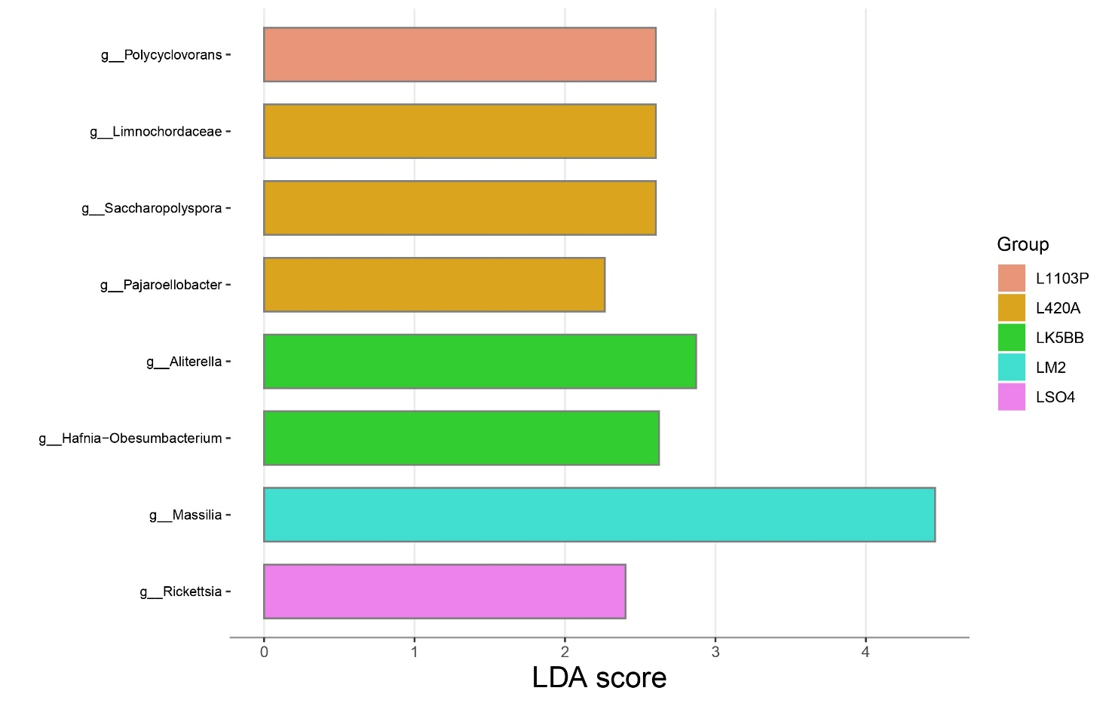
Fig. S3 LEfSe analysis of phyllosphere bacterial communities at flowering in 2024
Treatment
Treatment
Fig. S4 LEfSe analysis of phyllosphere bacterial communities at veraison in 2024

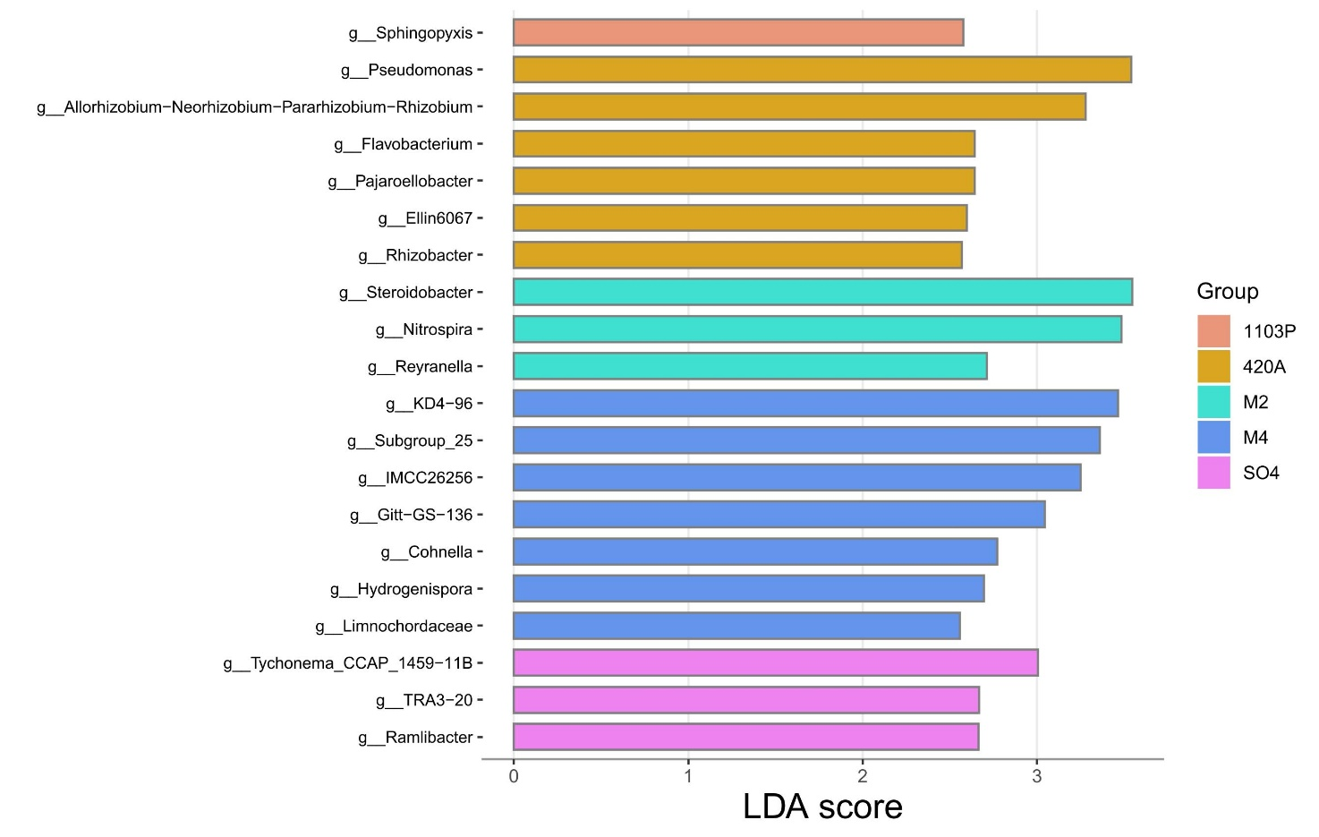Fig. S5 LEfSe analysis of rhizosphere bacterial communities at flowering in 2023
Treatment
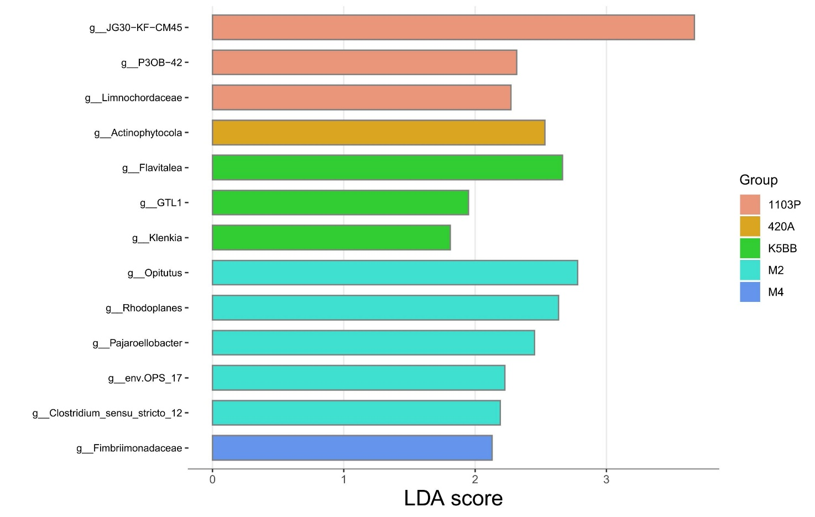Fig. S6 LEfSe analysis of rhizosphere bacterial communities at veraison in 2023
Treatment

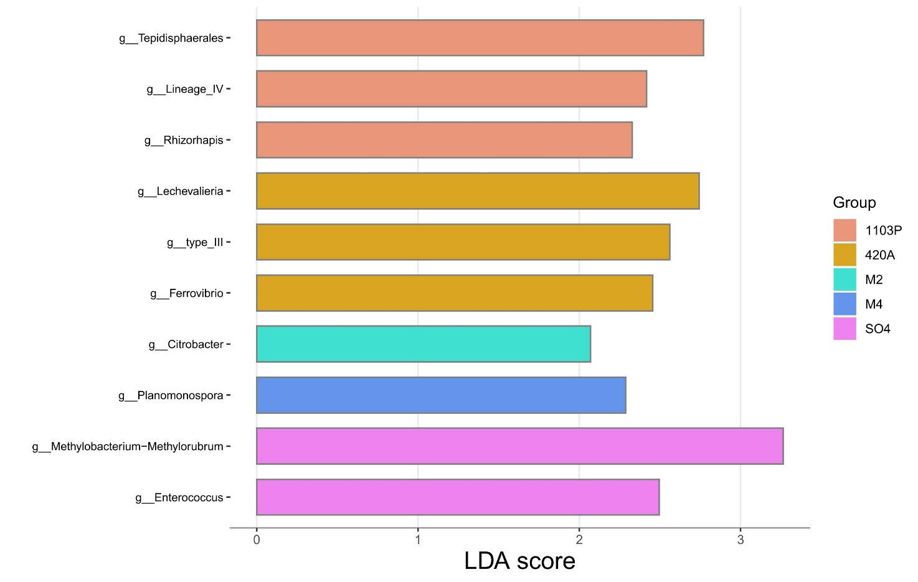Fig. S7 LEfSe analysis of rhizosphere fungal communities at flowering in 2024
Treatment
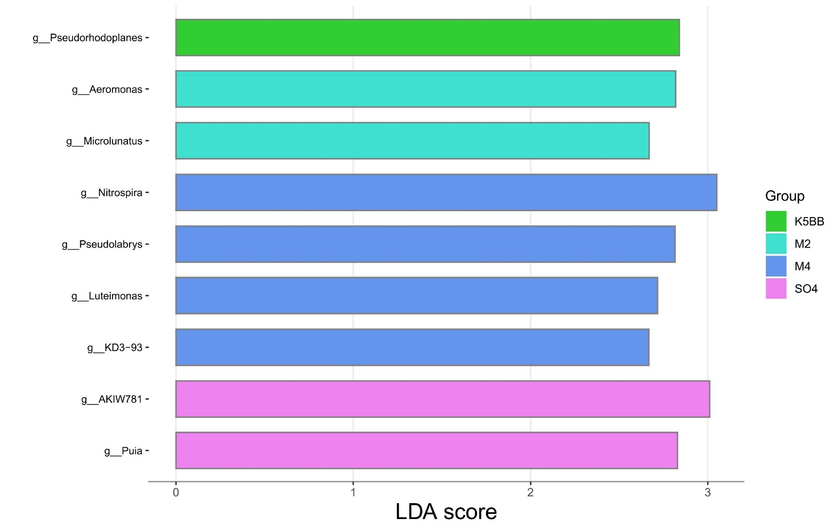Fig. S8 LEfSe analysis of rhizosphere fungal communities at veraison in 2024
Treatment

Treatment
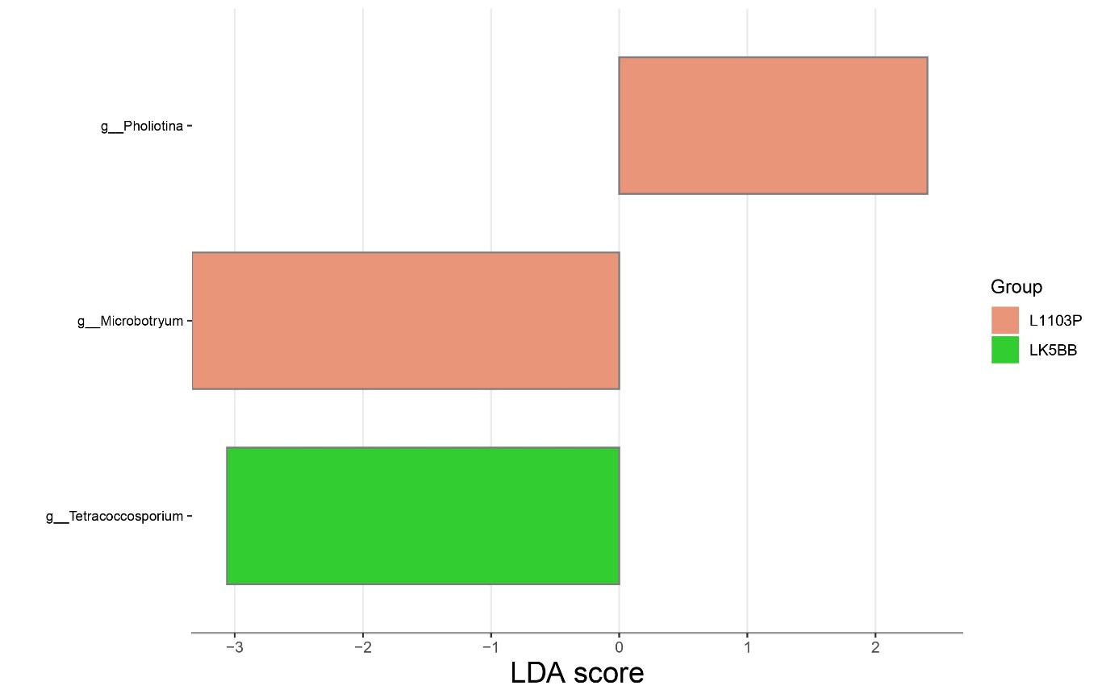
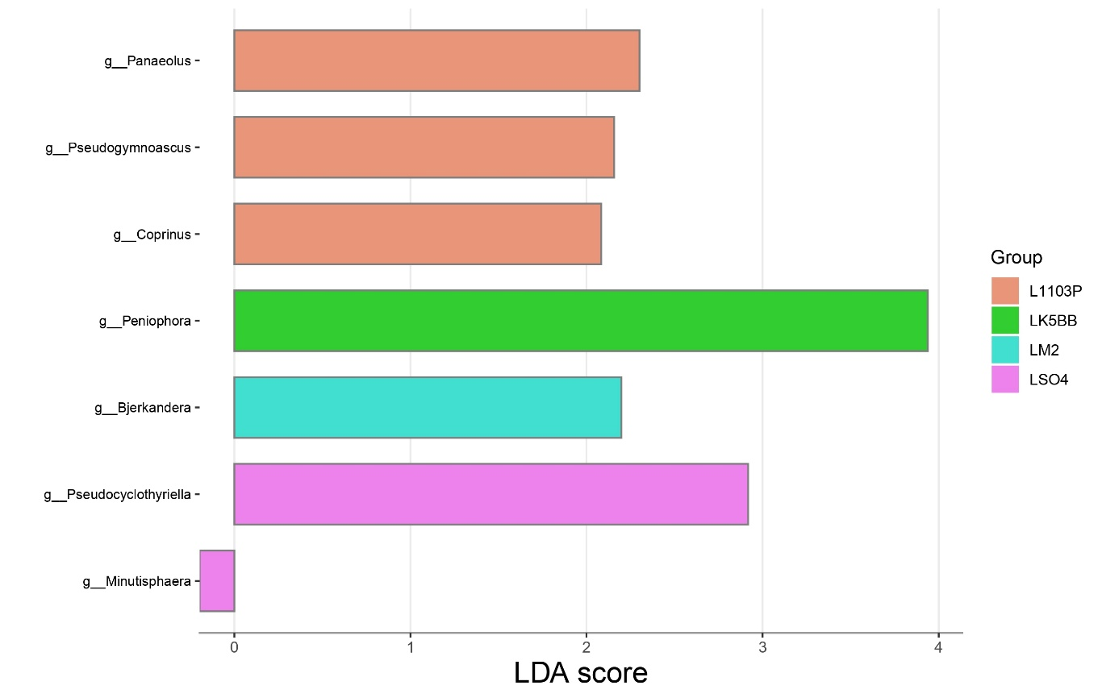
Fig. S9 LEfSe analysis of phyllosphere fungal communities at flowering in 2023
Treatment
Treatment
Fig. S10 LEfSe analysis of phyllosphere fungal communities at veraison in 2023

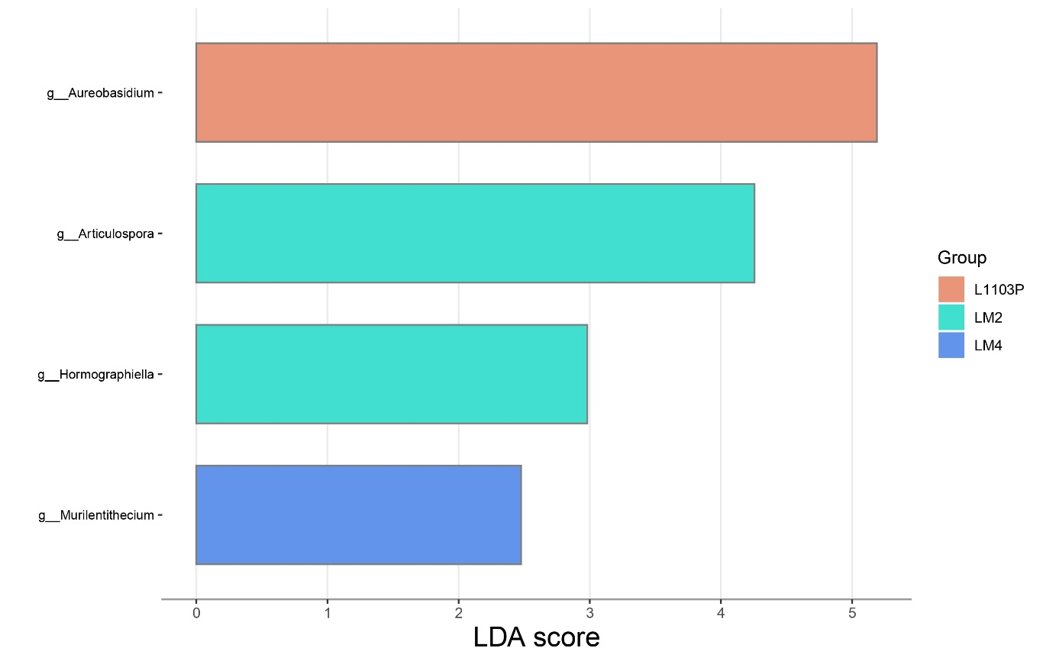
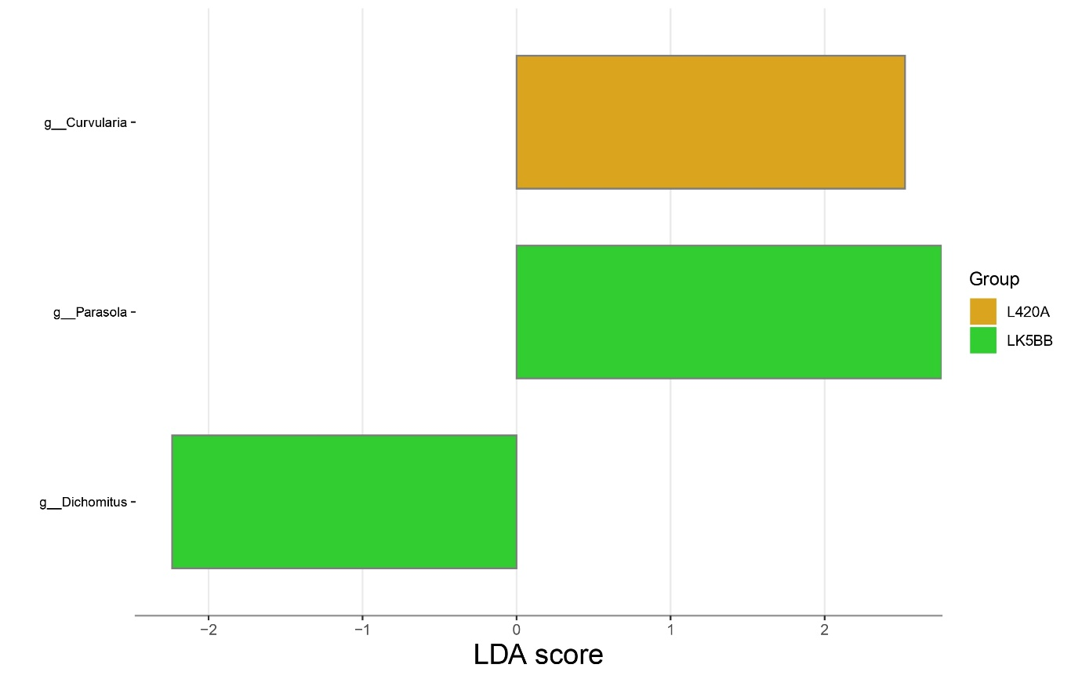
Fig. S11 LEfSe analysis of phyllosphere fungal communities at flowering in 2023
Treatment
Treatment
Fig. S12 LEfSe analysis of phyllosphere fungal communities at veraison in 2023

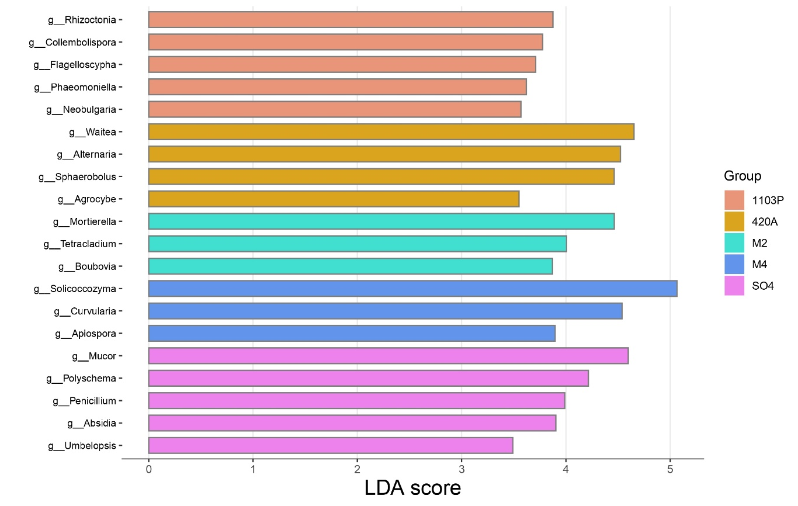
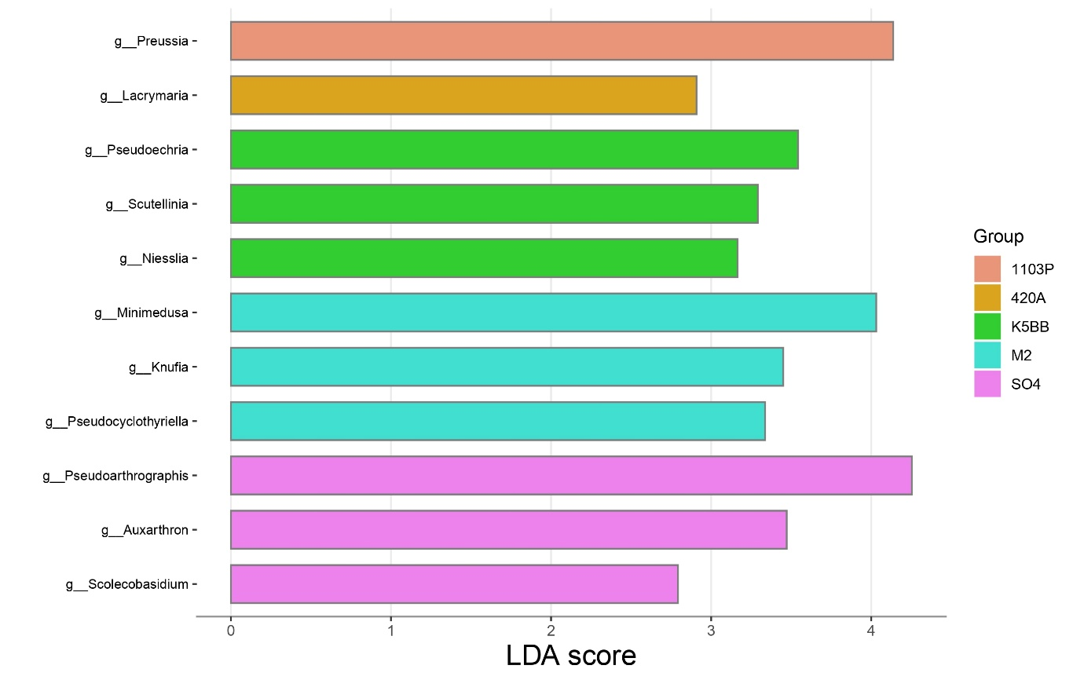
Fig. S13 LEfSe analysis of rhizosphere fungal communities at flowering in 2023
Treatment
Treatment
Fig. S14 LEfSe analysis of rhizosphere fungal communities at flowering in 2023

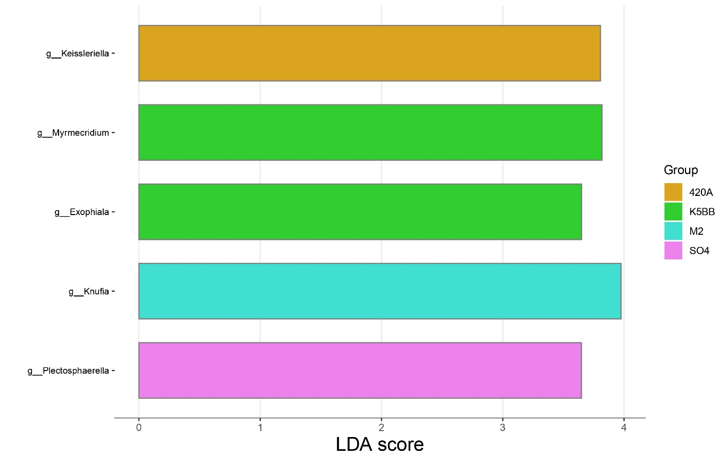
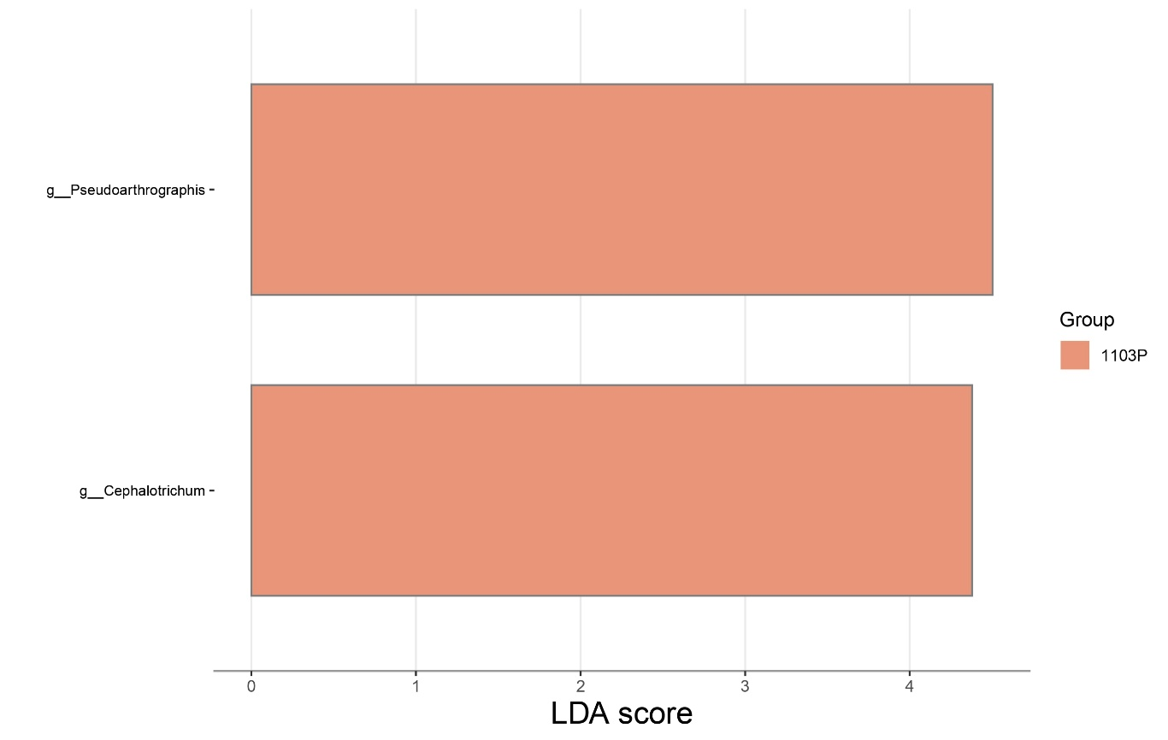
Fig. S15 LEfSe analysis of rhizosphere fungal communities at flowering in 2024
Treatment
Treatment
Fig. S16 LEfSe analysis of rhizosphere fungal communities at veraison in 2024

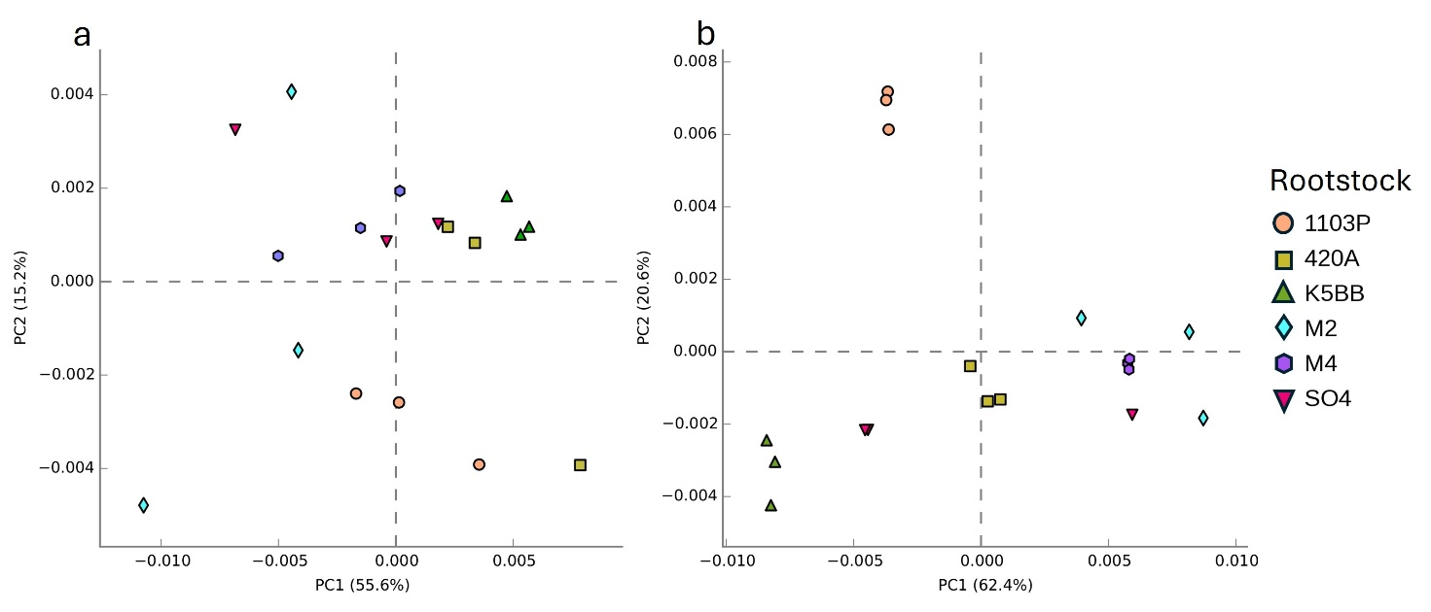Fig. S17 Principal Component Analysis (PCA) of PICRUSt2-predicted bacterial functional pathways in the phyllosphere at veraison in 2023 (a) and 2024 (b).
Treatment

