Supplementary Information
Table S1 Absolute Reaction Times and Error Rates for Age Group and Experimental Condition.
 | Young  (n = 20) |  |  | Old  (n = 21)
 | M | SD |  | M | SD
Reaction time (ms)
Single SRC | 414.31 | 75.12 |  | 474.39 | 72.68
Single SRI | 481.99 | 109.39 |  | 545.25 | 87.32
Dual SRC-RRC | 436.91 | 87.89 |  | 507.98 | 75.94
Dual SRI-RRC | 508.20 | 119.48 |  | 583.50 | 99.97
Dual SRC-RRI | 514.17 | 95.54 |  | 692.65 | 146.75
Dual SRI-RRI | 515.80 | 92.68 |  | 682.96 | 147.88
Error rate (%)
Single SRC | 3.44 | 2.29 |  | 3.92 | 4.94
Single SRI | 6.15 | 5.71 |  | 8.93 | 9.09
Dual SRC-RRC | 2.19 | 3.13 |  | 3.87 | 6.12
Dual SRI-RRC | 6.67 | 8.54 |  | 8.93 | 9.84
Dual SRC-SRI-RRI | 8.54 | 8.41 |  | 19.15 | 14.65
Note. M = mean; SD = standard deviation; SRC = stimulus–response compatible; SRI = stimulus–response incompatible; RRC = response–response congruent; RRI = response–response incongruent.

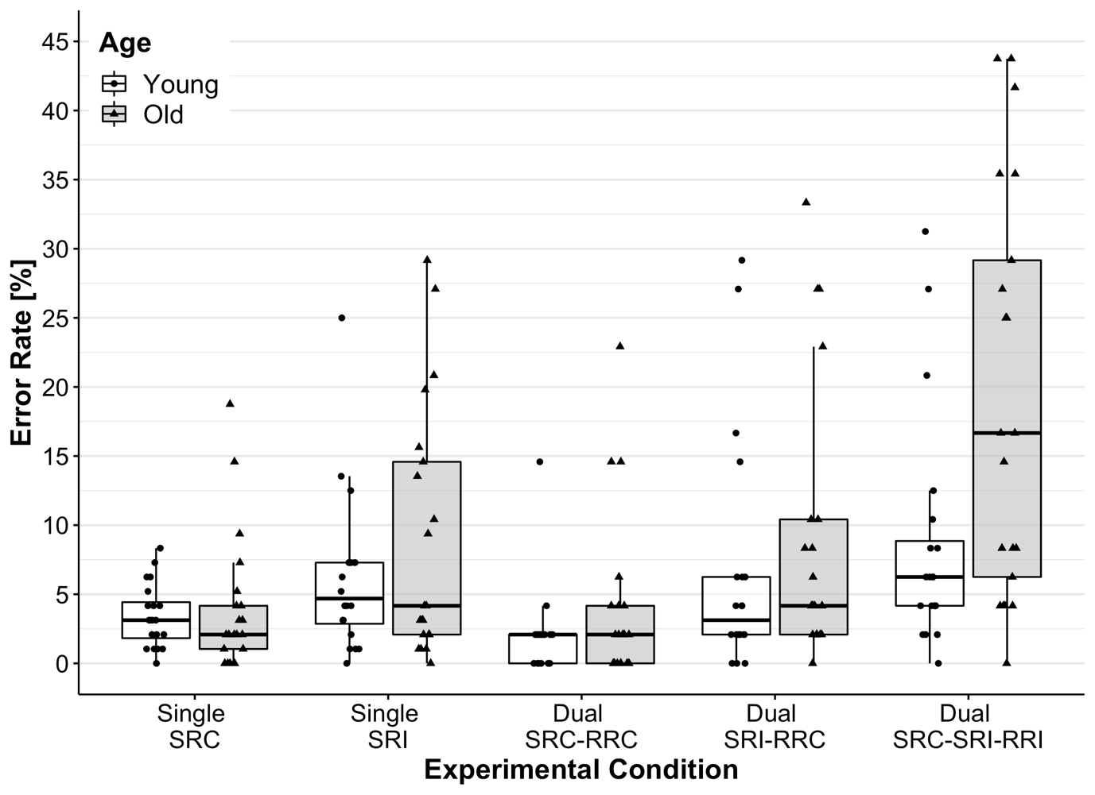
Fig. S1 Absolute Error Rates as a Function of Age Group and Experimental Conditions. SRC = stimulus–response compatible; SRI = stimulus–response incompatible; RRC = response–response congruent; RRI = response–response incongruent.

Table S2 Statistical Results of the Analysis of Variance for Dual-Task Speed Costs excluding Response-Grouped Trials (Cut-Off Value of IRI ≥ 32 ms) to Assess Task-Dependent and Generalized Slowing Effects.
 | Young  (n = 16) |  |  | Old  (n = 19) |  |  | ANOVA results
 | M | SD |  | M | SD |  | Effect / Interaction | df | F | p | η²
Dual-task speed costs (ms)
excluding Response-Grouped Trials
SRC-RRC | 41.10 | 75.48 |  | 35.62 | 57.03 |  | Age * | 1,33 | 9.21 | 0.005 | 0.22
SRI-RRC | 29.95 | 108.93 |  | 45.77 | 129.08 |  | S-R comp * | 1,33 | 6.51 | 0.02 | 0.17
SRC-RRI | 110.31 | 86.25 |  | 250.35 | 161.72 |  | R-R congr * | 1,33 | 18.07 | < 0.001 | 0.35
SRI-RRI | 43.62 | 61.51 |  | 171.52 | 170.16 |  | S-R comp × R-R congr * | 1,33 | 6.43 | 0.02 | 0.16
 |  |  |  |  |  |  | Age × S-R comp | 1,33 | 0.03 | 0.87 | 0.001
 |  |  |  |  |  |  | Age × R-R congr * | 1,33 | 6.69 | 0.01 | 0.17
 |  |  |  |  |  |  | Age × S-R comp × R-R congr | 1,33 | 0.34 | 0.56 | 0.01
Note. M = mean; SD = standard deviation; S-R comp = stimulus–response compatibility; SRC = stimulus–response compatible; SRI = stimulus–response incompatible; R-R congr = response–response congruency; RRC = response–response congruent; RRI = response–response incongruent.
* p ≤ 0.05
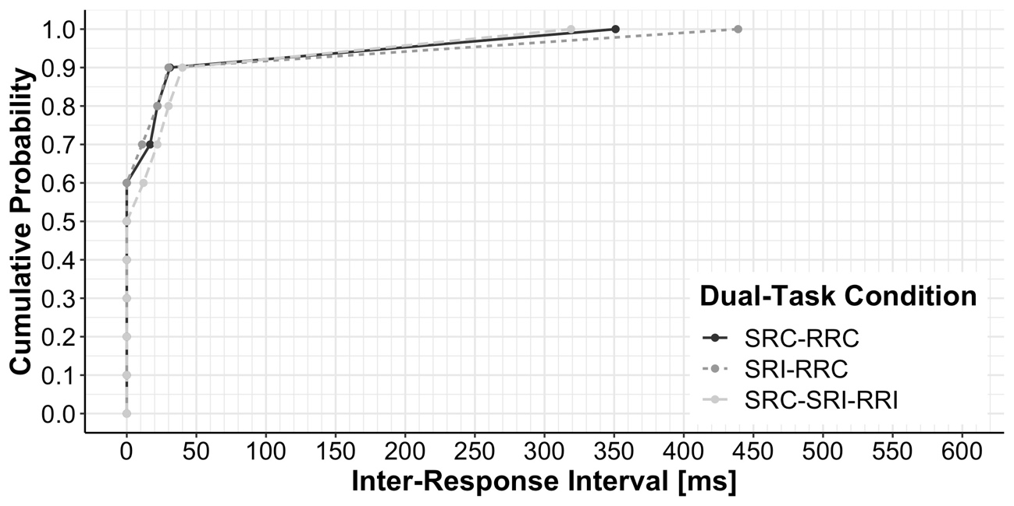
Fig. S2 Cumulative Frequency Distributions of Inter-Response Intervals (IRI) categorized in Deciles for Young Adults as a Function of Dual-Task Condition. SRC = stimulus–response compatible; SRI = stimulus–response incompatible; RRC = response–response congruent; RRI = response–response incongruent.

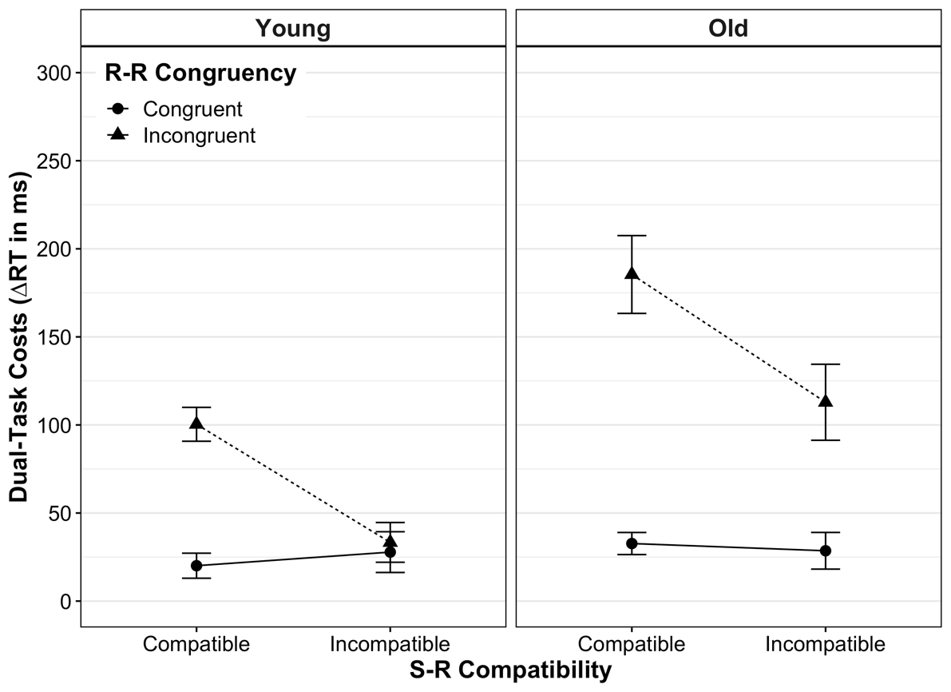
Fig. S3 Mean Dual-Task Costs on Reaction Time (RT) of Response-Grouped Trials (Cut-Off Value of IRI < 32 ms) according to Age Group, Stimulus–Response (S-R) Compatibility and Response–Response (R-R) Congruency. Dual-task costs were obtained through the difference in mean RT between analogous dual- and single-task conditions. Error bars represent the standard error of the mean.

