Table SI. Detailed number of trials in each condition:
Condition | Same-valence |  |  | Different-valence
Condition | Negative | Neutral | Positive | Negative | Neutral | Positive
N (%) | 72 (80%) | 76 (84.4%) | 72 (80%) | 76 (84.4%) | 70 (77.8%) | 69 (76.7%)

Pre-trial analysis:
The pre-trial time window was selected as 1.4s before the onset of the stimulus (-1.4-0). A 3 (emotion: negative/neutral/positive) × 2 (design: same-valence/different-valence) repeated-measures ANOVA found that both the main effects of emotion (F_{（1.833，130.131)} = 1.339, p=0.265, η_{p}² = 0.019) and design (F_{（1，71)} = 3.428, p=0.068, η_{p}² = 0.046) were not significant. The interaction between emotion and design was also not significant (F_{（1.729，122.765)} = 1.697, p=0.191, η_{p}² = 0.023).
When including within-trial period, a 2(time: pre-trial/within-trial) × 3 (emotion: negative/neutral/positive) × 2 (design: same-valence/different-valence) repeated-measures ANOVA found significant main effects of time (F_{（1，71)} = 446.25, p<0.001, η_{p}² = 0.86) and emotion (F_{（2，142)} = 14.84, p<0.001, η_{p}² = 0.17), the interactions between time*emotion, design*emotion, as well as time*design*emotion were also significant (ps<0.001). To disentangle the three-way interaction, we have analyzed the pre-trial and within-trial period separately.

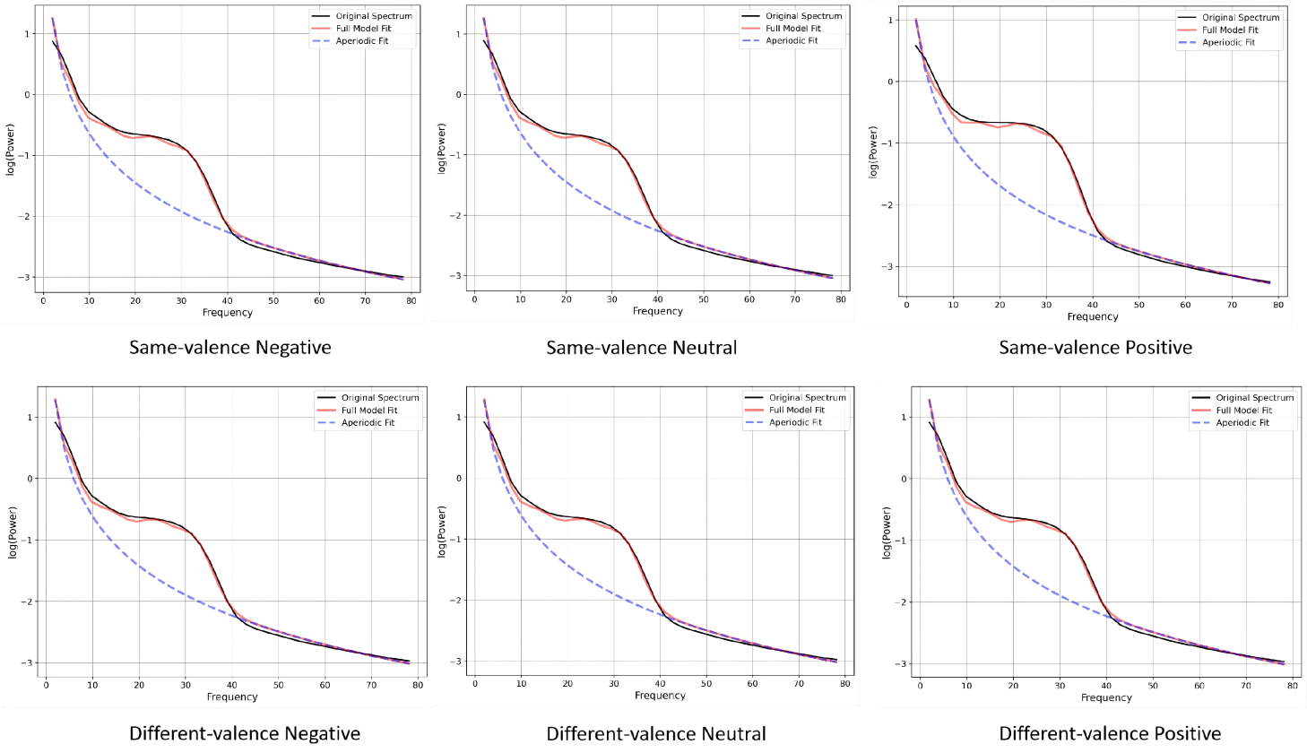
Figure SI. Model fit after averaging across all electrodes and participants in different conditions.

