Supplementary Material
The impact of intranasal oxytocin administration and social observation on time perception and task execution in a simple motor task
Orsolya Kiss, József Topál, Dorottya Berkes, Karolin Török-Suri, János Horváth
Supplementary Table S1. Correlation metrics for motor task outcome measures. This figure displays the Pearson correlation matrix for all the motor task metrics, highlighting the pairwise relationships between different outcome measures. Each cell in the matrix represents the correlation coefficient between two motor metrics
Variables | PL | Total impulse | Initial impulse |  | DA | T-INT
PF | 0.46 | 0.86 | 0.49 | 0.47 |  | 0.11
PL |  | 0.66 | 0.14 | 0.93 |  | 0.07
Total impulse |  |  | 0.37 | 0.72 |  | 0.14
Initial impulse |  |  |  | 0.21 |  | 0.11
DA |  |  |  |  |  | 0.06

Supplementary Table S2. Linear mixed-effects model output for the analysis of the Total impulse (log-transformed), the Initial impulse (log-transformed) and the time intervals between the consecutive actions (T-INT).
Performance measures | Total impulse |  |  |  | Initial impulse |  |  |  | T-INT
Predictors | χ2 (1) | p |  | χ2 (1) |  | p |  | χ2 (1) |  | p
Substance condition (OXT vs placebo) | 1.28 |  | 0.258 |  | 28.49 |  | <0.001 |  | 177.25 |  | <0.001
Observation (audience vs non audience) | 4.43 |  | 0.035 |  | 196.01 |  | <0.001 |  | 14.05 |  | <0.001
Auditory feedback (yes/no) | 12685.23 |  | <0.001 |  | 6615.03 |  | <0.001 |  | 12.31 |  | <0.001
STAI State | 99.53 |  | <0.001 |  | 67.86 |  | <0.001 |  | 264.69 |  | <0.001
Order of the visit | 77.50 |  | <0.001 |  | 35.64 |  | <0.001 |  | 183.68 |  | <0.001
Time of day | - |  | - |  | - |  | - |  | 33.52 |  | <0.001
Substance condition x Observation | 1.02 |  | 0.313 |  | 14.06 |  | <0.001 |  | 0.62 |  | 0.432
Substance condition by Auditory feedback | 0.93 |  | 0.335 |  | 0.01 |  | 0.940 |  | 0.09 |  | 0.769
Observation by Auditory feedback | 42.01 |  | <0.001 |  | 41.80 |  | <0.001 |  | 0.86 |  | 0.355
Note: The STAI scores were standardized. The random-effects structure included a random intercept for participant ID, and a random slope for the trial order.

Supplementary Table S3. Fixed effect estimates from the linear mixed-effects model predicting Initial impulse (log-transformed). The table reports unstandardized estimates, standard errors, t-values, and p-values for each predictor, including main effects and interaction terms.
Performance measures | Initial impulse
Predictors | Estimate | Std. error | t value | p
Intercept | 4.99 | 0.02 | 200.80 | <0.001
Substance condition - OXT vs placebo (ref) | -0.01 | 0.01 | -1.10 | 0.271
Observation (audience vs non audience) | -0.05 | 0.01 | -9.85 | <0.001
Auditory feedback (yes vs no) | -0.28 | 0.01 | -51.56 | <0.001
STAI State | 0.04 | 0.00 | 8.24 | <0.001
Order of the visit | -0.02 | 0.00 | -5.97 | <0.001
Substance condition x Observation | -0.02 | 0.01 | -3.75 | <0.001
Substance condition by Auditory feedback | 0.00 | 0.01 | 0.07 | 0.94
Observation by Auditory feedback | 0.04 | 0.01 | 6.47 | <0.001
Note: The STAI scores were standardized. The random-effects structure included a random intercept for participant ID, and a random slope for the trial order. Analysis included 6659 data points across 18 participants. The model accounted for 64% of the Initial impulse data (adjusted pseudo-R² = .64).

Supplementary Table S4. Fixed effect estimates from the linear mixed-effects model predicting Total impulse (log-transformed). The table reports unstandardized estimates, standard errors, t-values, and p-values for each predictor, including main effects and interaction terms.
Performance measures | Total impulse
Predictors | Estimate | Std. error | t value | p
Intercept | 7.10 | 0.13 | 55.06 | <0.001
Substance condition - OXT vs placebo (ref) | -0.04 | 0.02 | -1.79 | 0.073
Observation (audience vs non audience) | -0.07 | 0.02 | -3.14 | 0.002
Auditory feedback (yes vs no) | -1.52 | 0.02 | -70.46 | <0.001
STAI State | 0.17 | 0.02 | 9.98 | <0.001
Order of the visit | -0.13 | 0.01 | -8.80 | <0.001
Substance condition x Observation | 0.03 | 0.03 | 1.01 | 0.313
Substance condition by Auditory feedback | 0.02 | 0.03 | 0.96 | 0.335
Observation by Auditory feedback | 0.16 | 0.03 | 6.48 | <0.001
Note: The STAI scores were standardized. The random-effects structure included a random intercept for participant ID, and a random slope for the trial order. Analysis included 6659 data points across 18 participants. The model accounted for 78% of the variance in the Total impulse data (adjusted pseudo-R² = .78).

Supplementary Table S5. Fixed effect estimates from the linear mixed-effects model predicting T-INT (time intervals between actions). The table reports unstandardized estimates, standard errors, t-values, and p-values for each predictor, including main effects and interaction terms.
Performance measures | T-INT
Predictors | Estimate | Std. error | t value | p
Intercept | 3950.72 | 164.93 | 23.95 | <0.001
Substance condition - OXT vs placebo (ref) | 140.12 | 18.93 | 7.40 | <0.001
Observation (audience vs non audience) | -38.32 | 18.45 | -2.08 | 0.038
Auditory feedback (yes vs no) | -31.09 | 18.20 | -1.71 | 0.088
STAI State | 300.85 | 18.49 | 16.27 | <0.001
Order of the visit | 172.37 | 12.72 | 13.55 | <0.001
Time of day (<12 PM) | 102.28 | 38.35 | 2.67 | 0.008
Time of day (>4 PM) | 115.28 | 20.25 | 5.69 | <0.001
Substance condition x Observation | 16.94 | 21.56 | 0.79 | 0.432
Substance condition by Auditory feedback | 6.36 | 21.63 | 0.29 | 0.769
Observation by Auditory feedback | -19.95 | 21.55 | -0.93 | 0.355
Note: The STAI scores were standardized. The random-effects structure included a random intercept for participant ID, and a random slope for the trial order. Analysis included 6088 data points across 18 participants. The model accounted for 78% of the variance in the T-INT data (adjusted pseudo-R² = .78).

Supplementary Table S6. Post-hoc pairwise comparisons – Initial Impulse: Substance condition x Observation
Contrast | Estimate | SE | t | p (adj.)
placebo, non audience – OXT, non audience | 0.0059 | 0.0046 | 1.29 | .568
placebo, non audience – placebo, audience | 0.0333 | 0.0044 | 7.51 | <.001
placebo, non audience – OXT, audience | 0.0632 | 0.0046 | 13.75 | <.001
OXT, non audience – Placebo, audience | 0.0274 | 0.0046 | 5.95 | <.001
OXT, non audience – OXT, audience | 0.0573 | 0.0046 | 12.45 | <.001
placebo, audience – OXT, audience | 0.0298 | 0.0046 | 6.44 | <.001
Note: We report Tukey-adjusted p-values.

Supplementary Table S7. Post-hoc pairwise comparisons – Initial Impulse: Auditory feedback x Observation
Contrast | Estimate | SE | t | p (adj.)
no feedback, non audience – feedback, non audience | 0.2802 | 0.0045 | 62.44 | <.001
no feedback, non audience – no feedback, audience | 0.0659 | 0.0045 | 14.55 | <.001
no feedback, non audience – feedback, audience | 0.3049 | 0.0045 | 67.47 | <.001
feedback, non audience – no feedback, audience | −0.2143 | 0.0045 | −47.37 | <.001
feedback, non audience – feedback, audience | 0.0246 | 0.0045 | 5.47 | <.001
no feedback, audience – feedback, audience | 0.2389 | 0.0046 | 52.48 | <.001
Note: We report Tukey-adjusted p-values.

Supplementary Table S8. Post-hoc pairwise comparisons – Total Impulse: Auditory feedback x Observation
Contrast | Estimate | SE | t | p (adj.)
no feedback, non audience – feedback, non audience | 1.5065 | 0.0178 | 84.71 | <.001
no feedback, non audience – no feedback, audience | 0.0555 | 0.0180 | 3.09 | .011
no feedback, non audience – feedback, audience | 1.3979 | 0.0179 | 78.07 | <.001
feedback, non audience – no feedback, audience | −1.4511 | 0.0179 | −80.94 | <.001
feedback, non audience – feedback, audience | −0.1087 | 0.0179 | −6.09 | <.001
no feedback, audience – feedback, audience | 1.3424 | 0.0180 | 74.42 | <.001
Note: We report Tukey-adjusted p-values.

Supplementary Table S9. Model Comparison Across Upper-Interval Thresholds
Predictor | Original (6s)  LR χ² (p-value) | 7 s  LR χ² (p-value) | 8s  LR χ² (p-value) | No Upper Limit  LR χ² (p-value)
Substance condition | 177.25 (<.001) | 219.19 (<.001) | 270.31 (<.001) | 272.29 (<.001)
Observation | 14.05 (<.001) | 10.84 (.001) | 3.88 (.049) | 1.36 (.243)
Auditory Feedback | 12.31 (<.001) | 7.59 (.006) | 6.41 (.011) | 5.75 (.016)
STAI (state) | 264.69 (<.001) | 335.62 (<.001) | 279.91 (<.001) | 216.15 (<.001)
Order | 183.68 (<.001) | 291.72 (<.001) | 357.21 (<.001) | 343.14 (<.001)
Daytime | 33.52 (<.001) | 102.35 (<.001) | 246.02 (<.001) | 352.76 (<.001)
Substance condition × Observation | 0.62 (.432) | 2.26 (.132) | 1.54 (.215) | 1.24 (.266)
Substance condition × Auditory Feedback | 0.09 (.769) | 4.12 (.042) | 5.12 (.024) | 4.04 (.044)
Observation × Feedback | 0.86 (.355) | 0.04 (.836) | 0.26 (.607) | 0.70 (.404)
Note: Values represent likelihood-ratio χ² statistics with associated, non-adjusted p-values.

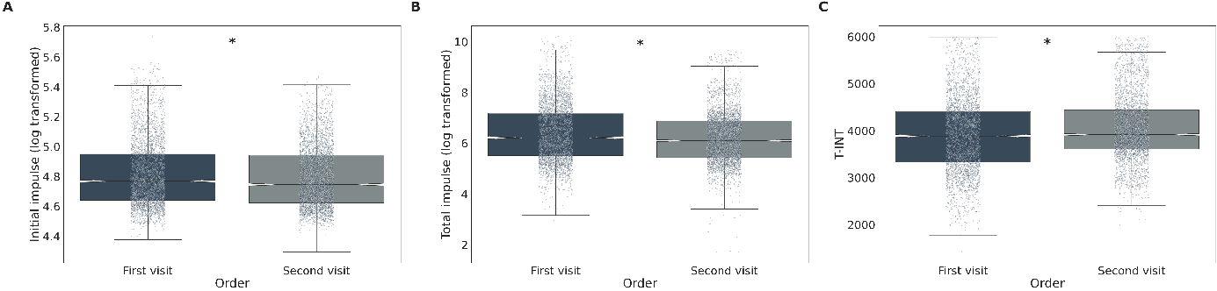
Figure S1: The effect of the visit order on the Initial impulse, Total impulse, and T-INT, and the time intervals between the consecutive actions – T-INT. In addition to individual data points, the boxplots display the medians (central line), inter-quartile range (IQR, represented by the box), and outliers (individual points outside the whiskers). The whiskers cover datapoints up to 1.5 times the IQR from the first and third quartiles. Asterisks mark significant differences

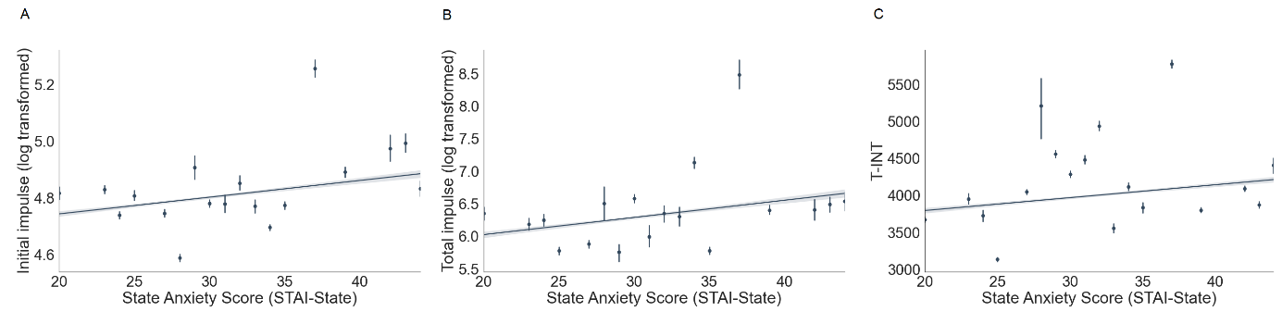
Figure S2: The association between State Anxiety, measured by the State – Trait Anxiety Inventory and the Initial impulse, Total impulse, and the time intervals between the consecutive actions – T-INT (dots: mean ± CI). We provide trend line fitted using linear regression.

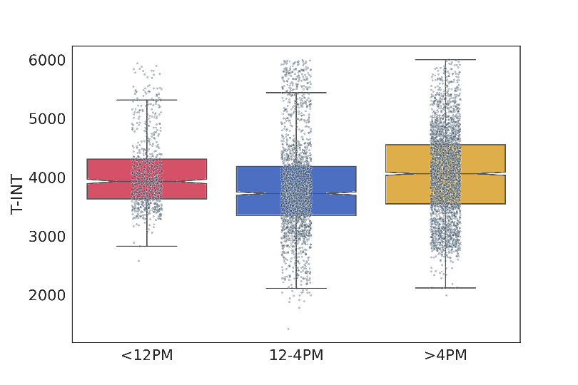
Figure S3: The effect of the time of day (medians ± IQT and outliers) on the time intervals (T-INT). In addition to individual data points, the boxplots display the medians (central line), inter-quartile range (IQR, represented by the box), and outliers (individual points outside the whiskers). The whiskers cover data points up to 1.5 times the IQR from the first and third quartiles.

