Supplementary Material S1.
Fixation‑Probability (AOI) and Time to First Fixation Analyses - Experiments 1b and 2b

Fixation‑Probability (AOI) Analyses - Experiments 1b and 2b
This Supplementary Material file reports AOI‑based fixation probabilities during the cue presentation window to complement the distance metrics presented in the main text.
Areas of interest (AOIs) were predefined rectangular regions on the display used to quantify gaze allocation (e.g., fixations) to specific on‑screen locations. In Experiment 1b, two predictor stimuli were presented on diagonal positions; therefore, separate AOIs captured fixations to the Threat_related ‑predictor and Neutral_related ‑predictor locations, in addition to a central Fixation‑cross AOI. In Experiment 2b, the predictor stimulus appeared centrally; therefore, we defined a Central‑predictor AOI and a central Fixation‑cross AOI. The Outside AOI represents all remaining screen areas not covered by any of the defined AOIs (i.e., the complement of the AOIs). All AOIs were identical in size across conditions and were centered on the corresponding stimulus locations.
Statistical analysis.
Experiment 1b: 4x3 repeated‑measures ANOVA with AOI (Fixation cross, Threat_related , Neutral_related , Outside) × Presentation time (100, 500, 1000 ms).
Experiment 2b: 3x2x3 repeated‑measures ANOVA with AOI (Fixation cross, Predictor position, Outside), Valence (Threat_related , Neutral_related ), Presentation time (100, 500, 1000 ms).
Effect sizes are partial eta squared (η_{p}²). Tukey‑adjusted post hoc comparisons unpack significant main effects and interactions. Follow‑up ANOVAs (simple effects) are reported by AOI within each presentation time and by presentation time within each AOI.

Table S1.1: Repeated measures ANOVA results for Experiments 1b.
Effect | Comparisons | df | F/t | p | η²p
Presentation time |  | 2,18 | 1.24e-15 | 1.000 | 0.000
AOI |  | 3 | 7.97 | <.001 | 0.470
 | Fix cross – Threat_related _related | 9 | 2.91 | 0.07
 | Fix cross – Neutral_related _related | 9 | 2.81 | 0.08
 | Fix cross – Outside | 9 | -0.07 | 1.00
 | Threat_related _related - Neutral_related _related | 9 | 0.37 | 0.98
 | Threat_related _related - Outside | 9 | -4.2 | 0.01
 | Neutral_related _related - Outside | 9 | -3.96 | 0.01
Presentation time ✻ AOI |  | 6 | 6.60 | <.001 | 0.423
Note: The follow analysis for the interactions is presented Table S1.2.

Figure S1.1: Differences in Fixation probability in the different AOIs (Fixation cross, Predictor position, Outside) and Presentation times (100, 500, 1000 ms).

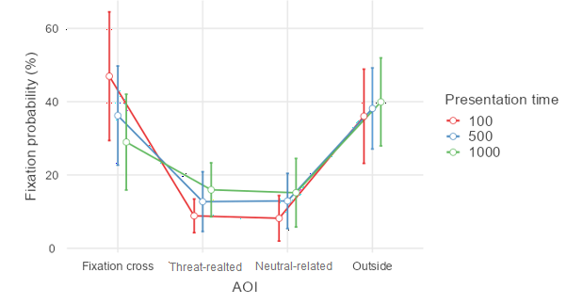

Table S1.2: Follow‑up rmANOVA for the significant interaction (Presentation time ✻ AOI).
Effect | Comparisons | df | F/t | p | η²p
100 ms | AOI | 3, 27 | 11.0 | <.001 | 0.550
 | Fix cross - Threat_related | 9.00 | 4.111 | 0.012
 | Fix cross - Neutral_related | 9.00 | 3.986 | 0.014
 | Fix cross - Outside | 9.00 | 0.851 | 0.829
 | Threat_related - Neutral_related | 9.00 | 0.407 | 0.976
 | Threat_related - Outside | 9.00 | -4.796 | 0.004
 | Neutral_related - Outside | 9.00 | -4.580 | 0.006
500 ms | AOI | 3, 27 | 7.11 | 0.001 | 0.441
 | Fix cross - Threat_related | 9.00 | 2.674 | 0.098
 | Fix cross - Neutral_related | 9.00 | 2.677 | 0.097
 | Fix cross - Outside | 9.00 | -0.227 | 0.996
 | Threat_related - Neutral_related | 9.00 | -0.112 | 0.999
 | Threat_related - Outside | 9.00 | -3.403 | 0.033
 | Neutral_related - Outside | 9.00 | -3.588 | 0.025
1000 ms | AOI | 3, 27 | 4.68 | 0.009 | 0.342
 | Fix cross - Threat_related | 9.00 | 1.572 | 0.439
 | Fix cross - Neutral_related | 9.00 | 1.541 | 0.454
 | Fix cross - Outside | 9.00 | -1.276 | 0.599
 | Threat_related - Neutral_related | 9.00 | 0.317 | 0.988
 | Threat_related - Outside | 9.00 | -3.185 | 0.045
 | Neutral_related - Outside | 9.00 | -2.939 | 0.066
Note: Bolded p-values represent significant effects

Table S1.3: Repeated measures ANOVA results for Experiments 2b.
Effects | Comparisons | df | F | p | η²p
AOI |  | 2,24 | 34.349 | <.001 | 0.741
 | Fix cross - Middle position (predictor) | 12.0 | -5.07 | <.001
 | Fix cross - Outside | 12.0 | 2.65 | 0.052
 | Middle position (predictor) - Outside | 12.0 | 9.46 | <.001
Valence |  | 1,12 | 1.738 | 0.212 | 0.127
Presentation time |  | 2,24 | 7.911 | 0.002 | 0.397
 | 100 - 500 | 12.0 | -2.70 | 0.047
 | 100 - 1000 | 12.0 | -2.82 | 0.038
 | 500 - 1000 | 12.0 | -2.84 | 0.037
AOI ✻ Valence |  | 2,24 | 0.603 | 0.555 | 0.048
AOI ✻ Presentation time |  | 4,48 | 9.862 | <.001 | 0.451
Valence ✻ Presentation time |  | 2,24 | 1.408 | 0.264 | 0.105
AOI ✻ Valence ✻ Presentation time |  | 4,48 | 1.244 | 0.305 | 0.094
Note: Bolded p-values represent significant effects

Figure S1.2.: Differences in Fixation probability in the different AOIs (Fixation cross, Predictor position, Outside) an Presentation times (100, 500, 1000 ms) and Valence (Threat_related , Neutral_related )

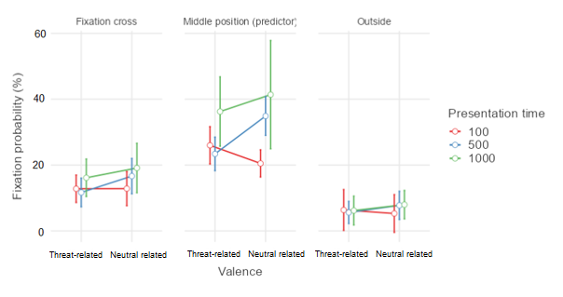

Table S1.4: Follow‑up rmANOVA for the significant interaction (Presentation time ✻ AOI).
Effect | Comparisons | df | F/t | p | η²p
AOI |  | 2,24 | 34.35 | <.001 | 0.741
 | Fix cross - Middle | 12.0 | -5.07 | <.001
 | Fix cross - Outside | 12.0 | 2.65 | 0.052
 | Middle - Outside | 12.0 | 9.46 | <.001
Presentation time |  | 2,24 | 7.91 | 0.002 | 0.397
 | 100 - 500 | 12.0 | -2.70 | 0.047
 | 100 - 1000 | 12.0 | -2.82 | 0.038
 | 500 - 1000 | 12.0 | -2.84 | 0.037
AOI ✻ Presentation time |  | 4,48 | 9.86 | <.001 | 0.451
 | Presentatiom time - 100ms | 2,24 | 26.7 | <.001 | 0.690
 | Fix cross - Middle | 12.0 | -5.44 | <.001
 | Fix cross - Outside | 12.0 | 2.37 | 0.084
 | Middle - Outside | 12.0 | 7.87 | <.001
 | Presentatiom time - 500ms | 2,24 | 32.3 | <.001 | 0.729
 | Fix cross - Middle | 12.0 | -5.14 | <.001
 | Fix cross - Outside | 12.0 | 2.41 | 0.078
 | Middle - Outside | 12.0 | 9.00 | <.001
 | Presentatiom time - 1000ms | 2,24 | 29.7 | <.001 | 0.713
 | Fix cross - Middle | 12.0 | -4.43 | 0.002
 | Fix cross - Outside | 12.0 | 2.79 | 0.040
 | Middle - Outside | 12.0 | 8.04 | <.001
Note: Bolded p-values represent significant effect

Time to First Fixation Analyses - Experiments 1b and 2b

This Supplementary Material file reports the analyses of time to first fixation in the AOI presented in the Supplementary Material S1.
Areas of interest (AOIs) were predefined rectangular regions on the display used to quantify gaze allocation (e.g., fixations) to specific on‑screen locations. In Experiment 1b, two predictor stimuli were presented on diagonal positions; therefore, separate AOIs captured fixations to the Threat‑predictor and Neutral‑predictor locations, in addition to a central Fixation‑cross AOI. In Experiment 2b, the predictor stimulus appeared centrally; therefore, we defined a Central‑predictor AOI and a central Fixation‑cross AOI. The Outside AOI represents all remaining screen areas not covered by any of the defined AOIs (i.e., the complement of the AOIs). All AOIs were identical in size across conditions and were centered on the corresponding stimulus locations.

Statistical analysis.
Experiment 1b: 4x3 repeated‑measures ANOVA with AOI (Fixation cross, Threat-related, Neutral-related, Outside) × Presentation time (100, 500, 1000 ms).
Experiment 2b: 3x2x3 repeated‑measures ANOVA with AOI (Predictor position, Outside), Valence (Threat-related, Neutral-related), Presentation time (100, 500, 1000 ms).
Dependent variable: Time to first fixation in each of the AOIs (ms).
Effect sizes are partial eta squared (ηp²). Tukey‑adjusted post hoc comparisons unpack significant main effects and interactions.

Table S1.5: Repeated measures ANOVA results for Experiments 1b.
Effect | Comparisons | df | F/t | p | η²p
AOI |  | 3,21 | 56.16 | <.001 | 0.889
 | Threat_realted-Neutral_related | 7.00 | -2.15 | 0.227
 | Threat_realted-Fixation-cross | 7.00 | 14.83 | <.001
 | Threat_realted-Outside | 7.00 | 10.33 | <.001
 | Neutral_related-Fixation-cross | 7.00 | 8.38 | <.001
 | Neutral_related-Outside | 7.00 | 6.28 | 0.002
 | Fixation-cross-Outside | 7.00 | -7.03 | <.001
Presentation time (ms) |  | 2,14 | 9.59 | 0.002 | 0.578
 | 100-500 | 7.00 | -2.24 | 0.132
 | 100-1000 | 7.00 | -3.58 | 0.021
 | 500-1000 | 7.00 | -2.84 | 0.058
AOI ✻ Presentation time (ms) |  | 6,42 | 3.47 | 0.007 | 0.331
 | Threat_realted 100-Outside 100 | 7.00 | 5.7573 | 0.015
 | Threat_realted 500-Outside 500 | 7.00 | 7.8467 | 0.002
 | Threat_realted 1000-Outside 1000 | 7.00 | 10.9506 | <.001
 | Threat_realted 100-Neutral_related 100 | 7.00 | -1.7347 | 0.812
 | Threat_realted 500-Neutral_related 500 | 7.00 | -1.6984 | 0.827
 | Threat_realted 1000-Neutral_related 1000 | 7.00 | -1.7255 | 0.816

Figure S1.3: Differences in time to first fixation in the different AOIs (Fixation cross, Predictor position, Outside) and Presentation times (100, 500, 1000 ms) in Experiment 1b.
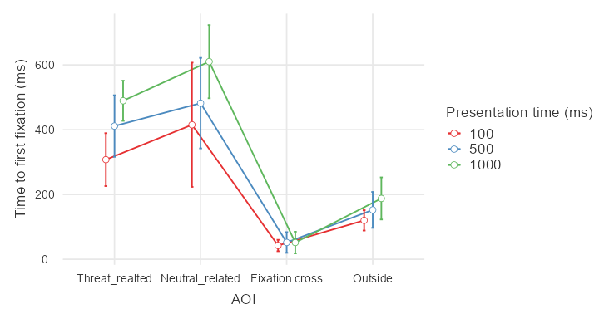

Table S1.6: Repeated measures ANOVA results for Experiments 2b.
Effects | df | F | p | η²p
Predictor Cue | 1,10 | 0.00341 | 0.955 | 0.000
AOI | 1,10 | 16.84439 | 0.002 | 0.627
Presentation Time (ms) | 2,20 | 46.18881 | <.001 | 0.822
Predictor Cue ✻ AOI | 1,10 | 0.36835 | 0.557 | 0.036
Predictor Cue ✻ Presentation Time (ms) | 2,20 | 0.24150 | 0.788 | 0.024
AOI ✻ Presentation Time (ms) | 2,20 | 9.30172 | 0.001 | 0.482
Predictor Cue ✻ AOI ✻ Presentation Time (ms) | 2,20 | 0.89968 | 0.423 | 0.083

Figure S1.4: Differences in time to first fixation in the different AOIs (Fixation cross, Predictor position, Outside) and Presentation times (100, 500, 1000 ms) in Experiment 2b.
