High throughput sequencing for community analysis: The promise of DNA barcoding to uncover diversity, relatedness, abundances and interactions in spider communities

Susan R. Kennedy¹, Stefan Prost^{2,3}, Isaac Overcast^{4,5}, Andrew J. Rominger⁶, Rosemary G. Gillespie⁷, Henrik Krehenwinkel⁸*

¹Okinawa Institute of Science and Technology, Biodiversity and Biocomplexity Unit, Onna, Okinawa, Japan; ORCID: 0000-0002-1616-3985
²LOEWE-Centre for Translational Biodiversity Genomics, Senckenberg Museum, Frankfurt, Germany; ORCID: 0000-0002-6229-3596
³South African National Biodiversity Institute, National Zoological Garden, Pretoria, South Africa
⁴Graduate Center of the City University New York, NY, USA; ORCID: 0000-0001-8614-6892
⁵Ecole Normale Supérieure, Paris, France
⁶Santa Fe Institute, Santa Fe, NM, USA; ORCID: 0000-0003-3755-4480
⁷University of California Berkeley, Environmental Sciences Policy and Management, Berkeley, CA, USA; ORCID: 0000-0003-0086-7424
⁸Trier University, Department of Biogeography, Trier, Germany; ORCID: 0000-0001-5069-8601
*Corresponding author: krehenwinkel@uni-trier.de

Supplementary Information

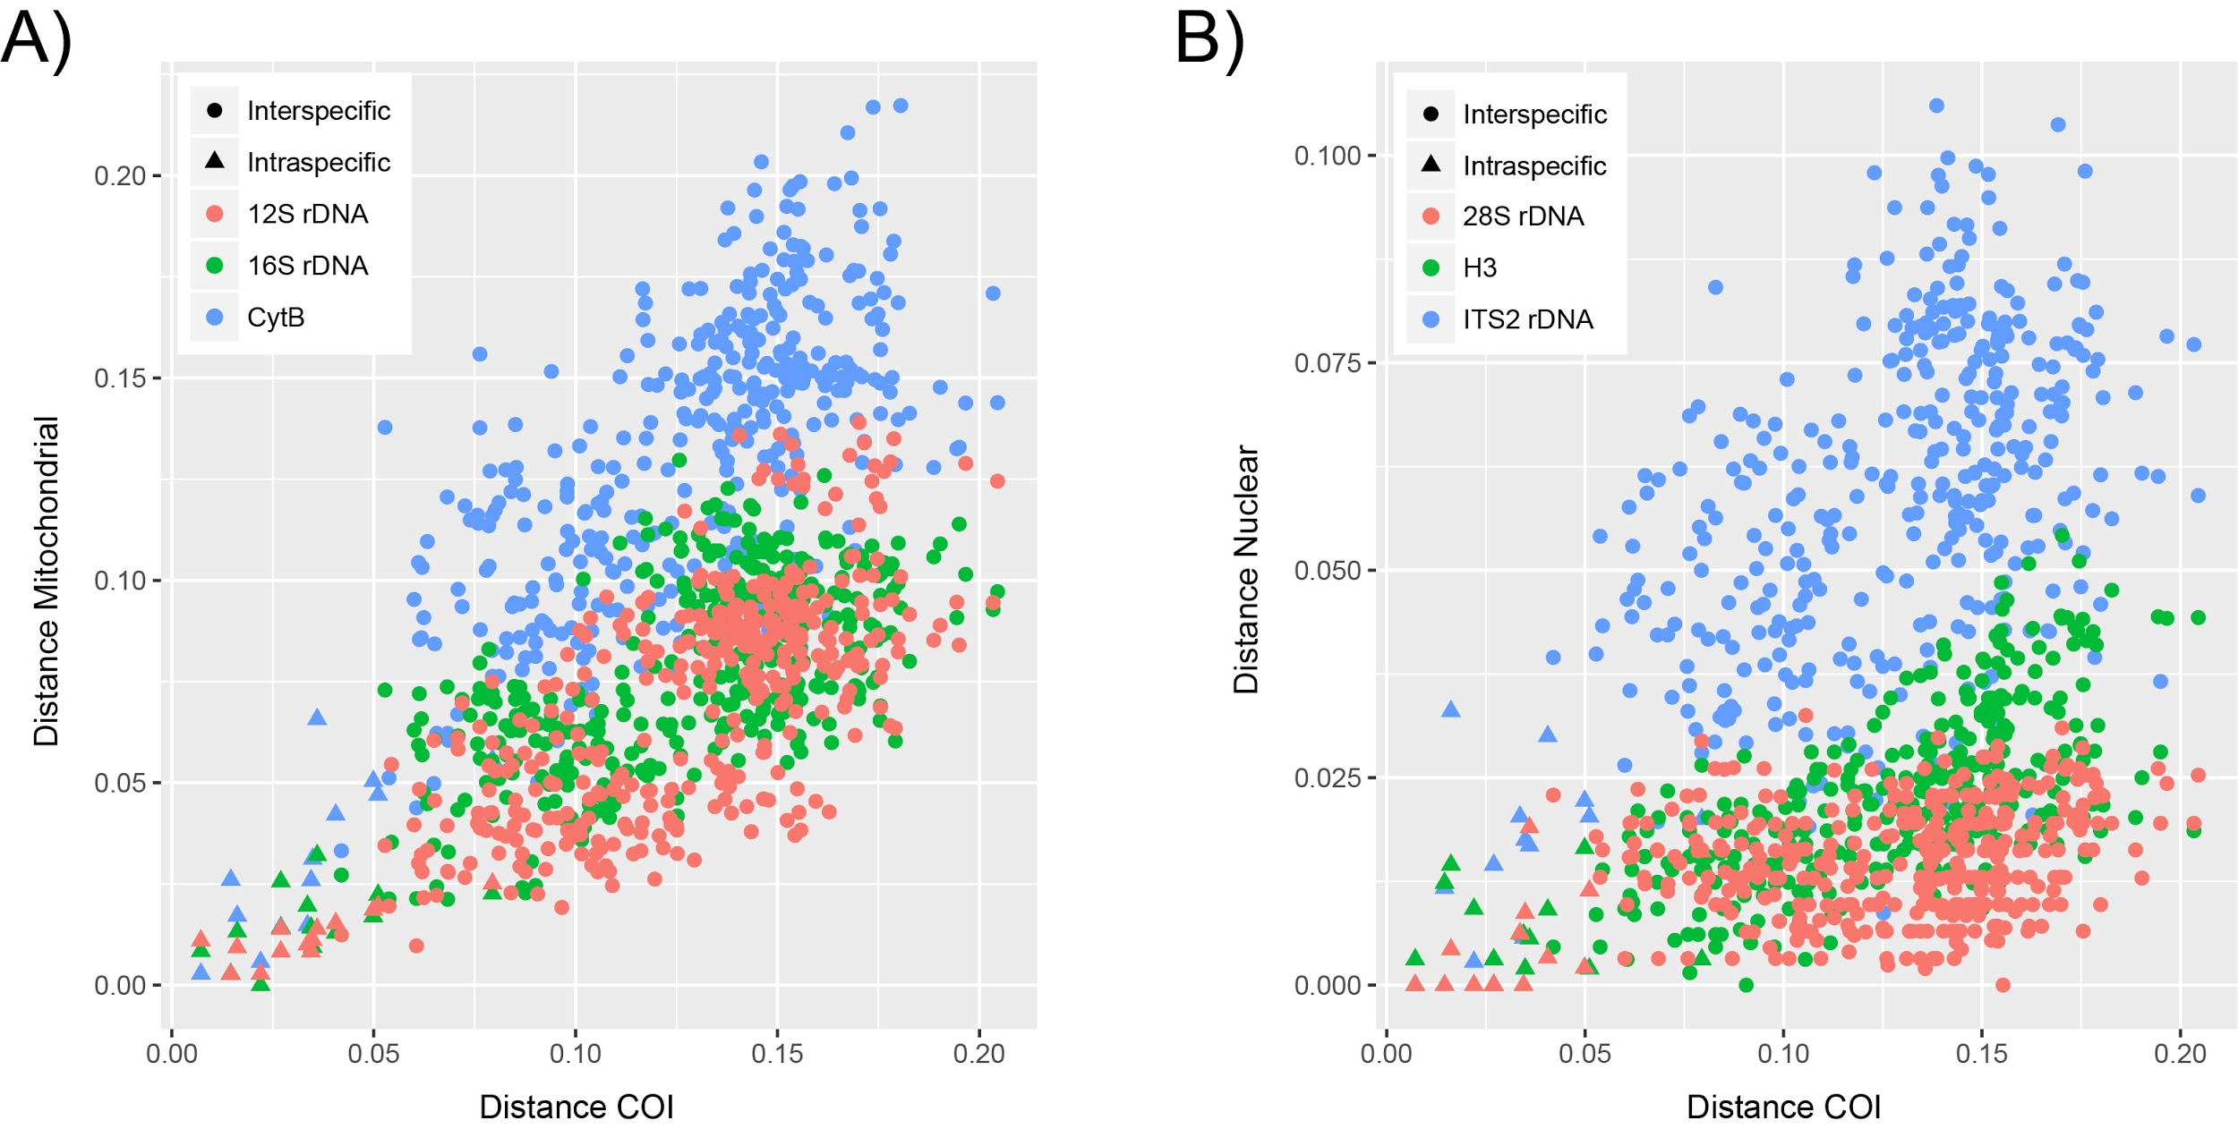

Supplementary Fig. 1 Intraspecific and interspecific pairwise genetic distances among 29 endemic Hawaiian spider species of the genus Tetragnatha. The genetic distances for the commonly used DNA barcode marker COI are shown on the X-axis in comparison to A) other mitochondrial and B) nuclear markers suitable for spider taxonomy on the Y-axis. While all markers except for mitochondrial Cytochrome B generally show shorter genetic distances than COI, they still show comparable divergence patterns. Based on data from Krehenwinkel et al. 2018

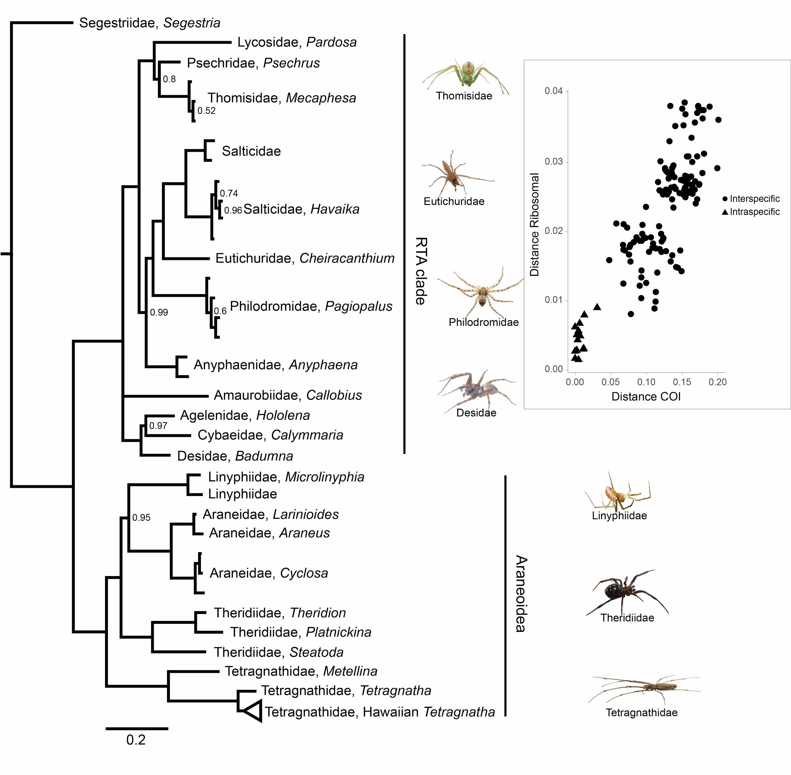

Supplementary Fig. 2 Bayesian phylogeny for spiders from 16 families, based on a 4200-bp alignment of the nuclear ribosomal cluster, covering 18S, ITS1, 5.8S, ITS2 and 28SrDNA. The splits are well supported, with only posterior probabilities below 1 shown. The tree generally matches results based on recent phylogenomic work (Bond et al. 2014; Fernández et al. 2018). The sequence information for this phylogeny was generated by sequencing long PCR amplicons on a Nanopore third generation sequencer. The inset in the upper right shows interspecific and intraspecific pairwise genetic distances for 16 endemic Hawaiian Tetragnatha species for COI on the X-axis and the ribosomal cluster on the Y-axis. Long ribosomal sequences show a comparable taxonomic resolution to the widely used COI. Modified from Krehenwinkel et al. 2019a

Supplementary Table 1 Useful primer sets for various applications of amplicon sequencing-based spider barcoding
Locus | F primer | F primer sequence 5' to 3' | R primer | R primer sequence 5' to 3' | Amplicon length | Description/application
COI | ArF1¹ | GCNCCWGAYATRGCNTTYCCNCG | Fol-degen-rev² | TANACYTCNGGRTGNCCRAARAAYCA | 467 | barcoding
COI | mlCOIintF³ | GGWACWGGWTGAACWGTWTAYCCYCC | Fol-degen-rev² | TANACYTCNGGRTGNCCRAARAAYCA | 365 | barcoding
16SrDNA | 16SF2⁴ | AATYCAACATCGAGGTCGCAA | 16SR2⁴ | TRACYGTRCWAAGGTAGCAT | 371 | barcoding
12SrDNA | 12SF1⁴ | NCHACTWTGTTACGACTT | 12SR1⁴ | AMTAGGATTAGATACCCT | 424 | barcoding
Cytochrome B | CB3degB^{4,5} | GAGGDGCHACHGTWATYACHAA | CB4deg^{4,5} | RAARTATCATTCDGGTTGRATRTG | 406 | barcoding
18SrDNA | 18s_2F⁶ | AACTTAAAGRAATTGACGGA | 18s_4R⁶ | CKRAGGGCATYACWGACCTGTTAT | 351 | barcoding
18SrDNA | SSU_FO4⁷ | GCTTGTCTCAAAGATTAAGCC | SSU_R22⁷ | GCCTGCTGCCTTCCTTGGA | 421 | barcoding
28SrDNA | 28s_3F⁶ | TTTTGGTAAGCAGAACTGGYG | 28s_4R⁶ | ABTYGCTACTRCCACYRAGATC | 363 | barcoding
ITS2 | 5.8S3F⁴ | ATCACTHGGCTCRYGGRTCGATG | 28S2R⁴ | TTCTTTTCCTCCSCTHANTDATATGC | 436 | barcoding
Histone H3 | H3aF⁸ | ATGGCTCGTACCAAGCAGACVGC | H3aR⁸ | ATATCCTTRGGCATRATRGTGAC | 374 | barcoding
ZBJ (COI) | ZBJ-ArtF1c⁹ | AGATATTGGAACWTTATATTTTATTTTTGG | ZBJ-ArtR2c⁹ | WACTAATCAATTWCCAAATCCTCC | 211 | gut content
16SrDNA_gut | 16SF_885¹⁰ | ARGACGAGAAGACCCYATA | 16SR_1086¹⁰ | ATWACGCTGTTATCCCYAA | 201 | gut content
18SrDNA_gut | 18SF_1332¹⁰ | AGCTCTTTCTYGATTCRGTGGGT | 18SR_1628¹⁰ | CACAGACCTGTTATTGCTCAA | 296 | gut content
18SrDNA_gut | 18SF_1392¹⁰ | GTCTGGTTRATTCCGRTAACGAA | 18SR_1628¹⁰ | CACAGACCTGTTATTGCTCAA | 236 | gut content
28SrDNA_gut | 28SF_788¹⁰ | CGTCTTGAAACACGGACCAA | 28SR_1062¹⁰ | GWCCTCCATCAGGGTTTCCC | 274 | gut content
nuclear rDNA | 18S_F4¹¹ | GGCTACCACATCYAARGAAGGCAGCAG | 28S_R8¹¹ | TCGGCAGGTGAGTYGTTRCACAYTCCT | variable; ca. 4200 in spiders | long-read barcoding
Minibar (COI) | Uni-MinibarF1¹² | TCCACTAATCACAARGATATTGGTAC | Uni-MinibarR1¹² | GAAAATCATAATGAAGGCATGAGC | 176 | mini-barcode

¹Gibson et al. (2014), ²Yu et al. (2012), ³Leray et al. (2013), ⁴Krehenwinkel et al. 2018, ⁵Barraclough et al. (1999), ⁶Machida and Knowlton (2012), ⁷Fonseca et al. (2010), ⁸Colgan et al. (1998), ⁹Zeale et al. (2011), ¹⁰Krehenwinkel et al. (2019c), ¹¹Krehenwinkel et al. (2019a), ¹²Meusnier et al. (2008)

Supplementary Table 2 Published spider genomes
Common Name | Latin Name | Sequencing Method | Reference/Genbank Accession
House spider | Parasteatoda tepidariorum | Illumina (PE, MP, Chicago) | Schwager et al. 2017  GCA_000365465.2
African social velvet spider | Stegodyphus mimosarum | Illumina (PE, MP) | Sanggaard et al. 2014  GCA_000611955.2
African social velvet spider | Stegodyphus dumicola | Illumina (PE), PacBio | Liu et al. 2019
Brazilian white-knee tarantula | Acanthoscurria geniculata | Illumina (PE, MP) | Sanggaard et al. 2014  GCA_000661875.1
Golden orb-weaver | Nephila clavipes | Illumina (PE, MP) | Babb et al. 2017  GCA_002102615.1
Brown recluse spider | Loxosceles reclusa | Illumina (PE, MP) | GCA_001188405.1
Western black widow | Latrodectus hesperus | Illumina (PE, MP) | GCA_000697925.1
Pond wolf spider | Pardosa pseudoannulata | Illumina (PE, MP, 10x Genomics), Pacbio | Yu et al. 2019  GCA_008065355.1
Woodlouse hunting spider | Dysdera silvatica | Illumina (PE, MP), Pacbio, Nanopore | Sánchez-Herrero et al. 2019  GCA_006491805.1

References

Babb PL, Lahens NF, Correa-Garhwal SM, Nicholson DN, Kim EJ, Hogenesch JB, Kuntner M, Higgins L, Hayashi CY, Agnarsson I, Voight BF (2017) The Nephila clavipes genome highlights the diversity of spider silk genes and their complex expression. Nat Genet 49:895-903.
Barraclough TG, Hogan JE, Vogler AP (1999) Testing whether ecological factors promote cladogenesis in a group of tiger beetles (Coleoptera: Cicindelidae). P Roy Soc Lond B Bio 266:1061-1067.
Bond JE, Garrison NL, Hamilton CA, Godwin RL, Hedin M, Agnarsson I (2014) Phylogenomics resolves a spider backbone phylogeny and rejects a prevailing paradigm for orb web evolution. Curr Biol 24:1765-1771.
Colgan DJ, McLauchlan A, Wilson GDF, Livingston SP, Edgecombe GD, Macaranas J, Cassis G, Gray MR (1998) Histone H3 and U2 snRNA DNA sequences and arthropod molecular evolution. Aust J Zool 46:419-437.
Fernández R, Kallal RJ, Dimitrov D, Ballesteros JA, Arnedo MA, Giribet G, Hormiga G (2018) Phylogenomics, diversification dynamics, and comparative transcriptomics across the spider tree of life. Curr Biol 28:1489-1497.
Fonseca VG, Carvalho GR, Sung W, Johnson HF, Power DM, Neill SP, Packer M, Blaxter ML, Lambshead PJD, Thomas WK, Creer S, (2010) Second-generation environmental sequencing unmasks marine metazoan biodiversity. Nat Commun. https://doi.org/10.1038/ncomms1095
Gibson J, Shokralla S, Porter TM, King I, van Konynenburg S, Janzen DH, Hallwachs W, Hajibabaei M (2014) Simultaneous assessment of the macrobiome and microbiome in a bulk sample of tropical arthropods through DNA metasystematics. P Natl Acad Sci USA 111:8007-8012.
Kennedy S, Lim JY, Clavel J, Krehenwinkel H, Gillespie RG (2019) Spider webs, stable isotopes and molecular gut content analysis: Multiple lines of evidence support trophic niche differentiation in a community of Hawaiian spiders. Funct Ecol 33:1722-1733.
Krehenwinkel H, Kennedy SR, Adams SA, Stephenson GT, Roy K, Gillespie RG (2019c) Multiplex PCR targeting lineage‐specific SNPs: A highly efficient and simple approach to block out predator sequences in molecular gut content analysis. Methods Ecol Evol 10:982-993.
Krehenwinkel H, Kennedy S, Pekár S, Gillespie RG (2017b) A cost‐efficient and simple protocol to enrich prey DNA from extractions of predatory arthropods for large‐scale gut content analysis by Illumina sequencing. Methods Ecol Evol 8:126-134.
Krehenwinkel H, Kennedy SR, Rueda A, Lam A, Gillespie RG (2018) Scaling up DNA barcoding – Primer sets for simple and cost efficient arthropod systematics by multiplex PCR and Illumina amplicon sequencing. Methods Ecol Evol 9:2181-2193.
Krehenwinkel H, Pomerantz A, Henderson JB, Kennedy SR, Lim JY, Swamy V, Shoobridge JD, Graham N, Patel NH, Gillespie RG, Prost S (2019a) Nanopore sequencing of long ribosomal DNA amplicons enables portable and simple biodiversity assessments with high phylogenetic resolution across broad taxonomic scale. GigaScience. https://doi.org/10.1093/gigascience/giz006
Krehenwinkel H, Wolf M, Lim JY, Rominger AJ, Simison WB, Gillespie RG (2017a) Estimating and mitigating amplification bias in qualitative and quantitative arthropod metabarcoding. Sci Rep-UK. https://doi.org/10.1038/s41598-017-17333-x
Leray M, Yang JY, Meyer CP, Mills SC, Agudelo N, Ranwez V, Boehm JT, Machida RJ (2013) A new versatile primer set targeting a short fragment of the mitochondrial COI region for metabarcoding metazoan diversity: Application for characterizing coral reef fish gut contents. Front Zool. https://doi.org/10.1186/1742-9994-10-34
Liu S, Aageaard A, Bechsgaard J, Bilde T (2019) DNA methylation patterns in the social spider, Stegodyphus dumicola. Genes. https://doi.org/10.3390/genes10020137
Machida RJ, Knowlton N (2012) PCR primers for metazoan nuclear 18S and 28S ribosomal DNA sequences. PLoS One. https://doi.org/10.1371/journal.pone.0046180
Meusnier I, Singer GA, Landry JF, Hickey DA, Hebert PD, Hajibabaei M (2008) A universal DNA mini-barcode for biodiversity analysis. BMC Genomics. https://doi.org/10.1186/1471-2164-9-214
Sánchez-Herrero JF, Frías-López C, Escuer P, Hinojosa-Alvarez S, Arnedo MA, Sánchez-Gracia A, Rozas J (2019) The draft genome sequence of the spider Dysdera silvatica (Araneae, Dysderidae): A valuable resource for functional and evolutionary genomic studies in chelicerates. GigaScience. https://doi.org/10.1093/gigascience/giz099
Sanggaard KW, Bechsgaard JS, Fang X, Duan J, Dyrlund TF, Gupta V, Jiang X, Cheng L, Fan D, Feng Y, Han L (2014) Spider genomes provide insight into composition and evolution of venom and silk. Nature Commun. https://doi.org/10.1038/ncomms4765
Schwager EE, Sharma PP, Clarke T, Leite DJ, Wierschin T, Pechmann M, Akiyama-Oda Y, Esposito L, Bechsgaard J, Bilde T, Buffry AD (2017) The house spider genome reveals an ancient whole-genome duplication during arachnid evolution. BMC Biology. https://doi.org/10.1186/s12915-017-0399-x
Yu DW, Ji Y, Emerson BC, Wang X, Ye C, Yang C, Ding Z (2012) Biodiversity soup: Metabarcoding of arthropods for rapid biodiversity assessment and biomonitoring. Methods Ecol Evol 3:613-623.
Yu N, Li J, Liu M, Huang L, Bao H, Yang Z, Zhang Y, Gao H, Wang Z, Yang Y, Van Leeuwen T (2019) Genome sequencing and neurotoxin diversity of a wandering spider Pardosa pseudoannulata (pond wolf spider). bioRxiv. https://doi.org/10.1101/747147
Zeale MR, Butlin RK, Barker GL, Lees DC, Jones G (2011) Taxon‐specific PCR for DNA barcoding arthropod prey in bat faeces. Mol Ecol Resour 11:236-244.

To avoid confusion, we retain the same lettering scheme used in the main paper even though Krehenwinkel et al. 2019b (Krehenwinkel, Pomerantz and Prost 2019) is not cited in the Supplement.

