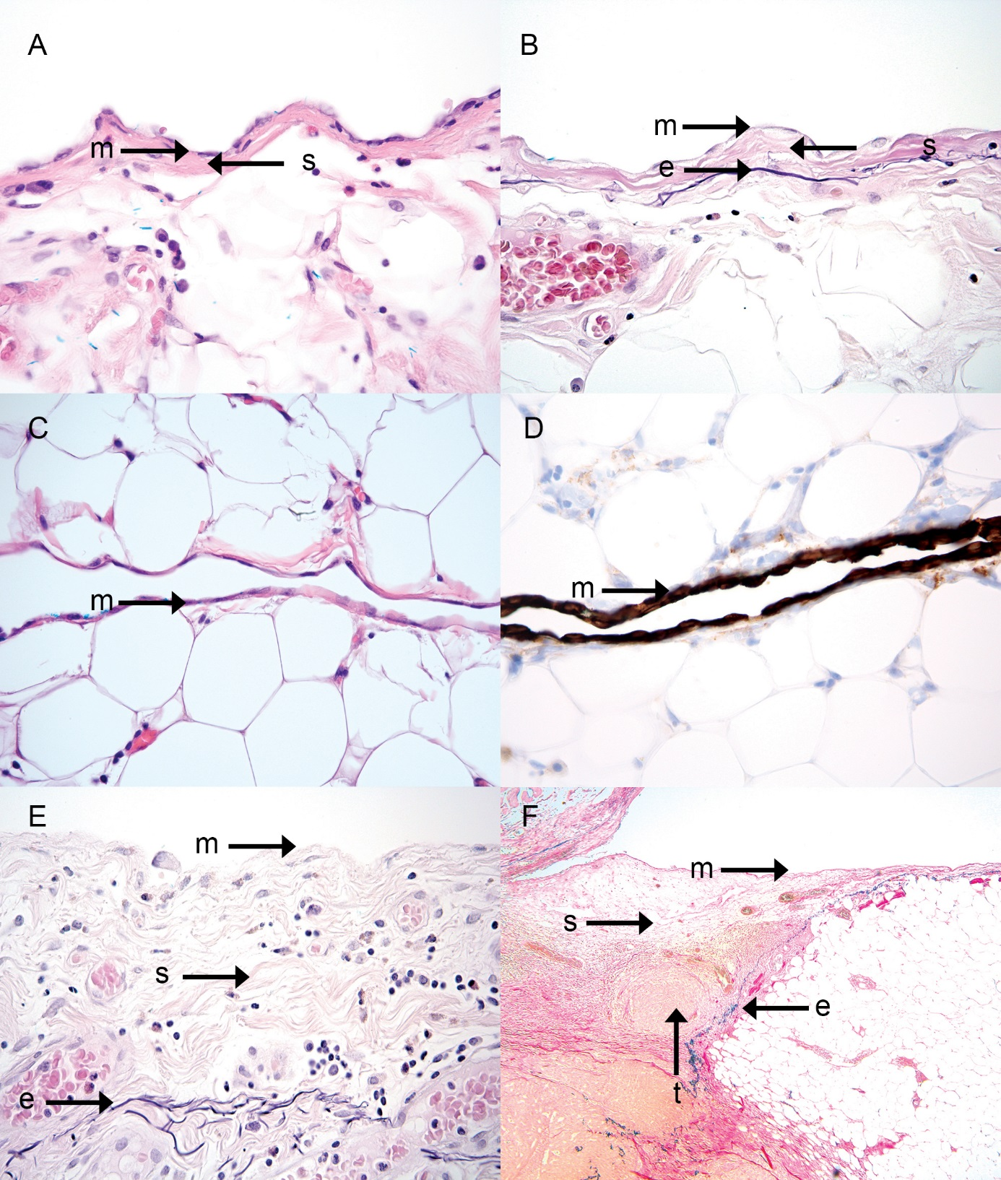Suppl. fig. 1 Anatomical layers of the peritoneum. Case a (H&E stain, x40) and b (Elastica van Gieson, EvG, stain, 40x) illustrate the prototypical microanatomy of the peritoneum (serosa, serous membrane), consisting of a mesothelium (m), a submesothelial stroma layer (s), and a peritoneal elastic lamina (e). The elastic fibers of the peritoneal elastic lamina stain black/dark purple in the EvG stain. Case c (H&E stain, 40x) and d (cytokeratin 7 stain, 40x) are examples of peritoneum in a cleft between fatty lobules, here consisting of a flat mesothelium with minimal submesothelial stroma and no demonstrable peritoneal elastic lamina (EvG stain not shown). The mesothelial cells are accentuated using the cytokeratin 7 stain (brown). Cases a through d demonstrate that the normal peritoneum is variously developed depending on the location. Case e (EvG stain, x40) illustrates slightly thickened submesothelial stroma layer (s) in the presence of mild inflammation. In case e the mesothelium (m) is largely stripped off. Case f (EvG stain, x10) illustrates severely thickened submesothelial stroma layer (s) due to colorectal carcinoma (t) that grows through the peritoneal elastic lamina (e) and into the thickened submesothelial stroma layer. The black stained peritoneal elastic lamina can be followed diagonally towards the right upper corner where the peritoneum is closer to normal thickness.
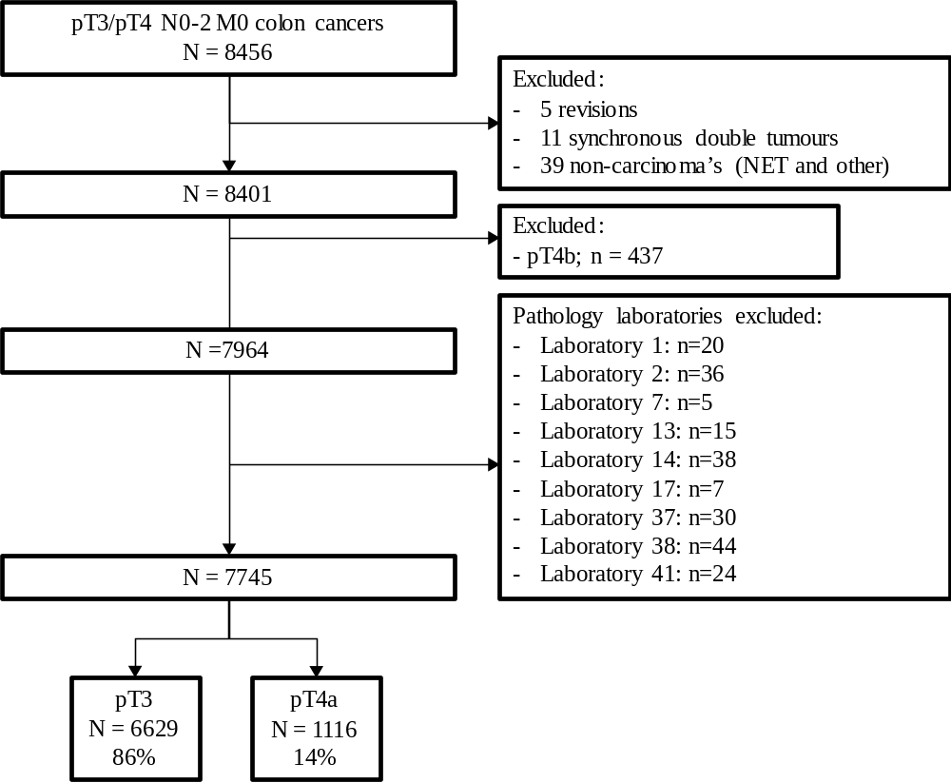
Suppl. Fig. 2 Patient inclusion

LPI - primary tumor
LPI1 | Tumor well clear of closest peritoneal surface
LPI2 | Mesothelial inflammatory and/or hyperplastic reaction with tumor close to, but not at the peritoneal surface
LPI3 | Tumor present at peritoneal surface with inflammatory reaction, mesothelial hyperplasia and/or erosion or ‘ulceration’
LPI4 | Tumor cells shown free on the serosal surface with evidence of adjacent ‘ulceration’ of the visceral peritoneum.

Suppl. table 1 Local Peritoneal Involvement (LPI) score according to Shepherd

Number of pathologists with same assessment | Number of cases  n = 66 | Cases assessed as:
Number of pathologists with same assessment | Number of cases  n = 66 | pT3 | pT4a
12 out of 12 pathologists (100% agreement) | 20 (30%) | 13 | 7
11 out of 12 pathologists (92% agreement) | 10 (15%) | 6 | 4
10 out of 12 pathologists (83% agreement) | 13 (20%) | 6 | 7
9 out of 12 pathologists (75% agreement) | 8 (12%) | 3 | 5
8 out of 12 pathologists (67% agreement) | 5 (8%) | 1 | 4
7 out of 12 pathologists (58% agreement) | 8 (12%) | 6 | 2
6 out of 12 pathologists (50% agreement) | 2 (3%) | NA | NA

Suppl. table 2 Level of agreement amongst the twelve pathologists per case

Suppl. table 3. Baseline characteristics and case mix correction
 |  |  | Total (T3+T4a) |  | T4a |  | OR | Adjusted OR
 |  |  | n | % | n | %
Sex | M |  | 3985 | 51.5% | 520 | 46.6%
 | V |  | 3760 | 48.5% | 596 | 53.4% | 1.255 (1.105-1.425) | 1.234 (1.078-1.413)
Age | < 60 |  | 1060 | 13.7% | 157 | 14.1%
 | 60-69 |  | 2252 | 29.1% | 305 | 27.3% | 0.901 (0.732-1.109)
 | 70-79 |  | 2640 | 34.1% | 351 | 31.5% | 0.882 (0.720-1.082)
 | 80 ≤ |  | 1793 | 23.2% | 303 | 27.2% | 1.170 (0.948-1.443)
Year of examination | 2012 |  | 1601 | 20.7% | 223 | 20.0%
Year of examination | 2013 |  | 2015 | 26.0% | 271 | 24.3% | 0.960 (0.793-1.162)
Year of examination | 2014 |  | 2341 | 30.2% | 354 | 31.7% | 1.101 (0.919-1.319)
 | 2015 |  | 1788 | 23.1% | 268 | 24.0% | 1.090 (0.899-1.320)
Tumour location | Right hemicolon |  | 4002 | 51.7% | 593 | 53.1%
Tumour location | Transverse colon |  | 350 | 4.5% | 57 | 5.1% | 1.118 (0.831-1.505)
Tumour location | Left hemicolon |  | 934 | 12.1% | 137 | 12.3% | 0.988 (0.808-1.208)
Tumour location | Sigmoid |  | 2412 | 31.1% | 320 | 28.7% | 0.879 (0.760-1.018)
Histological type | Adenocarcinoma, w./m. d. |  | 5834 | 75.3% | 747 | 66.9%
Histological type | Adenocarcinoma, poorly d. |  | 872 | 11.3% | 171 | 15.3% | 1.661 (1.382-1.997) | 1.294 (1.059-1.580)
Histological type | Mucinous carcinoma |  | 894 | 11.5% | 152 | 13.6% | 1.395 (1.153-1.688) | 1.506 (1.231-1.843)
Histological type | Signet ring cell carcinoma |  | 78 | 1.0% | 32 | 2.9% | 4.737 (2.998-7.487) | 3.633 (2.214-5.961)
Histological type | Other carcinoma’s |  | 67 | 0.9% | 14 | 1.3% | 1.799 (0.993-3.258) | 1.819 (0.967-3.421)
Lymphatic or vascular invasion |  | Absent | 5539 | 71.5% | 593 | 53.1%
 |  | Present | 2019 | 26.1% | 484 | 43.4% | 2.630 (2.302-3.004) | 1.839 (1.576-2.146)
Lymph node status | N0 |  | 4368 | 56.4% | 403 | 36.1%
Lymph node status | N1 |  | 2205 | 28.5% | 400 | 35.8% | 2.180 (1.878-2.531) | 1.921 (1.637-2.255)
Lymph node status | N2 |  | 1172 | 15.1% | 313 | 28.0% | 3.585 (3.040-4.228) | 2.477 (2.047-2.997)

Suppl. table 3 Baseline characteristics and case mix for pT3 and pT4a colon cancer patients. Abbreviations: adenocarcinoma w./m. d.: adenocarcinoma, well/moderately differentiated; adenocarcinoma poorly d.: adenocarcinoma poorly differentiated. OR: odds ratio.

