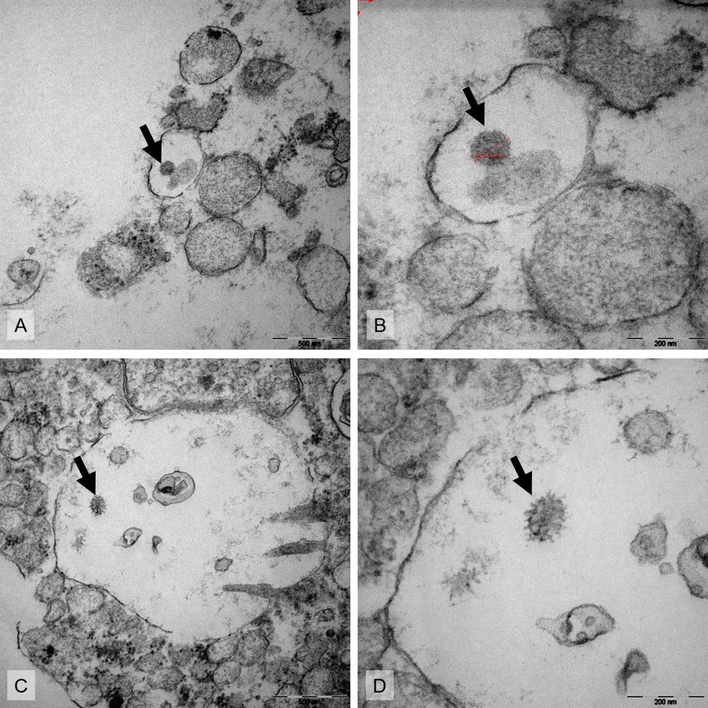
Supplementary Figure 1: Electron microscopical findings: Autopsy samples of electron microscopical anlayses showed severe signs of autolyses. At best, "virus-like" particles could be detected by transmissionelectron microscopical analyses in alveolar cells (A-D; P2, P3, arrow) with spike-like structures (B, P2; D, P3), while the nucleocapsid and the typical crown-like spikes of SARS-CoV2 have not been recognized at all.

Patient characteristics at the UKR Intensive Care Unit
COVID-positive patients with intensive care therapy | 55
COVID-positive patients who died at the UKR | 17 (30,9 %)
Autopsies of COVID-positive deceased UKR | 8 (47,1 %)
Male/Female | 4/4
Median Age | 62 (44 - 73) y
Body Mass Index | 30,2 (20,8 - 40,4) kg/m2
Days beeing hospitalized | 33,6 (16 - 56)
Days on mechanical ventilation | 29,6 (13 - 51)
Days between onset of first symptoms and death | 35,3 (21 - 54)
Therapy
ECMO | 5/8 (1 x VV-ECMO, 2 x VA-ECMO, 2 x VV- and VA-ECMO)
Dialysis | 8/8
Days on Dialysis | 19,5 (1 - 49)
Days on Antibiotics | 29,6 (2 - 56)
Days on Antimycotics | 9,5 (0 - 36)
Preexisting immunsuppressive Therapy | 0/8
Immunsuppressive Therapy | 8/8 (7 Anakinra, 1 Tozilizumab)
Prone Position Ventilation | 8/8
Convalescent plasmaTreatment | 4/8
Hyperinflammatory state  IL-6 | 7/8  3702,6 pg/ml (1728 - 9296pg/ml)
Comorbidities  Hypertension  Obesity  Liver disease (NASH, liver cirrhosis, etc.)  Diabetes  Others* | 5/8  6/8  2/8  1/8  8/8
Clinical causes of death  Multi organ failure  Sepsis  Liver failure | 8/8  4/8  1/8

Supplementary Table 1: Patient characteristics including information on therapy and comorbidities (VV-ECMO: veno-venous extracorporeal membrane oxygenation; VA-ECMO: veno-arterial extracorporeal membrane oxygenation; * Depression (1/8), COPD (1/8), Diabetes Mellitus (1/8), Abdominal Surgery (1/8), Sleep Apnea Syndrome (1/8), Factor V Leiden Deficiency (1/8), Atrial Fibrillation (2/8))

