A
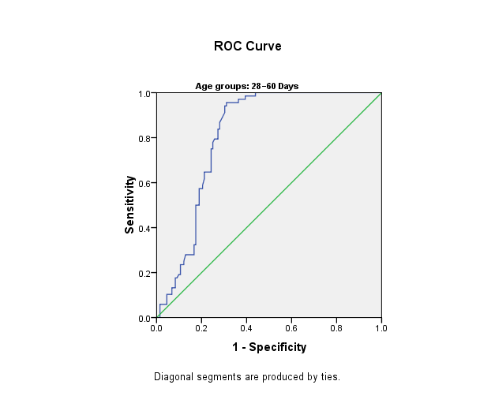 | 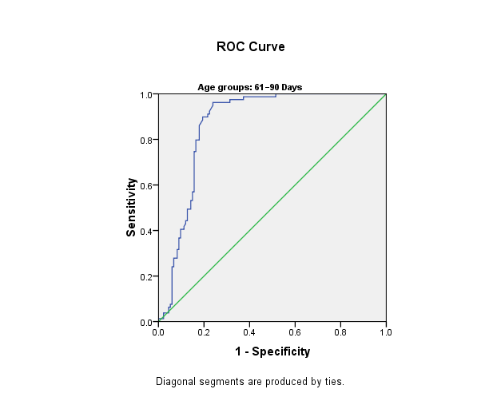  A | 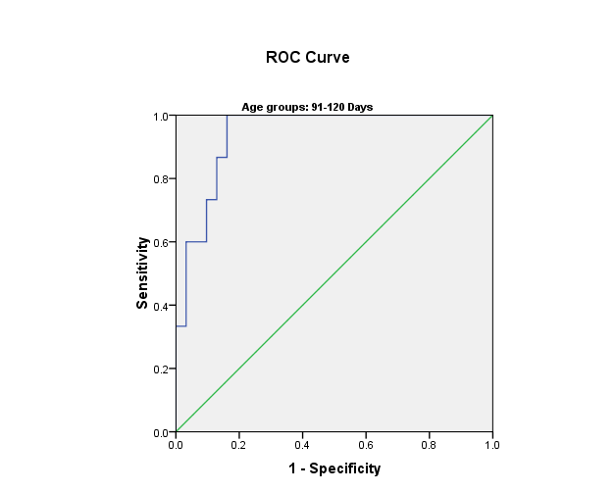  C
Figure 2. The area under the curve (AUC) of ROC curve of GGT level in different age groups A AUC of 0.812 in neonate ≤ 60days (95% CI 0.754-0.871). B AUC of 0.868 in age group 61-90 days (95% CI 0.818-0.917). C AUC of 0.940 in age group from 91-120 days (95% CI 0.876-1.004).

