Supplementary Figure 1: Sample 19 Archer NGS routine reference result.
A
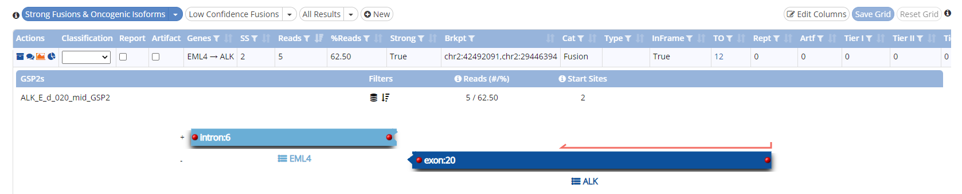
B
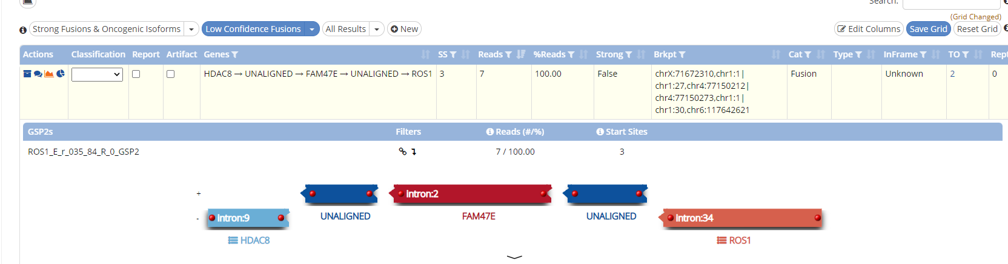
(A) ALK fusion NGS analysis result with positive call. (B) ROS1 fusion NGS analysis result with negative call.

Title: Multicenter evaluation of an automated, multiplex, RNA-based molecular assay for detection of ALK, ROS1, RET fusions and MET exon 14 skipping in NSCLC
Virchows Archiv
Authors: Melchior Linea, Hirschmann Astrid, Hofman Paul, Bontoux Christophe, Concha Angel, Mrabet-Dahbi Salima, Vannuffel Pascal, Watkin Emmanuel, Putzová Martina, Scarpino Stefania, Cayre Anne, Martin Paloma, Stoehr Robert, Hartmann Arndt
Corresponding author: Melchior Linea, Blegdamsvej 9, 2100 Ø København, +45 35455462, linea.cecilie.melchior@regionh.dk

