Supplementary Table 1. Tumour descriptor categories in the WHO Classification of Tumours 5th edition (1).
Section in the WHO Blue Book
Localisation
Clinical features | Clinical manifestation
Clinical features | Imaging
Clinical features | Others
Epidemiology
Aetiology
Pathogenesis
Macroscopic appearance
Histopathology | General features
Histopathology | Patterns/subtypes
Histopathology | Immunohistochemistry
Histopathology | Grading
Histopathology | Differential diagnosis
Histopathology | Others
Cytology
Diagnostic molecular pathology | In-situ hybridisation
Diagnostic molecular pathology | Sequencing
Diagnostic molecular pathology | Others
Staging
Prognosis and prediction
WHO: World Health Organization

Supplementary Table 2. Number of references per level of evidence and tumour type for the 5th WHO Classification of Tumours Edition of Thoracic Tumours, Tumours of the Lung Chapter (n=1434).
Tumour type | Low LOE % (n) | Moderate LOE  % (n) | High LOE  % (n) | Uncodable  % (n) | Total number of references  % of total references (n)
Adenocarcinoma in situ of the lung | 87,0% (20) | 4,3% (1) | 8,7% (2) | 0,0% (0) | 1,6% (23)
Adenoid cystic carcinoma of the lung | 100,0% (16) | 0,0% (0) | 0,0% (0) | 0,0% (0) | 1,1% (16)
Adenosquamous carcinoma of the lung | 90,7% (39) | 4,7% (2) | 0,0% (0) | 4,7% (2) | 3,0% (43)
Alveolar adenoma | 100,0% (9) | 0,0% (0) | 0,0% (0) | 0,0% (0) | 0,6% (9)
Atypical adenomatous hyperplasia of the lung | 75,9% (22) | 17,2% (5) | 6,9% (2) | 0,0% (0) | 2,0% (29)
Bronchial papillomas | 90,3% (28) | 6,5% (2) | 3,2% (1) | 0,0% (0) | 2,2% (31)
Bronchiolar adenoma / ciliated muconodular papillary tumour | 190,9% (10) | 9,1% (1) | 0,0% (0) | 0,0% (0) | 0,8% (11)
Carcinoid/neuroendocrine tumour of the lung | 92,6% (100) | 1,9% (2) | 2,8% (3) | 2,8% (3) | 7,5% (108)
Carcinosarcoma of the lung | 100,0% (22) | 0,0% (0) | 0,0% (0) | 0,0% (0) | 1,5% (22)
Colloid adenocarcinoma of the lung | 81,8% (9) | 0,0% (0) | 0,0% (0) | 18,2% (2) | 0,8% (11)
Congenital peribronchial myofibroblastic tumour | 100,0% (10) | 0,0% (0) | 0,0% (0) | 0,0% (0) | 0,7% (10)
Diffuse idiopathic pulmonary neuroendocrine cell hyperplasia | 90,9% (20) | 4,5% (1) | 4,5% (1) | 0,0% (0) | 1,5% (22)
Diffuse pulmonary lymphangiomatosis | 100,0% (7) | 0,0% (0) | 0,0% (0) | 0,0% (0) | 0,5% (7)
Enteric-type adenocarcinoma of the lung | 93,3% (14) | 0,0% (0) | 6,7% (1) | 0,0% (0) | 1,0% (15)
Epithelial-myoepithelial carcinoma of the lung | 88,9% (8) | 0,0% (0) | 11,1% (1) | 0,0% (0) | 0,6% (9)
Fetal adenocarcinoma of the lung | 100,0% (18) | 0,0% (0) | 0,0% (0) | 0,0% (0) | 1,3% (18)
Hyalinizing clear cell carcinoma of the lung | 100,0% (9) | 0,0% (0) | 0,0% (0) | 0,0% (0) | 0,6% (9)
Intravascular large B-cell lymphoma of the lung | 100,0% (14) | 0,0% (0) | 0,0% (0) | 0,0% (0) | 1,0% (14)
Invasive mucinous adenocarcinoma of the lung | 87,1% (27) | 3,2% (1) | 3,2% (1) | 6,5% (2) | 2,2% (31)
Invasive non-mucinous adenocarcinoma of the lung | 69,8% (150) | 13,0% (28) | 11,6% (25) | 5,6% (12) | 15,0% (215)
Large cell carcinoma of the lung | 100,0% (41) | 0,0% (0) | 0,0% (0) | 0,0% (0) | 2,9% (41)
Large cell neuroendocrine carcinoma of the lung | 691,7% (6) | 1,4% (1) | 1,4% (1) | 5,6% (4) | 5,0% (72)
Lymphangioleiomyomatosis of the lung | 84,2% (16) | 0,0% (0) | 15,8% (3) | 0,0% (0) | 1,3% (19)
Lymphoepithelial carcinoma of the lung | 100,0% (18) | 0,0% (0) | 0,0% (0) | 0,0% (0) | 1,3% (18)
Lymphomatoid granulomatosis of the lung | 100,0% (11) | 0,0% (0) | 0,0% (0) | 0,0% (0) | 0,8% (11)
MALT lymphoma of the lung | 100,0% (20) | 0,0% (0) | 0,0% (0) | 0,0% (0) | 1,4% (20)
Melanoma of the lung | 100,0% (21) | 0,0% (0) | 0,0% (0) | 0,0% (0) | 1,5% (21)
Meningioma of the lung | 100,0% (16) | 0,0% (0) | 0,0% (0) | 0,0% (0) | 1,1% (16)
Minimally invasive adenocarcinoma of the lung | 78,6% (22) | 0,0% (0) | 3.6% (1) | 17,9% (5) | 2,0% (28)
Mucinous cystadenoma of the lung | 100,0% (7) | 0,0% (0) | 0,0% (0) | 0,0% (0) | 0,5% (7)
Mucoepidermoid carcinoma of the lung | 91,7% (11) | 0,0% (0) | 0,0% (0) | 8,3% (1) | 0,8% (12)
Mucous gland adenoma of the lung | 100,0% (5) | 0,0% (0) | 0,0% (0) | 0,0% (0) | 0,3% (5)
Myoepithelioma and myoepithelial carcinoma of the lung | 100,0% (9) | 0,0% (0) | 0,0% (0) | 0,0% (0) | 0,6% (9)
Papillary adenoma of the lung | 90,5% (19) | 4,8% (1) | 4,8% (1) | 0,0% (0) | 1,5% (21)
PEComa of the lung | 100,0% (17) | 0,0% (0) | 0,0% (0) | 0,0% (0) | 1,2% (17)
Pleomorphic adenoma of the lung | 100,0% (7) | 0,0% (0) | 0,0% (0) | 0,0% (0) | 0,5% (7)
Pleomorphic carcinoma of the lung | 90,2% (46) | 2,0% (1) | 7,8% (4) | 0,0% (0) | 3,6% (51)
Pleuropulmonary blastoma | 88,9% (16) | 5,6% (1) | 0,0% (0) | 5,6% (1) | 1,3% (18)
Primary pulmonary myxoid sarcoma with EWSR1-CREB1 fusion | 100,0% (12) | 0,0% (0) | 0,0% (0) | 0,0% (0) | 0,8% (12)
Pulmonary artery intimal sarcoma | 100,0% (24) | 0,0% (0) | 0,0% (0) | 0,0% (0) | 1,7% (24)
Pulmonary blastoma | 100,0% (27) | 0,0% (0) | 0,0% (0) | 0,0% (0) | 1,9% (27)
Pulmonary chondroma | 100,0% (7) | 0,0% (0) | 0,0% (0) | 0,0% (0) | 0,5% (7)
Pulmonary diffuse large B-cell lymphoma | 87,5% (21) | 0,0% (0) | 0,0% (0) | 12,5% (3) | 1,7% (24)
Pulmonary Erdheim-Chester disease | 78,8% (26) | 9,1% (3) | 3,0% (1) | 9,1% (3) | 2,3% (33)
Pulmonary hamartoma | 94,7% (18) | 0,0% (0) | 0,0% (0) | 5,3% (1) | 1,3% (19)
Pulmonary Langerhans cell histiocytosis | 87,5% (14) | 6,3% (1) | 6,3% (1) | 0,0% (0) | 1,1% (16)
Sclerosing pneumocytoma | 94,1% (32) | 0,0% (0) | 0,0% (0) | 5,9% (2) | 2,4% (34)
Small cell lung carcinoma | 80,9% (55) | 2,9% (2) | 7,4% (5) | 8,8% (6) | 4,7% (68)
Squamous cell carcinoma of the lung | 86,0% (43) | 4,0% (2) | 2,0% (1) | 8,0% (4) | 3,5% (50)
Squamous dysplasia and carcinoma in situ of the lung | 74,1% (43) | 13,8% (8) | 6,9% (4) | 5,2% (3) | 4,0% (58)
Thoracic SMARCA4-deficient undifferentiated tumour | 93,8% (15) | 0,0% (0) | 0,0% (0) | 6,3% (1) | 1,1% (16)
CREB1: CAMP responsive element binding protein 1; EWSR1: RNA-binding protein EWS (Ewing sarcoma); MALT: mucosa-assisted lymphoid tissue; PEComa: perivascular epithelioid cell tumour; SMARCA4: Switch/sucrose non-fermentable-related, matrix-associated, actin-dependent regulator of chromatin, subfamily A.

Supplementary Table 3. Number of references per level of evidence and tumour type for the 5th WHO Classification of Tumours Edition of Thoracic Tumours, Tumours of the Thymus Chapter (n=677).
Tumour type | Low LOE % (n) | Moderate LOE % (n) | High LOE % (n) | Uncodable % (n) | Total number of references % (n)
Adenocarcinoma NOS | 91,7% (11) | 0,0% (0) | 0,0% (0) | 8,3% (1) | 1,8% (12)
Adenosquamous Carcinoma | 88,9% (8) | 0,0% (0) | 0,0% (0) | 11,1% (1) | 1,3% (9)
Basaloid Carcinoma | 94,4% (17) | 0,0% (0) | 0,0% (0) | 5,6% (1) | 2,7% (18)
Carcinoid/ neuroendocrine tumour | 89,1% (49) | 7,3% (4) | 0,0% (0) | 3,6% (2) | 8,1% (55)
Clear Cell Carcinoma | 91,7% (11) | 0,0% (0) | 0,0% (0) | 8,3% (1) | 1,8% (12)
Enteric-Type Adenocarcinoma | 92,3% (12) | 0,0% (0) | 0,0% (0) | 7,7% (1) | 1,9% (13)
Large cell neuroendocrine carcinoma | 75,0% (9) | 8,3% (1) | 0,0% (0) | 16,7% (2) | 1,8% (12)
Lipofibroadenoma | 100,0% (9) | 0,0% (0) | 0,0% (0) | 0,0% (0) | 1,3% (9)
Low-grade papillary adenocarcinoma | 83,3% (10) | 8,3% (1) | 0,0% (0) | 8,3% (1) | 1,8% (12)
Lymphoepithelial Carcinoma | 84,0% (21) | 8,0% (2) | 4,0% (1) | 4,0% (1) | 3,7% (25)
Metaplastic Thymoma | 34,8% (8) | 0,0% (0) | 4,3% (1) | 60,9% (14) | 3,4% (23)
Micronodular Thymoma with Lymphoid Stroma | 94,7% (18) | 0,0% (0) | 0,0% (0) | 5,3% (1) | 2,8% (19)
Mucoepidermoid carcinoma | 92,3% (12) | 0,0% (0) | 0,0% (0) | 7,7% (1) | 1,9% (13)
NUT Carcinoma of the Thorax | 74,5% (35) | 0,0% (0) | 4,3% (2) | 21,3% (10) | 6,9% (47)
Sarcomatoid Carcinoma | 100,0% (16) | 0,0% (0) | 0,0% (0) | 0,0% (0) | 2,4% (16)
Small cell carcinoma | 72,2% (13) | 11,1% (2) | 0,0% (0) | 16,7% (3) | 2,7% (18)
Squamous Cell Carcinoma | 83,9% (78) | 10,8% (10) | 2,2% (2) | 3,2% (3) | 13,7% (93)
Thymic Carcinoma with Adenoid Cystic Carcinoma-like features | 87,5% (7) | 0,0% (0) | 0,0% (0) | 12,5% (1) | 1,2% (8)
Thymic Carcinoma NOS | 38,5% (5) | 7,7% (1) | 7,7% (1) | 46,2% (6) | 1,9% (13)
Type A Thymoma | 80,8% (42) | 7,7% (4) | 7,7% (4) | 3,8% (2) | 7,7% (52)
Type AB Thymoma | 71,4% (25) | 11,4% (4) | 11,4% (4) | 5,7% (2) | 5,2% (35)
Type B1 Thymoma | 77,1% (27) | 17,1% (6) | 0,0% (0) | 5,7% (2) | 5,2% (35)
Type B2 Thymoma | 72,7% (32) | 15,9% (7) | 0,0% (0) | 11,4% (5) | 6,5% (44)
Type B3 Thymoma | 73,9% (51) | 14,5% (10) | 2,9% (2) | 8,7% (6) | 10,2% (69)
Undifferentiated Carcinoma | 93,3% (14) | 0,0% (0) | 0,0% (0) | 6,7% (1) | 2,2% (15)
NOS: not otherwise specified; NUT: nuclear protein in testis gene.

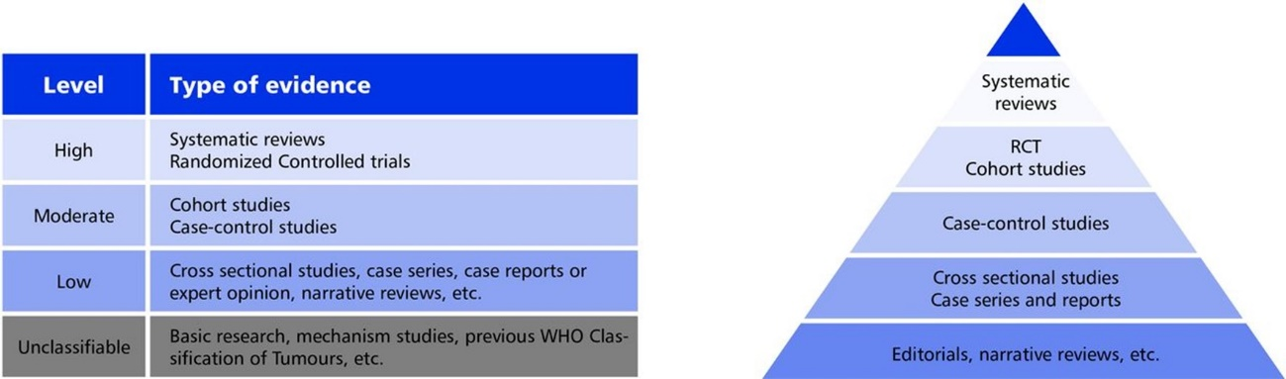
Supplementary Figure 1. Level of evidence categories used in the exploratory maps of the WCT 5th edition Thoracic Tumours (Del Aguila Mejía J et al. 2022) (13). RCT: randomized controlled trial

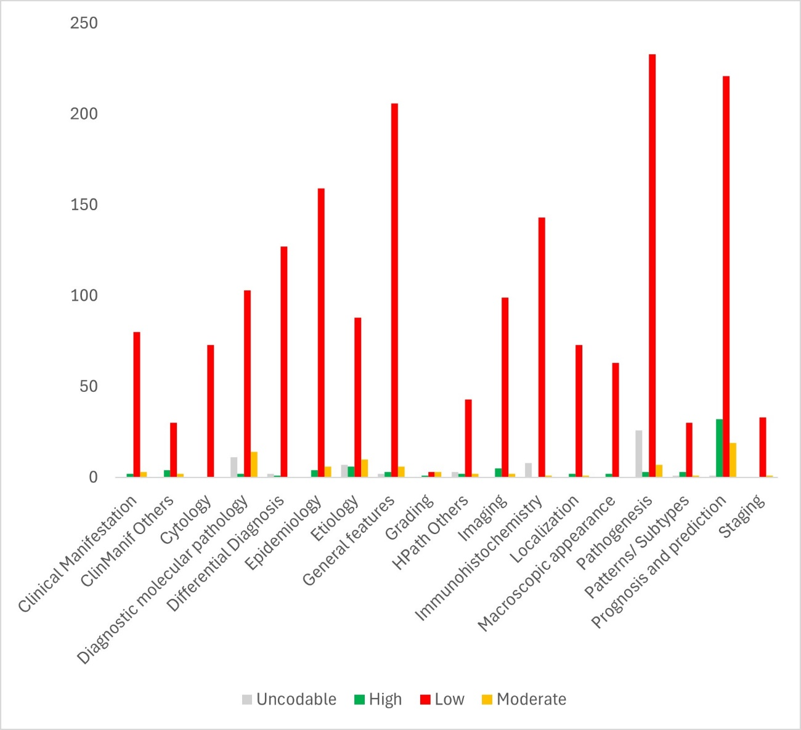
Supplementary Figure 2. Distribution of cited references per level of evidence (LOE) and tumour descriptor for the WHO Classification of Tumours 5th Edition of Thoracic Tumours, Tumours of the Lung Chapter (n=2018).
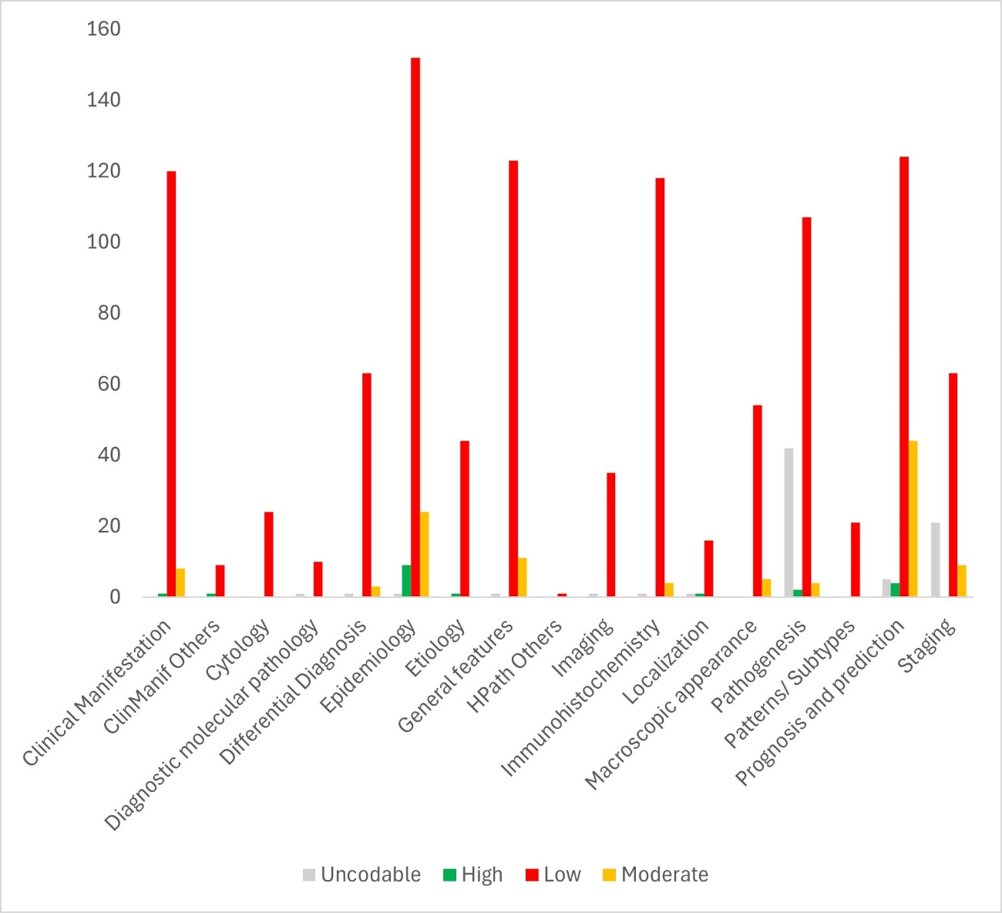
Supplementary Figure 3. Distribution of cited references per level of evidence (LOE) and tumour descriptor for the WHO Classification of Tumours 5th Edition of Thoracic Tumours, Tumours of the Thymus Chapter (n=1297).

