Kaplan–Meier survival curves for non-gynecologic leiomyosarcomas by sex and tumor grade. Sex and progression-free survival (PFS) (A), sex and disease-specific survival (DSS) (B), tumor grade and PFS (C), and tumor grade and DSS (D) failed to show significant correlation.
A
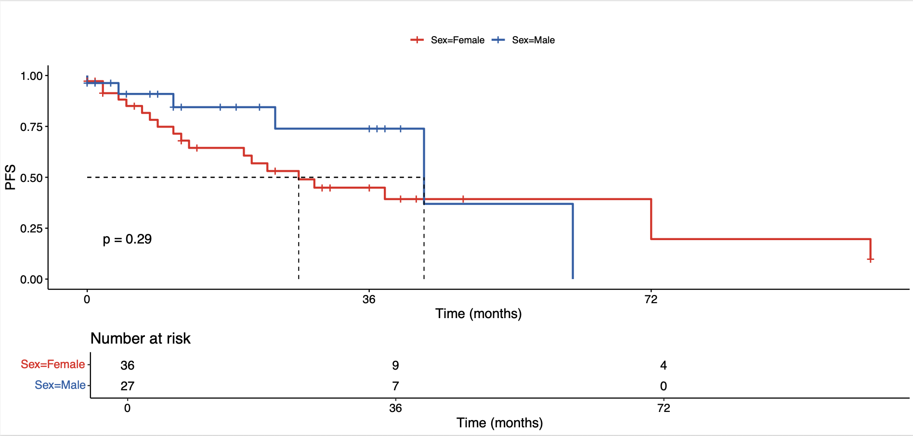
B
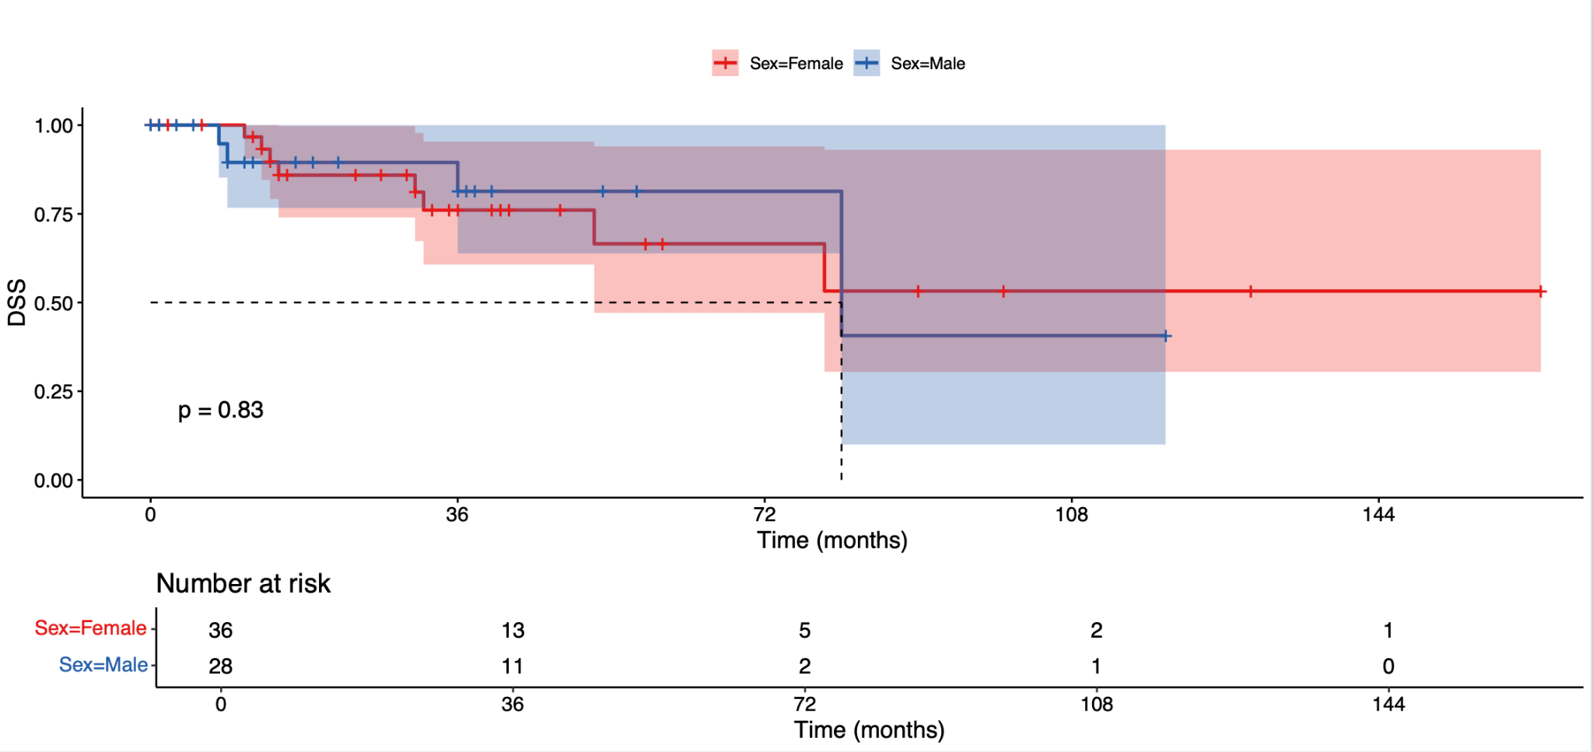
C
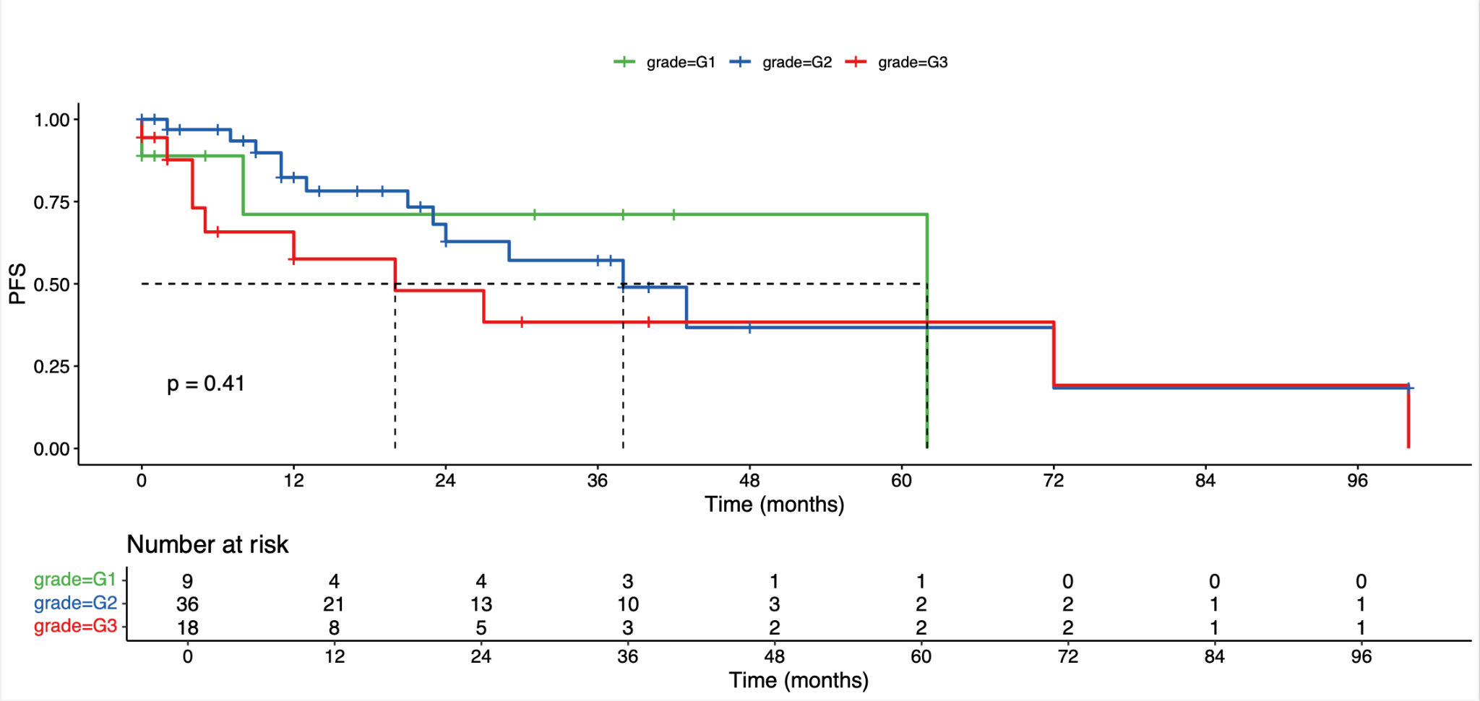
D
