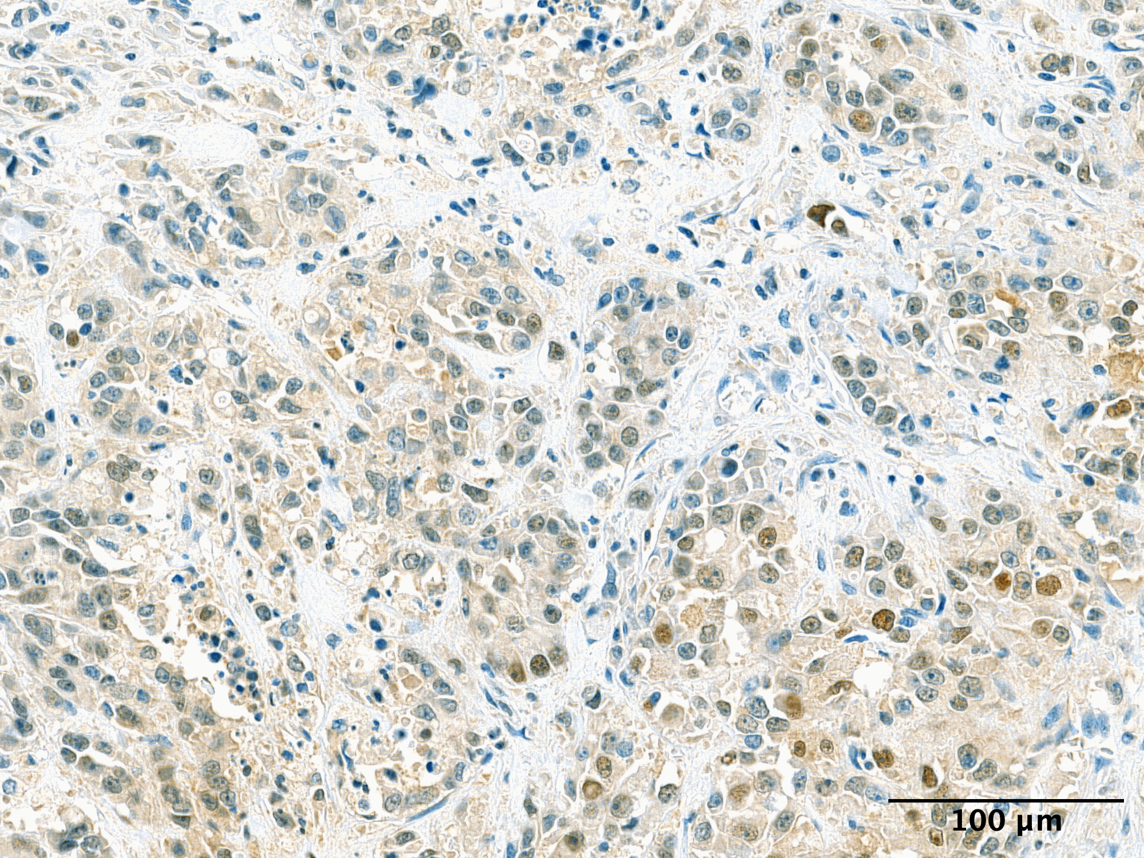
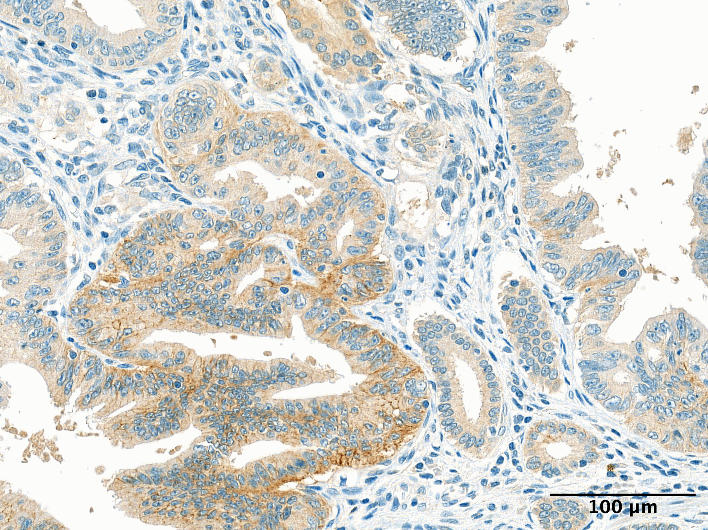
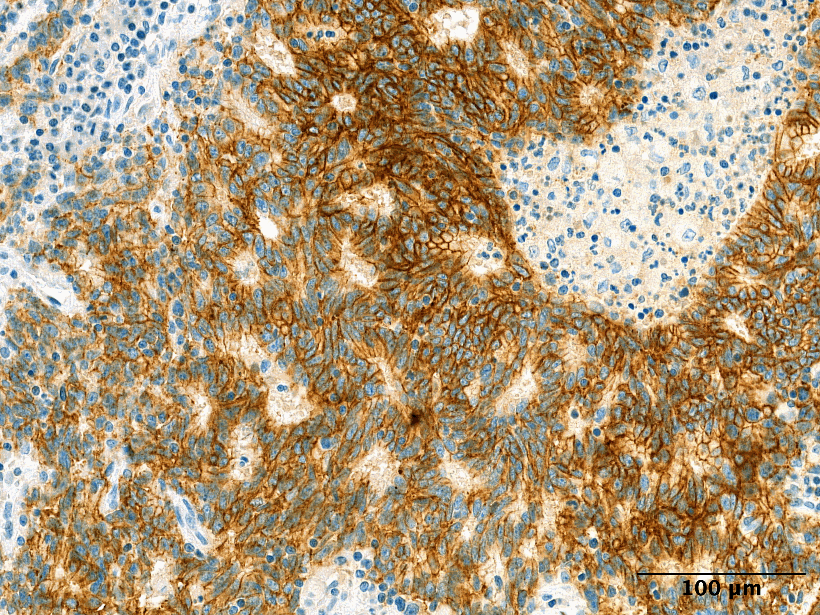
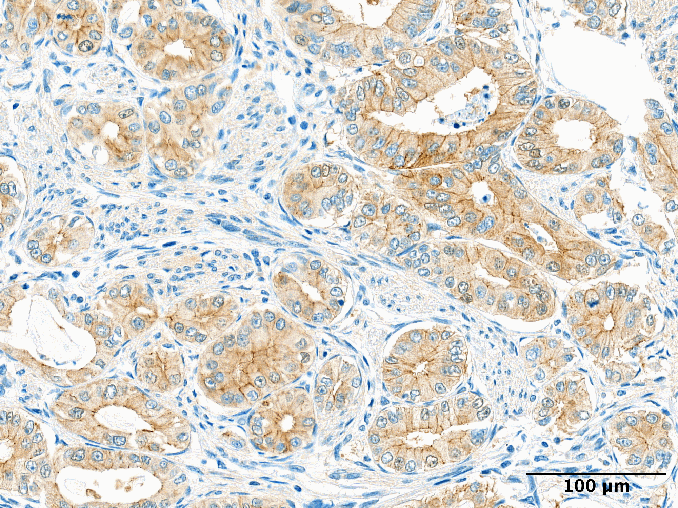
Supplementary Fig. S2 Variability of CLDN18 expression in AC detected using the Thermo Fisher Scientific clone 34H14L15 antibody; a: Negative for membranous CLDN18 expression, cytoplasmic and nuclear staining present; b: Focal membranous CLDN18 positivity accompanied by cytoplasmic staining; c: Low-intensity membranous CLDN18 expression with cytoplasmic staining; d: Strong membranous CLDN18 expression

Article Title: Immunohistochemical Profiling of Ampullary Carcinoma: Molecular Subtypes, Prognostic Markers, and the Role of Claudin-18

Journal Name: Virchows Archive

Author Names: Robert J. Pein¹, Ildikó Illyés¹, István Kenessey^{1,2}, Adrián Pesti¹, Gábor Lotz ¹, András Kiss¹, Katalin Borka¹

¹ Department of Pathology, Forensic and Insurance Medicine, Semmelweis University, Budapest, Hungary
² Hungarian National Cancer Registry and National Tumor Biology Laboratory, National Institute of Oncology, Budapest, Hungary

Affiliation and e-mail address of the corresponding author: Katalin Borka, Department of Pathology, Forensic and Insurance Medicine, Semmelweis University, Budapest, Hungary
e-mail: borka.katalin@semmelweis.hu

