Supplementary Table 1 IHC conditions
Antibody | Clone | Company | Dilution | Antigen Retrieval | Incubation condition | Assessment | Cutoff
ER | SP1 | Neomarkers | Pre-diluted | EDTA, pH8 | 32 min, 37ºC | N | 1%
PR | IE2 | Ventana | Pre-diluted | EDTA, pH8 | 32 min, 37ºC | N | 1%
HER2 | 4B5 | Ventana | Pre-diluted | EDTA, pH8 | 16 min, 37ºC | M | ASCO guideline
M: Membrane; N : Nuclear

Supplementary Table 2 P-values in pairwise analysis of clinicopathological features and metastasis sites of HER2-low breast cancer
 | All |  | TMA |  | Bx
 | Zero vs Low | Low vs Pos | Zero vs Low | Low vs Pos | Zero vs Low | Low vs Pos
Age | 1.00 | 1.00 | 1.00 | 1.00 | 1.00 | 1.00
Distant metastasis
ER | 0.033 | <0.001 | 0.685 | 0.402 | 0.004 | <0.001
PR | 0.037 | 0.019 | 1.000 | 0.169 | 0.015 | 0.139
Luminal | 0.047 | <0.001 | 0.685 | 0.402 | 0.009 | 0.002
Interval | 0.132 | 0.215 | 0.255 | 0.633 | 0.021 | 0.087
Primary tumor
ER | 0.595 | 0.001 | 0.238 | 0.315 | 0.257 | 0.017
PR | 0.915 | 0.055 | 0.184 | 0.596 | 0.503 | 0.152
Luminal | 0.373 | 0.006 | 0.230 | 0.633 | 0.138 | 0.011
Grade | 0.603 | 0.188 | 0.122 | 0.523 | 0.329 | 0.353
pT | 0.943 | 0.243 | 1.00 | 1.000 | 0.856 | 0.139
pN | 0.833 | 0.867 | 0.648 | 0.588 | 0.628 | 0.519
Histotype | 0.027 | 1.000 | 1.000 | - | 0.018 | 1.000
Metastasis sites
Bone | 0.237 | 0.990 | 0.817 | 0.580 | 0.458 | 0.246
Liver | <0.001 | 0.121 | 0.528 | 0.435 | <0.001 | 0.325
Brain | 0.339 | 0.047 | 1.00 | 0.229 | 1.00 | 0.439
Lung | 0.288 | 0.884 | 1.00 | 1.000 | 0.324 | 1.000
Gyn | 1.000 | 1.000 | 0.190 | 0.178 | 0.276 | 0.188
Pleura | 0.426 | 0.729 | 1.00 | - | 0.424 | 0.441
Bold indicates p value <0.05.

Supplementary Table 3 Metastasis organotropism pattern of breast cancer with different HER2 and HR status
 |  | HER2 |  |  |  |  |  | P value
 |  | Zero |  | Low |  | Pos |  | Overall | Zero vs Low | Low vs Pos
Luminal
Bone | Neg | 58 | 63.0% | 26 | 72.2% | 11 | 61.1% | 0.602 | 0.326 | 0.407
 | Pos | 34 | 37.0% | 10 | 27.8% | 7 | 38.9%
Liver | Neg | 80 | 87.0% | 19 | 52.8% | 13 | 72.2% | <0.001 | <0.001 | 0.170
 | Pos | 12 | 13.0% | 17 | 47.2% | 5 | 27.8%
Brain | Neg | 89 | 96.7% | 36 | 100.0% | 18 | 100.0% | 0.703 | 0.559 | /
 | Pos | 3 | 3.3% | 0 | 0.0% | 0 | 0.0%
Lung | Neg | 70 | 76.1% | 32 | 88.9% | 17 | 94.4% | 0.078 | 0.106 | 0.655
 | Pos | 22 | 23.9% | 4 | 11.1% | 1 | 5.6%
Gyn | Neg | 88 | 95.7% | 35 | 97.2% | 17 | 94.4% | 1.000 | 1.000 | 1.000
 | Pos | 4 | 4.3% | 1 | 2.8% | 1 | 5.6%
Pleura | Neg | 80 | 87.0% | 32 | 88.9% | 16 | 88.9% | 1.000 | 1.000 | 1.000
 | Pos | 12 | 13.0% | 4 | 11.1% | 2 | 11.1%
Non-luminal
Bone | Neg | 26 | 66.7% | 5 | 83.3% | 15 | 83.3% | 0.472 | 0.648 | 1.000
 | Pos | 13 | 33.3% | 1 | 16.7% | 3 | 16.7%
Liver | Neg | 33 | 84.6% | 5 | 83.3% | 14 | 77.8% | 0.878 | 1.000 | 1.000
 | Pos | 6 | 15.4% | 1 | 16.7% | 4 | 22.2%
Brain | Neg | 37 | 94.9% | 6 | 100.0% | 14 | 77.8% | 0.110 | 1.000 | 0.539
 | Pos | 2 | 5.1% | 0 | 0.0% | 4 | 22.2%
Lung | Neg | 32 | 82.1% | 4 | 66.7% | 14 | 77.8% | 0.646 | 0.583 | 0.618
 | Pos | 7 | 17.9% | 2 | 33.3% | 4 | 22.2%
Gyn | Neg | 37 | 94.9% | 5 | 83.3% | 17 | 94.4% | 0.395 | 0.356 | 0.446
 | Pos | 2 | 5.1% | 1 | 16.7% | 1 | 5.6%
Pleura | Neg | 32 | 82.1% | 6 | 100.0% | 16 | 88.9% | 0.642 | 0.569 | 1.000
 | Pos | 7 | 17.9% | 0 | 0.0% | 2 | 11.1%
“Gyn”, gynecological organs;
Bold indicates p value <0.05.

Supplementary Table 4 Multivariate analysis of OS
Features |  | HR | 95% Upper CI | 95% lower CI | P value
Grade |  | 1.496 | 1.108 | 2.019 | 0.008
Tumor size |  | 1.145 | 1.039 | 1.261 | 0.006
Lum/HER2 | Non-lum HER2-zero | ref |  |  | 0.022
 | Non-lum HER2-low | 1.418 | 0.516 | 3.899 | 0.499
 | Non-lum HER2-pos | 0.962 | 0.399 | 2.319 | 0.932
 | Lum HER2-zero | 0.558 | 0.322 | 0.967 | 0.037
 | Lum HER2-low | 0.431 | 0.225 | 0.826 | 0.011
 | Lum HER2-pos | 0.432 | 0.180 | 1.034 | 0.059
Primary/metastatic HER2 | Neg/Neg |  |  |  | 0.028
 | Pos/Neg | 3.186 | 1.341 | 7.572 | 0.009
 | Neg/Pos | 1.305 | 0.409 | 3.473 | 0.594

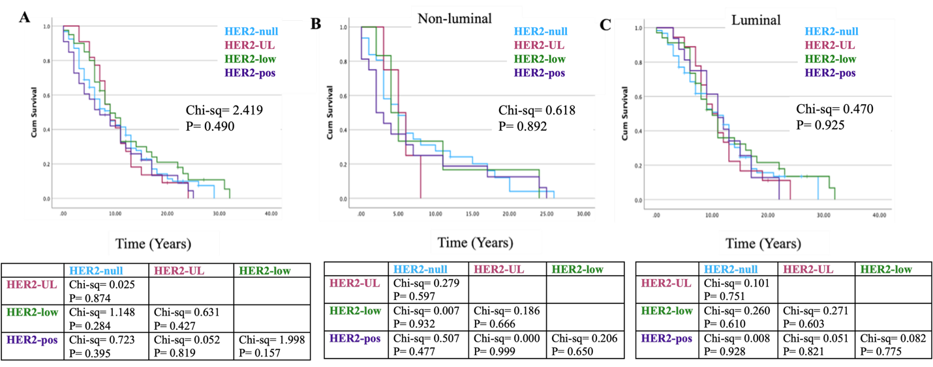

Supplementary Figure 1: Impact of biomarker status on overall survival in HER2-ultralow (HER2-UL) metastatic breast cancer population. Kaplan–Meier survival curves of different (A) HER2 status, (B-C) HER2 status according to HR status.

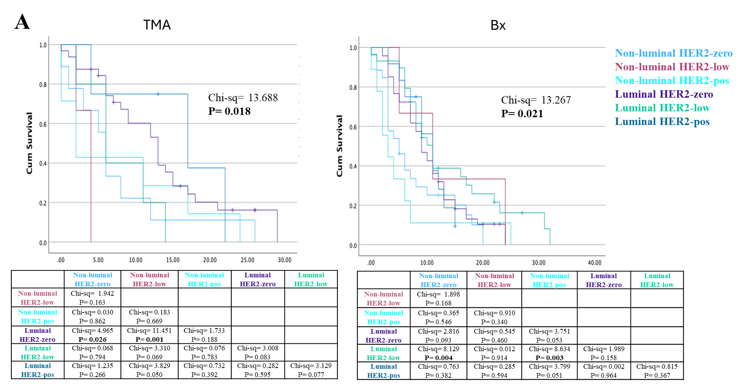

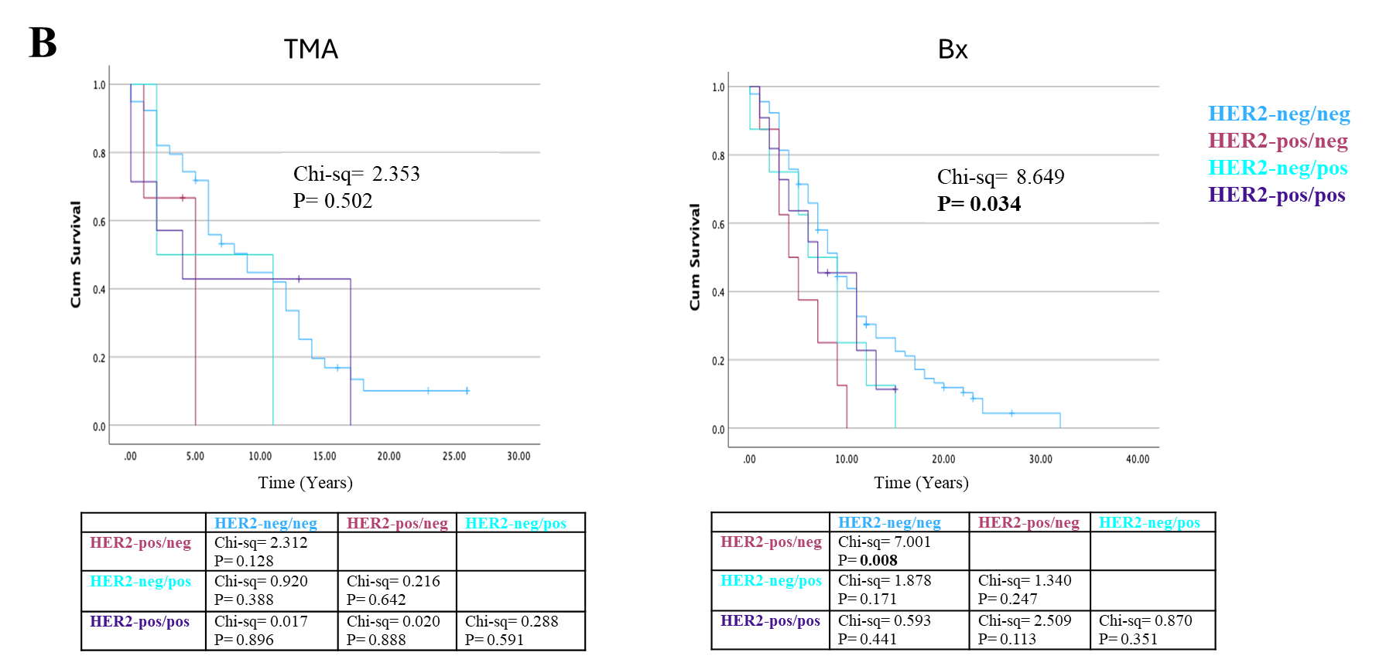

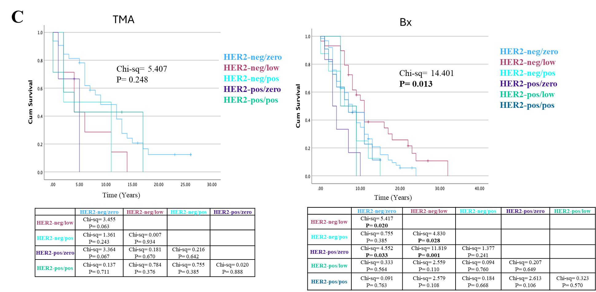
Supplementary Figure 2: Kaplan–Meier survival analysis of HER2 subtypes (A), discordance in HER2 diagnosis (B) and discordance in relation to HER2-low status (C) on overall survival from primary breast cancer diagnosis in TMA and Biopsy subgroups.

