Validation of Diagnostic Artificial Intelligence Models for Prostate Pathology in a Middle Eastern Cohort
Supplementary Appendix

Peshawa J. Muhammad Ali^{1,2*}, Navin Vincent^{3*}, Saman S. Abdulla^{4,5}, Han N. Mohammed Fadhl⁶, Anders Blilie^{7,8}, Kelvin Szolnoky³, Julia Anna Mielcarz³, Xiaoyi Ji³, Nita Mulliqi³, Abdulbasit K. Al-Talabani^{1⸸}, Kimmo Kartasalo^{9,10,3,11⸸}

- Department of Software Engineering, Faculty of Engineering, Koya University, Koya 44023, Kurdistan Region - F.R. Iraq
- Department of Mechanical and Manufacturing Engineering, Faculty of Engineering, Koya University, Koya 44023, Kurdistan Region - F.R. Iraq
- Department of Medical Epidemiology and Biostatistics, Karolinska Institutet, Stockholm, Sweden
- College of Dentistry, Hawler Medical University, Erbil, Kurdistan Region, Iraq
- PAR Private Hospital, Erbil, Kurdistan Region, Iraq
- College of Dentistry, University of Sulaimani, Sulaymaniyah, Kurdistan Region, Iraq
- Department of Pathology, Stavanger University Hospital, Stavanger, Norway
- Faculty of Health Sciences, University of Stavanger, Stavanger, Norway
- ELLIS Institute Finland, Espoo, Finland
- Department of Computing, Faculty of Technology, University of Turku, Turku, Finland
- Science for Life Laboratory (SciLifeLab), Karolinska Institutet, Stockholm, Sweden

* These authors contributed equally to this work.
⸸ These authors jointly supervised the work.

Corresponding author: Kimmo Kartasalo, kimmo.kartasalo@ki.se
Table of Contents
Supplementary Methods 3
Supplementary Figures 5
Supplementary Tables 10
Supplementary References 19

Supplementary Methods

eMethods 1. Case identification and specimen processing
The dataset comprises 339 glass slides representing 185 patients. Each slide contains an average of six biopsy cores, extracted with transrectal ultrasound-guided biopsy, and stained with haematoxylin & eosin. The minimum, mean, and maximum ages at biopsy were 33, 68, and 95 years, respectively, and the interquartile range was 64-74 years (Table 1). Two glass slides were available for 154 patients (representing cores from the right and left side of the prostate), while 31 patients had all cores on one slide. Stain fading was observed in older slides, and to produce samples reflecting those that would be analysed in a prospective setting, fresh slides were prepared from the original paraffin blocks by re-cutting (and re-embedding where necessary). De-identified samples were shipped to Karolinska Institutet for scanning.

eMethods 2. Reference standard and reader protocol
Three pathologists assessed the slides. Pathologist I (S.A.) is a general pathologist with 22 years of experience and a special interest in prostatic pathology. He serves as lecturer at Hawler Medical University, as consultant pathologist at PAR Hospital, and as senior examiner for the Royal College of Pathologists in the UK. Pathologist II (H.M.) is a general pathologist with 15 years of experience and is currently affiliated with the University of Sulaimani in Sulaymaniyah, Iraq. Pathologist III (A.B.) is a uropathologist with 6 years of experience at Stavanger University Hospital in Stavanger, Norway.
All pathologists conducted digital assessments of the Hamamatsu scans using Cytomine30 and assigned slide-level Gleason scores (GS) (using 0+0 for benign cases) (Table 1). The GS were additionally converted to International Society for Urological Pathology (ISUP) grades. S.A. graded all 339 slides, H.M. graded 337 slides, and A.B. evaluated a random subset of 59 slides stratified according to the ISUP grades assigned by S.A. The pathologists were blinded to the patients’ clinical characteristics, each other’s assessments, and AI outputs. Alternative diagnoses were reported during the original diagnostic assessment (eTable 6-7).
Following AI analysis, slides where any AI models showed marked errors compared to both S.A. and H.M. were further examined. We followed a pre-specified criterion27 for the most clinically significant errors: benign samples AI-predicted as ISUP grade ≳2 and samples of ISUP grade ≳2 AI-predicted as benign (eTable 8). Slides where at least two out of three AI models exhibited such an error were re-assessed and described by A.B., blinded to the other assessments and the AI models.

eMethods 3. Tissue detection and tiling
Tissue detection from WSIs was performed using a custom-built tissue segmentation model[1] based on a UNet++ architecture, incorporating a ResNet18 encoder.[2] Initially, 512×512px patches were extracted across the entire WSI at 8.0 μm/px resolution, with a 128 px overlap, followed by pixel-wise segmentation to identify tissue regions. These segmented regions were then combined into a single binary-tissue mask per WSI. Next, 256×256 px high-resolution tissue patches were extracted at 1.0 µm/px resolution, using the segmentation masks to retain only those patches where at least 10% of pixels contained tissue. During model training, patches were extracted without overlap to reduce GPU memory usage, whereas, for model prediction, a 128 px overlap was used to enhance diagnostic accuracy. To achieve a resolution of 1.0 µm/px, patches were downsampled from the nearest higher resolution level in the WSI resolution pyramid using Lanczos resampling. Each tile was stored as a compressed RGB image within an LMDB (Lightning Memory-Mapped Database) environment for efficient random access. To ensure modular storage and parallel data loading, each WSI was assigned its own LMDB file. Associated spatial and metadata information were stored in Parquet tables.
eMethods 4. Artificial intelligence model
The AI models were implemented in PyTorch. All evaluated AI models employ an attention-based multiple instance learning (ABMIL)[3] framework that uses only weakly supervised learning, leveraging slide-level labels. In the task-specific (TS) model,[4] patch-level features are extracted with an EfficientNet-V2-S[5] encoder and aggregated into slide-level representations with the ABMIL. Downstream linear classification layers are used to predict the two Gleason patterns (i.e. 3, 4, or 5), which are further translated into GS and ISUP grade. Training was conducted end-to-end, jointly optimising all parameters with cross-entropy loss and the AdamW optimiser[6] with a base learning rate of 0.0001. Full architectural choices, hyperparameters, and validation details are described in the original publication. The same pipeline was also run with the UNI and Virchow2 FMs,[7, 8] keeping their encoders frozen and training only the ABMIL and terminal classification layers identically to the TS setup. We used 10-fold cross-validation stratified by patient and ISUP grade. In inference, test-time augmentation (TTA) was applied for each fold and model. For each slide, the model network predicts primary and secondary Gleason patterns and aggregates them to slide-level GS based on the output softmax vector. We map GP∈{0,1,2,3} to Gleason score using a fixed rule (e.g.1+1→3+3, 1+2→3+4, 2+1→4+3) and then to ISUP Grade Group (0–5).[9] The pre-specified diagnostic decision rule declares test positivity (cancer present) when ISUP ≥ 1 and test negativity when ISUP = 0. The final slide-level GS and ISUP grade output was the majority vote across the 10 models, with cancer probability taken as the ensemble median. Mean attention scores from the ABMIL models were used to highlight tile-level regions of interest informing the prediction. All AI inferences were performed solely on digital slide images without access to patient clinical information or reference standard results.
eMethods 5. Hardware and software
We used Python 3.8.10 with PyTorch 2.0.0 (CUDA 12.2)[10] and PyTorch DDP[11] for multi-GPU training across all experiments and models. UNI[7] and Virchow2[8] foundation models were initialised from their HuggingFace releases and paired with timm 0.9.8 ViT implementations,[12] keeping encoder weights as provided. Containerisation used Docker 20.10.21 locally and Singularity/Apptainer on compute clusters.[13, 14] WSIs were accessed via OpenSlide 4.0.0,[15] openslide-python 1.3.1, and OpenPhi 2.1.0.[16] Image augmentations employed Albumentations 1.3.1 and Stainlib 0.6.1.[17] The tissue segmentation model was implemented with segmentation_models_pytorch 0.3.3.[18] The LMDB data access framework was implemented in Python using the lmdb library (1.5.1) for memory-mapped storage of compressed RGB tiles and Polars 1.8.2 for high-performance handling of Parquet metadata tables.[19] Numerical computing, evaluation, and data handling used NumPy 1.24.0,[20] scikit-learn 1.2.2,[21] and Pandas 1.5.3;[22] basic image processing used Pillow 9.4.0 and OpenCV-python. Visualisations were produced with Matplotlib 3.7.1 and Seaborn 0.12.2,[23, 24] and figure panels assembled in InkScape.

eMethods 6. Statistical analysis
To evaluate whether the mean concordance of AI systems with pathologists differed significantly from that between pairs of pathologists, we conducted bootstrap hypothesis testing. For each observer pair, we sampled patients with replacement, to construct bootstrap distributions of Cohen’s kappa (both QWK and LWK for ISUP and GS). These distributions were then pooled separately for pathologist–pathologist pairs and AI–pathologist pairs. We used a balanced sampling strategy targeting ~30,000 total samples (≈15,000 per group): three human–human pairs × 5,000 samples/pair = 15,000, and nine AI–human pairs × 1,666 samples/pair ≈ 14,994. The null hypothesis (H0) was that the mean kappa for AI–human pairs equals the mean kappa for human–human pairs. We derived a two-tailed bootstrap p-value from the empirical distribution of mean differences (AI−human). We also reported Cohen’s d as an effect size, computed as the observed mean difference in kappa divided by the pooled bootstrap standard deviation of the two groups. Statistical significance was assessed at α = 0.05.

Supplementary Figures
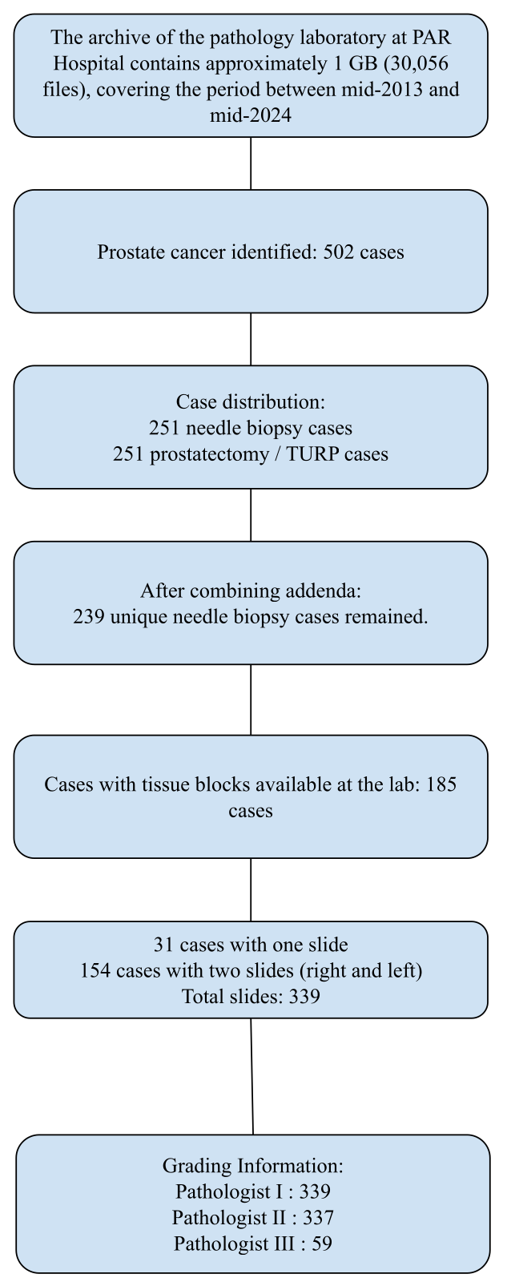

eFigure 1: CONSORT diagram presenting the study cohort. Flow diagram illustrating the selection of the study cohort from the pathology archive (2013–2024). The final dataset comprises 339 biopsy slides from 185 patients. TURP=transurethral resection of the prostate.
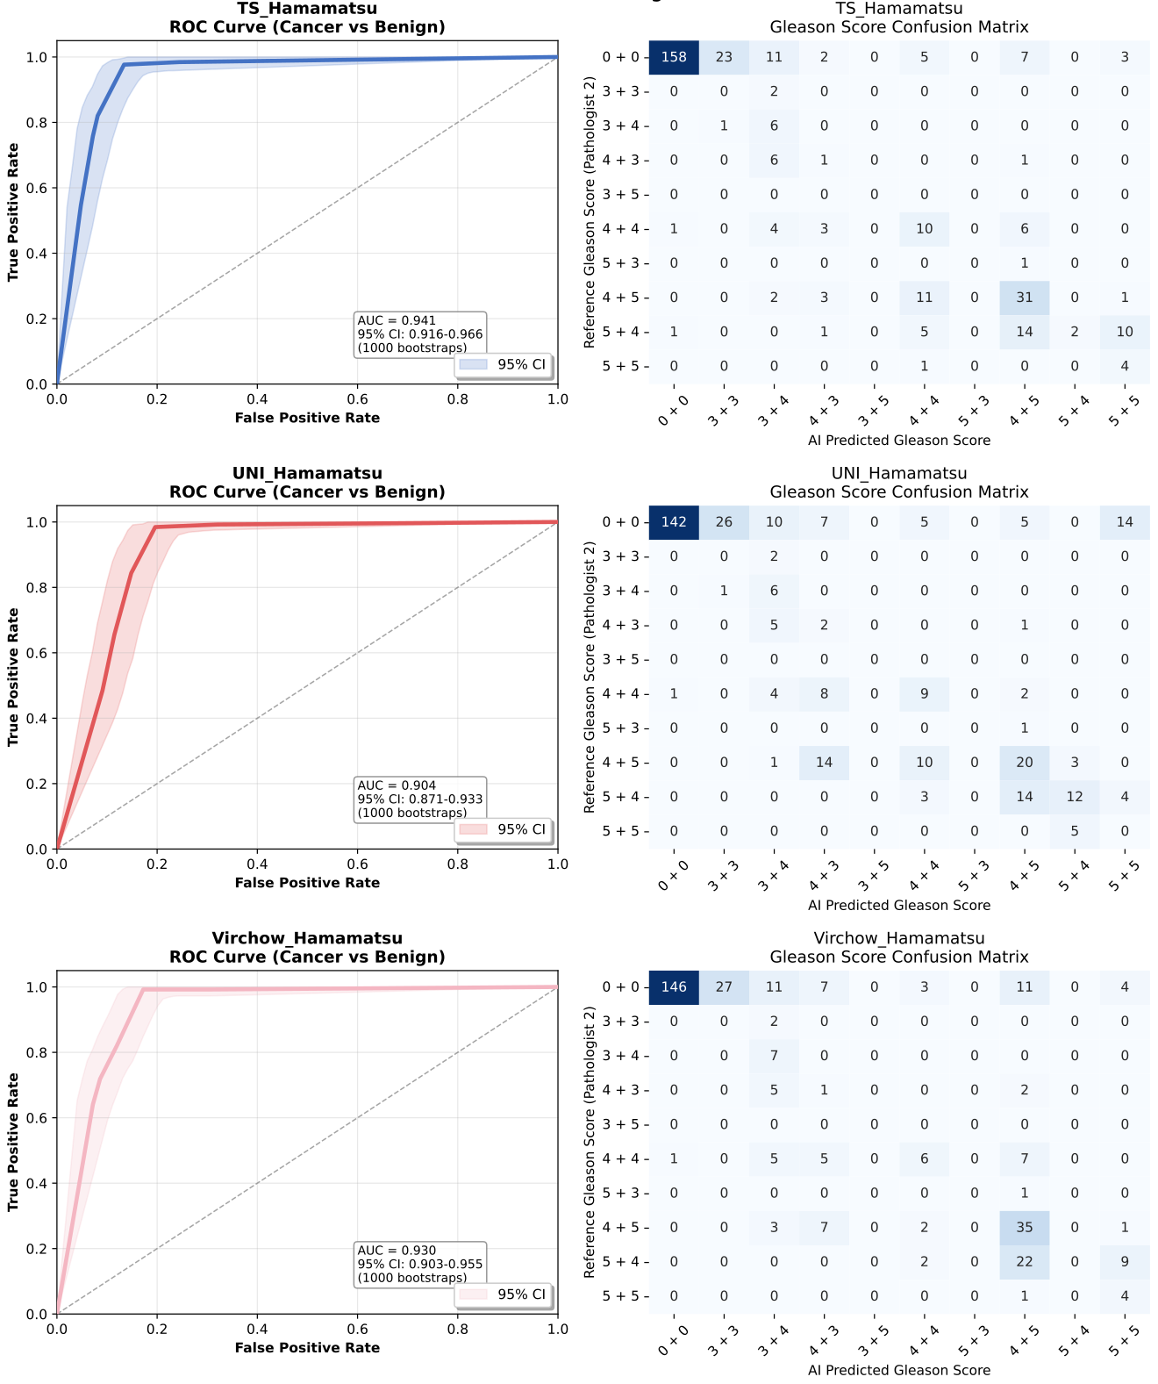
eFigure 2: Discriminatory performance and grading concordance of AI models (secondary reference standard). (Left) ROC analysis of the discriminatory performance between benign and malignant samples. Shaded regions represent 95% bootstrapped confidence intervals (n=337 slides). (Right) Confusion matrices comparing AI-predicted Gleason scores against the pathologist’s grading. (Top to Bottom) AI models based on TS, UNI and Virchow2. All models were evaluated on images acquired with the Hamamatsu scanner and compared to the secondary reference standard (pathologist II). AUC=area under the ROC curve, ROC=receiver operating characteristic, TS=task-specific model.

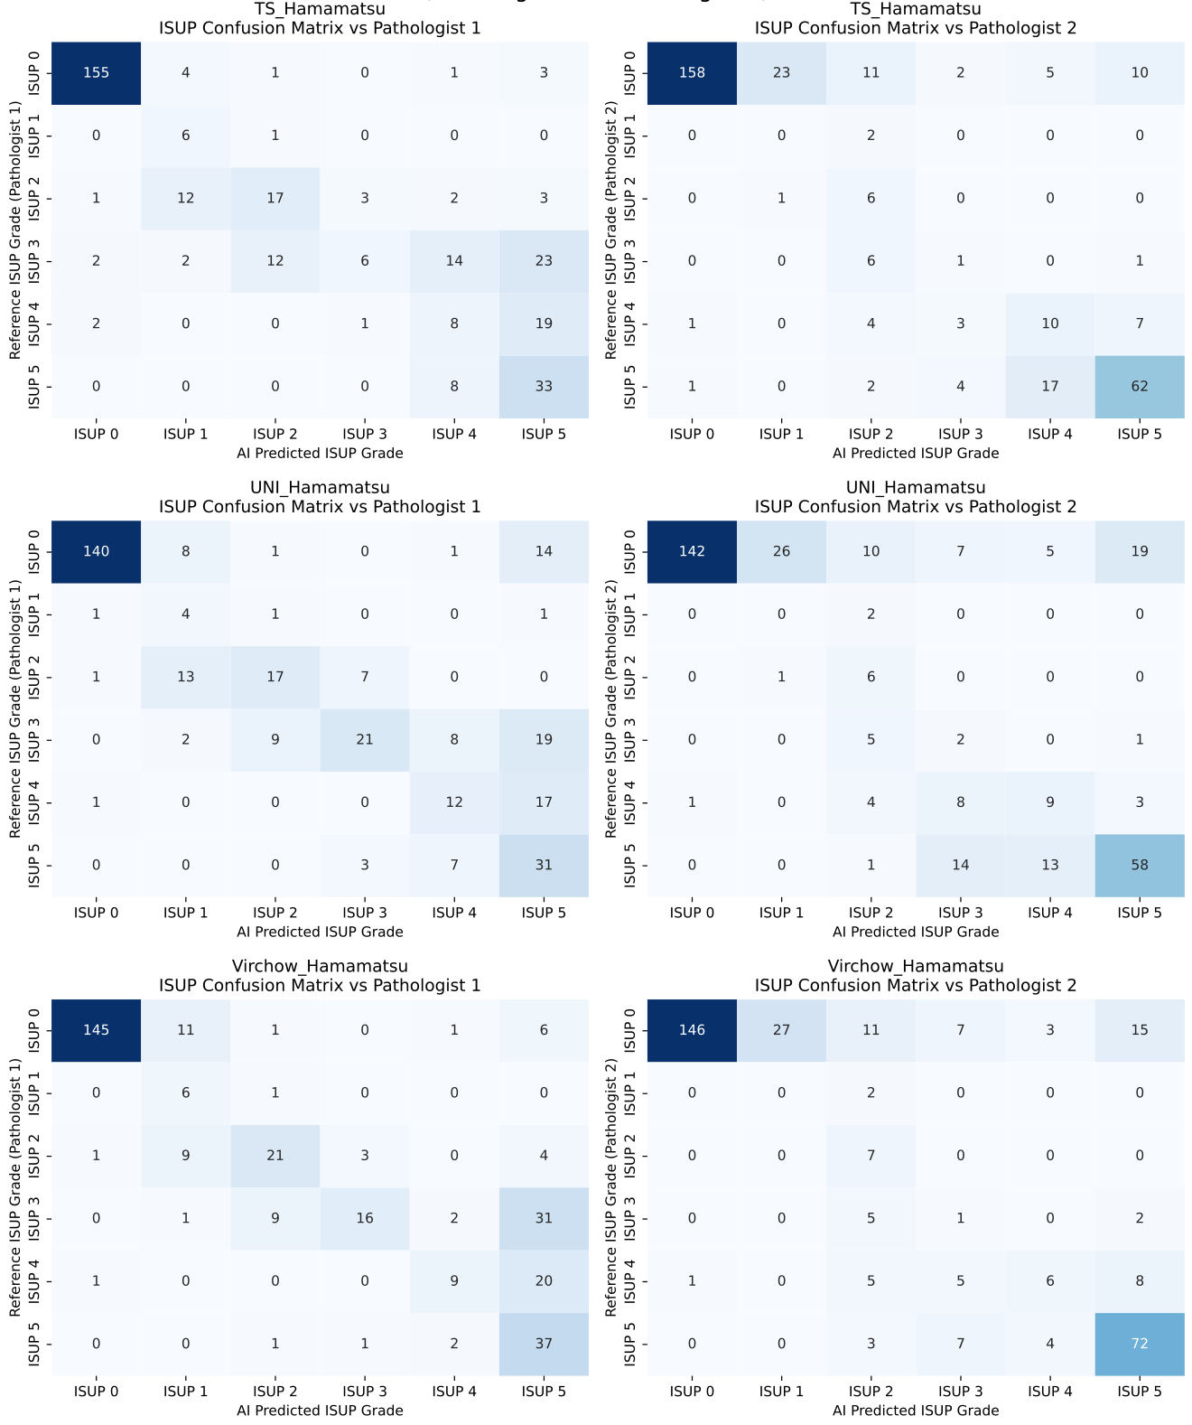
eFigure 3: Confusion matrices for ISUP grade predictions. Comparisons of AI model predictions of ISUP grade against primary reference standard, pathologist I (Left) and secondary reference standard, pathologist II (Right). (Top to Bottom) AI models based on TS, UNI and Virchow2. All models were evaluated on images acquired with the Hamamatsu scanner. ISUP=International Society for Urological Pathology, TS=task-specific model.

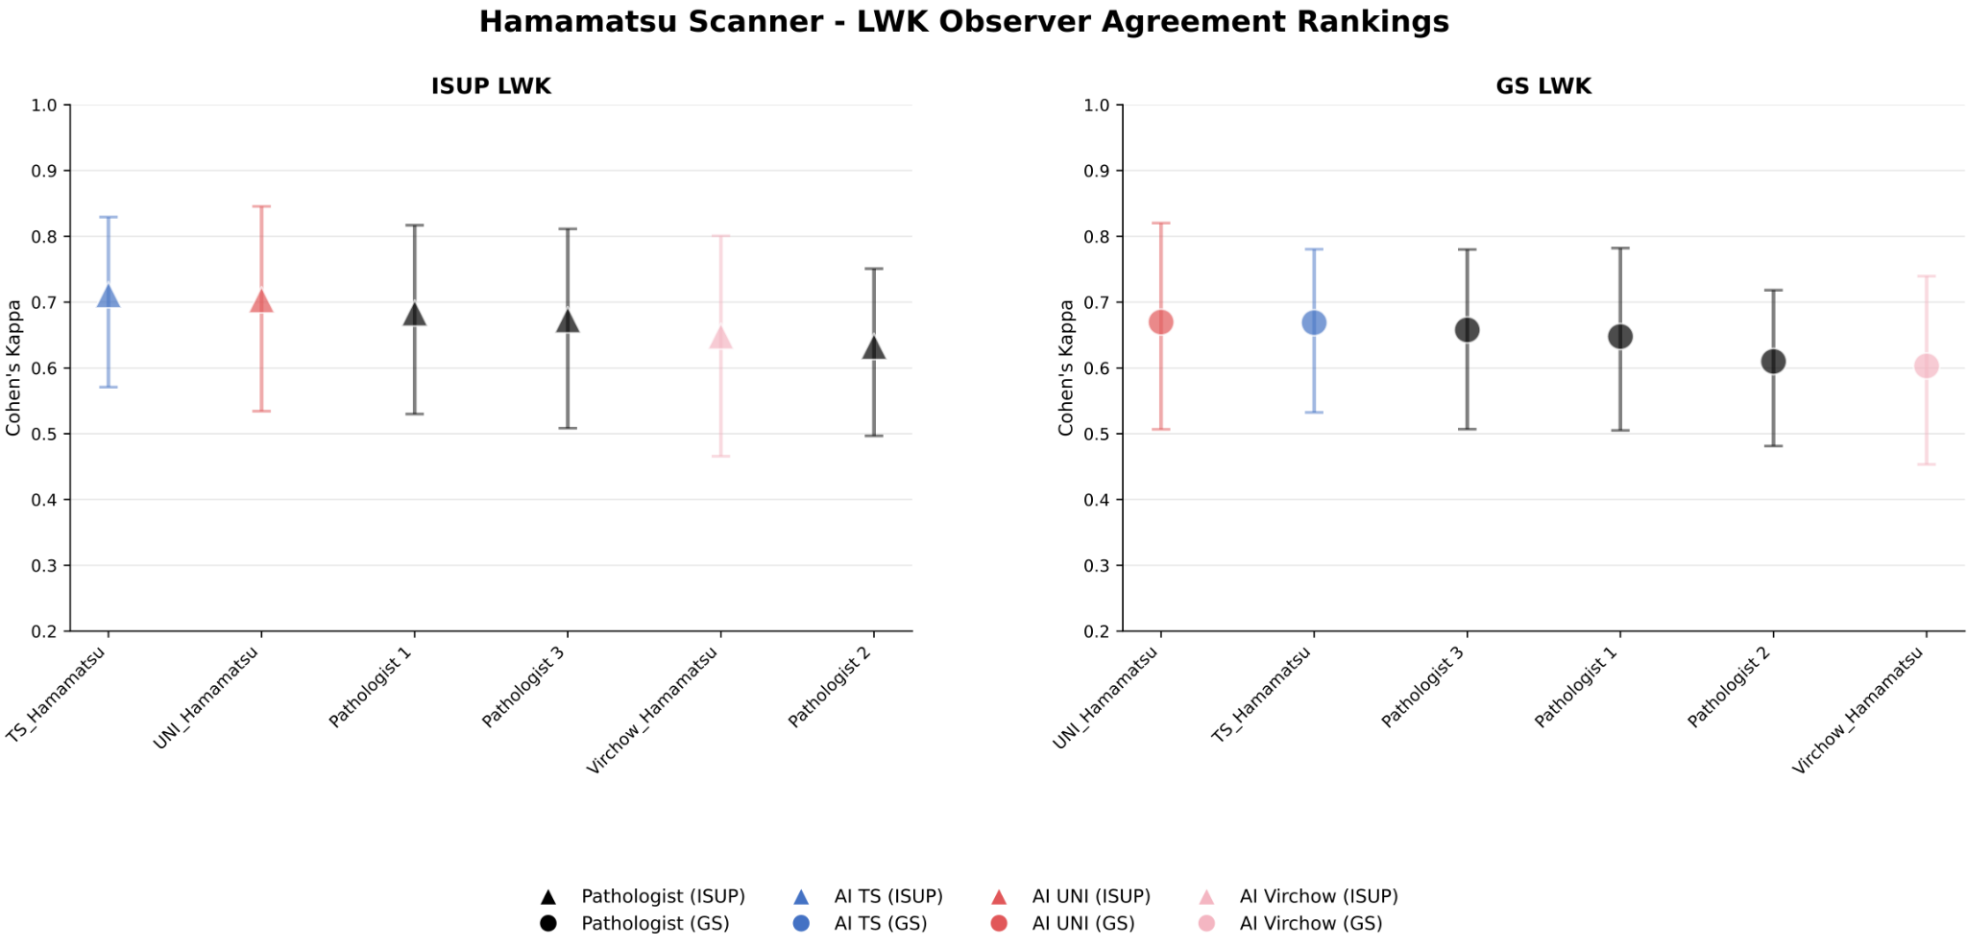
eFigure 4: Inter-observer agreement rankings (linearly weighted kappa). Mean pairwise Cohen’s LWK for (Left) ISUP grade and (Right) Gleason score, evaluated on the slides assessed by all three pathologists (n=59). Markers represent the mean LWK of each observer (pathologist or AI model) calculated relative to the human pathologists. Error bars indicate 95% confidence intervals. Images acquired with the Hamamatsu scanner were used for analysis. GS=Gleason score. ISUP=International Society for Urological Pathology. LWK=linearly weighted kappa, TS=task-specific model.
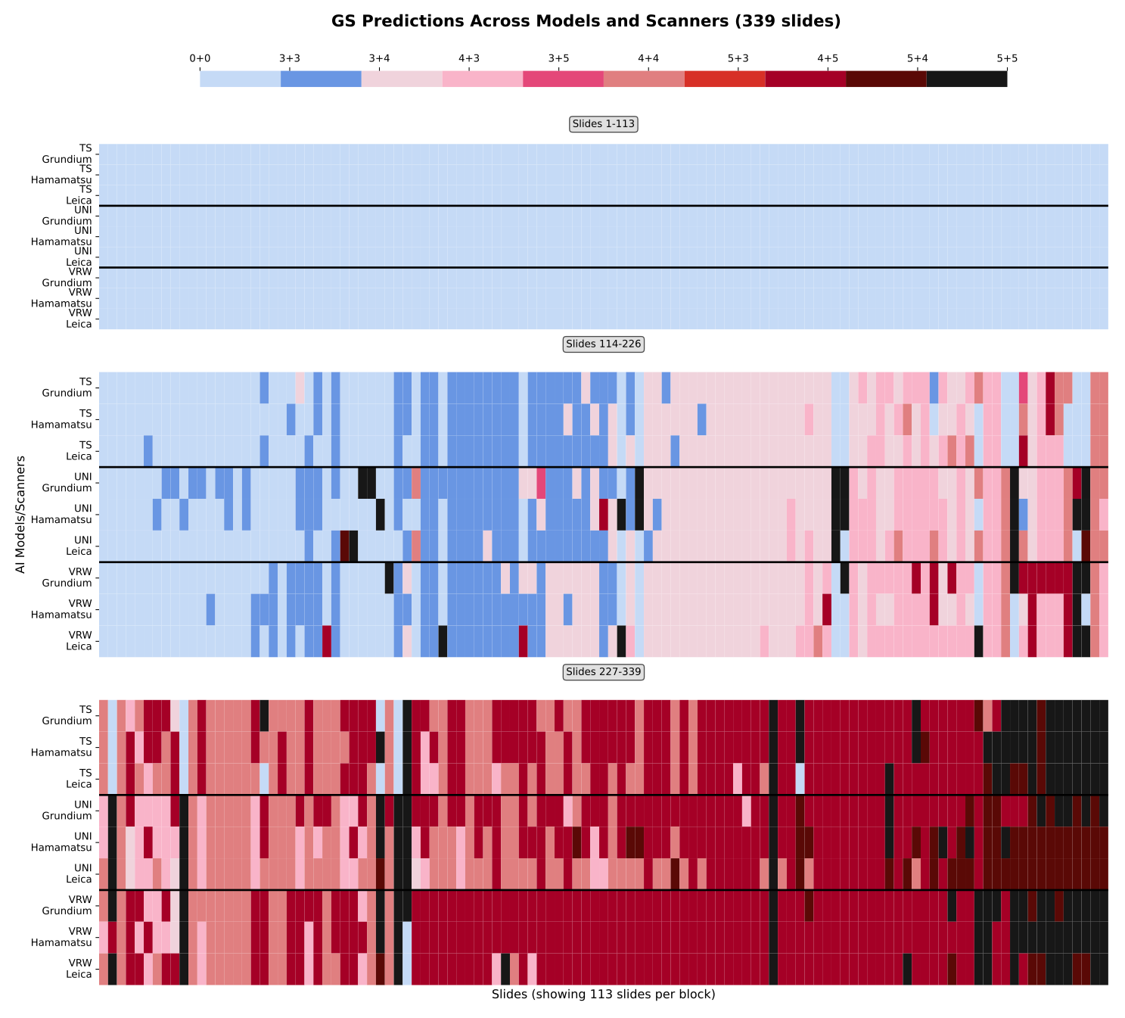
eFigure 5: Consistency of AI predictions of Gleason score across scanner platforms. Heatmap of slide-level GS predictions across three scanners for all 339 slides. Columns represent individual slides; rows represent AI model/scanner combinations. Colors correspond to Gleason scores. GS=Gleason score, TS=task-specific model, VRW=Virchow2 model.

Supplementary Tables
eTable 1: Overview of external validation studies for commercial or research-grade AI prostate pathology systems. The table lists the source region and size of the cohort, the software/model, and the scanner hardware. WSI=whole-slide image.
Validation study | Software or AI model | Cohort source | Scanner model | Cohort size
Raciti et al., 2020[25] | Paige Prostate | USA | Leica Aperio AT2 | 232 patients, 232 slides
Perinchiri et al. 2021[26] | Paige Prostate | USA | Leica Aperio AT2 | 118 patients, 1,876 cores
Da-silva et al, 2021[27] | Paige Prostate | Brazil | Leica Aperio AT2 | 100 patients
Jung et al., 2022[28] | DeepBio Dx | South Korea | Leica Aperio AT2 | 593 patients
Tolkach et al., 2023[29] | Halo Prostate | Germany & Austria | Leica Aperio GT450,  Hamamatsu NanoZoomer S360,  Hamamatsu NanoZoomer C9600-12 | The number of patients is not clear: 5,847 slides
Vazzano et al., 2023[30] | INIFY Prostate | USA | Leica Aperio ImageScope, Hamamatsu, Philips | 30 patients, 90 slides
Santa-Rosario et al., 2024[31] | IBEX Galen Prostate | USA | 3DHISTECH PANNORAMIC P-250 | 101 patients
Lami et al., 2024[32] | IBEX Galen Prostate | Japan | Philips Ultrafast Scanner | 100 cases (697 WSIs)

eTable 2: Age-standardised incidence, mortality, and mortality-to-incidence ratio (MIR) for prostate cancer in selected countries and regions. Values are based on international cancer registry estimates (Global Cancer Observatory). ASR=age-standardised rate per 100,000 population.
Countries/Regions | ASR Incidence | ASR Mortality | MIR
USA | 75.2 | 8.1 | 0.11
Sweden | 104.3 | 13.4 | 0.13
Northern Europe | 82.8 | 12.4 | 0.15
The Netherlands | 57 | 11.4 | 0.20
Western Asia | 24 | 7.9 | 0.33
Iraq | 12.7 | 4.9 | 0.39

eTable 3: Cancer detection and grading performance metrics of AI models (QWK, secondary reference standard). Specificity, sensitivity, and Cohen’s kappa for ISUP grade and Gleason score for three AI systems (task-specific model, UNI foundation model, Virchow2 foundation model). Concordance was computed relative to pathologist II who set the secondary reference standard. QWK values are reported for all slides (overall, n=337) and for malignant slides (n=128) only. Confidence intervals represent 95% bootstrapped estimates. GS=Gleason score, ISUP=International Society of Urological Pathology, QWK=quadratically weighted kappa.
AI model | Specificity | Sensitivity | QWK-  ISUP  (Overall) | QWK-  ISUP  (Malignant) | QWK-  Gleason  (Overall) | QWK-  Gleason  (Malignant)
Task-specific | 0.756 (0.695-0.813) | 0.984 (0.959-1.000) | 0.831 (0.771-0.883) | 0.602 (0.443-0.752) | 0.822 (0.752-0.879) | 0.690 (0.566-0.779)
UNI | 0.679  (0.618-0.742) | 0.992 (0.975-1.000) | 0.744 (0.670-0.813) | 0.594 (0.468-0.708) | 0.702 (0.617-0.786) | 0.644 (0.523-0.734)
Virchow2 | 0.699 (0.634-0.757) | 0.992 (0.972-1.000) | 0.793 (0.731-0.846) | 0.616 (0.471-0.742) | 0.792 (0.727-0.850) | 0.672 (0.549-0.770)

eTable 4: Grading performance metrics of AI models (LWK, primary reference standard). Specificity, sensitivity, and Cohen’s kappa for ISUP grade and Gleason score for three AI systems (task-specific model, UNI foundation model, Virchow2 foundation model). Concordance was computed relative to pathologist I who set the primary reference standard. LWK values are reported for all slides (overall, n=339) and for malignant slides (n=175) only. Confidence intervals represent 95% bootstrapped estimates. GS=Gleason score, ISUP=International Society of Urological Pathology, LWK=linearly weighted kappa.
AI model | LWK-  ISUP  (Overall) | LWK-  ISUP  (Malignant) | LWK-  GS  (Overall) | LWK-  GS  (Malignant)
TS | 0.764 (0.720-0.804) | 0.489 (0.405-0.563) | 0.687 (0.637-0.729) | 0.445 (0.371-0.523)
UNI | 0.723 (0.670-0.774) | 0.522 (0.445-0.595) | 0.641 (0.581-0.702) | 0.477 (0.404-0.554)
Virchow2 | 0.760 (0.713-0.800) | 0.489 (0.399-0.572) | 0.681 (0.620-0.731) | 0.413 (0.336-0.493)

eTable 5: Grading performance metrics of AI models (LWK, secondary reference standard). Specificity, sensitivity, and Cohen’s kappa for ISUP grade and Gleason score for three AI systems (task-specific model, UNI foundation model, Virchow2 foundation model). Concordance was computed relative to pathologist II who set the secondary reference standard. LWK values are reported for all slides (overall, n=337) and for malignant slides (n=128) only. Confidence intervals represent 95% bootstrapped estimates. GS=Gleason score, ISUP=International Society of Urological Pathology, LWK=linearly weighted kappa.
AI model | LWK-  ISUP  (Overall) | LWK-  ISUP  (Malignant) | LWK-  Gleason  (Overall) | LWK-  Gleason  (Malignant)
TS | 0.751 (0.700-0.805) | 0.498 (0.377-0.688) | 0.728 (0.677-0.777) | 0.524 (0.423-0.617)
UNI | 0.666 (0.604-0.720) | 0.469 (0.354-0.580) | 0.632 (0.568-0.694) | 0.480 (0.384-0.576)
Virchow2 | 0.715 (0.659-0.772) | 0.515(0.386-0.635) | 0.695 (0.638-0.752) | 0.507 (0.396-0.608)

eTable 6: Distribution of alternative (non-malignant) clinical diagnoses among patients with ISUP < 2. Frequency counts of clinician-recorded alternative diagnoses (for patients whose final ISUP grade was < 2) as recorded in pathology/clinical notes. This table summarises the set of common non-malignant diagnostic labels present in the cohort and their approximate frequencies. ISUP=International Society for Urological Pathology, LUTS=lower urinary tract symptoms.
Alternative diagnosis | Frequency
Benign prostatic hyperplasia | ~6–7
Prostatic nodules | ~5–6
Hard / firm prostate | ~5
LUTS / obstructive symptoms | ~2–3
Suspicious area (no cancer) | ~2
Other (plasmacytoma, etc.) | 1

eTable 7: Representative examples of alternative diagnoses extracted from clinical notes. Representative text excerpts and short free-text examples from pathology/clinical notes illustrating the kinds of alternative diagnoses recorded for patients with ISUP grade < 2. BPH=benign prostatic hyperplasia, ISUP=International Society for Urological Pathology, LUTS=lower urinary tract symptoms, TRUS=transrectal ultrasound, TURP=transurethral resection of the prostate, US=ultrasound.
Category | Representative examples (from “Notes”)
Benign prostatic hyperplasia | “BPH exists”, “Mild BPH with nodules”, “BPH 125 gm”, “Enlarged prostate”, “TURP in 2010”
Prostatic nodules | “Left prostatic nodule”, “Right side hard nodule”, “Prostatic nodules on US (over 15 nodules)”
LUTS / Obstructive symptoms | “LUTS with hard nodule in the prostate”, “Obstructive urinary”
Suspicious but non-malignant findings | “Highly suspicious irregular hypoechoic bulge”, “Suspicious area in the right posterolateral prostate”
Firm or stony hard glands | “Stony hard prostate”, “Firm right prostate gland”, “Hard prostate, TRUS”
Miscellaneous / rare | “Plasmacytoma (left prostatic mass)”, “Pinal masses”

eTable 8: Review of slides with clinically significant AI errors. Slide-level summary of cases where any AI model exhibited clinically significant errors relative to both pathologist I and pathologist II, in accordance with the pre-specified error definition (benign predicted as ISUP ≳ 2, or ISUP ≳ 2 predicted as benign). For each slide the table lists IDs, Gleason scores assigned by pathologists I and II and by each AI model (TS, UNI, Virchow2). For slides where at least two out of three models exhibited a significant error, a third Gleason scoring by pathologist III and a free-text assessment is shown. GS=Gleason score, TS=task-specific model, UFM = UNI foundation model, VFM = Virchow2 foundation model.
ID | GS  Path. I | GS  Path. II | GS  TS | GS  UFM | GS  VFM | GS  Path. III | Comment (Path. 3)
C017A | 0+0 | 0+0 | 0+0 | 5+5 | 5+5 | 5+4 | Thick cut and markedly overstained tissue. Not possible to evaluate nuclear/cytological features - assessment primarily based on architecture. Very hard to evaluate in many areas - there is some obvious inflammation; presence of acute inflammatory cells distinctly different from prostatic epithelium. But also cells too large and atypical to represent granulocytes or lymphocytes - favors cancer. Single cells, solid areas, and poorly formed glands. Would do immunostaining (PSA/PSMA/PANCK) to confirm and assess the extent of cancer. If possible: new slide preparation with better quality.
C017B | 0+0 | 0+0 | 0+0 | 5+5 | 0+0 | - | Single model error (UNI).
C018B | 0+0 | 0+0 | 0+0 | 5+5 | 0+0 | - | Single model error (UNI).
C029A | 0+0 | 0+0 | 0+0 | 5+5 | 0+0 | - | Single model error (UNI).
C033A | 0+0 | 0+0 | 0+0 | 5+5 | 0+0 | - | Single model error (UNI).
C043A | 4+4 | 4+4 | 0+0 | 0+0 | 0+0 | 4+5 | Thick cut and markedly overstained tissue. Not possible to evaluate nuclear/cytological features - assessment primarily based on architecture. Areas of tightly packed small, dark cells interpreted as inflammation/lymphoid aggregates (although one could argue for cancer due to gland-like openings/slit spaces here). Within the eosinophilic stroma there are numerous cells with pale cytoplasm, interpreted as cancer. Partly poorly formed glandular structures, partly single cells. Also areas of solid, seemingly intraductal proliferations and one gland with cribriform appearance, but they do not necessarily look infiltrative (IDC possible). I believe the pale areas in the stroma represent true cancer, but it is difficult to rule out inflammation with some sort of artifact producing the paleness in these parts. Immunostaining to confirm epithelial origin of the pale-area cells would be necessary (e.g. PANCK or PSA).
C066A | 0+0 | 0+0 | 5+5 | 5+5 | 0+0 | 5+5 | Slide not as overstained as others, but still hard to grasp nuclear features which makes assessment difficult. There is definitive inflammation, but also a high number of stromal single cells that are more atypical than acceptable for lymphocytes or fibroblasts. Would do IHC (PANCK/PSA).
C066B | 0+0 | 0+0 | 5+5 | 5+5 | 5+5 | 5+5 | Slide not as overstained as others, but still hard to grasp nuclear features which makes assessment difficult. There is a marked increase of cells in the stroma which are difficult to place in the inflammatory vs. cancer category. Definitively some of it represents inflammation, including many seemingly eosinophilic cells, but also large atypical cells which I believe to be malignant. Would do IHC (PANCK/PSA).
C070 | 0+0 | 0+0 | 4+4 | 4+4 | 4+4 | 4+5 | Slide not as overstained as others, but still hard to grasp nuclear features which makes assessment difficult. It is easy to see that there is some definitive cancer in this slide - certain areas of solid/cribriform tumor. But pale areas and single stromal cells are hard to assess in terms of inflammation vs. cancer. There are some large atypical cells within these areas, favoring Gleason pattern 5 cancer. Would do IHC (PANCK/PSA).
C084 | 0+0 | 0+0 | 0+0 | 5+5 | 4+5 | 4+5 | Thick cut and overstained tissue. Not possible to evaluate nuclear/cytological features - assessment primarily based on architecture. Stromal cells are hard to assess in terms of inflammation vs. cancer. Some areas of seemingly poorly formed glands of Gleason pattern 4, plus single cells that seem too large and atypical for inflammation. Would do IHC (PANCK/PSA).
C089A | 0+0 | 0+0 | 0+0 | 5+5 | 0+0 | - | Single model error (UNI).
C089B | 0+0 | 0+0 | 5+5 | 5+5 | 5+5 | 5+4 | Thick cut and overstained tissue. Not possible to evaluate nuclear/cytological features - assessment primarily based on architecture. Marked increase of cells in the stroma which are difficult to place in the inflammatory vs. cancer category. Definitively some of it is inflammation, including many macrophages and possible granulomas, but also large atypical cells which I believe to be malignant. Would do IHC (PANCK/PSA).
C140 | 0+0 | 0+0 | 0+0 | 5+5 | 0+0 | - | Single model error (UNI).
C160A | 0+0 | 0+0 | 0+0 | 5+5 | 0+0 | - | Single model error (UNI).
C165A | 0+0 | 0+0 | 3+3 | 3+4 | 3+3 | 3+3 | Slide not as overstained as others, but still hard to grasp nuclear features which makes assessment difficult. There are some areas of low-grade 3+3 cancer. No definitive high-grade cancer, but it is hard to assess areas of increased cellularity within the stroma (inflammation vs. malignancy). Could just be inflammation - not enough atypia in these cells to justify a diagnosis of high-grade cancer. There are also pale areas which are hard to assess - leaning towards benign in these areas. There is an area of solid epithelium within glands, but this looks more like squamous metaplasia than cancer. Would do IHC (PANCK/PSA).
C170B | 0+0 | 0+0 | 0+0 | 5+5 | 5+5 | 4+5 | Slide not as overstained as others, but still hard to grasp nuclear features which makes assessment difficult. Much of the tissue is normal, without cancer or inflammation. There is an area of Gleason pattern 4 cancer that is possible to assess.The main problem is the areas of increased single cells in the stroma, where inflammation vs. G5 cancer is more or less a coin-toss decision. Favoring cancer due to some atypia, but would need confirmatory IHC (PANCK/PSA).

eTable 9: Adherence to STARD-AI reporting items for diagnostic accuracy studies of AI. Item-by-item STARD-AI[33] checklist mapping: each reporting item is linked to the manuscript page/section where it is addressed and judged as “Satisfied”, “Partially satisfied”, or “Not applicable”. This table documents compliance with reporting standards for AI diagnostic accuracy studies and highlights areas where reporting could be strengthened for transparency and reproducibility.
No. | STARD-AI Item | Location (Page/ Section) | Context/ Evidence | Status
1 | Identification as AI diagnostic accuracy study in title/abstract | p. 1 Title;  p. 2 Abstract | Title includes "Diagnostic Artificial Intelligence Models"; abstract describes diagnostic accuracy metrics (AUC, sensitivity, specificity). | Satisfied
2 | Structured abstract with design, methods, results, conclusions | p. 2 Abstract | Journal format do not allow a structured abstract | Not applicable
3 | Scientific & clinical background; intended use of index test | pp. 3-4 Introduction | Discusses exclusion of under-represented groups, and explains digital pathology context, inequities, and the purpose of AI models (TS, UNI, Virchow) for prostate biopsy diagnosis. | Satisfied
4 | Study objectives & hypotheses | p. 4 end of Introduction | "We hypothesised that (i) the AI systems would perform comparably... (ii) their predictions would remain consistent...". | Satisfied
5 | Prospective / retrospective design | p. 4-5 Methods - Study design and participants | “The dataset represents a consecutive series …” and  “...and the study was retrospective.” | Satisfied
6 | Ethics approval / waiver | p. 5 Methods - Study design and participants | "PAR Hospital (permit 1002/07072024)... Swedish Ethical Review Authority (permit 2019-05220)" | Satisfied
7 | Inclusion / exclusion criteria | p. 4 Methods - Study design and participants  eMethod1 and eFigure1 | Describes restriction to needle biopsies and exclusion of prostatectomy/TURP. | Satisfied
8 | Basis for identifying eligible participants | p. 4 Methods - Study design and participants | "All pathology reports mentioning prostate cancer were retrieved... restricted to suspected adenocarcinoma …." | Satisfied
9 | Setting/location / dates | p. 4 Methods - Study design and participants | "PAR Private Hospital, Erbil, Kurdistan Region of Iraq... between mid-2013 to mid-2024." | Satisfied
10 | Consecutive / random / convenience series | p. 4 Methods - Study design and participants | "Consecutive series...". | Satisfied
11 | Source of data and collection purpose | p. 4-5 Methods - Study design and participants | Retrospective routine archival data collected for diagnostic use then repurposed for validation. | Satisfied
12 | Who annotated / experience | p. 5-6 Methods - Reference standard | “Three pathologists assessed the slides. Pathologist I….Hospital in Stavanger, Norway.” | Satisfied
13 | Devices and software | p. 5 Methods - Slide scanning;  p. 6 Methods - Artificial intelligence model | Lists Grundium Ocus, Hamamatsu HT 2.0, Leica Aperio; TS, UNI, Virchow2. | Satisfied
14 | Data acquisition & pre-processing protocols | p. 5 Methods - Slide scanning;  p. 6 Methods - Artificial intelligence model | "scanned at 40× magnification, yielding resolutions of 0.22 … 0.26 … and 0.25 µm/pixel”. Mentions UNet++ architecture, ABMIL, UNI, Virchow2 etc . | Satisfied
15a | Index test description for replication | p. 6 Methods - Artificial intelligence model  eMethods4 | Describes ABMIL architecture, EfficientNet-V2-S encoder, loss functions, training scheme. | Satisfied
15b | Development & training / validation sets & sizes | p. 6 Methods - Artificial intelligence model;  p. 4-5 Methods - Study design and participants | "In the TS model, patch-level … The same design was applied to the UNI and Virchow2 FMs keeping their encoders frozen and training the ABMIL and classification layers identically to the TS setup." These models are all cited properly.  For the external validation set  "The dataset comprises 339 glass slides representing 185 patients." | Satisfied
15c | Definition of cut-offs for positivity | eMethods4 Supplementary Methods - Artificial intelligence model | "test positivity (cancer present) when ISUP ≥ 1 negativity when ISUP = 0". | Satisfied
15d | End-user and required expertise | p. 3 Introduction | Models serve as decision support; implied in "support health care struggling with pathology workforce shortages". | Satisfied
16a | Reference standard detail for replication | p. 5-6 Methods - Reference standard | Three pathologists, blinded ISUP/Gleason grading on Hamamatsu WSIs via Cytomine. | Satisfied
16b | Rationale for reference standard | p. 3-4 (Introduction) | States "Gleason grading of cancer is crucial in therapeutic decision-making", implying it is the established clinical standard. | Satisfied
16c | Cut-offs in reference standard | p. 5-6 Methods - Reference standard | Uses ISUP grading system (0-5) based on Gleason scores. | Satisfied
17a | Whether performers of index test had access to clinical info / reference results | p. 6 Methods - Artificial intelligence model | "All AI inferences were performed solely on WSIs without access to clinical information or reference standards." | Satisfied
17b | Whether assessors of reference standard had access to index test results | p. 6 Methods - Reference standard | "Pathologists were blinded to the patients’ clinical characteristics... and AI outputs". | Satisfied
18 | Methods for estimating diagnostic accuracy | p. 6-7 Methods - Statistical analysis | "Sensitivity... specificity... AUC... Cohen’s quadratically weighted kappa" with bootstrapped CIs. | Satisfied
19 | Handling of indeterminate results | p. 7 Methods - Statistical analysis, eMethods2 - Reference standard | "No indeterminate or AI-ungradable slides were encountered"  "S.A. graded all 339 slides, H.M. graded 337 slides..." | Satisfied
20 | Handling of missing data | p. 19 Table 1 | States missing = 0 for slides | Satisfied
21 | Analyses of variability (prespecified vs exploratory) | p. 7 Methods - Statistical analysis  p. 9-10 Results - Scanner consistency analysis | Reports bootstrapped CI and scanner variability analysis. | Satisfied
22 | Intended sample size and determination | p.6-7 Methods - Statistical analysis | “Sample size was dictated by the inclusion of all available eligible archival cases rather than based on formal power calculations” | Satisfied
23 | Algorithmic bias and fairness assessment | pp. 3-4 Introduction | Discusses equity motivation and underrepresented setting validation. The work aims to prove the generalisability of the models in the underrepresented populations. | Satisfied
24 | Participant flow diagram | eFigure 1 | Diagram from 502 cases -> 185 patients -> 339 slides. | Satisfied
25 | Baseline demographic / technical characteristics | p. 19 Table 1 | Age distribution, ISUP grades, slide counts, scanner types. | Satisfied
26a | Disease severity distribution | p. 19 Table 1 | ISUP grades 0-5 shown with percentages. | Satisfied
26b | Alternative diagnoses distribution | eMethods2 - Reference standard  eTable 6-7 | "Alternative diagnoses were reported... (eTables 6-7)" | Satisfied
27 | Interval and interventions between index and reference tests | p. 4-5 Methods - Study design and participants | The study is retrospective using archival material (2013–2024). AI and pathologists assessed the same digital images; no clinical interventions occurred between these assessments. | Satisfied
28 | Dataset represents intended-use population | p. 4-5 Methods - Study design and participants | "Mirrors the intended-use population in this region". | Satisfied
29 | Differences between external and training sets | p. 4-5 Methods - Study design and participants | Contrasts Iraqi single-centre vs multi-country Western training set. | Satisfied
30 | Cross-tabulation of index vs reference results | p. 21 Figure 2  eFigure 2 and eFigure 3. | Confusion matrices comparing AI vs Pathologist. | Satisfied
31 | Estimates of diagnostic accuracy + precision | pp. 7-9 Results  p. 19 Table 2 | Sensitivity/specificity with 95% CIs, QWK values shown. | Satisfied
32 | Adverse events from tests | N/A | Retrospective/Non-invasive | Not applicable
33 | Study limitations, bias, uncertainty, and generalisability | pp. 9-13 Discussion | Discusses observer variability, scanner differences, and generalisation limits. | Satisfied
34 | Implications for practice / intended use | p. 9-13 Discussion | Emphasises AI use in resource-limited labs and equity implications. | Satisfied
35 | Ethical issues of AI use / fairness | pp. 3-4 Introduction  p. 9-13 Discussion | Addresses equity and bias context; ethical use implicitly covered. | Satisfied
36 | Registration number and registry | p. 4 (end of Introduction);  p. 17 Ref 27 | Refers to pre-registered BMJ Open study protocol (BMJ Open 2025 e097591) | Satisfied
37 | Access to full protocol | p. 17 Ref 27 | Public protocol accessible via BMJ Open link. | Satisfied
38 | Funding sources and roles | p. 13 Funding and Acknowledgments | Lists SciLifeLab, Wallenberg, KI Research Foundation; | Satisfied
39 | Commercial interests | p. 13 (Conflic of interests) | "N.M. and K.K. are shareholders of Clinsight AB. Other authors declare no competing interests." | Satisfied
40a | Availability of datasets and code | p. 6 Methods - Artificial intelligence model  p. 14 Data sharing | Dataset in BioImage Archive, CC BY 4.0 license. No significant custom code developed for this study. | Satisfied
40b | Auditability / stored outputs | p. 14 Data sharing | All AI predicted outputs are available as supplementary material. | Satisfied

Supplementary References

1. Boman SE, Mulliqi N, Blilie A, et al (2025) The impact of tissue detection on diagnostic artificial intelligence algorithms in digital pathology. arXiv [cs.CV]

2. He K, Zhang X, Ren S, Sun J (2015) Deep residual learning for image recognition. arXiv [cs.CV]

3. Ilse M, Tomczak JM, Welling M (2018) Attention-based deep multiple instance learning. arXiv [cs.LG] 2127–2136

4. Mulliqi N, Blilie A, Ji X, et al (2025) Foundation models -- A panacea for artificial intelligence in pathology? arXiv [cs.CV]

5. Tan M, Le QV (2021) EfficientNetV2: Smaller models and faster training. arXiv [cs.CV] 10096–10106

6. Loshchilov I, Hutter F (2017) Decoupled weight decay regularization. arXiv [cs.LG]

7. Chen RJ, Ding T, Lu MY, et al (2024) Towards a general-purpose foundation model for computational pathology. Nat Med 30:850–862. https://doi.org/10.1038/s41591-024-02857-3

8. Zimmermann E, Vorontsov E, Viret J, et al (2024) Virchow2: Scaling self-supervised mixed magnification models in pathology. arXiv [cs.CV]

9. Epstein JI, Egevad L, Amin MB, et al (2016) The 2014 international society of urological pathology (ISUP) consensus conference on Gleason grading of prostatic carcinoma: Definition of grading patterns and proposal for a new grading system. Am J Surg Pathol 40:244–252. https://doi.org/10.1097/PAS.0000000000000530

10. Paszke A, Gross S, Massa F, et al (2019) PyTorch: An imperative style, high-performance deep learning library. arXiv [cs.LG]

11. Li S, Zhao Y, Varma R, et al (2020) PyTorch distributed. Proceedings VLDB Endowment 13:3005–3018. https://doi.org/10.14778/3415478.3415530

12. Wightman R, Raw N, Soare A, et al (2023) rwightman/pytorch-image-models: v0.8.10dev0 Release. Zenodo

13. Kurtzer GM, Sochat V, Bauer MW (2017) Singularity: Scientific containers for mobility of compute. PLoS One 12:e0177459. https://doi.org/10.1371/journal.pone.0177459

14. Merkel D (2014) Docker: lightweight Linux containers for consistent development and deployment. Linux Journal 2014:2

15. Goode A, Gilbert B, Harkes J, et al (2013) OpenSlide: A vendor-neutral software foundation for digital pathology. J Pathol Inform 4:27. https://doi.org/10.4103/2153-3539.119005

16. Mulliqi N, Kartasalo K, Olsson H, et al (2021) OpenPhi: an interface to access Philips iSyntax whole slide images for computational pathology. Bioinformatics 37:3995–3997. https://doi.org/10.1093/bioinformatics/btab578

17. Buslaev A, Iglovikov VI, Khvedchenya E, et al (2020) Albumentations: Fast and flexible image augmentations. Information (Basel) 11:125. https://doi.org/10.3390/info11020125

18. Iakubovskii P segmentation_models.pytorch: Semantic segmentation models with 500+ pretrained convolutional and transformer-based backbones. Github

19. Vink R, de Gooijer S, Beedie A, et al (2025) pola-rs/polars: Python Polars 1.36.1. Zenodo

20. Harris CR, Millman KJ, van der Walt SJ, et al (2020) Array programming with NumPy. Nature 585:357–362. https://doi.org/10.1038/s41586-020-2649-2

21. Pedregosa F, Varoquaux G, Gramfort A, et al (2012) Scikit-learn: Machine Learning in Python. arXiv [cs.LG] 2825–2830

22. McKinney W (2010) Data Structures for Statistical Computing in Python. In: Proceedings of the Python in Science Conference. SciPy, pp 56–61

23. Hunter JD (2007) Matplotlib: A 2D Graphics Environment. Comput Sci Eng 9:90–95. https://doi.org/10.1109/mcse.2007.55

24. Waskom M (2021) seaborn: statistical data visualization. J Open Source Softw 6:3021. https://doi.org/10.21105/joss.03021

25. Raciti P, Sue J, Ceballos R, et al (2020) Novel artificial intelligence system increases the detection of prostate cancer in whole slide images of core needle biopsies. Mod Pathol 33:2058–2066. https://doi.org/10.1038/s41379-020-0551-y

26. Perincheri S, Levi AW, Celli R, et al (2021) An independent assessment of an artificial intelligence system for prostate cancer detection shows strong diagnostic accuracy. Mod Pathol 34:1588–1595. https://doi.org/10.1038/s41379-021-00794-x

27. da Silva LM, Pereira EM, Salles PG, et al (2021) Independent real-world application of a clinical-grade automated prostate cancer detection system. J Pathol 254:147–158. https://doi.org/10.1002/path.5662

28. Jung M, Jin M-S, Kim C, et al (2022) Artificial intelligence system shows performance at the level of uropathologists for the detection and grading of prostate cancer in core needle biopsy: an independent external validation study. Mod Pathol 35:1449–1457. https://doi.org/10.1038/s41379-022-01077-9

29. Tolkach Y, Ovtcharov V, Pryalukhin A, et al (2023) An international multi-institutional validation study of the algorithm for prostate cancer detection and Gleason grading. NPJ Precis Oncol 7:77. https://doi.org/10.1038/s41698-023-00424-6

30. Vazzano J, Johansson D, Hu K, et al (2023) Evaluation of A computer-aided detection software for prostate cancer prediction: Excellent diagnostic accuracy independent of preanalytical factors. Lab Invest 103:100257. https://doi.org/10.1016/j.labinv.2023.100257

31. Santa-Rosario JC, Gustafson EA, Sanabria Bellassai DE, et al (2024) Validation and three years of clinical experience in using an artificial intelligence algorithm as a second read system for prostate cancer diagnosis-real-world experience. J Pathol Inform 15:100378. https://doi.org/10.1016/j.jpi.2024.100378

32. Lami K, Yoon H-S, Parwani AV, et al (2024) Validation of prostate and breast cancer detection artificial intelligence algorithms for accurate histopathological diagnosis and grading: a retrospective study with a Japanese cohort. Pathology 56:633–642. https://doi.org/10.1016/j.pathol.2024.02.009

33. Sounderajah V, Guni A, Liu X, et al (2025) The STARD-AI reporting guideline for diagnostic accuracy studies using artificial intelligence. Nat Med 31:3283–3289. https://doi.org/10.1038/s41591-025-03953-8

