THE NEOSTRIATUM: TWO ENTITIES, ONE STRUCTURE?
Violeta G. Lopez-Huerta, Yoko Nakano, Johannes Bausenwein, Omar Jaidar, Michael Lazarus¹, Y. Cherassse¹, Marianela Garcia-Munoz and Gordon Arbuthnott
Corresponding author:

Prof. Gordon Arbuthnott
email: gordon@oist.jp
postal addresss:
Okinawa Institute of Science and Technology Graduate University
1919-1 Tancha, Onna-Son
Kunigami Gun, Okinawa
904-0412 Japan

Telephone number: + 81-98-966-8402

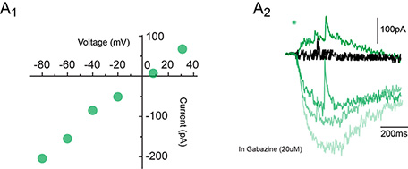

Online Resource 1. Glutamate-evoked current reversal potential (n=4).

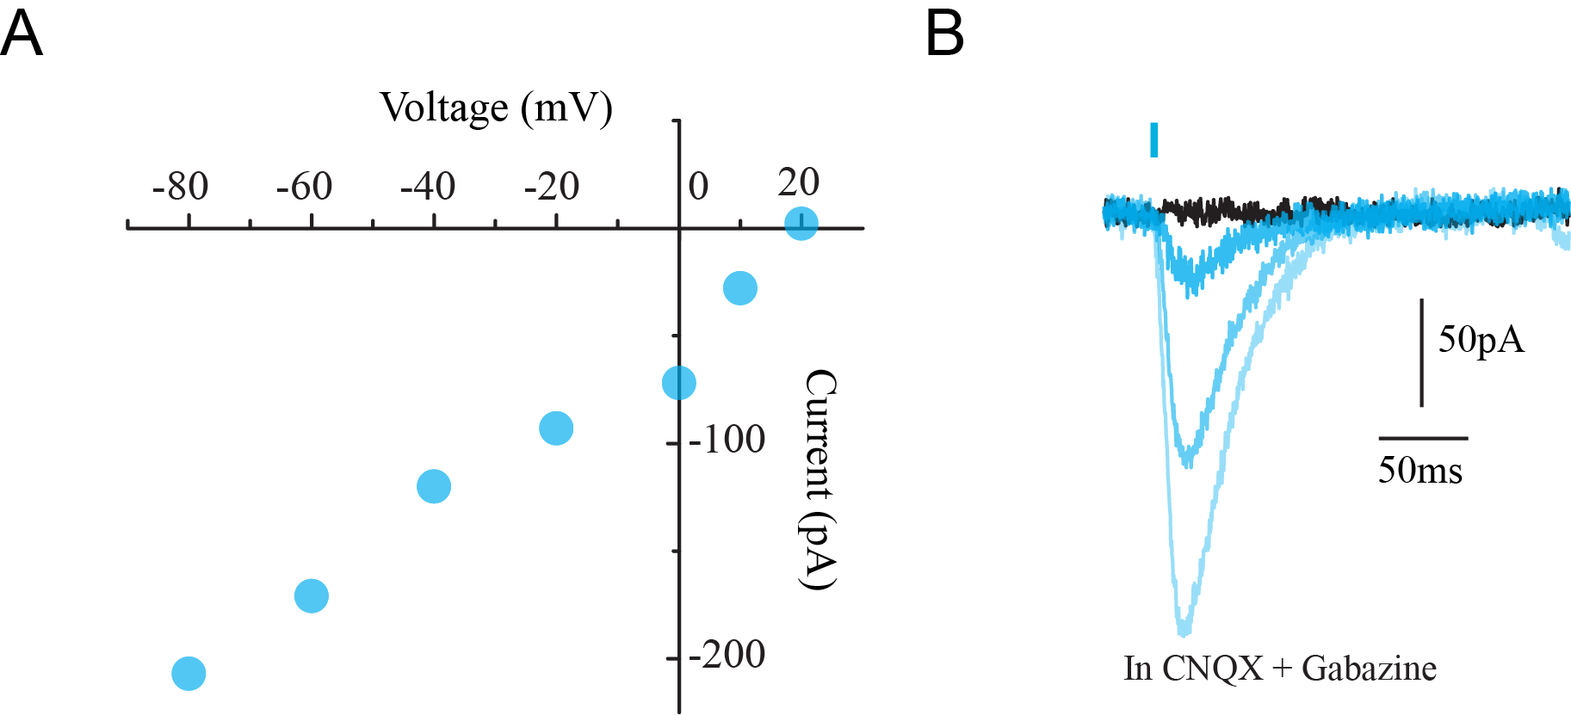

Online Resource 2. Photocurrent-evoked current reversal potential (n= 11).

