Supplementary material:
Figure SM1. Single-subject comparison with the axial slice D 4.5 of Morel’s atlas
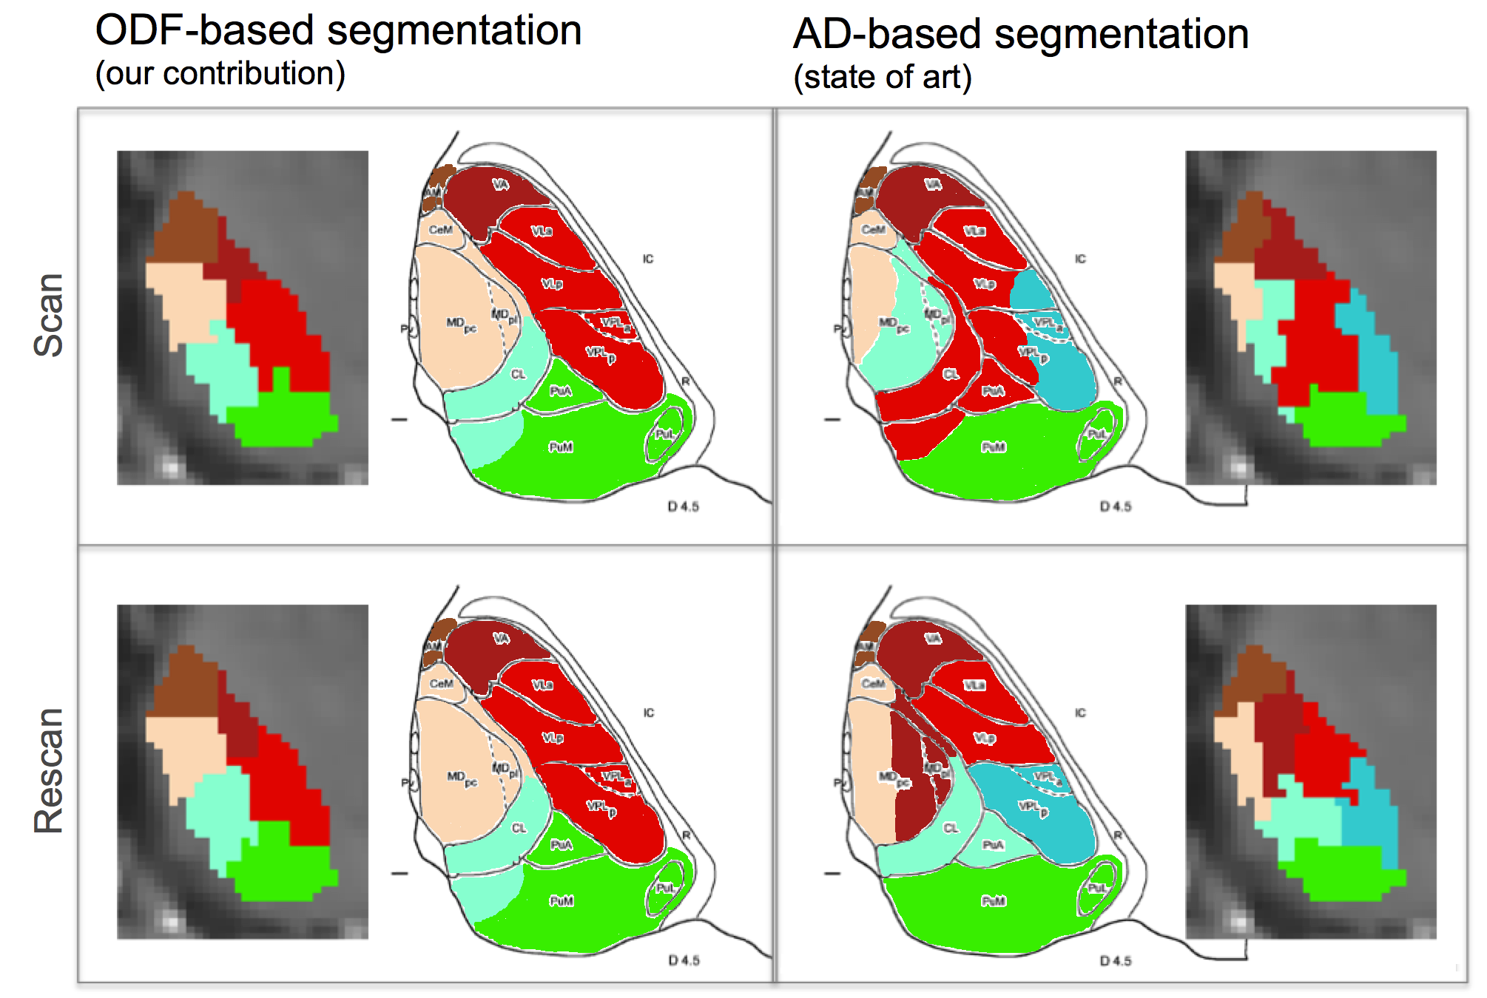
Figure SM2. Single-subject comparison with the axial slice D 10.8 of Morel’s atlas
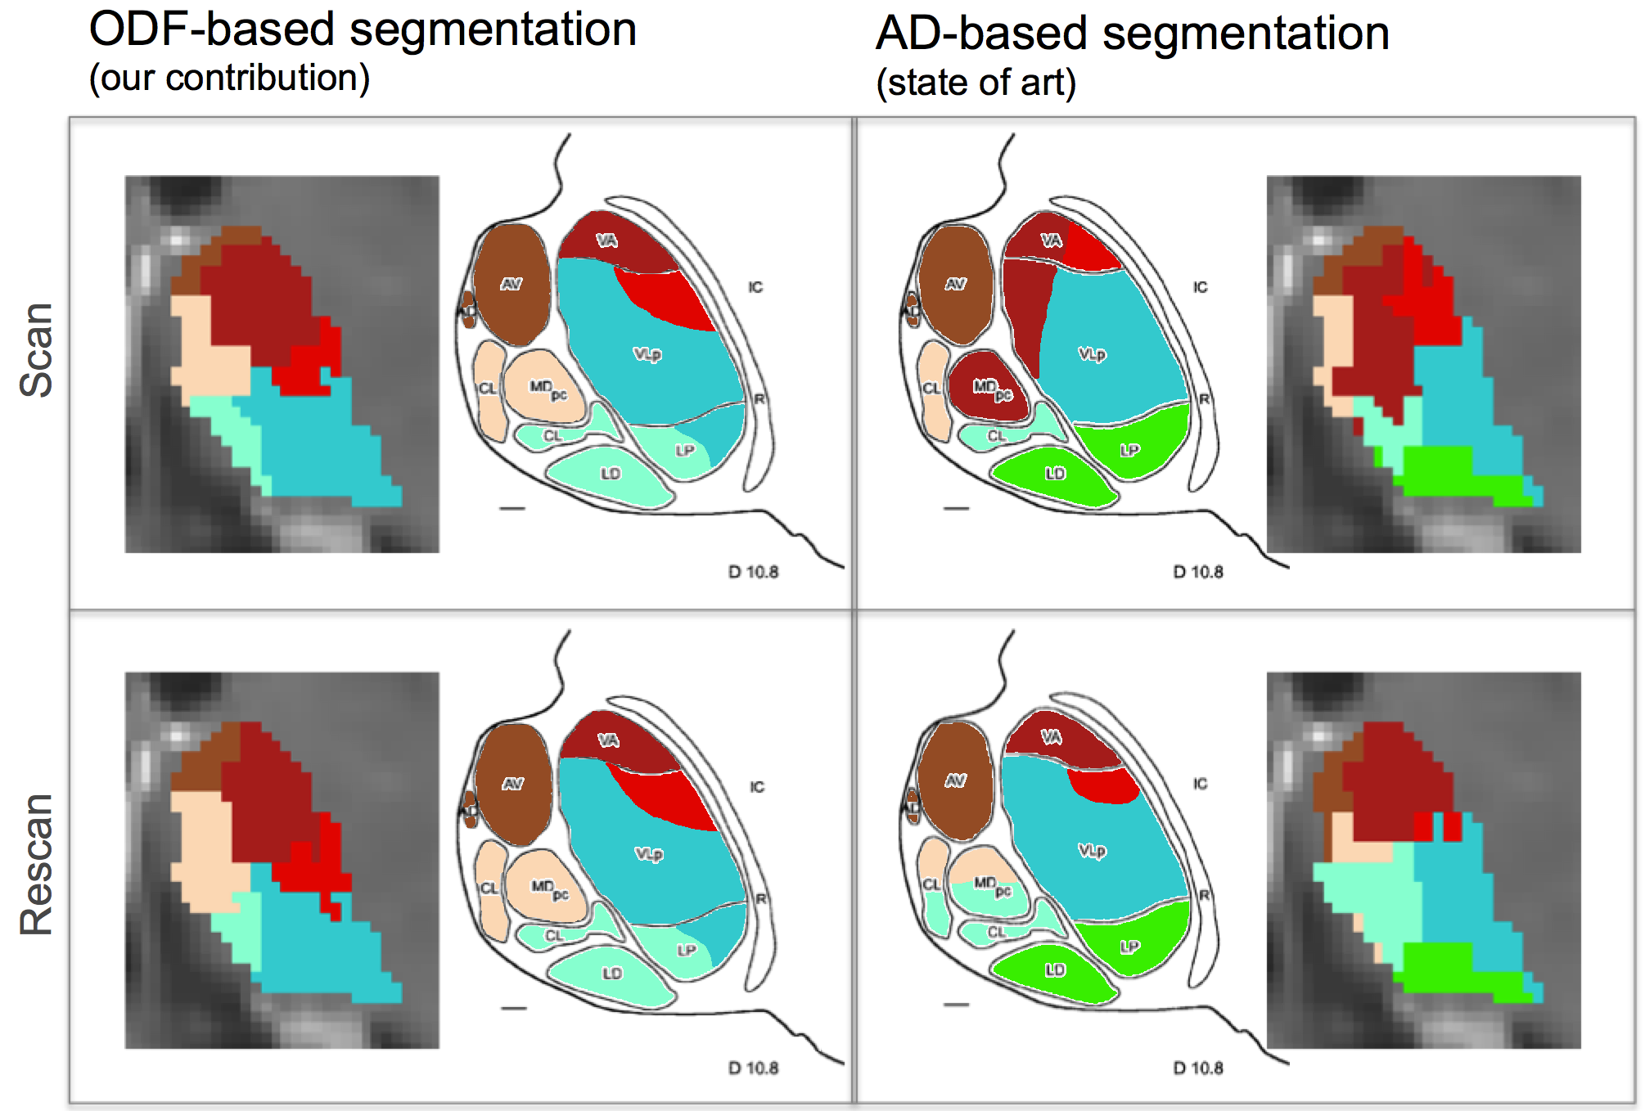
Figure SM3. Reconstruction of thalamic long connections. 3D views of the reconstructed fiber tracts (in white) for the Medio-Dorsal group (panel A) and the Pulvinar (panel B). Probabilistic tracts were reconstructed using the whole thalamus mask and the following seed regions (in yellow): left middle frontal sulcus and amygdala for the MD group, and left inferior angular gyrus and left calcarine sulcus for the Pulvinar.
