Supplementary Materials

- Activations Full Test Sound Phase (complete 7.4 seconds)
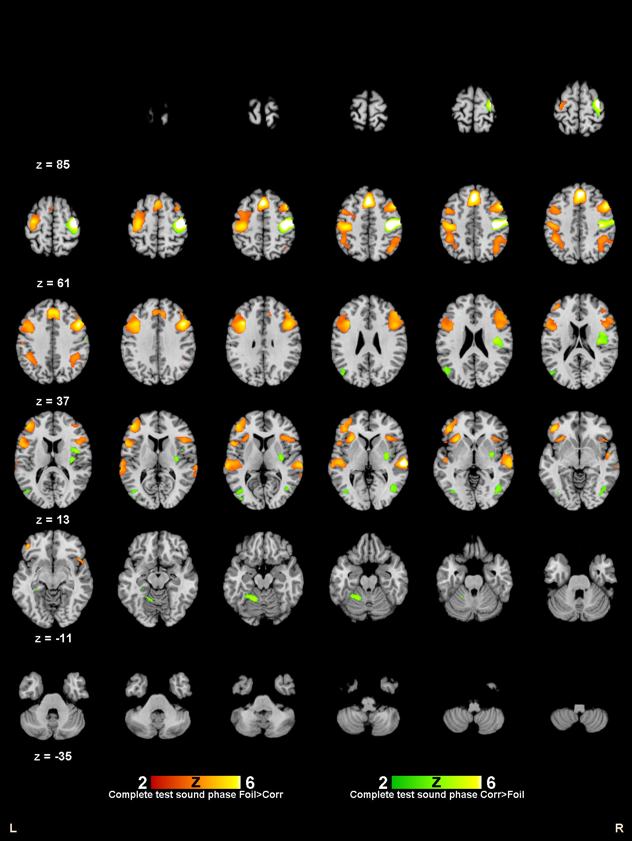

- Activity patterns during Generation phase

  - Recursion > Iteration

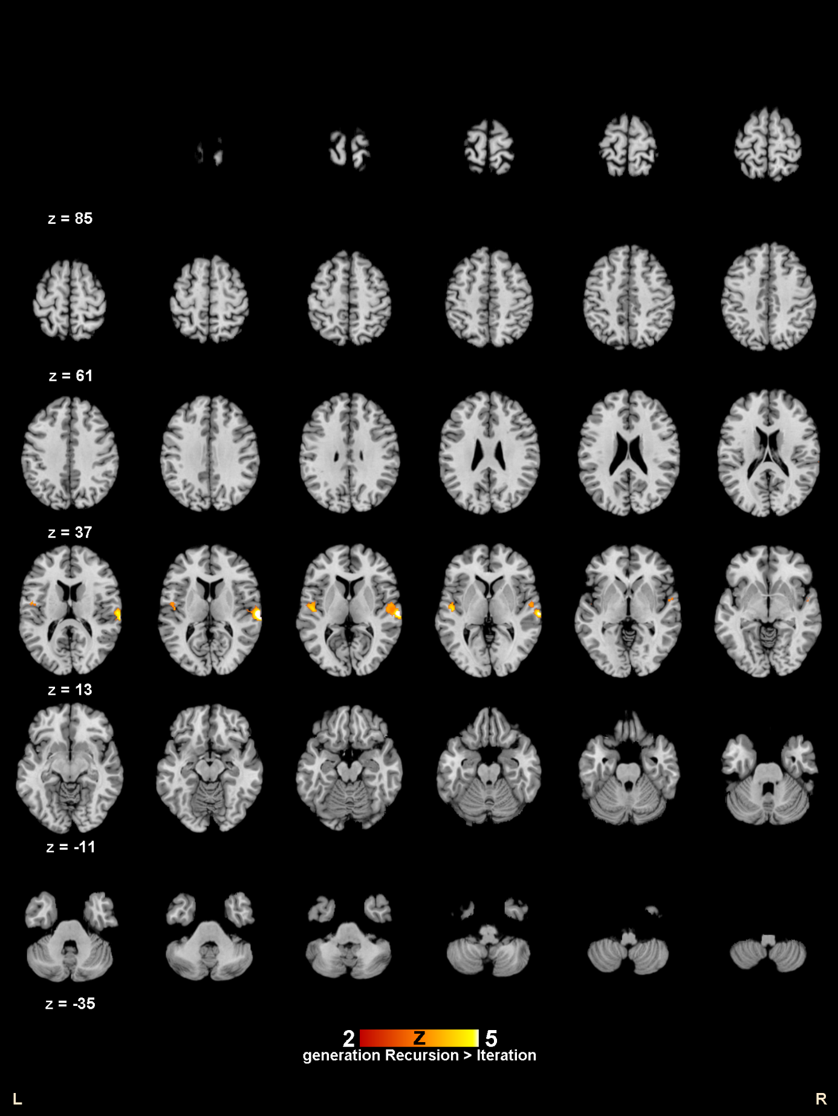

  - Recursion > Repetition
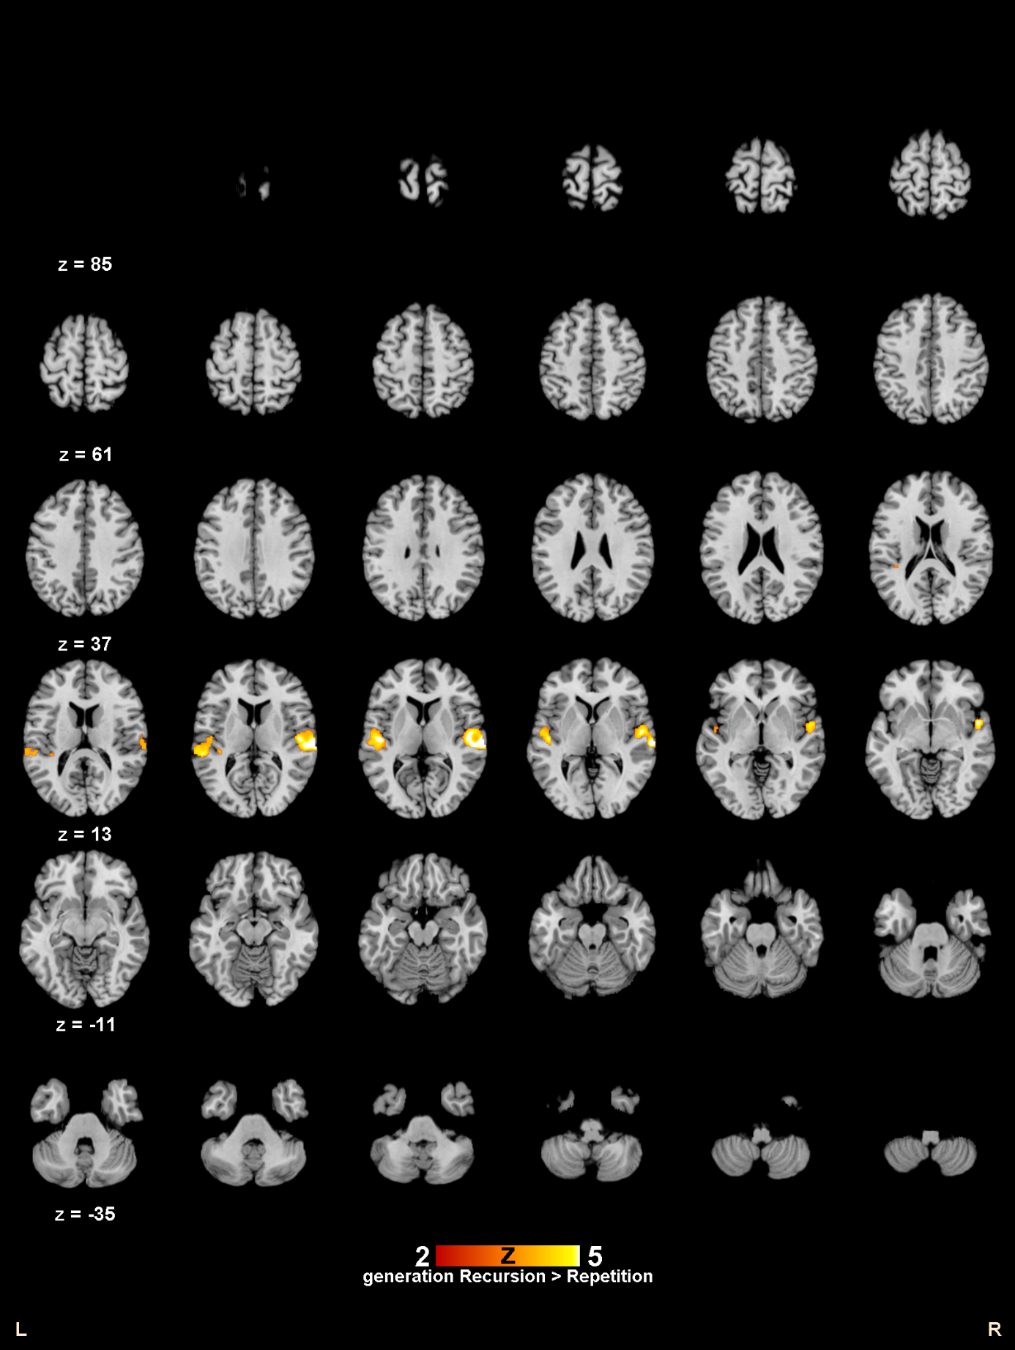
- Activity patterns during the steps I, II and III (i.e. trial period BEFORE planning)

  - Recursion > Iteration
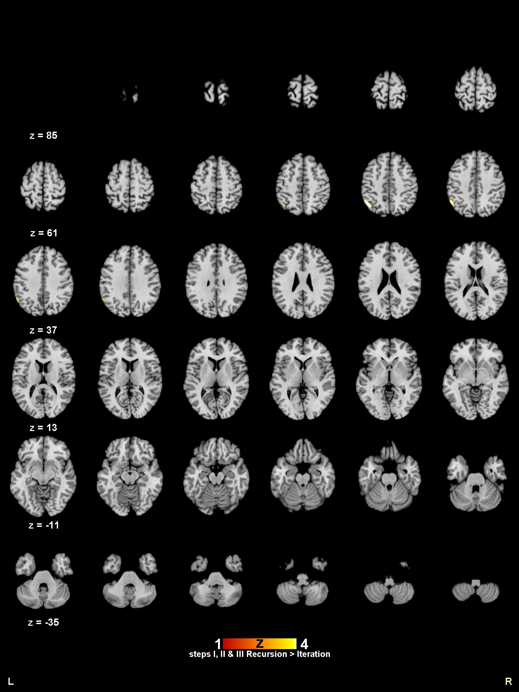

- Recursion > Repetition
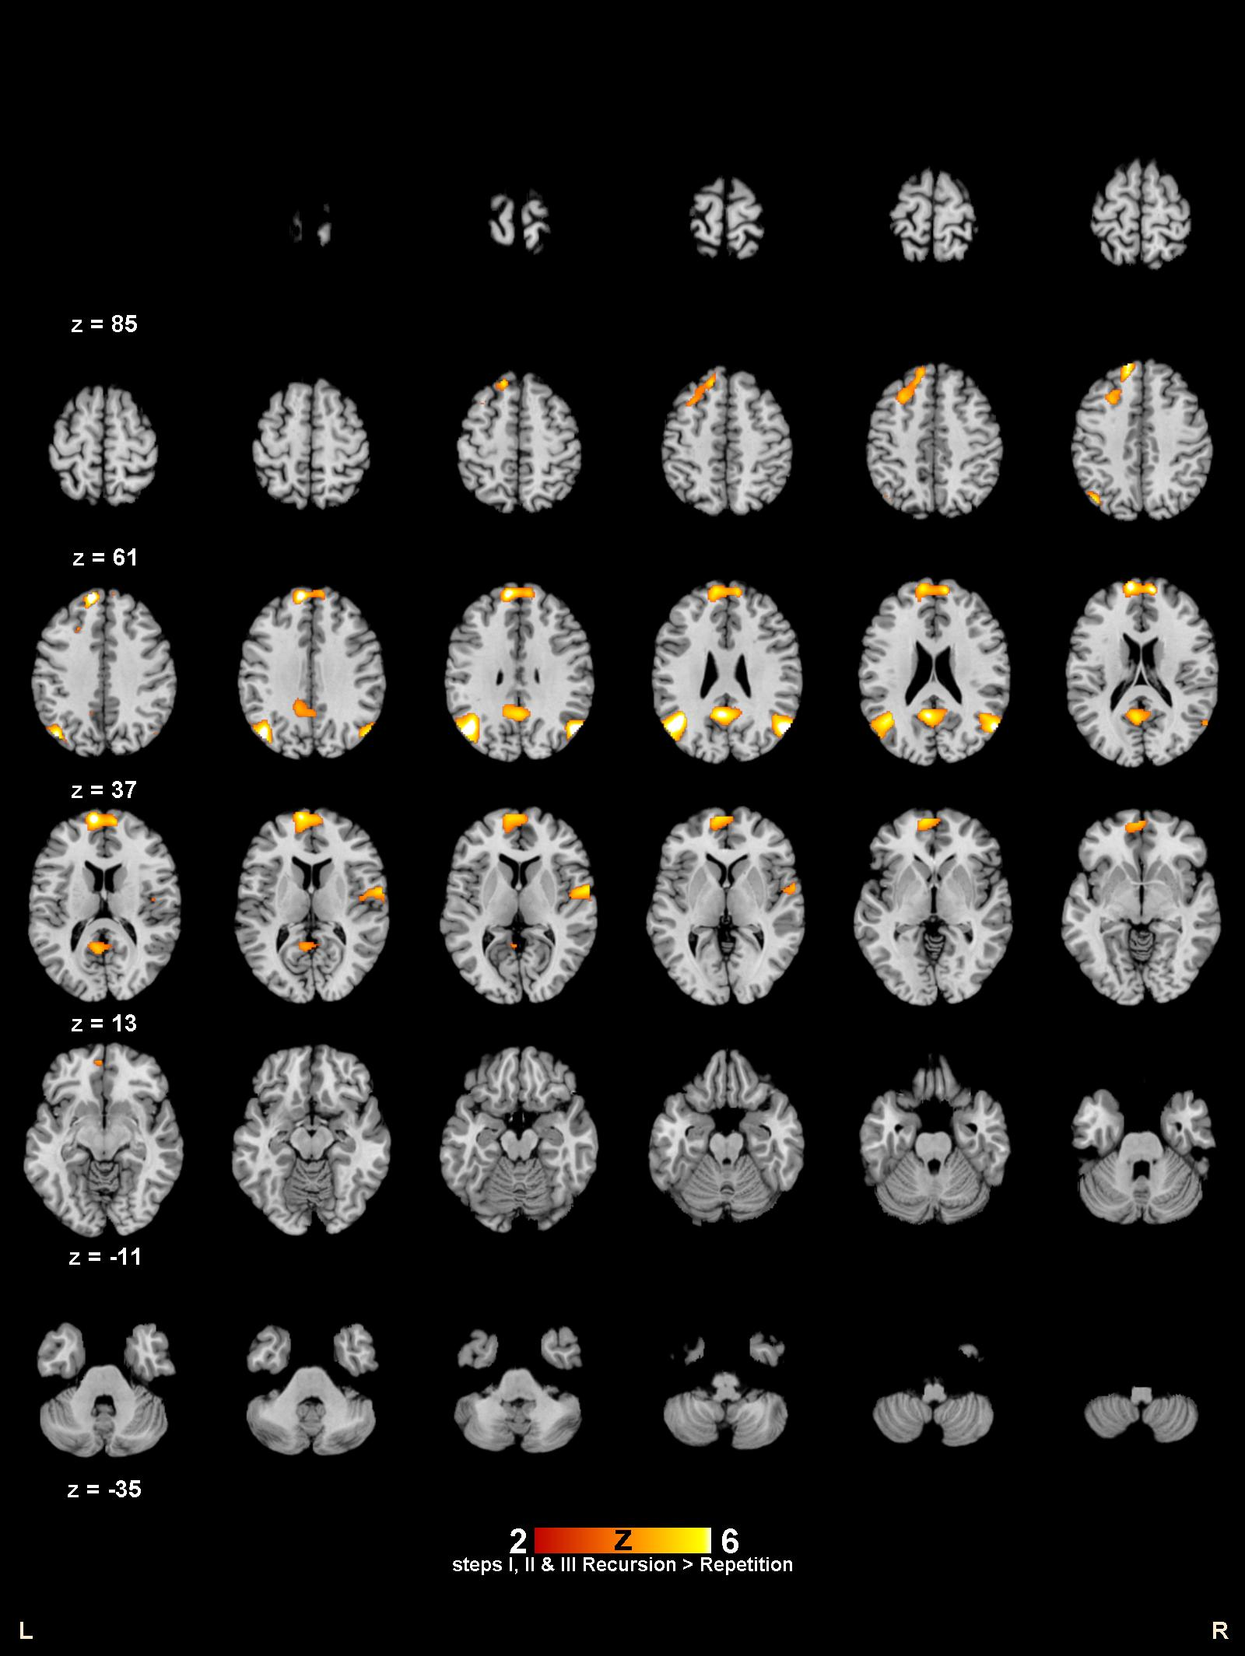

- Repetition > Recursion
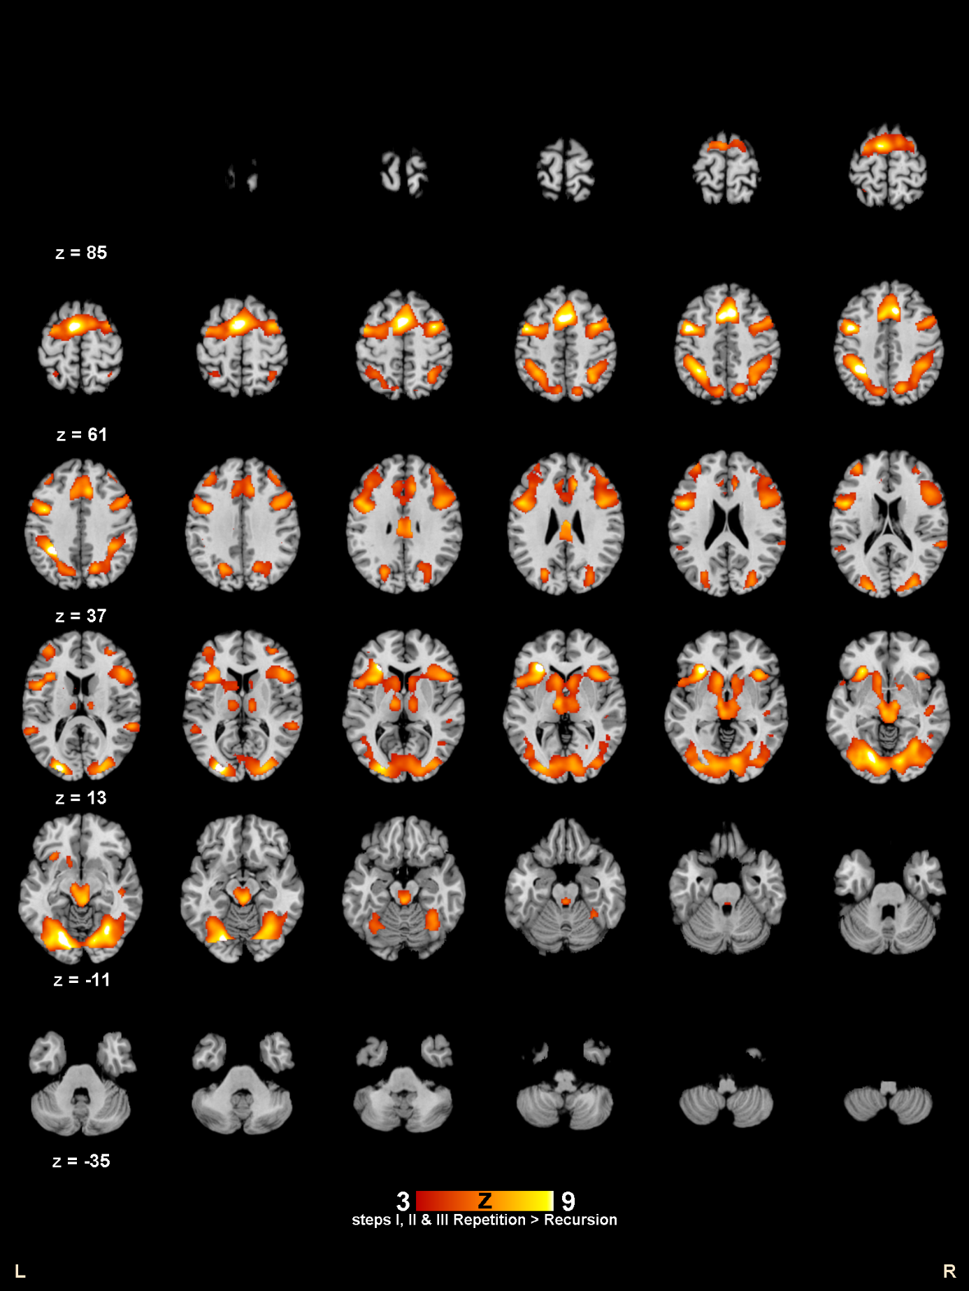

- Repetition > Iteration
