Supplementary Figures

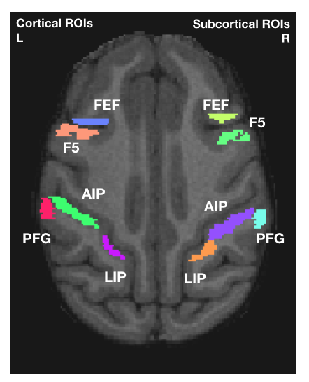
Supplementary Figure 1.

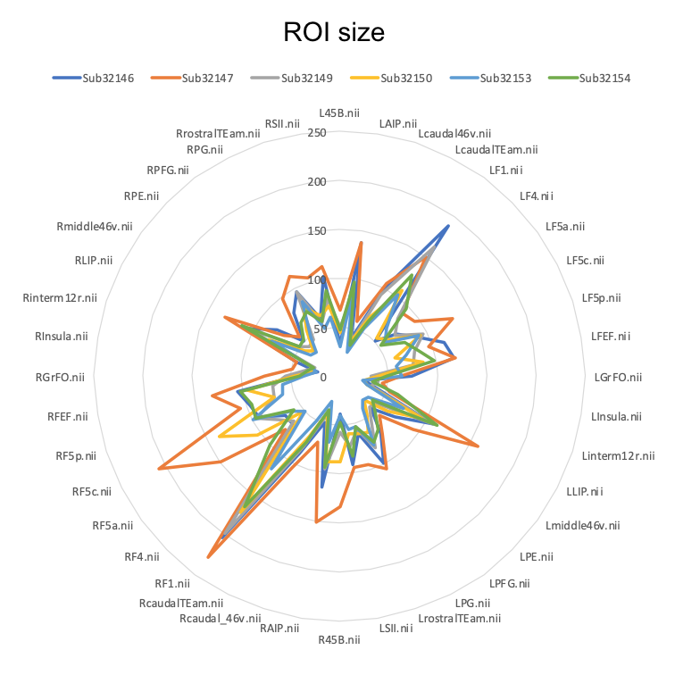
Supplementary Figure 2.

