Neocortical pyramidal cells with axon-carrying basal dendrites: A prominent feature regulated by activity
David Bietz, Burak Ceylan, Andrea Räk, Ina Köhler Petra Wahle

Supplemental Material

Supplemental Table S1. Developmental material. The developmental approach is based on the control data from the six experimental approaches plus assessment of control cultures from batches prepared for unrelated purposes. dash, not assessed.
 |  |  | Pyramidal cells |  |  |  | Basket cells |  | Non-basket cells
Experiment | Age in DIV,  Condition |  | # of batches  # of OTC  # of cells |  |  | # of values plotted | # of cells | # of values plotted | # of cells | # of values plotted
Development | 05 | Ctrl | 16 | 129 | 1953 | 59 | / | / | / | /
Development | 10 | Ctrl | 68 | 608 | 7625 | 284 | 727 | 55 | 1171 | 78
Development | 15 | Ctrl | 50 | 407 | 4230 | 119 | 439 | 37 | 655 | 46
Development | 20 | Ctrl | 51 | 379 | 3032 | 96 | 471 | 37 | 581 | 36
Development | 30 | Ctrl | 23 | 183 | 1252 | 46 | 259 | 21 | 272 | 20
Total |  |  | 208 | 1706 | 18092 | 604 | 1896 | 150 | 2679 | 180

Supplemental Table S2. Experimental material. Summary of the number of batches, the number of OTC per batch, and the total number of pyramidal cells, basket cells and non-basket cells assessed per batch.
 |  |  | Pyramidal cells |  |  |  | Basket cells |  | Non-basket cells
Experiment | Age in DIV,  Condition |  | # of batches  # of OTC  # of cells |  |  | # of values plotted | # of cells | # of values plotted | # of cells | # of values plotted
GluN2A/B | 10 | Ctrl | 15 | 114 | 1868 | 51 | 151 | 8 | 234 | 11
GluN2A/B | 10 | Ifen | 13 | 117 | 1456 | 49 | 99 | 8 | 190 | 13
GluN2A/B | 10 | NVP | 9 | 93 | 899 | 31 | 77 | 6 | 140 | 9
GluN2A/B | 15 | Ctrl | 5 | 48 | 513 | 16 | 56 | 5 | 86 | 6
GluN2A/B | 15 | Ifen | 5 | 45 | 476 | 16 | 48 | 4 | 62 | 5
GluN2A/B | 15 | NVP | 3 | 23 | 142 | 5 | 32 | 3 | 35 | 3
GluN2A/B | 20 | Ctrl | 10 | 97 | 428 | 14 | 56 | 5 | 68 | 6
GluN2A/B | 20 | Ifen | 10 | 73 | 403 | 11 | 61 | 5 | 70 | 6
GluN2A/B | 20 | NVP | 9 | 71 | 413 | 11 | 54 | 5 | 60 | 5
GluN2D | 10 | Ctrl | 12 | 111 | 1498 | 57 | 221 | 17 | 257 | 20
GluN2D | 10 | CIQ | 10 | 92 | 1216 | 49 | 161 | 16 | 195 | 17
GluN2D | 10 | DQP | 11 | 92 | 1302 | 51 | 195 | 15 | 227 | 18
GluN2D | 20 | Ctrl | 7 | 56 | 726 | 15 | 118 | 10 | 132 | 11
GluN2D | 20 | CIQ | 7 | 60 | 718 | 13 | 84 | 7 | 141 | 12
GluN2D | 20 | DQP | 7 | 51 | 781 | 17 | 133 | 9 | 153 | 11
GECI | 14 | Ctrl | 20 | 106 | 1776 | 44 | 85 | 8 | 153 | 11
GECI | 14 | G3 | 12 | 88 | 1036 | 27 | 40 | 4 | 61 | 5
GECI | 14 | G6m | 10 | 46 | 431 | 12 | 23 | 2 | 26 | 2
GECI | 22-25 | Ctrl | 12 | 58 | 751 | 25 | 113 | 9 | 119 | 9
GECI | 22-25 | G3 | 9 | 60 | 480 | 16 | 67 | 6 | 65 | 5
GECI | 22-25 | G6m | 7 | 43 | 274 | 9 | 26 | 2 | 31 | 3
Magnesium | 05 | Ctrl | 6 | 40 | 304 | 9 | / | / | / | /
Magnesium | 05 | Mg | 6 | 54 | 398 | 11 | / | / | / | /
Magnesium | 10 | Ctrl | 17 | 137 | 1165 | 52 | 93 | 8 | 162 | 10
Magnesium | 10 | Mg | 17 | 137 | 1166 | 58 | 89 | 8 | 157 | 10
Magnesium | 15-20 | Ctrl | 9 | 76 | 703 | 26 | 157 | 13 | 236 | 15
Magnesium | 15-20 | Mg | 9 | 82 | 638 | 24 | 104 | 10 | 154 | 13
Magnesium | 30 | Ctrl | 10 | 111 | 501 | 23 | 146 | 12 | 162 | 14
Magnesium | 30 | Mg | 10 | 118 | 540 | 26 | 117 | 10 | 158 | 14
Kainate | 05 | Ctrl | 5 | 60 | 950 | 23 | / | / | / | /
Kainate | 05 | KA | 5 | 57 | 877 | 21 | / | / | / | /
Kainate | 10 | Ctrl | 9 | 82 | 1155 | 30 | 138 | 9 | 209 | 11
Kainate | 10 | KA | 9 | 97 | 1192 | 29 | 67 | 6 | 125 | 10
Kainate | 15-20 | Ctrl | 6 | 59 | 190 | 7 | 50 | 5 | 72 | 7
Kainate | 15-20 | KA | 6 | 53 | 176 | 7 | 51 | 5 | 57 | 5
Carbachol | 05 | Ctrl | 4 | 28 | 343 | 12 | / | / | / | /
Carbachol | 05 | CCH | 4 | 28 | 404 | 13 | / | / | / | /
Carbachol | 10 | Ctrl | 7 | 83 | 957 | 26 | 145 | 10 | 288 | 14
Carbachol | 10 | CCH | 7 | 68 | 984 | 27 | 124 | 9 | 236 | 13
Carbachol | 15 | Ctrl | 10 | 121 | 792 | 22 | 177 | 11 | 208 | 12
Carbachol | 15 | CCH | 10 | 112 | 752 | 22 | 254 | 12 | 238 | 12
Carbachol | 20 | Ctrl | 11 | 51 | 691 | 19 | 99 | 7 | 111 | 9
Carbachol | 20 | CCH | 11 | 46 | 954 | 22 | 70 | 6 | 112 | 8
Total |  |  | 175 | 3244 | 33419 | 1048 | 3781 | 297 | 5190 | 364

Supplemental Fig. S1. Interneurons with axons from soma or dendrites. a. Basket cell with somatic axon and neighboring supragranular pyramidal neurons; inset shows axon origin at higher magnification. Former pial surface top left. b. Basket cell with axon seemingly in a ‘shared root’ configuration; inset, overexposure reveals that the axon hillock is on the soma, not merged with the nearby dendrite. c. AcD basket cell; upper inset, axon origin and a basket cell terminal (‘t’). d. Non-basket cell with somatic axon; left inset, at higher magnification; right inset, overexposure revealing the axon origin from the soma at a z-level different from the dendrites. e. AcD non-basket cell; inset shows arcade axon at higher manification. f. Non-basket cell; inset shows the ‘shared root’. Arrows indicate axons, asterisks mark branch points. Isolated black grains: gold particles. Scale bars: 20 µm.
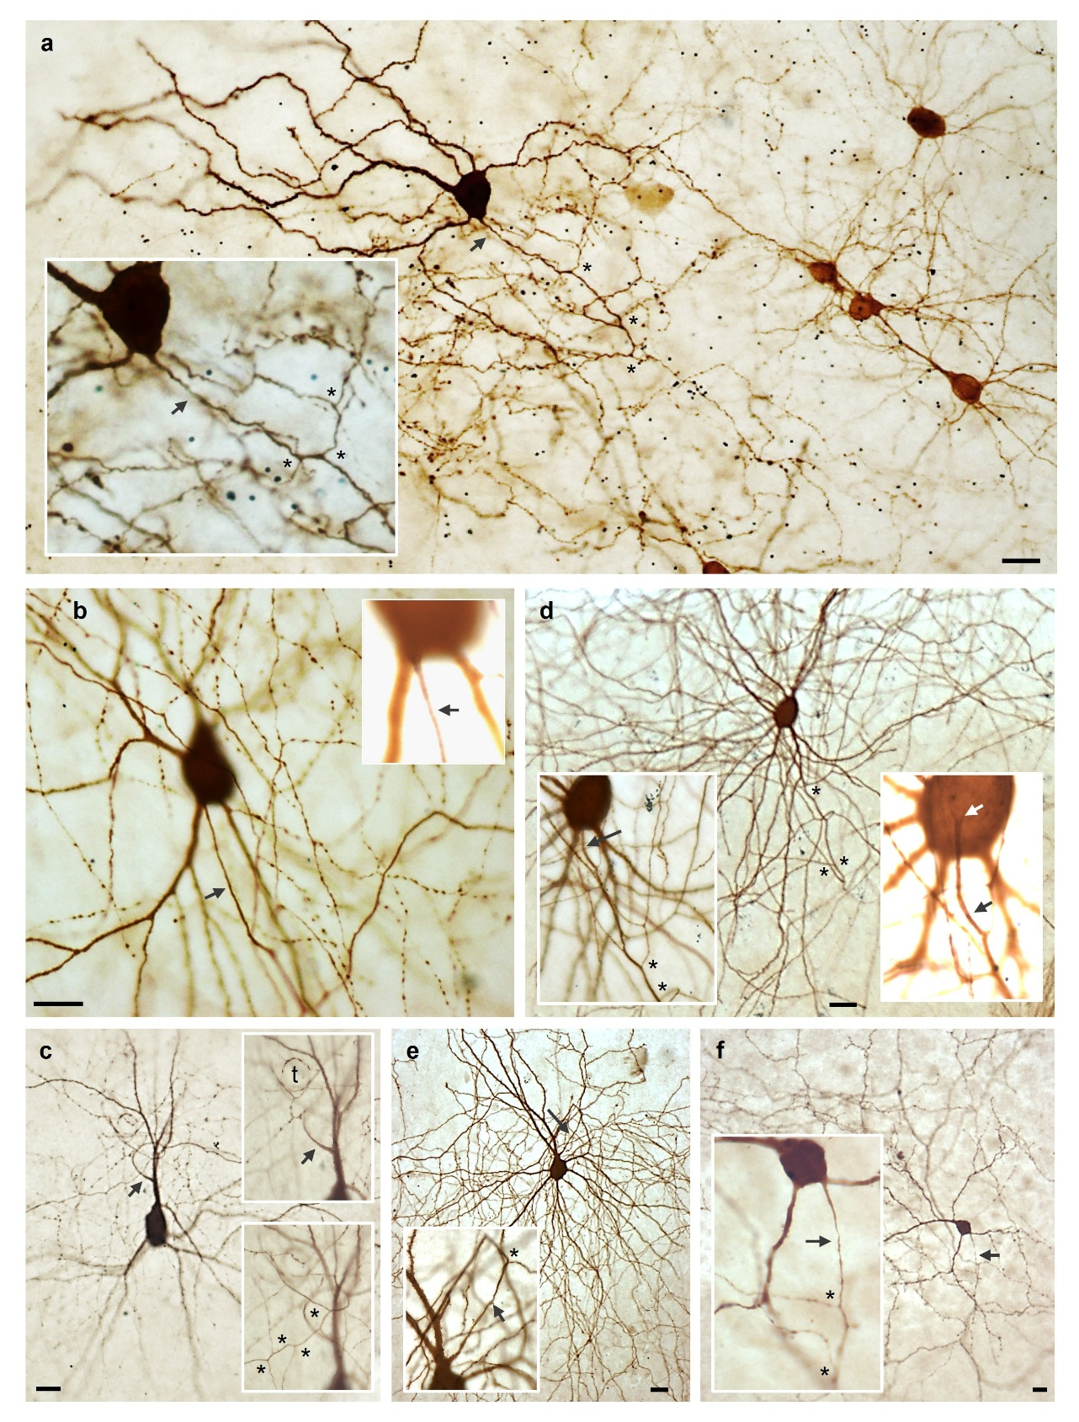

Supplemental Table S3. Pyramidal cell dendrites under MgSO₄ activity deprivation. Given is the mean ± S.E.M., and n, the number of cells analyzed. Per cell, the average of basal dendritic length and segements, and the apical dendritic length and segments has been computed. P values of Mann-Whitney rank sum test versus control are in italics, significant differences in bold.

Age, Condition  (Number of batches) | Basal dendritic  length (n) | Basal dendritic  segments
DIV 10 Control | 285 ± 15 (88) | 7.6 ± 0.43
10 mM MgSo₄ (7) | 262 ± 12 (103) | 7.9 ± 0.37
Mann-Whitney test vs control | 0.41 | 0.35
DIV 20 Control | 377 ± 17 (78) | 7.8 ± 0.31
10 mM MgSo₄ (7) | 311 ± 14 (97) | 7.0 ± 0.28
Mann-Whitney test vs control | 0.002 | 0.031
Age, Condition  (Number of batches) | Apical dendritic  length (n) | Apical dendritic  segments
DIV 10 Control | 1376 ± 82 (88) | 33.8 ± 2.39
10 mM MgSo₄ (7) | 1361 ± 67 (103) | 36.9 ± 2.28
Mann-Whitney test vs control | 0.85 | 0.35
DIV 20 Control | 1557 ± 91 (78) | 29.2 ± 1.59
10 mM MgSo₄ (7) | 1679 ± 74 (97) | 34.5 ± 1.71
Mann-Whitney test vs control | 0.32 | 0.08
Supplemental Fig. S2. Response of basket and non-basket cells to the experimental conditions. a-e. Basket cells. f-j. Non-basket cells. Every dot represents the proportion of AcD cells obtained in most cases from one batch. In some cases data were pooled accross batches to reach the minimum of 10 cells per value.
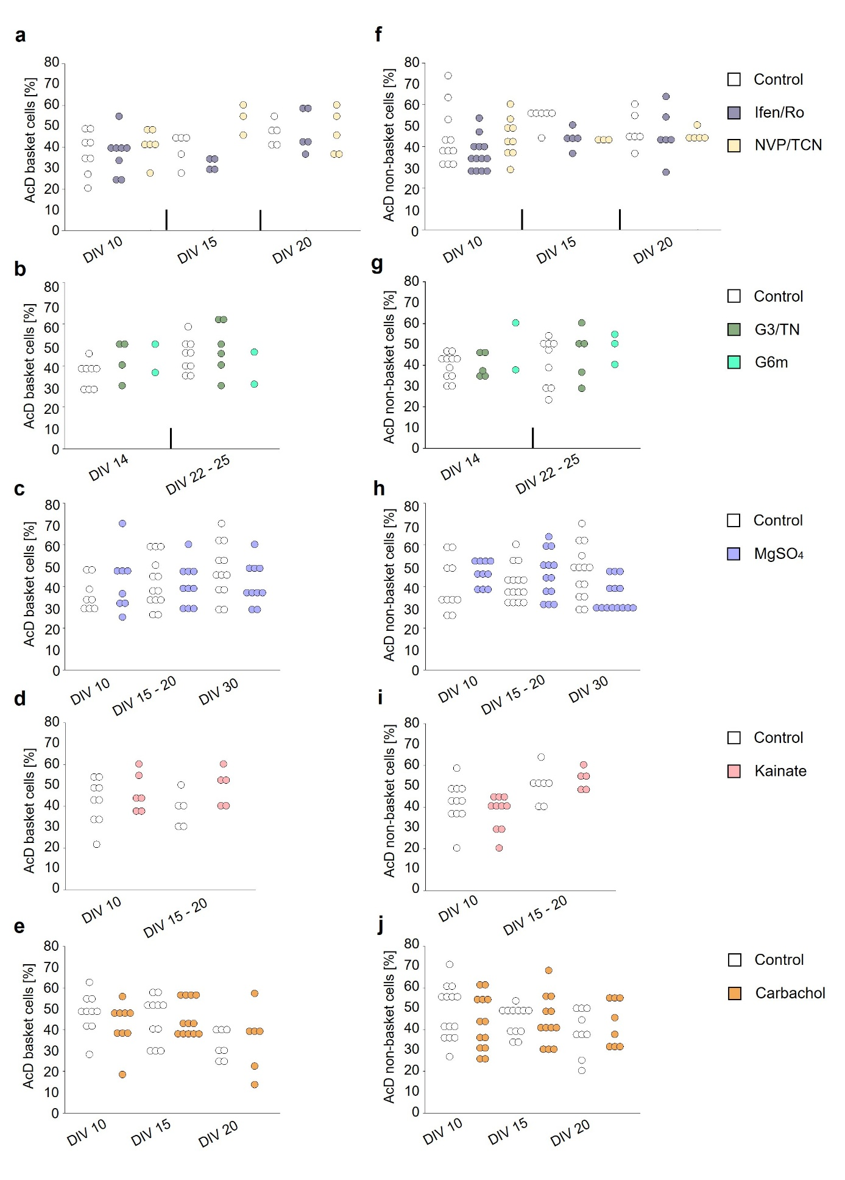
Supplemental Fig. S3. Proportion of pyramidal cells with basal AcD and of AcD interneurons was not changed upon activation or inhibition of interneuronal GluND-containing receptors. a. Time line of treatment in two time windows with analysis at DIV 10 and DIV 20. b. The proportion of pyramidal cells with basal AcD increases from DIV 10 to DIV 20. Neither CIQ not DQP altered the proportions. c. Pyramidal cells with apical AcD occurred in variable proportions, none altered by the treatments. d. The proportion of AcD BC was not altered by treatments. e. The proportion of AcD non-BC was not altered by treatments. In d., e., every dot represents the proportion of AcD cells obtained in most cases from one batch, in some cases data were pooled accross batches to reach the minimum of 10 cells per value. The number of batches, of cultures, and of neurons assessed is given in Supplemental Table S2.
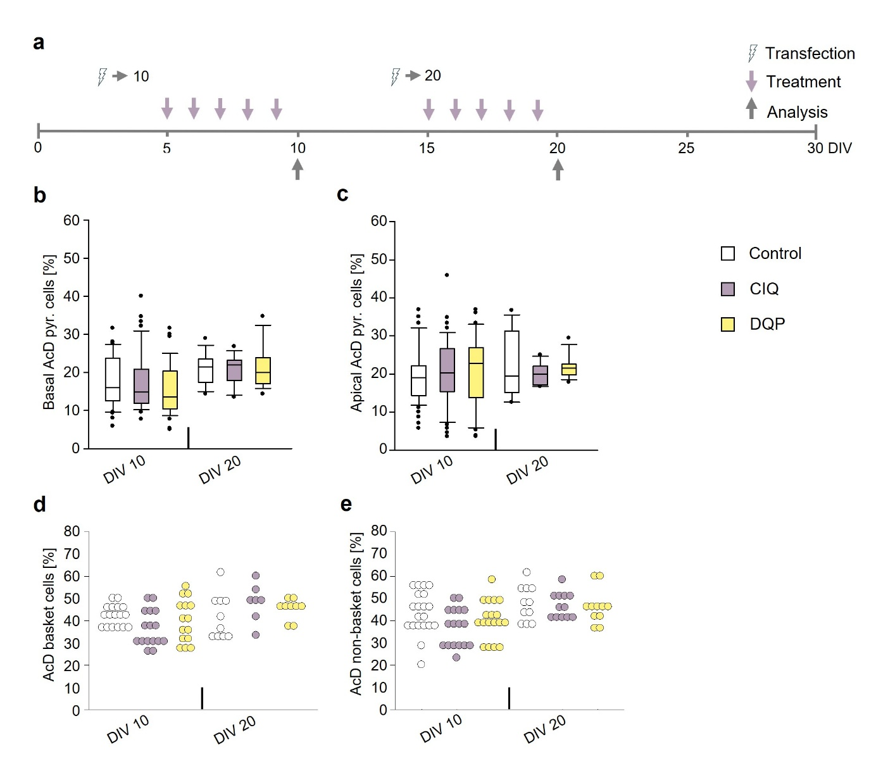

Supplemental Fig. S4. Axons from apical dendrites of pyramidal cells. a. Pyramidal cell at DIV 5; inset, overexposure reveals that what looks like an apical AcD is in fact a somatic axon which ascends nestled against the apical dendrite before turning away and branching. b. Pyramidal cells at DIV 5 with somatic axon (left ) and apical AcD (right). c. Obliquely oriented pyramidal cell at DIV 5 with axon descending from the apical trunk. d. Pyramidal cell at DIV 15, inset showns the axon’s origin from the apical dendrite bending down towards the white matter. e. Pyramidal cell at DIV 15, inset shows the axon’s origin from a secondary apical dendritic branch. The diagonally crossing neurite came from a neighboring cell. f. Pyramidal cell at DIV 20, the axon emerges from a secondary apical branch and immediately descends towards the white matter. a-d. Cells from supragranular layers; e-f. Cells from infragranular layers, all arranged with the former pial surface to the top. Arrows indicate axons, asterisks mark branch points. Scale bars: 20 µm.
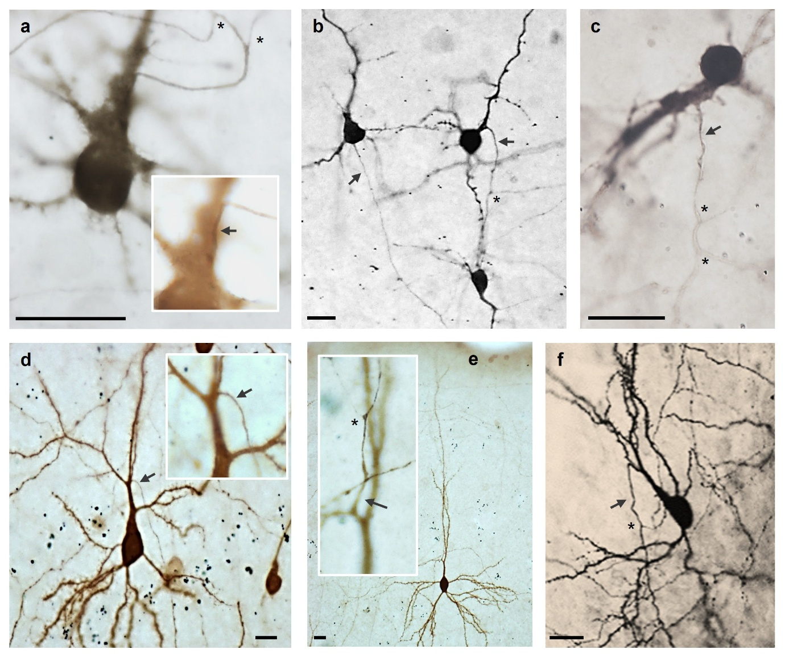

Supplemental Fig. S5. Proportion of pyramidal cells with apical AcD. a. Apical AcD are regulated by development with a plateau from DIV 10 onwards. b-f. Apical AcD are not regulated by the experimental conditions assessed in this study.
