In silico identification and ex vivo evaluation of Toxoplasma gondii peptides restricted to HLA-A*02, HLA-A*24 and HLA-B*35 alleles in human PBMC from a Colombian population

Journal name: Medical Microbiology and Immunology

Mónica Vargas-Montes https://orcid.org/0000-0003-2418-3596¹, María Camila Valencia-Jaramillo¹, Juan David Valencia-Hernández https://orcid.org/0000-0002-9189-5684¹, Jorge Enrique Gómez-Marín https://orcid.org/0000-0001-6472-33291 Ailan Farid Arenas https://orcid.org/0000-0002-0331-5556¹, Néstor Cardona https://orcid.org/0000-0002-6967-165X^{1,2*}
¹ Grupo de Estudio en Parasitología Molecular (GEPAMOL), Faculty of Health Sciences, Centro de Investigaciones Biomédicas, Universidad del Quindío, Quindío, Armenia, Colombia.
² Faculty of Dentistry, Universidad Antonio Nariño, Quindio, Armenia, Colombia.
* Corresponding author:
E-mail address: nestorcardonape@uan.edu.co, nicardona@uniquindio.edu.co

Supplementary tables (St) and figures (Sf)

St. 1. Peptides of 9 AA predicted by the neural network in Approach 1. The probability for each peptide, some characteristics of the proteins from which they were derived according to ToxoDB, and the most important criteria of the in silico analysis are presented. All peptides were conserved in the 7 strains analyzed.
No. | Peptide | Probability  (X̅ +/- SD) | Alleles-affinity | Code Toxo DB and Protein | Expression/Stage^{A} | Subcellular Localization ^{B} | TCR- immunogenicity  (presence of AA) ^{C} | Cleavage prediction: proteasome/TAP (score > 0,5) ^{D} | BLASTp ^{D}  Identity >70% with humans
1 | FLFAWITYV | 0.999  +/- 6.38E-05 | HLA-A*02 | TGME49_217870 DHHC3 Palmitoyl transferase | 3 stages  (Higher in Oocyst) | Membrane  Golgi A. | Yes | Positive  (score: 1.10) | No
2 | FLFSFFFFV | 0.998  +/- 8.05E-05 | HLA-A*02 | TGME49_213100 Hypothetical protein | 3 stages | ND | Yes /No | Positive  (score: 0.93) | No
3 | FLLDFLLYV | 0.998  +/- 1.05E-04 | HLA-A*02 | TGME49_223920  Rhoptry neck protein RON3 | 3 stages | Rhoptry organelles | Yes | Positive  (score: 1.22) | Yes (89%)
4 | FLMDFDFHV | 0.999  +/- 7.86E-05 | HLA-A*02 | TGME49_271335 Hypothetical protein | 3 stages  (Higher in Oocyst) | ND | Yes | Positive  (score: 1.21) | No
5 | FLWPFDYPV | 0.999  +/- 6.88E-05 | HLA-A*02 | TGME49_217480 Hypothetical protein | 3 stages | Nucleus | Yes | Positive  (score: 0.70) | No
6 | YLWHFSYEV | 0.998  +/- 2.81E-04 | HLA-A*02 | TGME49_253290  Valyl-tRNA synthetase | 3 stages | Citosol | Yes /No | Positive  (score: 1.13) | No
7 | MPLGGGFAM | 0.855  +/- 3.75E-03 | HLA-B*35 | TGME49_300130  AMA-1 domain-containing protein | 3 stages  (Higher in Bradyzoite) | Membrane | - | Positive  (score:0.95) | No
8 | FPFAGWTAM | 0.839  +/- 4.23E-03 | HLA-B*35 | TGME49_242020  Mannosyl-oligosaccharide glucosidase | 3 stages | Endoplasmic reticulum | Yes | Positive  (score: 1.10) | No
9 | YPIAPSFAM | 0.813  +/- 1.07E-02 | HLA-B*35 | TGME49_208740  Microneme protein, putative | 3 stages  (Higher in Tachyzoite and bradyzoite) | Micronemes | Yes /No | Positive  (score:0.89) | No
^{A}Expression in the three stages of the parasite: Oocyst, tachyzoite and bradyzoite (RMA>3).
^{B}ND: Does not present data in ToxoDB.
^{C} Positive association F, I, W, A. Negative associationS, K, M, Q (According to the literature [49]).
^{D} Exclusion or elimination criteria.

St. 2. 9 and 10-AA peptides selected by neural networks for the HLA-A*24 complex. IC50< 50nM in Epitope prediction. Redundant peptide sequences between strains and with the highest prediction probabilities for supertype A*24 are shown. Characteristics of the proteins from which the peptides were derived, as determined by ToxoDB and the most important criteria considered in the in silico analysis are presented. All peptides were conserved in the 7 T. gondii strains analyzed.
No. | Peptide | Probability  (X̅ +/- SD) | Alleles-affinity | Code Toxo DB Protein | Expression/Stage^{A} | Subcellular Localization ^{B} | TCR- immunogenicity  (presence of AA) ^{C} | Cleavage prediction: proteasome/TAP (score>0,5) ^{D} | BLASTp ^{D}  Identity >70% with humans
1 | IFLSIYWKI | 0.998  +/- 00E+00 | HLA-A*24 | TGME49_252640  P-type ATPase PMA1 | 3 stages  (Higher in Bradyzoite) | Membrane | Yes/No | Positive  (score: 1.19) | No
2 | VFAFAFFLI | 0.99  +/- 00E+00 | HLA-A*24 | TGME49_273380  Ion channel protein | 3 stages (Higher in Oocyst) | Membrane | Yes | Positive  (Score:0.99) | No
3 | RFAGVFMFF | 0.891 +/- 00E+00 | HLA-A*24 | TGME49_226020  Transporter, major facilitator family protein | 3 stages | Micronemes | Yes | Positive  (score: 1.51) | No
4 | LYLLHSWTW | 0.704  +/- 00E+00 | HLA-A*24 | TGME49_286500  Multidrug resistance efflux transport | 3 stages  (Higher in Tachyzoite) | Membrane | No | Positive  (score: 1.61) | Yes (77%)
5 | RWFWTFRFNW | 0.928 +/- 2.17E-02 | HLA-A*24 | TGME49_239755  Hypothetical protein | 3 stages | Membrane | Yes | SI  (score: 1.24) | No

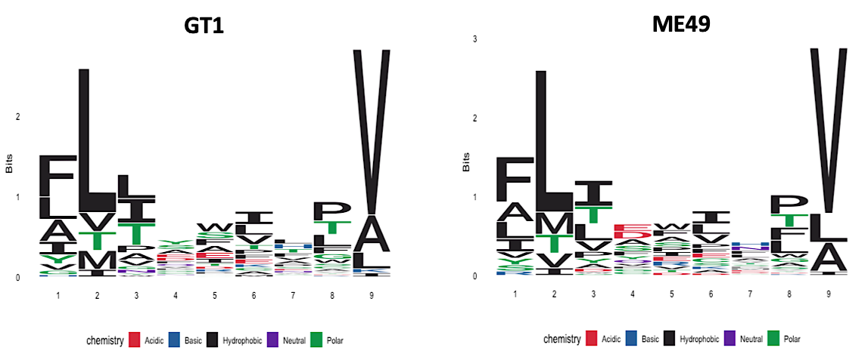

Sf 1. 9 AA peptide logos predicted by the HLA-I network with the highest probability (>0.90) in Approach 2. Logos for strains GT1 and ME49 are shown as examples. Sequence logos were generated using the R Peptools library.

.

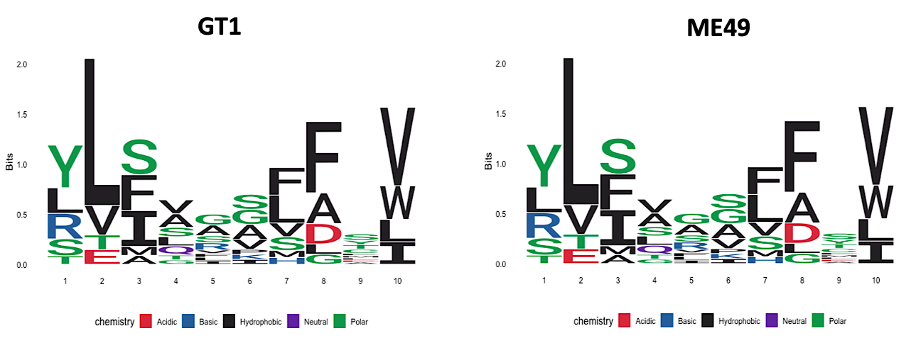

Sf 2. 10 AA peptide logos predicted by the HLA-I network with the highest probability (>0.85) in Approach 2. Logos for strains GT1 and ME49 are shown as examples. Sequence logos were generated using the R Peptools library.

St 3. 9-AA peptides predicted by the neural networks in Approach 2 for HLA-A*02, HLA-B*35 and HLA-A*24 complexes. Redundant peptide sequences between strains and those with the highest prediction are shown. Characteristics of the proteins from which these peptides were derived as determined by ToxoDB, and the most important criteria considered in the in silico analysis.
No. | Peptide | Redundancy between strains | Probability  (X̅ +/- SD) | Alleles-affinity | Code Toxo DB and Protein | Expression/Stage^{A} | Subcellular Localization ^{B} | TCR- immunogenicity  (presence of AA) ^{C} | Cleavage prediction: proteasome/TAP (score > 0,5) ^{D} | BLASTp ^{D}  Identity >70% with humans
1 | ALAEFIETV | 7 | 0.979  +/- 9.47E-03 | HLA-A*02 | TGGT1_252640  P-type ATPase PMA1 | 3 stages  (Higher in Bradyzoite) | Cell membrane | Yes | Positive  (score: 1.06) | No
2 | LLLQWLTTV | 7 | 0.966  +/- 1.88E-02 | HLA-A*02 | TGGT1_253330  Rhoptry kinase family protein | 3 stages  (Higher in Bradyzoite) | Rhoptry organelles | Yes /No | Positive  (score: 0.97) | No
3 | ALLDEILRA | 3 | 0.979 +/- 5.88E-03 | HLA-A*02 | TGGT1_214080 Toxofilin | 3 stages | Cell membrane | Yes | Positive  (score: 1.27) | No
4 | MPVVTTTVL | 7 | 0.804  +/- 1.26E-02 | HLA-B*35 | TGGT1_252640  P-type ATPase PMA1 | 3 stages  (Higher in Bradyzoite) | Cell membrane | - | Positive  (score: 1.67) | No
5 | FPGVIGAPM | 6 | 0.605  +/- 8.28E-02 | HLA-B*35 | TGGT1_266610  Kazal-type protein | 3 stages | ND | Yes | Positive  (score:0.76) | No
6 | FPVLTCDLF | 4 | 0.675  +/- 8.08E-03 | HLA-B*35 | TGGT1_411360  Rhoptry kinase (ROP19A) | 3 stages  (Higher in Tachyzoite) | Rhoptry organelles | - | Positive  (score: 1.08) | No
7 | IFWGILWFF | 7 | 0.590  +/- 5.25E-02 | HLA-A*24 | TGGT1_252640  P-type ATPase PMA1 | 3 stages  (Higher in Bradyzoite) | Cell membrane | Yes | Positive  (score: 1.18) | No
^{A}Expression in the three stages of the parasite: Oocyst, tachyzoite and bradyzoite (RMA>3).
^{B}ND: Does not present data in ToxoDB.
^{C} Positive association F, I, W, A. Negative associationS, K, M, Q (According to the literature [49]).
^{D} Exclusion or elimination criteria.

St 4. 10-AA peptides predicted by the neural networks in Approach 2 for HLA-A*02, HLA-B*35 and HLA-A*24 complexes. Redundant peptide sequences between strains and those with the highest prediction are shown. Characteristics of the proteins from which these peptides were derived as determined by ToxoDB, and the most important criteria considered in the in silico analysis.
No. | Peptide | Redundancy between strains | Probability  (X̅ +/- SD) | Alleles-affinity | Code Toxo DB and Protein | Expression/Stage^{A} | Subcellular Localization ^{B} | TCR- immunogenicity  (presence of AA) ^{C} | Cleavage prediction: proteasome/TAP (score > 0,5) ^{D} | BLASTp ^{D}  Identity >70% with humans
1 | YLIALKHAFI | 7 | 0.957  +/- 1.17E-02 | HLA-A*02 | TGGT1_252640  P-type ATPase PMA1 | 3 stages  (Higher in Bradyzoite) | Cell membrane | Yes | Positive  (score: 1.19) | No
2 | LLIVAALFSV | 7 | 0.900  +/- 5.31E-02 | HLA-A*02 | TGGT1_252640  P-type ATPase PMA1 | 3 stages  (Higher in Bradyzoite) | Cell membrane | Yes | Positive  (score: 0.95) | No
3 | YLSQSVSFCV | 6 | 0.737  +/- 1.61 E-01 | HLA-A*02 | TGGT1_278090  Toxoplasma gondii family A protein | 3 stages  (Higher in Bradyzoite) | ND | No | Positive  (score: 1.07) | No
4 | SLFSGGVFTL | 5 | 0.810  +/- 1.50 E-03 | HLA-A*02 | TGGT1_411360  Rhoptry kinase family protein | 3 stages  (Higher in Tachyzoite) | Rhoptry organelles | No | Positive  (score: 1.55) | No
5 | FPLGSRFSPF | 6 | 0.636  +/- 6.13E-02 | HLA-B*35 | TGGT1_249150  PAN domain-containing protein | 3 stages | ND | No | Positive  (score: 0.75) | No
6 | VWILALLIMF | 5 | 0.518  +/- 1.70E-01 | HLA-A*24 | TGGT1_219348  SAG-related sequence SRS55M | 3 stages | Cell membrane | Yes | Positive  (score:1.40) | No
7 | RYSTFRPALF | 4 | 0.510  +/- 2.06E-02 | HLA-A*24 | TGGT1_207140  SAG-related sequence SRS49B | 3 stages  (Higher in Bradyzoite) | Cell membrane | Yes | Positive  (score: 1.13) | No
^{A}Expression in the three stages of the parasite: Oocyst, tachyzoite and bradyzoite (RMA>3).
^{B}ND: Does not present data in ToxoDB.
^{C} Positive association F, I, W, A. Negative associationS, K, M, Q (According to the literature [49]).
^{D} Exclusion or elimination criteria.

St 5. Serological test results of 50 individuals included in the study. Results of PCRs for the HLA-I of interest are also showed in the table. ^{A}Values equal to or greater than 8 IU/ml of IgG indicate positivity of the serological test. ^{B} Values equal to or greater than 0.65 IU/ml of IgM indicate positivity of the serological test.

Samples  CODE | IgG Anti-T. gondii  (UI/ml) ^{A} | IgM Anti-T. gondii  (UI/ml) ^{B} | A*02 | HLA-I - PCR  A*24 | B*35
1 | 0 | 0.03 | POSITIVE | NEGATIVE | NEGATIVE
2 | >300 | 0.05 | POSITIVE | POSITIVE | NEGATIVE
3 | 0 | 0.07 | NEGATIVE | POSITIVE | NEGATIVE
4 | 7 | 0.06 | POSITIVE | NEGATIVE | NEGATIVE
5 | 0 | 0.05 | POSITIVE | NEGATIVE | NEGATIVE
6 | 38 | 0.07 | POSITIVE | POSITIVE | NEGATIVE
7 | 0 | 0.04 | NEGATIVE | NEGATVE | NEGATIVE
8 | 163 | 0.25 | POSITIVE | NEGATIVE | POSITIVE
9 | 0 | 0.5 | POSITIVE | POSITIVE | NEGATIVE
10 | 28 | 0.04 | NEGATIVE | POSITIVE | POSITIVE
11 | 10 | 0.11 | NEGATIVE | POSITIVE | NEGATIVE
12 | 170 | 0.39 | NEGATIVE | POSITIVE | NEGATIVE
13 | 0 | 0.03 | NEGATIVE | POSITIVE | POSITIVE
14 | 0 | 0.03 | NEGATIVE | NEGATIVE | NEGATIVE
15 | 0 | 0.14 | NEGATIVE | POSITIVE | NEGATIVE
16 | 0 | 0.06 | NEGATIVE | POSITIVE | POSITIVE
17 | 0 | 0.05 | NEGATIVE | POSITIVE | NEGATIVE
18 | 0 | 0.1 | NEGATIVE | POSITIVE | POSITIVE
19 | 0 | 0.07 | POSITIVE | POSITIVE | NEGATIVE
20 | 69 | 0.04 | NEGATIVE | POSITIVE | NEGATIVE
21 | 0 | 0.04 | NEGATIVE | NEGATIVE | POSITIVE
22 | >300 | 0.14 | POSITIVE | NEGATIVE | NEGATIVE
23 | 77 | 0.08 | POSITIVE | POSITIVE | NEGATIVE
24 | 0 | 0.03 | NEGATIVE | POSITIVE | NEGATIVE
25 | 0 | 0.03 | POSITIVE | NEGATIVE | NEGATIVE
26 | 0 | 0.03 | NEGATIVE | POSITIVE | POSITIVE
27 | 0 | 0.03 | POSITIVE | NEGATIVE | POSITIVE
28 | 0 | 0.03 | NEGATIVE | POSITIVE | NEGATIVE
29 | 59 | 0.02 | POSITVE | NEGATIVE | NEGATIVE
30 | 48 | 0.03 | NEGATIVE | POSITIVE | NEGATIVE
31 | 0 | 0.07 | NEGATIVE | POSITIVE | NEGATIVE
32 | 0 | 0.05 | POSITIVE | POSITIVE | NEGATIVE
33 | 0 | 0.14 | NEGATIVE | NEGATIVE | NEGATIVE
34 | 0 | 0.05 | NEGATIVE | POSITIVE | POSITIVE
35 | 12 | 0.04 | POSITIVE | NEGATIVE | NEGATIVE
36 | 0 | 0.03 | NEGATIVE | POSITIVE | NEGATIVE
37 | 62 | 0.05 | NEGATIVE | POSITIVE | NEGATIVE
38 | 110 | 0.23 | NEGATIVE | POSITIVE | NEGATIVE
39 | 0 | 0.04 | POSITIVE | NEGATIVE | NEGATIVE
40 | 69 | 0.05 | NEGATIVE | NEGATIVE | NEGATIVE
41 | 0 | 0.03 | POSITIVE | POSITIVE | NEGATIVE
42 | 0 | 0.04 | NEGATIVE | POSITIVE | NEGATIVE
43 | 151 | 0.21 | NEGATIVE | POSITIVE | NEGATIVE
44 | 0 | 0.06 | NEGATIVE | POSITIVE | NEGATIVE
45 | 176 | 0.05 | NEGATIVE | POSITIVE | NEGATIVE
46 | 123 | 0.05 | NEGATIVE | POSITIVE | POSITIVE
47 | 226 | 0.08 | POSITIVE | POSITIVE | NEGATIVE
48 | 0 | 0.04 | NEGATIVE | NEGATIVE | NEGATIVE
49 | 0 | 0.02 | POSITIVE | POSITIVE | POSITIVE
50 | 34 | 0.05 | NEGATIVE | POSITIVE | NEGATIVE

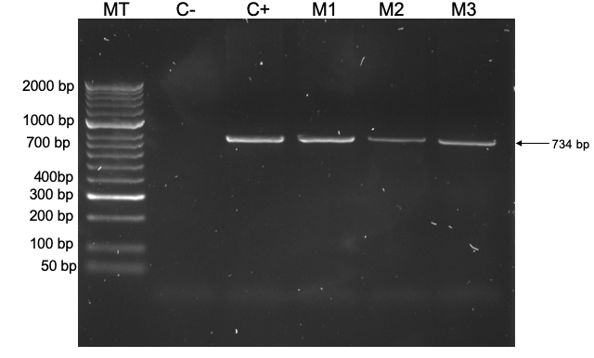
Sf 3. Electrophoresis for visualization of the HLA-A*02 allele amplification with an expected band of approximately 734 bp. MT: Hyperladder II molecular size marker from 50 bp to 2000 bp (BIOLINE). C-: negative control (distilled water), C+: positive control (sample positive for HLA-A*02 and confirmed by sequencing in previous work). M1-M3: DNA samples from 3 individuals included in the study.

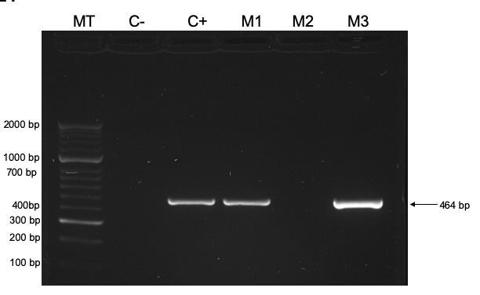
Sf 4. Electrophoresis for visualization of the HLA-A*24 supertype, with an expected band of approximately 464 bp. MT: Hyperladder II molecular size marker from 50 bp to 2000 bp (BIOLINE). C-: negative control (distilled water), C+: positive control (HLA-A*24 positive sample). M1-M3: DNA samples from 3 individuals included in the study.

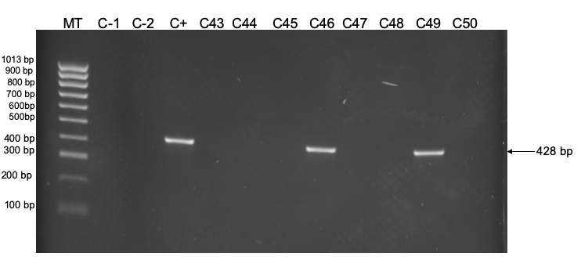
Sf 5. Electrophoresis for visualization of the HLA-B*35 allele, with an expected band of approximately 428 bp. MT: HyperLadder™ 100bp molecular size marker (BIOLINE). C-1: negative control (distilled water). C-2: negative control (DNA sample negative for the allele). C+: positive control (positive sample for HLA-B*35). C43-C50: DNA samples from 8 individuals included in the study.

