Supplementary File 3 PRISMA 2020 flow diagram
Clinical question 1 (remdesivir)
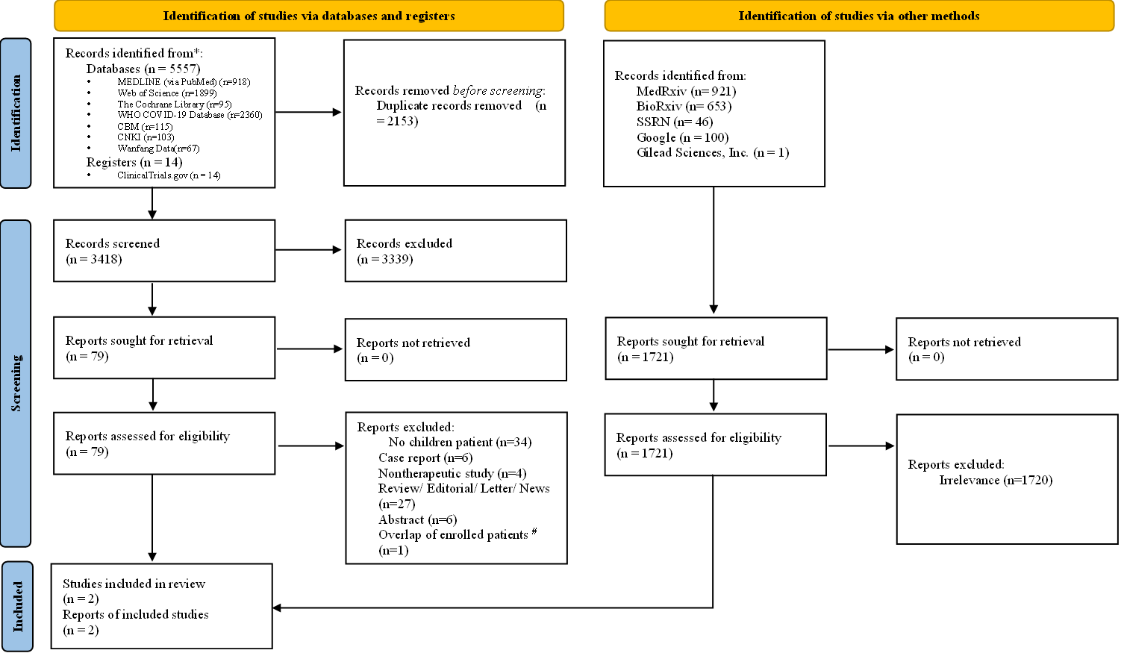
# Three patients in the cohort of Méndez-Echevarría et al. (Eur J Pediatr. 2021, n=8) were also included in Goldman et al. (Pediatrics. 2021, n=77) cohort. So we only include the Goldman cohort which with a larger sample size to improve the quality of the manuscript.
Clinical question 2 (glucocorticoids)
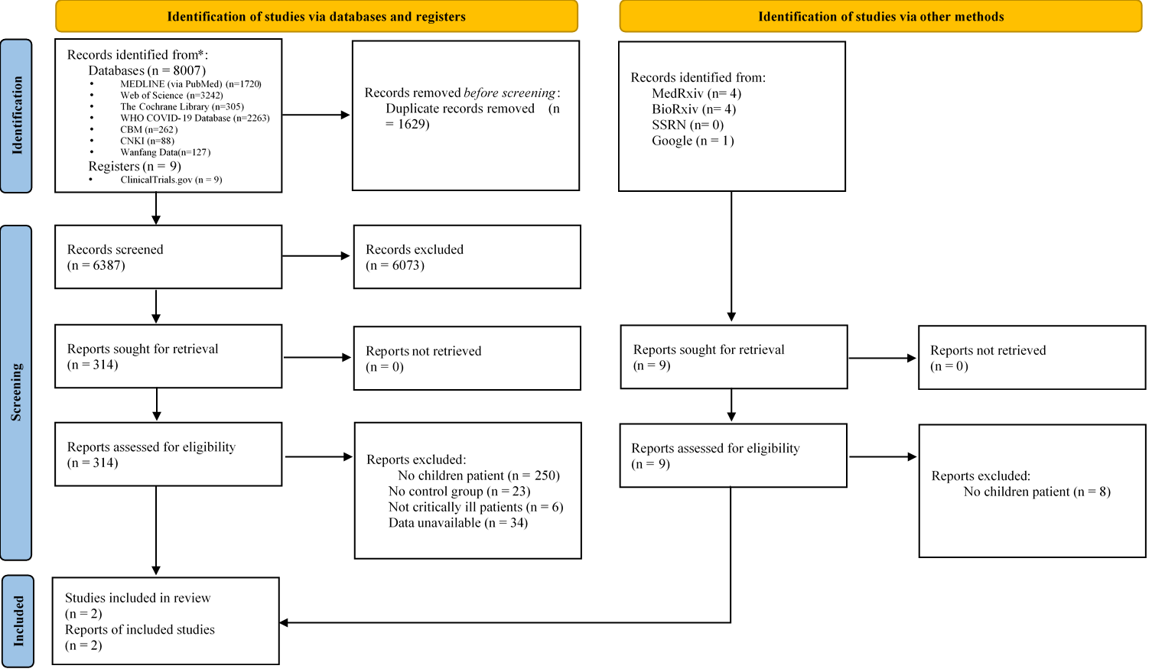
Clinical question 3 (IVIG)
