Title: A randomized controlled trial of a home-based computerized executive function intervention for children with cerebral palsy - Supplementary material
Journal: European Journal of Pediatrics.
Authors: García-Galant M_{1,2,3}, Blasco M_{1,2,3}, Laporta-Hoyos O_{1,2,3}, Berenguer-González A₁, Moral-Salicrú P₁, Ballester-Plané J_{1,2,3}, Caldú X_{1,2,3}, Miralbell J_{1,2,3}, Alonso X₄, Medina-Cantillo J₅, Povedano-Bulló E₅, Leiva D₆, Boyd R.N₇, Pueyo R_{1,2,3}*
- Departament de Psicologia Clínica i Psicobiologia, Universitat de Barcelona, Passeig de la Vall d’Hebron, 171, 08035, Barcelona, Spain
- Institut de Neurociències, Universitat de Barcelona, Passeig de la Vall d’Hebron, 171, 08035, Barcelona, Spain
- Institut de Recerca Sant Joan de Déu, Santa Rosa 39-57, 08950, Esplugues de Llobregat, Barcelona, Spain
- Servei de Neurologia, Hospital Sant Joan de Déu, Passeig de Sant Joan de Déu, 2, 08950, Esplugues de Llobregat, Barcelona, Spain
- Servei de Rehabilitació i Medicina Física, Passeig de Sant Joan de Déu, 2, 08950, Esplugues de Llobregat, Barcelona, Spain
- Departament de Psicologia Social i Psicologia Quantitativa, Universitat de Barcelona, Passeig de la Vall d’Hebron, 171, 08035, Barcelona, Spain.
- Queensland Cerebral Palsy and Rehabilitation Research Centre, Faculty of Medicine, The University of Queensland, 62 Graham St., Brisbane, 4101, Queensland, Australia

* Corresponding author at: Passeig de la Vall d’Hebron, 171, 08035, Barcelona, Spain
E-mail address: rpueyo@ub.edu
ORCID: 0000-0002-8230-8409
Fax number: [+34] 93 402 1584

Supplementary Material
Table S1
Mean (SD) and median (minimum/maximum) Z scores on the neuropsychological assessment tasks of the intervention and waitlist groups at baseline.
 |  |  |  |  |  | EF Intervention group |  |  |  |  | Waitlist group
 |  |  | Baseline |  |  | Post-intervention |  |  | Follow-Up |  | Baseline |  | Post-intervention |  | Follow-Up
Executive Functions |  |  | n | Mean*  (SD)  Median  (range) |  | n | Mean*  (SD)  Median  (range) |  | n | Mean*  (SD)  Median  (range) | n | Mean*  (SD)  Median  (range) | n | Mean*  (SD)  Median  (range) | n | Mean*  (SD)  Median  (range)
 | Inhibitory Control
 | Digit Span  (WISC-V) |  | 30 | -0.67  (-3.00/0.67) |  | 30 | -0.33  (-3.00/1.00) |  | 30 | -0.67  (-0.00/1.67) | 29ª | -1.44*  (0.17) | 29^{c} | -1.44*  (0.17) | 29^{c} | -1.6*  (0.17)
 | Spatial Span (WNV) |  | 30 | -0.91*  (0.22) |  | 30 | -0.53*  (0.28) |  | 30 | -0,64*  (0.23) | 29^{c} | -1.52*  (0.20) | 30 | -1.63*  (0.20) | 30 | -1.37*  (0.18)
 | Inhibition (FDT) |  | 29^{c} | -1.22  (-2.33/2.33) |  | 30 | -0.52  (-2.33/2.33) |  | 29^{c} | -0.84  (-2.33/2.33) | 26^{c} | -1.75  (-2.33/2.33) | 27^{c} | -0.84  (-2.33/2.33) | 27^{c} | -1.28  (-2.33/2.33)
 | Auditory Attention (NEPSY-II) |  | 30 | 0.50  (-3.00/1.33) |  | 29^{c} | 0.33  (-3.00/1.33) |  | 30 | 0.00  (-2.67/1.50) | 30 | -1.33  (-3.00/1.00) | 30 | -0.97  (-3.00/1.50) | 29^{c} | -0.33  (-3.00/1.50)
 | Working Memory
 | Digit Span Backward  (WISC-V) |  | 30 | -0.59  (-4.4/0.91) |  | 30 | -0.55*  (0.20) |  | 30 | -0.65*  (0.84) | 29ª | -1.09*  (0.25) | 29^{c} | -0.90  (-4.40/1.10) | 29^{c} | -1.33  (-3.00/0.33)
 | Spatial Span Backward* (WNV) |  | 30 | -0.64*  (0.27) |  | 30 | -1.57*  (0.30) |  | 30 | -0.55  (-5.10/1.25) | 29ª | -0.90  (-5.10/1.00) | 30 | -1.28*  (0.23) | 30 | -1.30*  (0.25)
 | Cognitive Flexibility
 | Word Generation (NEPSY-II)
 | Semantic Total |  | 30 | -0.56*  (0.19) |  | 30 | -0.71*  (0.21) |  | 30 | -0.49*  (0.19) | 28ª | -0.89*  (0.26) | 28ª | -0.79*  (0.26) | 28ª | -1.16  (-3.00/1.33)
 | Initial Letter |  | 30 | -1.06*  (0.16) |  | 30 | -3.74*  (0.14) |  | 30 | -0.63*  (0.21) | 28ª | -1.34*  (0.15) | 27^{ac} | -4.30  (-5.00/-2.00) | 28ª | -1.33  (-2.6/1.67)
 | Response Set  (NEPSY-II) |  | 30 | -0.58*  (0.25) |  | 29^{c} | -0.33  (-3.00/1.67) |  | 30 | 0.16  (-3.00/1.50) | 30 | -1.50  (-3.00/1.00) | 30 | -1.67  (-3.00/1.00) | 28^{cd} | -1.16  (-3.00/1.50)
 | Flexibility  (FDT) |  | 29^{c} | -0.52  (-2.33/2.33) |  | 30 | -0.45  (-2.33/2.33) |  | 29^{c} | <0.01*  (0.17) | 26^{c} | -2.05  (-2.33/2.33) | 27^{c} | -2.32  (-2.33/2.33) | 28^{c} | <0.01  (0.20)
 | Higher-Order Executive Functions
 | Tower  (D-KEFS) |  | 30 | -0.41*  (0.20) |  | 30 | 0.33  (-3.00/2.33) |  | 30 | 0.33  (-3.00/2.33) | 29^{b} | -1.00  (-3.00/0.33) | 28^{c} | -0.67  (-2.6/1.00) | 28^{bc} | -0.59*  (0.24)
 | Parental Executive function Questionnaires
 | BRIEF-2 (T-scores)
 |  | Behavioural Regulation Index | 30 | 62.17*  (2.28) |  | 27e | 56.00*  (41.00/92.00) |  | 26e | 59.58*  (2.69) | 29e | 61.14*  (2.01) | 29e | 61.03*  (1.88) | 27e | 62.00  (50.00/83.00)
 |  | Emotional  Regulation Index | 30 | 65.83*  (2.20) |  | 27e | 65.26*  (2.76) |  | 26e | 67.19*  (2.88) | 29e | 61.69*  (1.97) | 29e | 61.83*  (2.08) | 27e | 61.78  (2.21)
 |  | Cognitive Regulation Index | 29e | 63.97*  (2.22) |  | 27e | 62.96*  (2.76) |  | 26e | 63.57  (2.65) | 28e | 63.82*  (1.8) | 28e | 65.07*  (2.01) | 26e | 64.03*  (1.99)
 | Global Index of EF |  | 29e | 66.31*  (2.24) |  | 27e | 64.56*  (2.90) |  | 26e | 65.54  (2.83) | 28e | 64.54*  (1.91) | 28e | 65.39*  (2.04) | 26e | 65.04  (2.00)

Notes: Reasons for missing data: a = very slow communication system that precluded the use of an appropriate response system for the test used; b = severe motor impairment that made it difficult to complete the task; c = being not able to complete the test due to fatigue; d = lockdown precluded assessment, e = not answered by the parents.
Abbreviations: BRIEF-2 = Behavior Rating Inventory of Executive Function-Second Edition;
EF = Executive function; D-KEFS = Delis–Kaplan Executive Function System; FDT = Five Digit Test; NEPSY-II = A Developmental Neuropsychological Assessment, Second Edition;
SD = Standard deviation; WISC-V = Wechsler Intelligence Scale for Children-Fifth Edition; WNV = Wechsler Nonverbal Scale of Ability.

Table S2
Analysis of covariance comparing intervention and waitlist groups on EF postintervention outcomes
Outcomes |  |  | Intervention Group |  | Control Group |  | ANCOVA  Post-intervention
 |  |  | Estimated marginal mean  (SD) |  | Estimated marginal mean  (SD) |  | F |  | p |  | $$n_{p}^{2}$$
Executive Functions
Inhibitory Control
 | Digit Span (WISC-V) |  |  | -0.87  (0.10) |  | -1.10  (0.10) |  | 2.13 |  | 0.150 |  | 0.03
 | Spatial Span (WNV) ^{ac} |  |  | -0.70  (0.16) |  | -1.36  (0.16) |  | 7.58 |  | 0.008 |  | 0.13
 | Inhibition (FDT) ^{b} |  |  | -0.26  (0.28) |  | -0.48  (0.30) |  | 0.26 |  | 0.608 |  | 0.01
 | Auditory Attention (NEPSY-II) ^{c} |  |  | -0.73  (0.20) |  | -0.53  (0.19) |  | 0.43 |  | 0.514 |  | 0.01
Working Memory
 | Digit Span Backward  (WISC-V) ^{c} |  |  | -0.51  (0.13) |  | -0.82  (0.14) |  | 2.49 |  | 0.120 |  | 0.04
 | Spatial Span Backward (WNV) ^{ab} |  |  | -0.17  (0.23) |  | -0.15  (0.23) |  | 8.34 |  | 0.006 |  | 0.14
Cognitive Flexibility
 | Word Generation (NEPSY-II)
 | Semantic Total ^{c} |  |  | -0.80  (0.16) |  | -0.65  (0.16) |  | 0.40 |  | 0.526 |  | <0.01
 | Initial Letter |  |  | -3.82  (0.10) |  | -3.95  (0.11) |  | 0.68 |  | 0.412 |  | 0.01
 | Response Set (NEPSY-II) ^{ac} |  |  | -0.41  (0.16) |  | -0.95  (0.16) |  | 4.87 |  | 0.032 |  | 0.09
 | Flexibility (FDT) |  |  | -0.49  (0.26) |  | -1.03  (0.28) |  | 1.86 |  | 0.178 |  | 0.03
Higher-Order Executive Functions
 | Tower (D-KEFS) |  |  | -0.11  (0.18) |  | -0.39  (0.18) |  | 1.09 |  | 0.300 |  | 0.02
Manifestations of EF in daily life
 | BRIEF-2 (T-scores)
 |  | Behavioural Regulation Index^{abc} |  | 57.63  (1.24) |  | 60.76  (1.24) |  | 3.03 |  | 0.088 |  | 0.06
 |  | Emotional Regulation Index^{ac} |  | 63.11  (1.55) |  | 63.04  (1.55) |  | <0.01 |  | 0.978 |  | <0.01
 |  | Cognitive Regulation Index^{ac} |  | 62.58  (1.10) |  | 64.03  (1.10) |  | 0.85 |  | 0.360 |  | 0.02
 | Global Index of Executive Function ^{abc} |  |  | 63.44  (1.10) |  | 65.30  (1.10) |  | 1.37 |  | 0.248 |  | 0.03
Abbreviations: BRIEF-2 = Behavior Rating Inventory of Executive Function-Second Edition;
EF = Executive function; D-KEFS = Delis–Kaplan Executive Function System; FDT = Five Digit Test; NEPSY-II = A Developmental Neuropsychological Assessment, Second Edition;
SD = Standard deviation; WISC-V = Wechsler Intelligence Scale for Children-Fifth Edition; WNV = Wechsler Nonverbal Scale of Ability. Covariates: ª ASSQ = Autism Spectrum Screening Questionnaire; ^{b}PSS = Parental Stress Scale; ^{c} SDQ = Strengths and Difficulties Questionnaire.

Table S3
Analysis of covariance comparing intervention and waitlist groups on EF follow-up outcomes
Outcomes |  |  | Intervention Group | Waitlist Group | ANCOVA  Follow-up
 |  |  | Estimated marginal mean  (SD) | Estimated marginal mean  (SD) | F | p | $$n_{p}^{2}$$
Executive Functions
Inhibitory Control
 | Digit Span (WISC-V) |  | -0.88  (0.10) | -1.31  (0.10) | 7.85 | 0.007 | 0.12
 | Spatial Span (WNV) ^{ac} |  | -0.77  (0.13) | -1.10  (0.13) | 2.70 | 0.106 | 0.05
 | Inhibition (FDT) ^{b} |  | -0.74  (0.23) | -0.97  (0.25) | 0.44 | 0.510 | <0.01
 | Auditory Attention (NEPSY-II) ^{c} |  | -0.39  (0.20) | -0.40  (0.20) | <0.01 | 0.976 | <0.01
Working Memory
 | Digit Span Backward (WISC-V) ^{c} |  | -0.88  (0.13) | -1.09  (0.13) | 1.19 | 0.280 | 0.02
 | Spatial Span Backward (WNV)^{ab} |  | -0.41  (0.18) | -1.16  (0.18) | 7.55 | 0.008 | 0.13
Cognitive Flexibility
 | Word Generation (NEPSY-II)
 | Semantic Total^{c} |  | -0.58  (0.14) | -0.71  (0.15) | 0.39 | 0.532 | <0.01
 | Initial Letter |  | -0.75  (0.15) | -1.05  (0.16) | 1.78 | 0.187 | 0.03
 | Response Set (NEPSY-II) ^{ac} |  | -0.07  (0.21) | -0.74  (0.23) | 4.19 | 0.046 | 0.08
 | Flexibility (FDT) |  | -0.83  (0.20) | -1.36  (0.21) | 3.19 | 0.080 | 0.06
Higher-Order Executive Functions
 | Tower (D-KEFS) |  | -0.03  (0.14) | -0.26  (0.14) | 1.27 | 0.265 | 0.02
Manifestations of EF in daily life
 | BRIEF-2 (T-scores)
 |  | Behavioural Regulation Index ^{abc} | 58.83  (1.27) | 62.39  (1.24) | 3.82 | 0.057 | 0.07
 |  | Emotional Regulation Index ^{ac} | 64.93  (1.90) | 63.98  (1.86) | 0.12 | 0.727 | <0.01
 |  | Cognitive Regulation Index ^{ac} | 63.43  (1.48) | 63.68  (1.48) | 0.01 | 0.906 | <0.01
 | Global Index of Executive Function ^{abc} |  | 65.16  (1.44) | 64.95  (1.44) | 0.01 | 0.921 | <0.01
Abbreviations: BRIEF-2 = Behavior Rating Inventory of Executive Function-Second Edition;
EF = Executive function; D-KEFS = Delis–Kaplan Executive Function System; FDT = Five Digit Test; NEPSY-II = A Developmental Neuropsychological Assessment, Second Edition;
SD = Standard deviation; WISC-V = Wechsler Intelligence Scale for Children-Fifth Edition; WNV = Wechsler Nonverbal Scale of Ability. Covariates: ª ASSQ = Autism Spectrum Screening Questionnaire; ^{b}PSS = Parental Stress Scale; ^{c} SDQ = Strengths and Difficulties Questionnaire.
Table S4
Intention to treat analysis of covariance comparing intervention and waitlist groups on EF postintervention outcomes
Outcomes |  |  | Intervention Group |  | Control Group |  | ANCOVA  Post-intervention
 |  |  | Estimated marginal mean  (SD) |  | Estimated marginal mean  (SD) |  | F |  | p |  | $$n_{p}^{2}$$
Executive Functions
Inhibitory Control
 | Digit Span (WISC-V) |  |  | -0.95  (0.10) |  | -1.16  (0.10) |  | 2.30 |  | 0.135 |  | <0.01
 | Spatial Span (WNV) ^{ab} |  |  | -0.72  (0.16) |  | -1.40  (0.16) |  | 6.00 |  | 0.018 |  | 0.14
 | Inhibition (FDT)^{c} |  |  | -0.36  (0.25) |  | -0.58  (0.26) |  | 0.38 |  | 0.540 |  | <0.01
 | Auditory Attention (NEPSY-II)^{b} |  |  | -0.74  (0.19) |  | -0.53  (0.19) |  | 0.63 |  | 0.431 |  | <0.01
Working Memory
 | Digit Span Backward  (WISC-V) ^{b} |  |  | -0.59  (0.15) |  | -0.91  (0.15) |  | 2.40 |  | 0.127 |  | <0.01
 | Spatial Span Backward (WNV) ^{ac} |  |  | -0.17  (0.23) |  | -0.16  (0.24) |  | 7.52 |  | 0.008 |  | 0.03
Cognitive Flexibility
 | Word Generation (NEPSY-II)
 | Semantic Total ^{b} |  |  | -0.82  (0.16) |  | -0.67  (0.16) |  | 0.51 |  | 0.477 |  | <0.01
 | Initial Letter |  |  | -0.8  (0.16) |  | -1.04  (0.16) |  | 1.15 |  | 0.287 |  | <0.01
 | Response Set (NEPSY-II) ^{ab} |  |  | -0.47  (0.16) |  | -1.00  (0.16) |  | 6.49 |  | 0.014 |  | 0.12
 | Flexibility (FDT) |  |  | -0.62  (0.25) |  | -1.17  (0.24) |  | 2.43 |  | 0.124 |  | <0.01
Higher-Order Executive Functions
 | Tower (D-KEFS) |  |  | -0.16  (0.17) |  | -0.41  (0.17) |  | 1.04 |  | 0.311 |  | <0.01
Manifestations of EF in daily life
 | BRIEF-2 (T-scores)
 |  | Behavioural Regulation Index^{abc} |  | 58.46  (1.87) |  | 60.27  (1.91) |  | 0.49 |  | 0.488 |  | <0.01
 |  | Emotional Regulation Index^{ab} |  | 63.38  (1.39) |  | 63.54  (1.42) |  | 0.05 |  | 0.824 |  | <0.01
 |  | Cognitive Regulation Index^{ab} |  | 62.52  (0.97) |  | 64.06  (1.00) |  | 1.06 |  | 0.308 |  | 0.02
 | Global Index of Executive Function ^{abc} |  |  | 66.81  (2.48) |  | 63.58  (2.53) |  | 0.42 |  | 0.518 |  | <0.01
Abbreviations: BRIEF-2 = Behavior Rating Inventory of Executive Function-Second Edition;
EF = Executive function; D-KEFS = Delis–Kaplan Executive Function System; FDT = Five Digit Test; NEPSY-II = A Developmental Neuropsychological Assessment, Second Edition;
SD = Standard deviation; WISC-V = Wechsler Intelligence Scale for Children-Fifth Edition; WNV = Wechsler Nonverbal Scale of Ability. Covariates: ª ASSQ = Autism Spectrum Screening Questionnaire; ^{b}PSS = Parental Stress Scale; ^{c} SDQ = Strengths and Difficulties Questionnaire.

Table S5
Intention to treat analysis of covariance comparing intervention and waitlist groups on EF follow-up outcomes
Outcomes |  |  | Intervention Group |  | Control Group |  | ANCOVA  Follow-Up
 |  |  | Estimated marginal mean  (SD) |  | Estimated marginal mean  (SD) |  | F |  | p |  | $$n_{p}^{2}$$
Executive Functions
Inhibitory Control
 | Digit Span (WISC-V) |  |  | -1.06  (0.09) |  | -1.43  (0.09) |  | 8.38 |  | 0.005 |  | <0.01
 | Spatial Span (WNV) ^{ab} |  |  | -0.80  (0.13) |  | -1.34  (0.13) |  | 1.25 |  | 0.269 |  | 0.14
 | Inhibition (FDT) c |  |  | -0.80  (0.22) |  | -1.06  (0.23) |  | 0.99 |  | 0.323 |  | <0.01
 | Auditory Attention (NEPSY-II)^{b} |  |  | -0.48  (0.20) |  | -0.38  (0.20) |  | 0.08 |  | 0.772 |  | <0.01
Working Memory
 | Digit Span Backward  (WISC-V) ^{c} |  |  | -0.97  (0.14) |  | -1.12  (0.13) |  | 0.69 |  | 0.408 |  | <0.01
 | Spatial Span Backward (WNV) ^{ac} |  |  | -0.49  (0.23) |  | -1.15  (0.23) |  | 8.52 |  | 0.067 |  | 0.03
Cognitive Flexibility
 | Word Generation (NEPSY-II)
 | Semantic Total ^{b} |  |  | -0.6  (0.14) |  | -0.74  (0.14) |  | 0.33 |  | 0.566 |  | <0.01
 | Initial Letter |  |  | -0.74  (0.15) |  | -1.03  (0.15) |  | 1.84 |  | 0.180 |  | <0.01
 | Response Set (NEPSY-II) ^{ab} |  |  | -0.14  (0.21) |  | -0.82  (0.21) |  | 6.04 |  | 0.017 |  | 0.12
 | Flexibility (FDT) |  |  | -0.98  (0.19) |  | -1.49  (0.18) |  | 3.63 |  | 0.062 |  | <0.01
Higher-Order Executive Functions
 | Tower (D-KEFS) |  |  | -0.05  (0.14) |  | -0.32  (0.14) |  | 1.93 |  | 0.170 |  | <0.01
Manifestations of EF in daily life
 | BRIEF-2 (T-scores)
 |  | Behavioural Regulation Index^{abc} |  | 58.55  (1.88) |  | 62.20  (1.88) |  | 2.51 |  | 0.119 |  | 0.05
 |  | Emotional Regulation Index^{ab} |  | 64.44  (1.75) |  | 64.00  (1.78) |  | <0.01 |  | 0.945 |  | <0.01
 |  | Cognitive Regulation Index^{ab} |  | 63.12  (1.37) |  | 63.81  (1.42) |  | 0.03 |  | 0.856 |  | <0.01
 | Global Index of Executive Function ^{abc} |  |  | 64.31  (1.33) |  | 64.66  (1.36) |  | 0.44 |  | 0.509 |  | <0.01
Abbreviations: BRIEF-2 = Behavior Rating Inventory of Executive Function-Second Edition;
EF = Executive function; D-KEFS = Delis–Kaplan Executive Function System; FDT = Five Digit Test; NEPSY-II = A Developmental Neuropsychological Assessment, Second Edition;
SD = Standard deviation; WISC-V = Wechsler Intelligence Scale for Children-Fifth Edition; WNV = Wechsler Nonverbal Scale of Ability. Covariates: ª ASSQ = Autism Spectrum Screening Questionnaire; ^{b}PSS = Parental Stress Scale; ^{c} SDQ = Strengths and Difficulties Questionnaire.

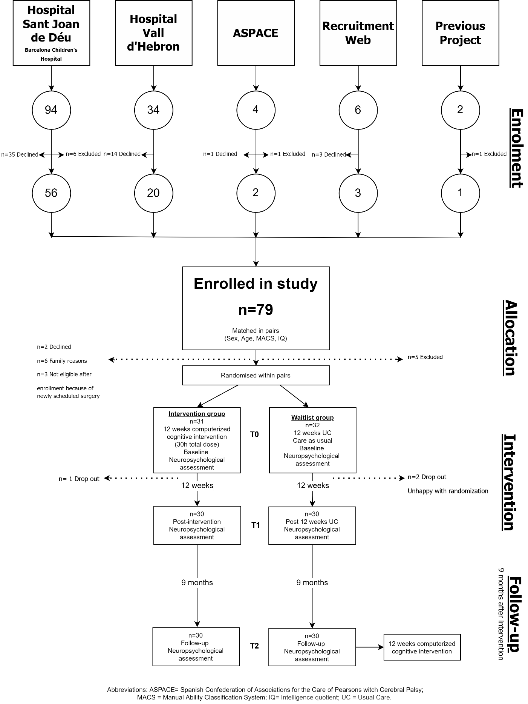
Figure S1. Sample flowchart

Abbreviations: IQ = Intelligence Quotient; MACS = Manual Ability Classification System.

Figure S2. Graphical representation of differences between intervention and waitlist groups in higher-order graphical representation
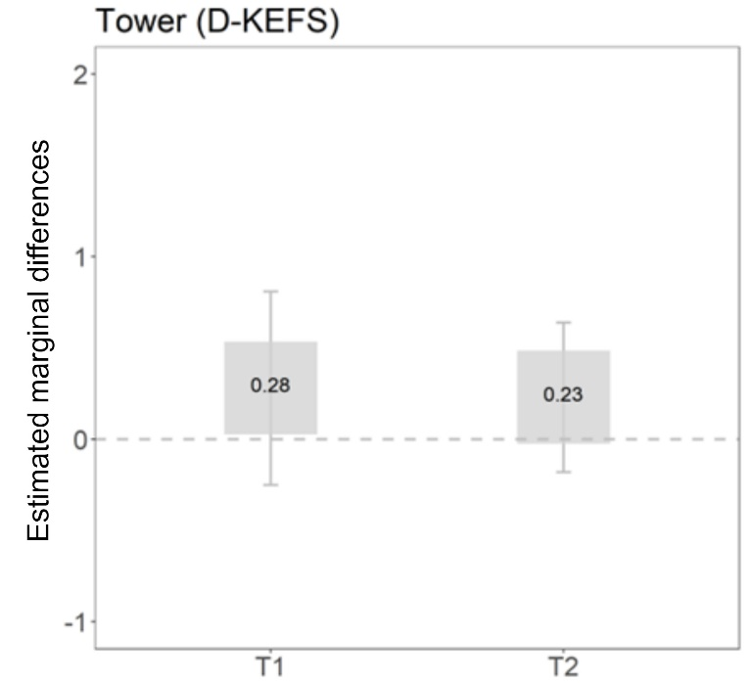

Notes: dark grey box (significant differences between the intervention and waitlist group); light grey (no significant differences). Estimated marginal differences (estimated marginal mean of the intervention group – estimated marginal mean of the waitlist control group) above zero indicate that the intervention group has better performance than the waitlist group. Whiskers correspond to the 95% CIs for the marginal differences.
Abbreviations: T1 = postintervention; T2 = 9-month follow-up after the intervention; D-KEFS = Delis-Kaplan Executive Function System.

Figure S3. Graphical representation of differences between intervention and waitlist groups in manifestations of EF in daily life graphical representation
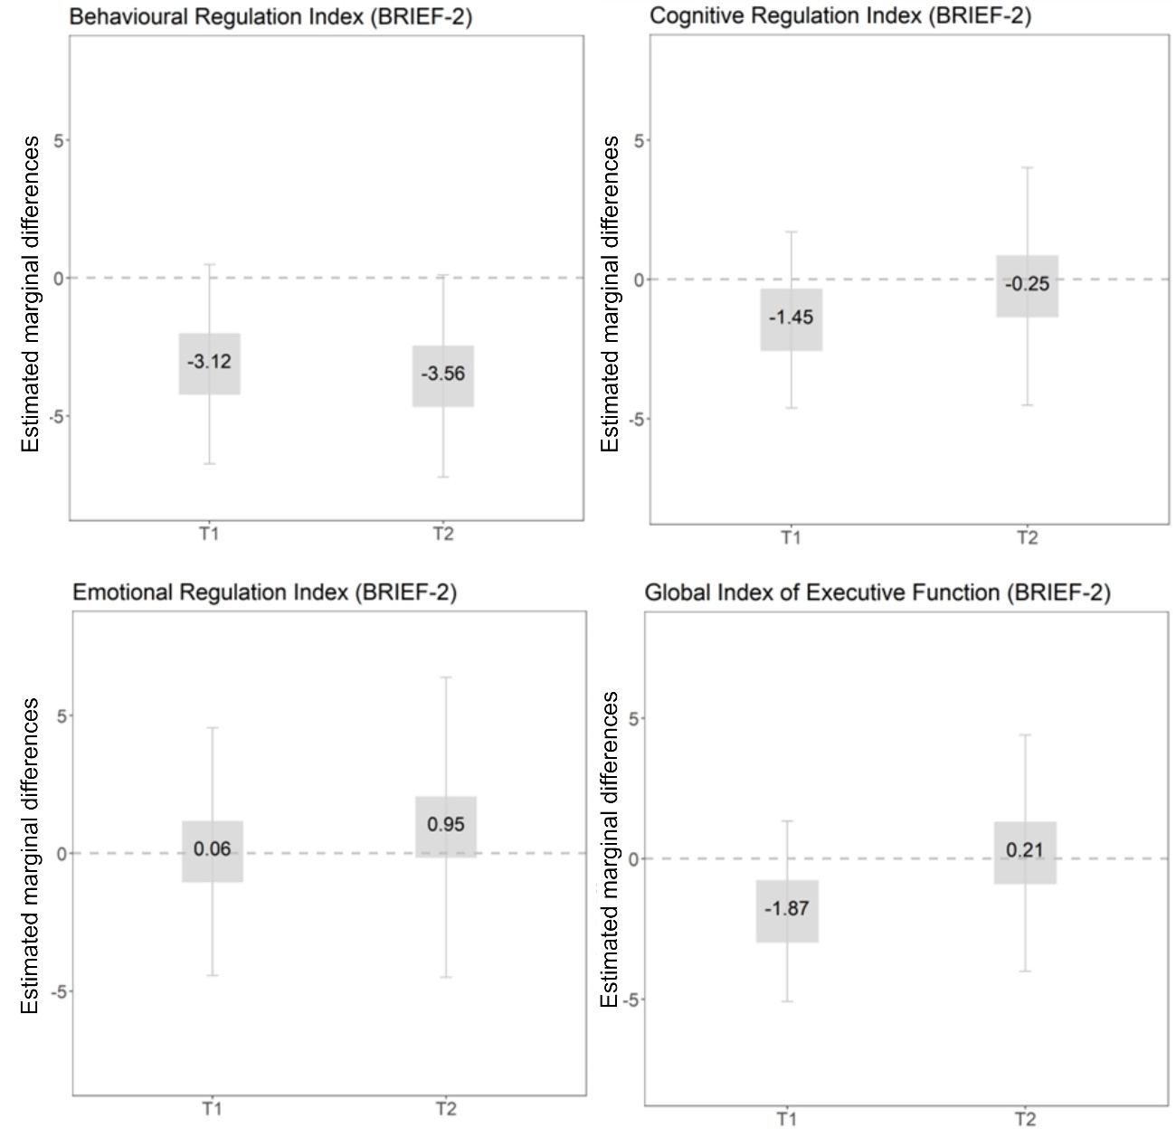
Notes: dark grey box (significant differences between the intervention and waitlist group); light grey (no significant differences). Estimated marginal differences (estimated marginal mean of the intervention group – estimated marginal mean of the waitlist control group) under zero indicate that the intervention group has better performance than the waitlist group. Whiskers correspond to the 95% CIs for the marginal differences.
Abbreviations: T1 = postintervention; T2 = 9-month follow-up after the intervention; BRIEF-2 = Behavior Rating Inventory of Executive Function-2.

