Supplementary File 1: Causal diagram of a priori selected potential confounders, which is an independent cause of the outcome and associated with the exposure.

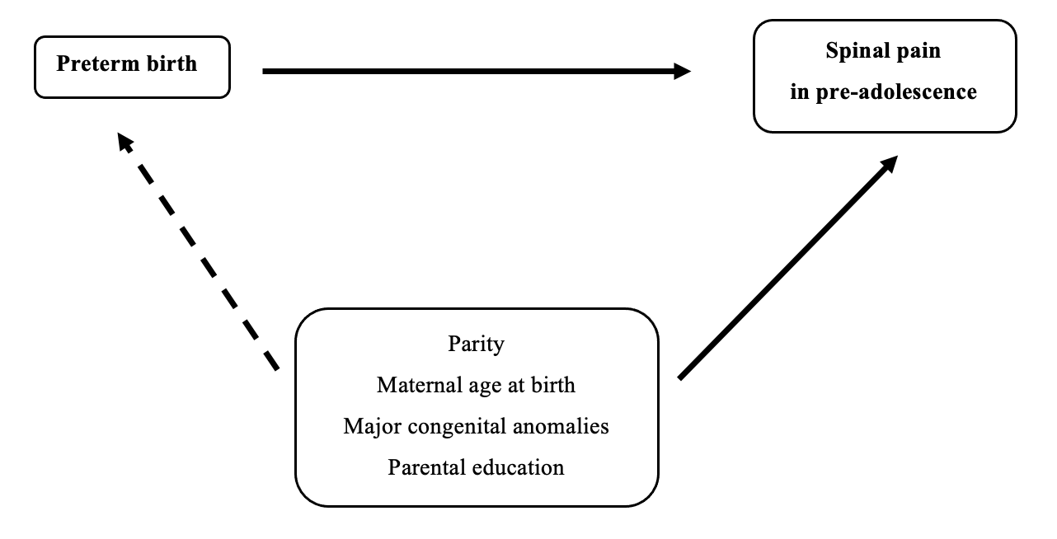

Supplementary File 2
Loss to follow-up (The Danish National Birth Cohort, 1996-2003)
Characteristics | Study population  47,063 (51.7) | Lost to follow-upª  43,917 (48.3)
Child’s sex
Boys | 22,439 (47.7) | 24,098 (54.9)
Girls | 24,624 (52.2) | 19,819 (45.1)
Gestational age
Term | 44,546 (94.7) | 41,101 (93.6)
Moderate preterm | 1,937 (4.1) | 2,059 (4.7)
Very preterm | 580 (1.2) | 757 (1.7)
Parity
Nulliparous | 22,607 (48.0) | 20,091 (45.8)
Parous | 24,456 (52.0) | 23,766 (54.2)
Missing | 0 | 60
Maternal age at birth
< 25 years | 2,586 (5.5) | 4,269 (9.7)
25-29 years | 16,371 (34.8) | 15,865 (36.1)
30-34 years  ≥ 35 years | 19,123 (40.6)  8,983 (19.1) | 16,590 (37.8)  7,193 (16.4)
Parental education
High | 29,847 (63.4) | 20,892 (47.7)
Medium | 16,028 (34.1) | 20,253 (46.2)
Low | 1,188 (2.5) | 2,697 (6.2)
Missing | 0 | 75
Major congenital anomalies
No | 45,371 (96.4) | 42,084 (95.8)
Yes | 1,692 (3.6) | 1,833 (4.2)
a We used chi-squared tests of heterogeneity to compare study participants with individuals lost to follow-up. Chi-squared tests were statistically significant for all variables

Supplementary File 3
Prevalence of all types of spinal pain measured
Characteristics |  | Neck pain |  | Mid back pain |  | Low back pain
 | Total (%) | Prevalence | Total (%) | Prevalence | Total (%) | Prevalence
Boys (n=22,439)
Term | 1,353 (94.2) | 6 % | 707 (94.1) | 3.2% | 537 (93.6) | 2.4 %
Moderate preterm | 63 (4.4) | 0.3 % | 34 (4.5) | 0.2 % | 31 (5.4) | 0.1 %
Very preterm | 20 (1.4) | 0.1 % | 10 (1.3) | >0.1 % | 6 (1.1) | >0.1 %
Girls (n=24,624)
Term | 2,002 (96.2) | 8.1 % | 1,188 (95.2) | 4.8 % | 1,116 (95.4) | 4.5 %
Moderate preterm | 65 (3.12) | 0.3 % | 50 (4.0) | 0.2 % | 45 (3.9) | 0.2 %
Very preterm | 15 (0.7) | 0.1 % | 10 (0.8) | >0.1 % | 9 (0.8) | >0.1 %

