Supplementary Table 1. Description of five Norwegian national health and social registries providing data for this study.

Registries | Description | Main variables used in the study | Data available from years
Medical Birth Registry of Norway | Provides data on pregnancy, delivery, and perinatal period. | Maternal health variables, mode of delivery, gestational age, birth weight, Apgar scores, congenital malformations, admission data and basic treatment variables in the neonatal period, see Table 1. | 1999- 2019
The Norwegian Patient Registry | Provides data on diagnostic and surgical and medical procedural codes, | Detailed diagnoses for hearing impairment and other relevant diagnoses and therapies used in the NICU, see Table 1. | 2008-2019
The Norwegian National Insurance Scheme | Provides data on diagnoses causing illness-related expenses | Only hearing impairment | 1999-2019
Norwegian Cause of Death registry | Provides time and cause of death according to ICD-10 diagnoses | Data was used to filter out participants that died before the age of 2 years. | 1999-2019
Statistics Norway | Provides data on a wealth of aspects from national statistics in Norway | Data on parental immigration status and educational level of the mother | 1999-2019

Supplementary Table 2. Diagnostic codes for hearing impairment in ICD-10 and included cases from Norwegian patient registry (NPR) and the Norwegian national insurance scheme (NIS).
ICD-10  Diagnostic codes |  | Cases included from NPR* | Cases included from NIS** | Cases registered in both NPR and NIS | Total number of cases included.
H 90.0 | Conductive hearing loss, bilateral | No | No
H 90.1 | Conductive hearing loss, unilateral | No | No
H 90.2 | Conductive hearing loss, unspecified | No | No
H 90.3 | Sensorineural hearing loss, bilateral | Yes | Yes
H 90.4 | Sensorineural hearing loss, unilateral | Yes | Yes
H 90.5 | Sensorineural hearing loss, unspecified | Yes | Yes
H 90.6 | Mixed conductive and sensorineural hearing loss, bilateral | No | Yes
H 90.7 | Mixed conductive and sensorineural hearing loss, unilateral | No | Yes
H 90.8 | Mixed conductive and sensorineural hearing loss, unspecified | No | Yes
H 91.0 | Ototoxic hearing loss | No | No
H 91.1 | Presbycusis | No | No
H 91.2 | Sudden idiopathic hearing loss | No | No
H 91.3 | Deaf mutism, not elsewhere classified | No | Yes
H 91.8 | Other specified hearing loss | No | Yes
H 91.9 | Hearing loss, unspecified | No | Yes
TOTAL |  | 5 339 | 433 | 363 | 5 409

* if registered two times or more
** if registered once or more

Supplementary Table 3. Prevalence, crude and adjusted odds ratio (OR) for sensorineural hearing impairment, in relation to perinatal asphyxia and neonatal morbidity, among boys and girls in a total cohort of 866 232 infants born ≥ 36 weeks gestation between 1999 and 2014 and alive at 2 years of age.
 |  |  | BOYS | GIRLS | BOYS (1) | GIRLS (0) | Interaction term
Gender distribution within group | Criteria for group definition | Clinical description | Hearing impairment  N % | Hearing impairment  N (%) | Adjusted OR *  (95% CI) | Adjusted OR *  (95% CI) | Adjusted OR *  (95% CI)
Reference group  N=759 322  Boys 50.5% (N= 383 553) | Apgar 5-min 7-10  No NICU-admission | Healthy | 2301 (0.6) | 2187 (0.6) | Not applicable | Not applicable | Not applicable
Group 1  N=53 572  Boys 57.5% (N= 30 784) | Apgar 5-min 7-10  NICU-admission | Neonatal illness - not asphyxia | 298 (1) | 223 (1) | 1.6 (1.4-1.8) | 1.6 (1.4-1.9) | 1.6 (1.4-1.8)
Group 2  N=2 175  Boys 57.1 % (N=1 243) | Apgar 5-min < 7  No NICU-admission | Low Apgar score, rapid recovery | 8 (0.6) | 2 (0.2) | 1.1 (0.5-2.1) | 0.4 (0.1-1.5) | 3.0 (0.6-14.2)
Group 3  N=4 591  Boys 56.6 % (N=2 598) | Apgar 5-min: 4-6  NICU-admission | Moderate asphyxia | 38 (1.5) | 22 (1.1) | 2.4 (1.7-3.3) | 1.9 (1.2-2.9) | 1.3 (0.8-2.2)
Group 4  N=972  Boys 55.1 % (N=536) | Apgar 5-min: 0-3  NICU-admission | Severe asphyxia | 19 (3.5) | 11 (2.5) | 5.9 (3.7-9.4) | 4.3 (2.4-7.9) | 1.4 (0.7-3.0)
Group 5†  N=115  Boys 54.8 % (N=63) | Apgar 5-min < 7  NICU-admission Seizures, no TH | Neonatal encephalopathy with seizures† | 3 (4.8) | 1 (1.9) | 9.1 (2.8-29.1) | 4.1 (0.6-29.9) | 2.6 (0.3- 25.3)
Group 6†  N=155  Boys 54.2 % (N=84) | Moderate-severe HIE  NICU-admission TH | Moderate-severe HIE and TH† | 6 (7.1) | 2 (2.8) | 14.2 (6.2-32.6) | 6.2 (1.5-25.1) | 2.6 (0.5-13.5)
† Data available only for birth cohorts 2008-2014 (N = 391 817)
*Adjusted for a diagnosis of being small for gestational age
HIE; hypoxic-ischemic encephalopathy, NICU; neonatal intensive care unit, TH; therapeutic hypothermia
Supplementary Table 4. Prevalence, crude, and adjusted odds ratio (OR) for sensorineural hearing impairment, in relation to perinatal asphyxia and neonatal morbidity, among 866 232 infants born ≥ 36 weeks gestation in Norway 1999-2014 and alive at two years of age.
Clinical description  of exposure | Criteria | Hearing impairment  N (%) | Crude OR  (95 % CI) | Adjusted OR  (95 % CI) | Adjusted OR (95 % CI)  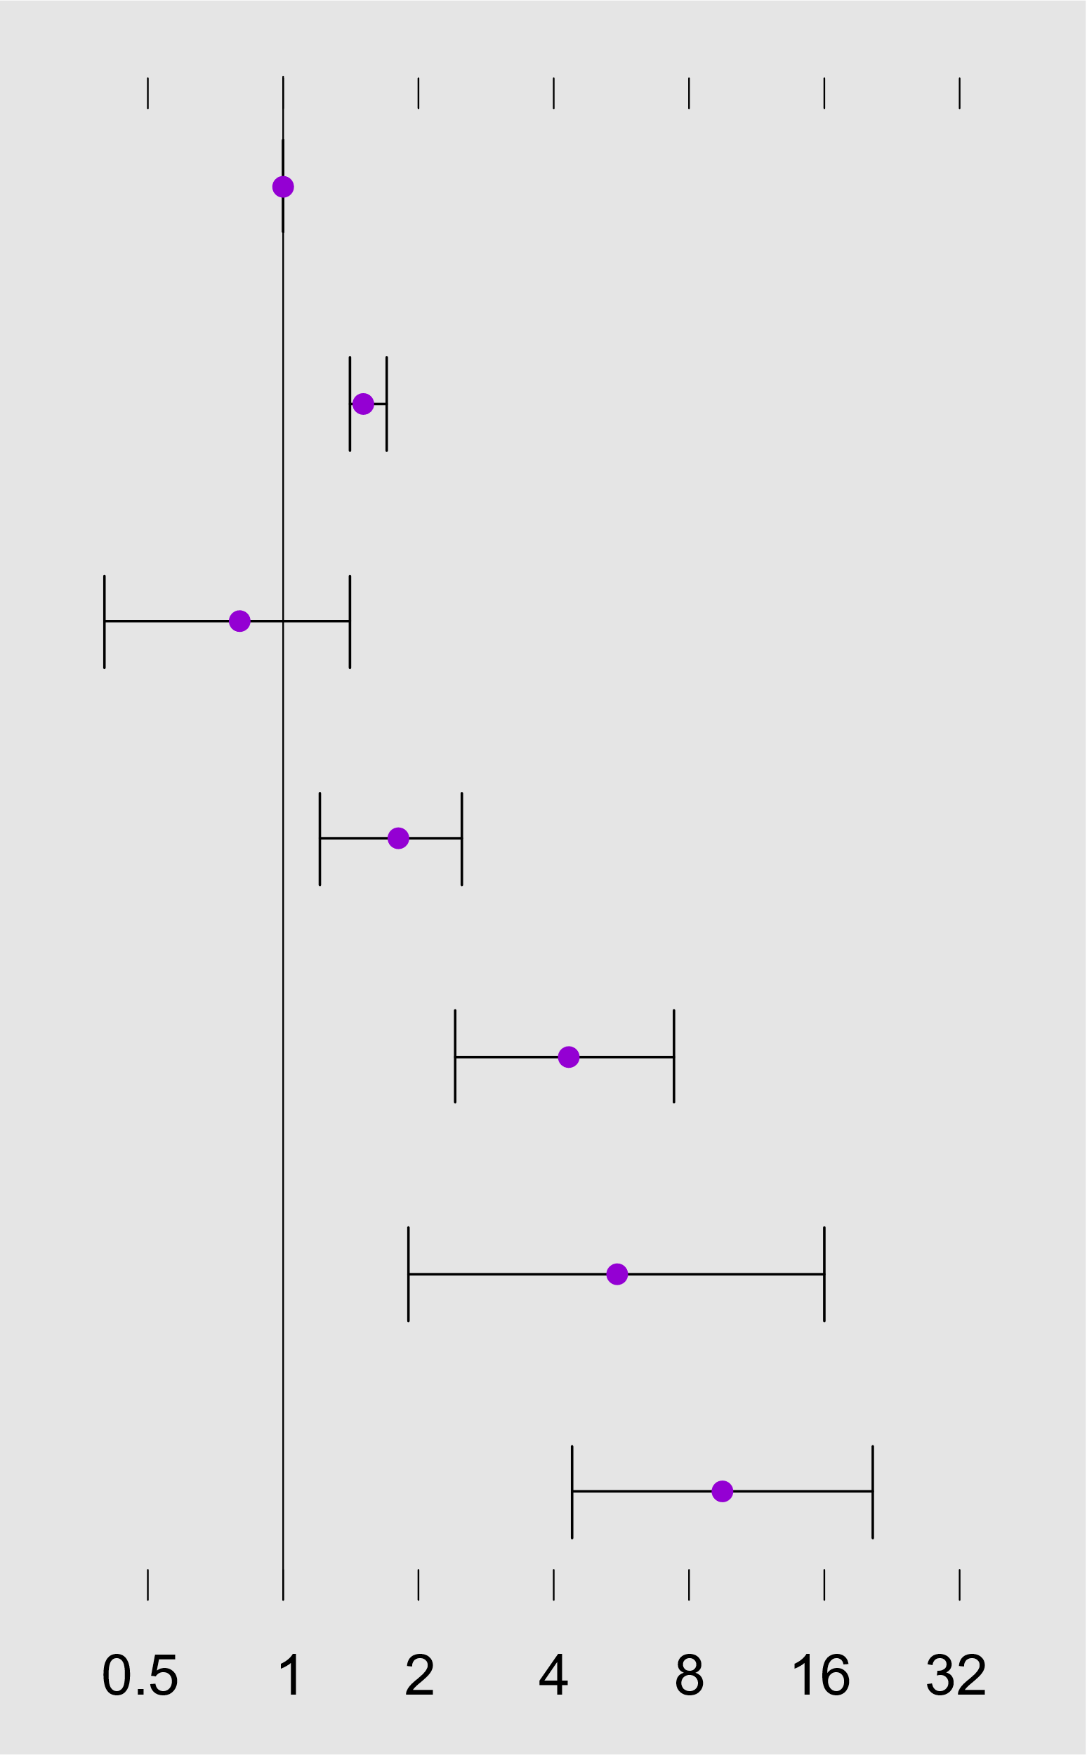
Healthy reference group  N=759 322 | Apgar 5-min 7-10  No NICU admission | 4 488 (0.6) | 1.0  (reference) | 1.0  (reference)
Neonatal illness - not asphyxia  N=53 572 | Apgar 5-min 7-10  NICU-admission | 521 (1.0) | 1.6 (1.5-1.8) | 1.5 (1.4-1.7)  **
Low Apgar score, rapid recovery  N=2 175 | Apgar 5-min < 7  No NICU admission | 10 (0.5) | 0.8 (0.4-1.4) | 0.8 (0.4-1.4)  **
Moderate asphyxia  N=4 591 | Apgar 5-min 4-6  NICU-admission | 60 (1.3) | 2.1 (1.2-2.7) | 1.8 (1.2-2.5)  **
Severe asphyxia  N=972 | Apgar 5-min 0-3  NICU-admission | 30 (3.1) | 5.1 (3.5-7.3) | 4.3 (2.4-7.4)  **
Neonatal encephalopathy †  N=115 | Apgar 5-min < 7  Neonatal seizures, no TH  NICU-admission | 4 (3.5) | 7.2 (2.6-19.5) | 5.5 (1.9-16.0) ***
Moderate-severe HIE †  N=155 | Received TH  NICU-admission | 8 (5.2) | 10.9 (5.3-22.1) | 9.5 (4.4-20.4) ***
† Data available only for birth cohorts 2008-2014 (N = 391 817)
** Adjusted for neonatal systemic antibiotic therapy and a diagnosis of being small for gestational age
*** Adjusted for being diagnosed with neonatal sepsis and a diagnosis of being small for gestational age
HIE; hypoxic-ischemic encephalopathy, min; minute, NICU; neonatal intensive care unit, TH; therapeutic hypothermia.
Supplementary Table 5. Prevalence, crude, and adjusted odds ratio (OR) for sensorineural hearing impairment in relation to defined confounders, mediators, and covariates among 866 232 infants born ≥ 36 weeks gestation in Norway 1999-2014.
EXPOSURES | N (%) | Hearing impairment N (%) | Crude OR (95 % CI) | Adjusted OR (95 % CI) *
Confounders
Antibiotic therapy | 16 196 (1.9) | 200 (1.2) | 2.0 (1.8-2.3) | 1.4 (0.7-2.7)
Neonatal sepsis † | 2 976 (0.8) | 38 (1.3) | 2.5 (1.8-3.4) | 1.7 (0.6-4.8)
Small for gestational age | 76 858 (8.9) | 645 (0.8) | 1.4 (1.3-1.5) | 1.3 (1.2-1.4)
Mediators
Mechanical ventilation | 1 220 (0.1) | 53 (4.3) | 7.3 (5.5-9.6) | 2.9 (1.4-5.9)
Non-invasive respiratory support | 5 045 (0.6) | 78 (1.5) | 2.5 (2.0-3.2) | 1.7 (0.8-3.5)
Covariates
Jaundice therapy | 42 555 (4.9) | 338 (0.8) | 1.3 (1.2-1.4) | 1.2 (1.1-1.4)
Emergency cesarean delivery | 73 860 (8.5) | 547 (0.7) | 1.2 (1.1-1.3) | 1.0 (0.9-1.2)
Maternal obesity**  (Body Mass Index ≥ 30) | 24 764 (2.9) | 136 (0.5) | 1.2 (1.0-1.4) | 1.1 (0.9-1.4)
Daily smoking early in  pregnancy *** | 46 529 (5.4) | 339 (0.7) | 1.4 (1.3-1.5) | 1.4 (1.3-1.5)
Low education  (High school or less) | 394 578 (45.6) | 2 765 (0.7) | 1.2 (1.2-1.3) | 1.2 (1.2-1.3)
Parental consanguinity | 8 970 (1.0) | 103 (1.1) | 1.9 (1.5-2.3) | 1.9 (1.5-2.3)
† Data available only for birth cohorts 2008-2014 (N = 391817)
*Adjusted for severe perinatal asphyxia (Apgar 5-min 0-3 and NICU admission) ** Missing data for 77 % of population, not included in analysis. *** Missing data for 15.7 % of population, not included in analysis

