Supplementary material
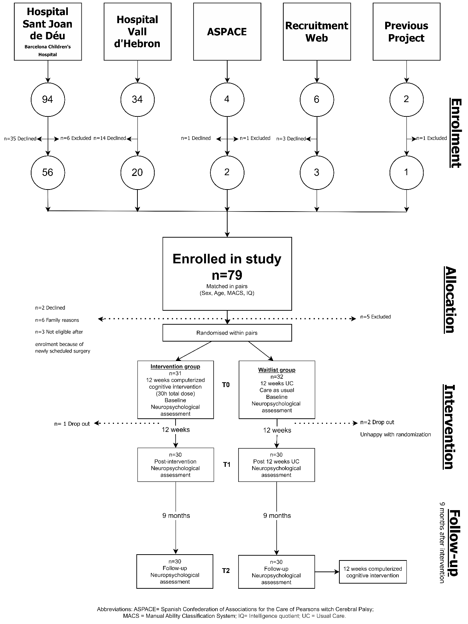
Figure S1. Sample flowchart

Abbreviations: ASPACE = Spanish Confederation of Associations of the Care of People with Cerebral Palsy; IQ = Intelligence Quotient; MACS = Manual Ability Classification System; UC = Usual Care.

Table S1. Descriptive statistics for potential covariates
 |  | Intervention group |  | Control group
Frequency of Pain (CHQ), n (%)
 | Never |  | 8 (26) | 16 (29)
 | A few times |  | 14 (46) | 10 (18)
 | Often |  | 4 (13) | 3 (5.4)
 | Unknown |  | 4 (13) | 1 (1.8)
ASSQ, median (range) |  |  | 4.5 (0-36) | 9 (0-25)
SDQ, mean ± SD |  |  | 13.9 ± 6.2 | 13.7 ± 5.2
fQOL, mean ± SD |  |  | 3.8 ± 0.7 | 3.8 ± 0.6
PSS, median (range) |  |  | 22 (13-43) | 25 (17-45)
Abbreviations: ASSQ = Autism Spectrum Screening Questionnaire; CHQ = Child Health Questionnaire; fQOL = Beach Center Family Quality of Life Scale; PSS = Parental Stress Scale; SD = Standard Deviation; SDQ = Strengths and Difficulties Questionnaire.

Table S2. Mean (SD) and Median (minimum/maximum) of Z scores on the SC assessment tasks of Intervention and Control groups baseline.
 |  |  |  | EF Intervention group |  |  |  | Control group
 |  | Baseline |  | Post-intervention |  | Follow-up |  | Baseline |  | Post-intervention |  | Follow-up
Social Cognition |  | n | Mean*  (SD)  Median  (min/max) | n | Mean*  (SD)  Median  (min/max) | n | Mean*  (SD)  Median  (min/max) | n | Mean*  (SD)  Median  (min/max) | n | Mean*  (SD)  Median  (min/max) | n | Mean*  (SD)  Median  (min/max)
 | Affect Recognition (NEPSY-II) | 30 | -0.48*  (1.20) | 30 | 0.00*  (1.20) | 29ª | -0.15*  (0.95) | 30 | -1.08*  (1.01) | 30 | -1.01*  (1.11) | 30 | -0.91*  (1.01)
 | Theory of Mind  (NEPSY-II) | 29 | -0.95  (-2.19-1.50) | 30 | -0.32  (-2.19/1.50) | 29ª | -0.32  (-2.19/1.50) | 30 | -1.63  (-2.19/1.50) | 29ª | -1.41  (-2.19/1.50) | 29ª | -0.91  (-2.19/1.50)
Notes: Reasons for missing data: a = Lockdown precluded assessment. Abbreviations: NEPSY-II = A Developmental Neuropsychological Assessment, Second Edition; SD = Standard Deviation.

