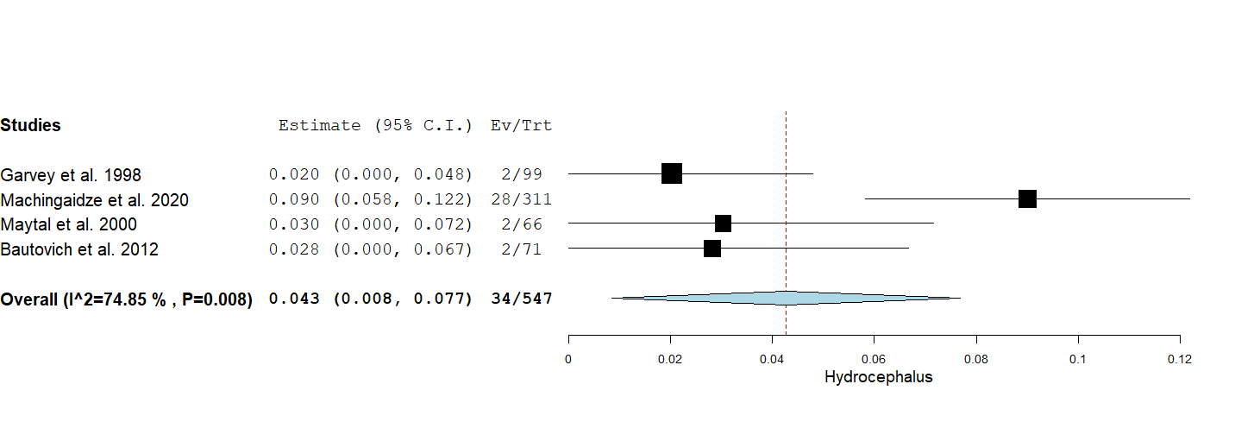
Figure S1: Forest plot of the rate of usage of CT scan of the head in patients with hydrocephalus.

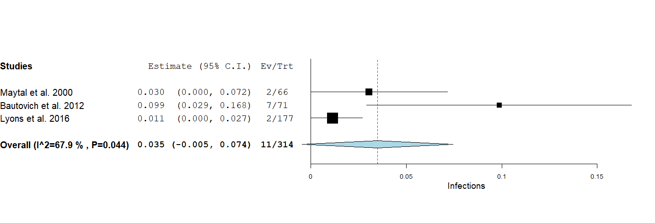
Figure S2: Forest plot of the rate of usage of CT scan of the head in patients with infection.

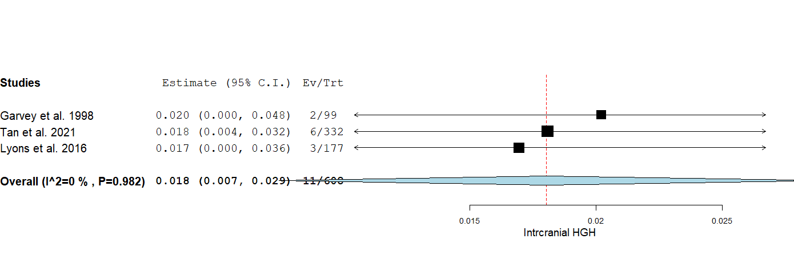
Figure S3: Forest plot of the rate of usage of CT scan of the head in patients with intracranial hemorrhage.

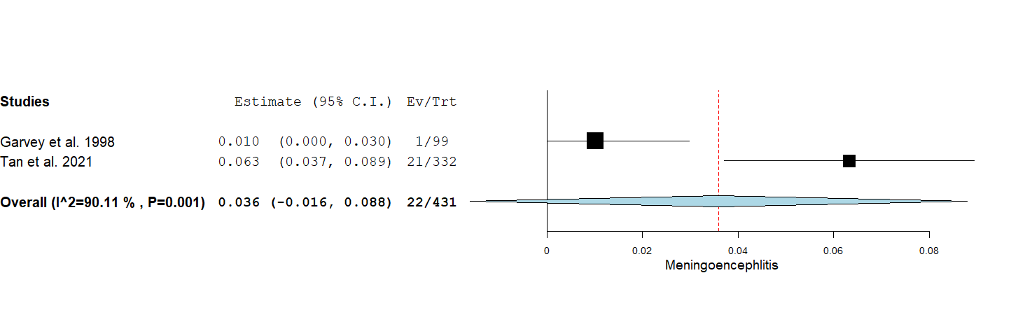
Figure S4: Forest plot of the rate of usage of CT scan of the head in patients with meningoencephalitis presentation.

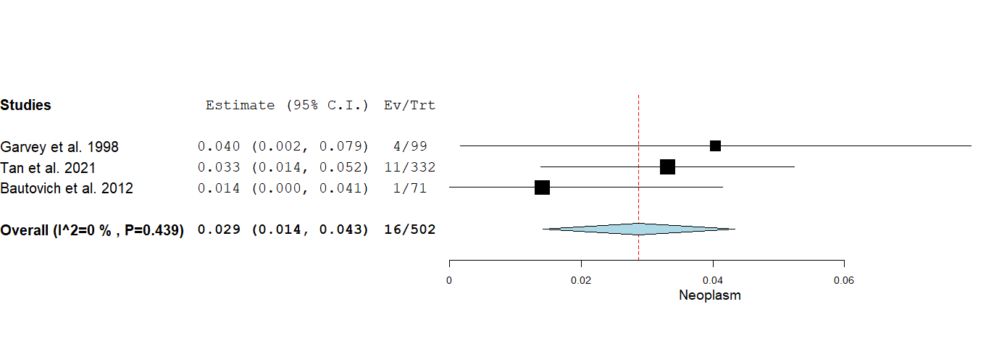
Figure S5: Forest plot of the rate of usage of CT scan of the head to aid in the diagnosis of neoplasms.
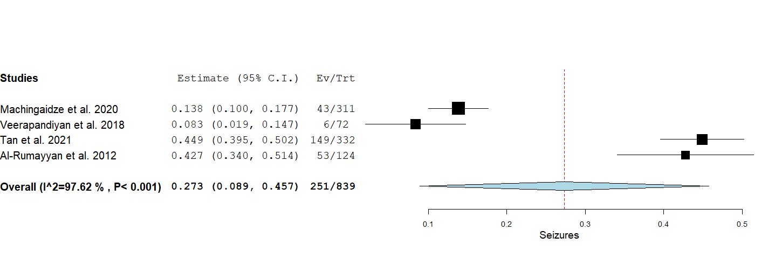
Figure S6: Forest plot of the rate of usage of CT scan of the head in patients with seizures.
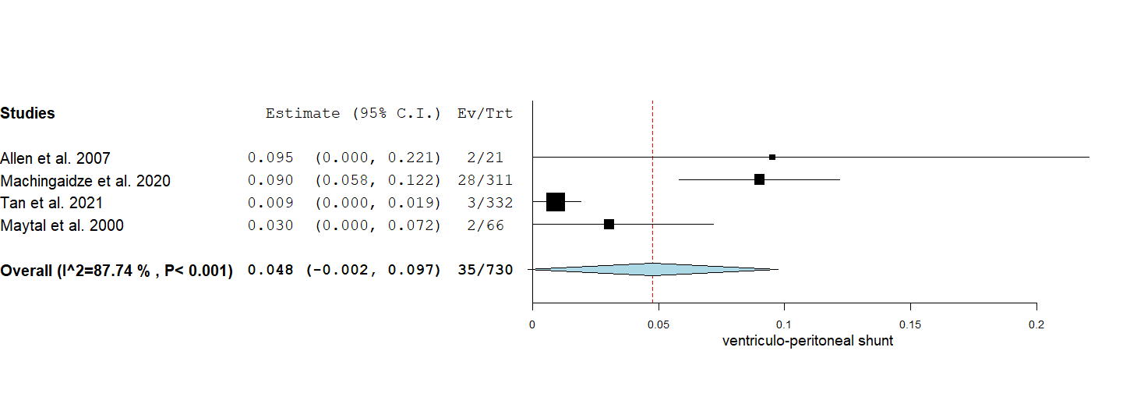
Figure S7: Forest plot of the rate of usage of CT scan of the head in patients with VP shunts.
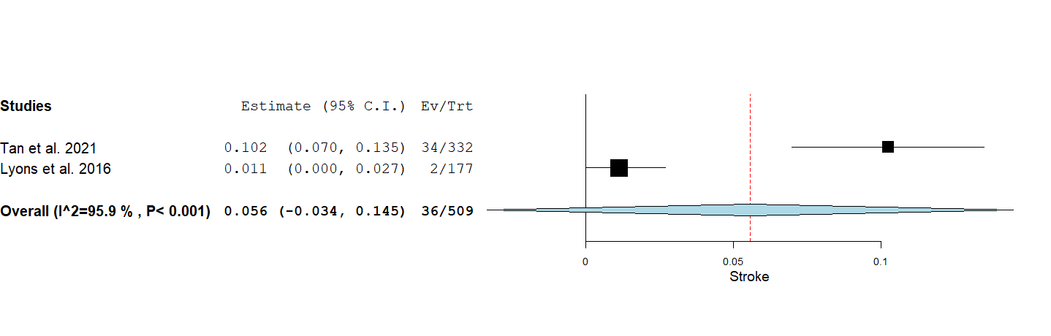
Figure S8: Forest plot of the rate of usage of CT scan of the head to aid in the diagnosis of stroke.

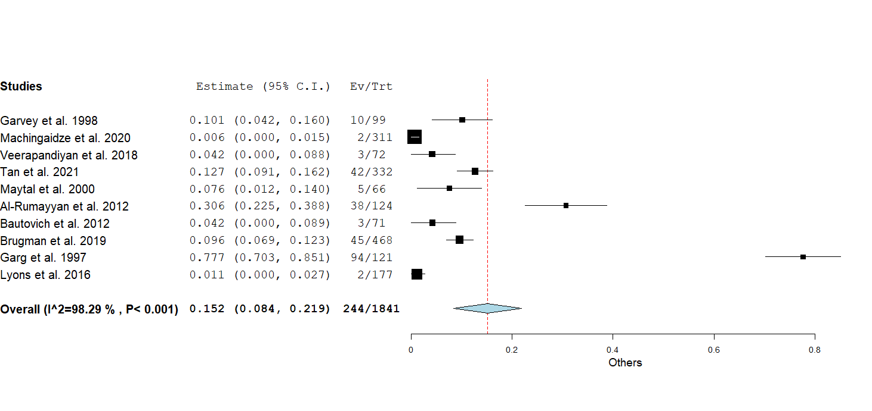
Figure S9: Forest plot of the rate of usage of CT scan of the head for other non-specified reasons which are not specifically mentioned in the literature.

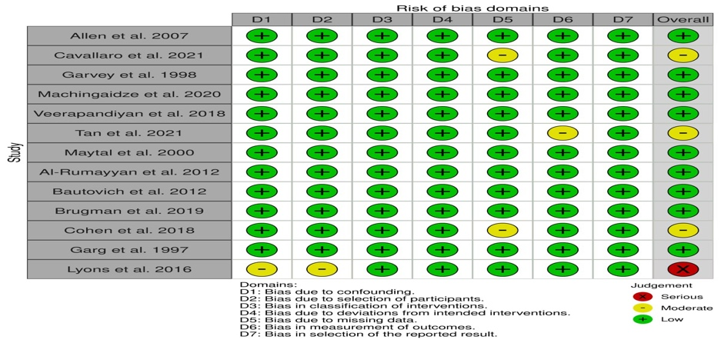
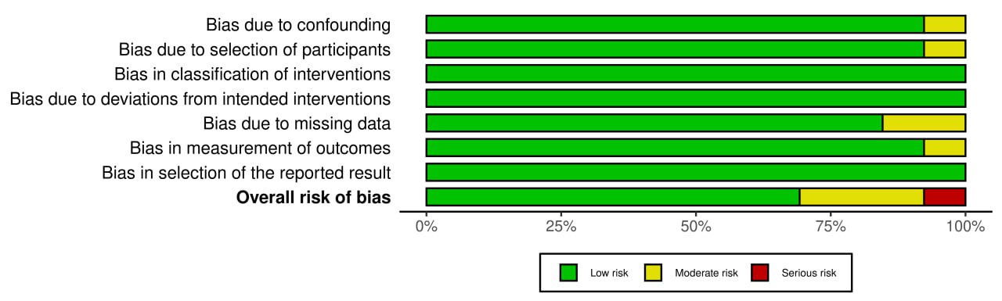

Fig.S10: Risk of bias assessment using the ROBINS-I tool presented as a proportion of relevant studies (n = 13)

Figures’ Legends
Fig.S1: Forest plot of the rate of usage of CT scan of the head in patients with hydrocephalus.
Fig.S2: Forest plot of the rate of usage of CT scan of the head in patients with infection.
Fig.S3: Forest plot of the rate of usage of CT scan of the head in patients with intracranial hemorrhage.
Fig.S4: Forest plot of the rate of usage of CT scan of the head in patients with meningoencephalitis presentation.
Fig. S5: Forest plot of the rate of usage of CT scan of the head to aid in the diagnosis of neoplasms.
Fig.S6: Forest plot of the rate of usage of CT scan of the head in patients with seizures.
Fig.S7: Forest plot of the rate of usage of CT scan of the head in patients with VP shunts.
Fig.S8: Forest plot of the rate of usage of CT scan of the head to aid in the diagnosis of stroke.
Fig.S9: Forest plot of the rate of usage of CT scan of the head for other non-specified reasons which are not specifically mentioned in the literature.
Fig. S10: Risk of bias assessment using the ROBINS-I tool presented as a proportion of relevant studies (n = 13)

