Supplementary information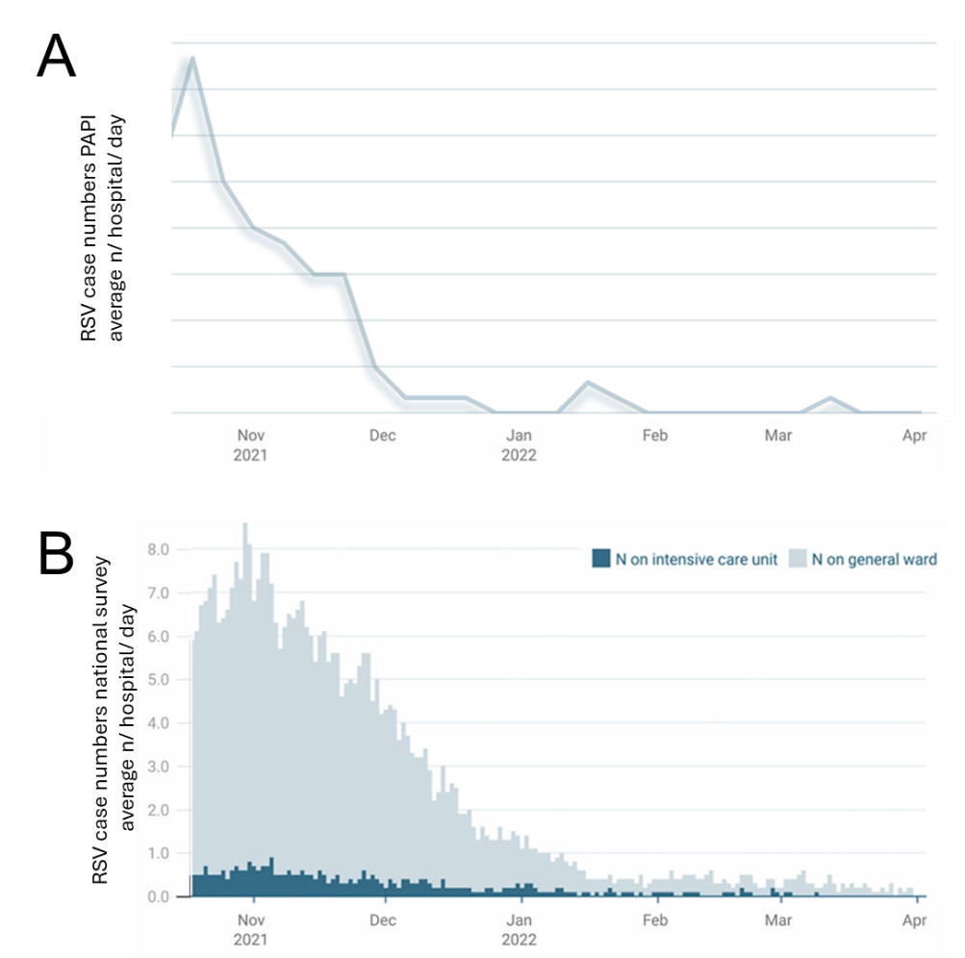
Suppl. Fig. 1: Comparison of RSV seasonality in participating PAPI centers and across Germany. [A] RSV seasonality in our study (season 2021/2022, average cases per hospital) as compared to [B] national ad hoc survey data on hospitalized RSV cases (Figure adapted from [1]).
´
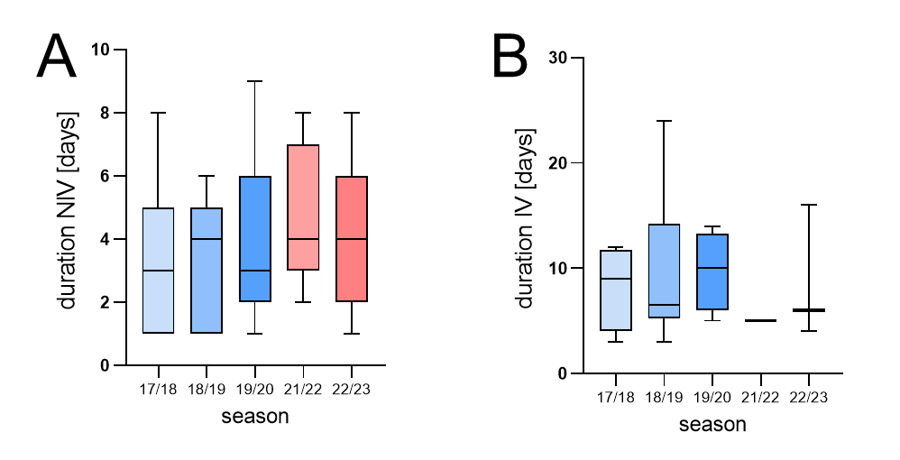
Suppl. Fig. 2: [A] Duration of hospitalization non-invasive (NIV) and [B] rates of invasive (IV) ventilation [bars display box and whiskers].

Supplementary Reference
1. Tenenbaum T, Doenhardt M, Diffloth N, Berner R, Armann JP: High burden of RSV hospitalizations in Germany 2021-2022. Infection 2022, 50(6):1587-1590.

