Baby Name:
Hospital Number:
NHS number:
Affix label

Clinical and demographic factors
Date and Time of birth
Birth gestational age
Birth weight
Sex
Maternal Antenatal steroids (Complete/Incomplete/No/Unknown)
Maternal infection/chorioamnionitis (Yes/No)
Mode of delivery
Maternal diabetes (Yes/No)
Multiple pregnancy (Yes/No)
Admission temperature
Worst BE in 12hrs
Respiratory support at ≤3 hrs (CPAP/HF/Low flow)

1st Lung Ultrasound (Any time less than 3hrs prior to first surfactant)-Clinical details
Date and Time of the scan
Performed by (Name)
Grade (Consultant/Trainee/ANNP)
Your experience with Lung Ultrasound (Please select one option) | - Attended only teaching and workshop.  - Beginner: 20 scans with 5-10 supervised scans  - Intermediate: 50 LU of all pathologies  - Advanced: 70 LU of all pathologies
Supervised by, if applicable (Name, grade)
Maximum CPAP pressure (cm H₂O) /Maximum HF (L/Min) at the time of scan
Spo2 at the time of scan
Recent PCO₂ at the time of scan
Maximum FiO₂ at the time of scan
Silverman Anderson score at the time of scan
Date and time of first Chest X-ray
Chest X-ray score at the time of scan
Infant position (for at least last 30mins) before the scan (Supine/Prone)

1st Lung Ultrasound (Any time less than 3hrs prior to first surfactant)-Scan details
 | Pleural sliding (Yes/No) | Pleural line  - Normal  - Thickened  - Irregular with subpleural consolidation. | Lung parenchyma (scoring as below)  0: Presence of A-lines only  1: Presence of ≥3 well-spaced B-lines  2: Presence of coalescent B-lines with or without consolidations limited to the subpleural space  3: Extended consolidations (>0.5cm). | M mode in suspicion of pneumothorax | Pleural effusion (Y/N)
Right Upper Anterior
Right Lower Anterior
Right Lateral
Right Upper Posterior
Right Lower Posterior
Left Upper Anterior
Left Lower Anterior
Left Lateral
Left Upper Posterior
Left Lower Posterior

2nd Lung Ultrasound-Clinical details (3-6hrs after surfactant or 6-12hrs if not received surfactant)
Date and Time of the scan
Performed by (Name)
Grade (Consultant/Trainee/ANNP)
Your experience with Lung Ultrasound (Please select one option) | - Attended only teaching and workshop.  - Beginner: 20 scans with 5-10 supervised scans  - Intermediate: 50 LU of all pathologies  - Advanced: 70 LU of all pathologies
Supervised by, if applicable (Name, grade)
If ventilated: Mean airway pressure
If ventilated: Targeted tidal volume (ml/kg)
If not ventilated: Maximum CPAP pressure (cm H₂O) /Maximum HF (L/Min) at the time of scan
Spo2 at the time of scan
Recent PCO₂ at the time of scan
Maximum FiO₂ at the time of scan
Silverman Anderson score at the time of scan
Chest X-ray score at the time of scan (If applicable, taken recently)
Infant position (for at least last 30mins) before the scan (Supine/Prone)

2nd Lung Ultrasound Scan details (3-6hrs after surfactant or 6-12hrs if not received surfactant)
 | Pleural sliding (Yes/No) | Pleural line  - Normal  - Thickened  - Irregular with subpleural consolidation. | Lung parenchyma (scoring as below)  0: Presence of A-lines only  1: Presence of ≥3 well-spaced B-lines  2: Presence of coalescent B-lines with or without consolidations limited to the subpleural space  3: Extended consolidations (>0.5cm). | M mode in suspicion of pneumothorax | Pleural effusion (Y/N)
Right Upper Anterior
Right Lower Anterior
Right Lateral
Right Upper Posterior
Right Lower Posterior
Left Upper Anterior
Left Lower Anterior
Left Lateral
Left Upper Posterior
Left Lower Posterior

3rd Lung Ultrasound-Clinical details (12-24hrs after the second LU)
Date and Time of the scan
Performed by (Name)
Grade (Consultant/Trainee/ANNP)
Your experience with Lung Ultrasound (Please select one option) | - Attended only teaching and workshop.  - Beginner: 20 scans with 5-10 supervised scans  - Intermediate: 50 LU of all pathologies  - Advanced: 70 LU of all pathologies
Supervised by, if applicable (Name, grade)
If ventilated: Mean airway pressure
If ventilated: Targeted tidal volume (ml/kg)
If not ventilated: Maximum CPAP pressure (cm H₂O) /Maximum HF (L/Min) at the time of scan.
Spo2 at the time of scan
Recent PCO₂ at the time of scan
Maximum FiO₂ at the time of scan
Silverman Anderson score at the time of scan
Chest X-ray score at the time of scan (If applicable, taken recently)
Infant position (for at least last 30mins) before the scan (Supine/Prone)

3rd Lung Ultrasound-Scan details (12-24hrs after the second LU)
 | Pleural sliding (Yes/No) | Pleural line  - Normal  - Thickened  - Irregular with subpleural consolidation. | Lung parenchyma (scoring as below)  0: Presence of A-lines only  1: Presence of ≥3 well-spaced B-lines  2: Presence of coalescent B-lines with or without consolidations limited to the subpleural space  3: Extended consolidations(>0.5cm). | M mode in suspicion of pneumothorax | Pleural effusion (Y/N)
Right Upper Anterior
Right Lower Anterior
Right Lateral
Right Upper Posterior
Right Lower Posterior
Left Upper Anterior
Left Lower Anterior
Left Lateral
Left Upper Posterior
Left Lower Posterior

4th Lung Ultrasound-Clinical details (12-24hrs after the third LU)
Date and Time of the scan
Performed by (Name)
Grade (Consultant/Trainee/ANNP)
Your experience with Lung Ultrasound (Please select one option) | - Attended only teaching and workshop.  - Beginner: 20 scans with 5-10 supervised scans  - Intermediate: 50 LU of all pathologies  - Advanced: 70 LU of all pathologies
Supervised by, if applicable (Name, grade)
If ventilated: Mean airway pressure
If ventilated: Targeted tidal volume (ml/kg)
If not ventilated: Maximum CPAP pressure (cm H₂O) /Maximum HF (L/Min) at the time of scan.
Spo2 at the time of scan
Recent PCO₂ at the time of scan
Maximum FiO₂ at the time of scan
Silverman Anderson score at the time of scan
Chest X-ray score at the time of scan (If applicable, taken recently)
Infant position (for at least last 30mins) before the scan (Supine/Prone)

4th Lung Ultrasound-Scan details (12-24hrs after the third LU)
 | Pleural sliding (Yes/No) | Pleural line  - Normal  - Thickened  - Irregular with subpleural consolidation. | Lung parenchyma (scoring as below)  0: Presence of A-lines only  1: Presence of ≥3 well-spaced B-lines  2: Presence of coalescent B-lines with or without consolidations limited to the subpleural space  3: Extended consolidations(>0.5cm). | M mode in suspicion of pneumothorax | Pleural effusion (Y/N)
Right Upper Anterior
Right Lower Anterior
Right Lateral
Right Upper Posterior
Right Lower Posterior
Left Upper Anterior
Left Lower Anterior
Left Lateral
Left Upper Posterior
Left Lower Posterior

Date and Time of 1st dose of surfactant (If applicable)
Dose of 1st dose of surfactant (If applicable)
Date and Time of 2nd dose of surfactant (If applicable
Dose of 2nd dose of surfactant (If applicable)

Chest X-ray scoring by Perri et al
0 | normal radiolucent lung fields with sharp cardiac and diaphragmatic margins
1 | slightly reduced radiolucency with still sharp cardiac and diaphragmatic margins
2 | markedly reduced radiolucency with retained cardiac and diaphragmatic margins
3 | severely reduced radiolucency with air bronchogram and blurred cardiac and diaphragmatic margins
4 | almost completely white lung fields with or without air bronchogram and barely visible cardiac and diaphragmatic margins.

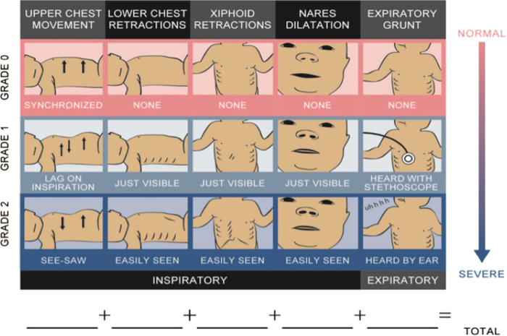
Silverman Anderson score

If you have any questions or clarifications, please use the contact details below

Please return the completed

Site | Research-Principal Investigator (s) | Research nurse
James Cook University Hospital | Dr. Prakash Loganathan  Consultant Neonatologist  James Cook University Hospital  Marton Road, Middlesbrough  Email: pkannanloganathan@nhs.net | Amanda Forster  Neonatal Research Nurse  Neonatal Unit  James Cook University Hospital  Marton Road  Middlesbrough  TS4 3BW  Email : amanda.forster@nhs.net  Tel: +44 642854872 Ext: 53517
University Hospital Wishaw | Dr Mahmoud Montasser  Consultant Neonatologist  University Hospital Wishaw  50 Netherton St, Wishaw ML2 0DP  Email:Mahmoud.Montasser@lanarkshire.scot.nhs.uk
Medway NHS Foundation Trust | Dr Bikash Bhojnagarwala  Consultant Neonatologist  Oliver Fisher Neonatal unit  Medway NHS Foundation Trust  Gillingham Kent ME7 5NY  Tel: +44 1634 825399

Any other comments:

