SLURP- NCT05782569
Title: Serial Lung Ultrasound in predicting the need for surfactant and Respiratory course in Preterm infants -Observational study (SLURP)

Investigators:
Dr. Prakash Loganathan
Consultant Neonatologist
James Cook University Hospital
Marton Road, Middlesbrough
Email: pkannanloganathan@nhs.net

Dr Mahmoud Montasser
Consultant Neonatologist
Honorary Clinical Senior Lecturer
University Hospital Wishaw
50 Netherton St, Wishaw ML2 0DP
Email: Mahmoud.Montasser@lanarkshire.scot.nhs.uk

Dr. Virginie Meau-Petit
Consultant Neonatologist,
Neonatal and Paediatric intensive care unit
Bicetre Hospital APHP
78, rue du General Leclerc, 94270 le Kremlin-Bicetre, France
Email: docteurmeaupetit@gmail.com

Dr Vrinda Nair
Consultant Neonatologist
James Cook University Hospital
Marton Road, Middlesbrough
Email: vrinda.nair1@nhs.net

Dr Bikash Bhojnagarwala
Consultant Neonatologist with Special Interest in Neonatal and Paediatric cardiology
Oliver Fisher Neonatal unit, Medway NHS Foundation Trust, Gillingham Kent ME7 5NY
Email: bikash.bhojnagarwala@nhs.net

Abbreviations: RCT randomised controlled trials, BPD broncho pulmonary dysplasia; continuous positive airway pressure (CPAP), respiratory distress syndrome (RDS), lung ultrasound (LU), lung ultrasound score (LUS), fraction of inspired oxygen (FiO₂)

Layman’s summary:
Babies born early (under 34 weeks) are at risk of developing lung problems after birth. A major reason for this is that the lungs are not fully developed (lung immaturity). One of the important components not yet produced by the lungs is the surfactant, which allows premature babies to breathe without much effort. Very often Babies born early, very often need some help with their breathing and also need treating with surfactant. The surfactant is administered through a breathing tube which is placed into the baby’s airway. It is important that surfactant is administered early after birth when the baby cannot produce it. Early administration of surfactant provides better clinical outcomes.
Currently, the decision to give surfactant is based on clinical parameters such as the level of oxygen that the baby requires. Current strategy of waiting for the baby to reach certain oxygen level, may result in a delay in administering surfactant. Recent scientific data from other countries suggest that ultrasound of the chest/lungs can predict early which babies need surfactant. This would help us to administer surfactant earlier and improve their respiratory outcome. In this study, we want to confirm the value of chest/Lung ultrasound (LU) to predict the need for surfactant in UK population. As a part of the study, we will perform early LU and serial LU in the first few days of life. In this current study, LU images will only be recorded and not used for clinical management.

Background:
Early use of continuous positive airway pressure (CPAP) and early selective use of surfactant in preterm infants with respiratory distress syndrome (RDS) /surfactant deficiency is recommended by international committees¹ ². This recommendation is based on systematic reviews which included large sample size from randomised controlled trials (RCT). Studies have shown that compared to intubation group, infants receiving CPAP at birth had reduced death and /or broncho pulmonary dysplasia (BPD)³. SUPPORT trial also showed a significant decrease in mortality, [23.9% vs. 32.1%, RR=0.74, (0.57, 0.98), p=0.034] in the immature strata of 24 to 25 6/7 weeks birth gestation randomized to CPAP⁴. In these studies, 50 to 75% of infants got intubated at some point during their neonatal unit stay. A Cochrane review has shown that prophylactic use of surfactant is associated with higher risk of death /BPD ((RR: 1.12; 95% CI: 1.02–1.24; P <. 05)⁵, and the review suggests early selective use of surfactant rather than prophylactic surfactant use⁶.
Early selective use of surfactant has been shown to have significant reductions in the risk of neonatal mortality (RR 0.84; (0.74 to 0.95); BPD (RR 0.69; (0.55 to 0.86); and BPD or death at 36 weeks (RR 0.83; 0.75 to 0.91)⁶. Intubated infants randomized to early selective surfactant administration also demonstrated a decreased risk of acute lung injury, including a decreased risk of pneumothorax (RR 0.69; 0.59 to 0.82;), pulmonary interstitial emphysema (RR 0.60; 0.41 to 0.89) and overall air leak syndromes (RR 0.61; 0.48 to 0.78)⁷.
This FiO₂ (fraction of inspired oxygen ) threshold is used without any strong evidence⁸. Infants could take variable time to reach this threshold, which could reduce the benefits of early surfactant administration. In a study, median time for preterm infants to receive surfactant was 6hrs (Inter-quartile range: 2.5 to 24hrs)⁹.
Few studies have shown that early lung ultrasound (LU) could predict the need for surfactant in this preterm population¹⁰⁻¹². Quality improvement project on echography guided surfactant therapy (ESTHER) in preterm infants <32 weeks¹³compared the number of infants receiving surfactant in the first 3 hrs of life during 2 historical periods: before LU implementation (surfactant administration was based on European guidelines) and after introduction of ESTHER. They showed that more infants received surfactant within 3 hours of life when LU was implemented (90% versus 71%), without increase of total surfactant use. This was associated with decreased oxygen exposure and duration of mechanical ventilation. In another RCT (the ULTRASURF study) conducted in preterm infants ≤32 weeks with RDS, infants received surfactant earlier (1 hr vs 6hr, p<0.001) in the ultrasound group with post treatment higher oxygen saturation (SpO₂)/FiO₂ ratio¹⁴. In this study there was no difference in any of other respiratory outcomes like duration of mechanical ventilation and BPD, etc.
LU can be performed easily at the bed side (Point-of-care), requires a very short period of time (3mins ± 2¹¹), is non-invasive, does not expose the patient to any radiation hazard (unlike X-rays), has a steep learning curve and has a very good inter-rater reliability (k=0.89)¹⁰ ¹¹. In this study we will be performing LU before 3 hours of age and subsequent serial LU every 12hrs-24hrs (one LU/day) until day 3 to predict the respiratory course. We choose 3 hours as our cut off as this is the preferred time period for early surfactant⁶. We hypothesize lung ultrasound would be able to predict the need for surfactant, need for repeat course of surfactant, and predict the respiratory course including BPD at 36 weeks.

Methods:
Type of study: Prospective, Observational, longitudinal.

P: preterm infants ≤34 weeks on non-invasive respiratory support
E: early lung ultrasound before surfactant administration (within 3 hours of life)
C: Chest X-ray, Clinical criteria: FiO₂>30% PEEP>5-6cm H₂O
O: need for surfactant.

Primary objective
In preterm infants ≤ 34 weeks on non-invasive respiratory support, to identify the best lung ultrasound score (LUS) before 3hrs of age to predict the need for surfactant. We would calculate the diagnostic value (sensitivity, specificity, likelihood ratio) and area under the curve for each of the LUS.

Secondary Objectives
- Evolution of LUS over the first 3 days.
- LUS within 3-6hrs of first dose of surfactant and predicting the need for second dose of surfactant.
- For infants who continue to need non-invasive respiratory without need for surfactant, LU at 6-12hrs of life predicting the respiratory course.
- Diagnostic value of adding LUS from the dependant regions.
- Correlation with radiological (1st/earliest chest X-ray image available) image and LUS. Chest X-ray taken as a part of usual clinical care and not as a part of research.
- Correlation with Silverman clinical scoring system (at the time or immediately after admission) for respiratory distress and LUS.
- Correlation with SpO₂/FiO₂ (SF) ratio and LUS. As SF ratio is a non-invasive measurement with a good correlation with extent of lung injury¹⁵.
- Predictive value of Chest X-ray, Silverman clinical scoring system and SpO₂/FiO₂ with need for surfactant.
- In preterm infants <30 weeks LUS in the first 3 days and prediction of BPD.
- At all the time points, we will calculate neonatal OI on non-invasive ventilation: PEEP*FiO₂/SpO₂, which takes PEEP into account.

Study Primary outcome:
- Predicting the need for 1st dose of surfactant.

Study secondary outcomes:
- Predicting the need for second dose of surfactant
- Predicting the development of BPD.
Study end point:
- Primary: First three days of life on respiratory support.
- Secondary: 36 weeks or hospital discharge, whichever happens earlier.

Chest X-ray scoring:
We would use the scoring used by Perri et al¹⁶:
- 0 = normal radiolucent lung fields with sharp cardiac and diaphragmatic margins
- 1 = slightly reduced radiolucency with still sharp cardiac and diaphragmatic margins
- 2 = markedly reduced radiolucency with retained cardiac and diaphragmatic margins
- 3 = severely reduced radiolucency with air bronchogram and blurred cardiac and diaphragmatic margins
- 4 = almost completely white lung fields with or without air bronchogram and barely visible cardiac and diaphragmatic margins.

Silverman scoring for respiratory distress:
It is simple bedside clinical assessment tool with predictive value to estimate the severity of respiratory status and the need for respiratory support¹⁷.

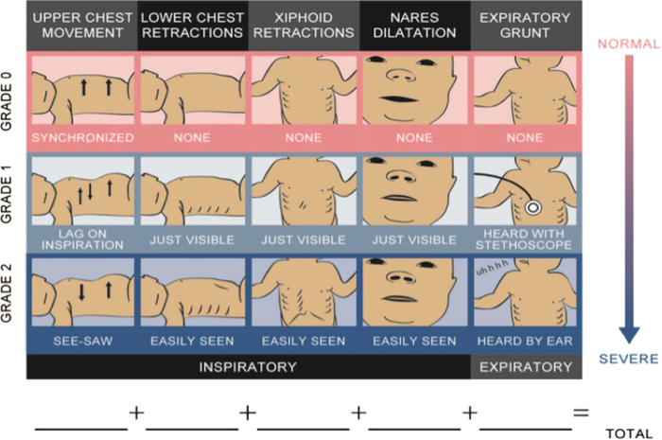

Inclusion criteria
- Gestational age ≤34 weeks based on last menstrual period or ultrasound dating.
- Non-invasive respiratory support or low flow oxygen needing neonatal unit admission.
Exclusion criteria
- Received surfactant before first LU (<3hrs of life).
- Major congenital malformations including congenital lung disease and congenital heart disease as ascertained by the medical team.
- Infants receiving delivery room surfactant or required intubation shortly after admission.
- Infants diagnosed with pneumothorax needing needle or chest tube drainage.

LU Procedure:
We will perform the first LUS within 3 hours of admission. Longitudinal (Figure A) will be obtained using a 15 Mhz hockey stick probe (CX50; Philips Healthcare, Eindhoven, Netherlands at James Cook and Samsung at UHW)‍. Probe marker will be placed towards patient’s head with focus on pleural line and depth of 2-3 cm will be used. Ribs are identified in the near field as bright interface. Pleural layer is identified as bright hyperechoic line below the rib shadow.
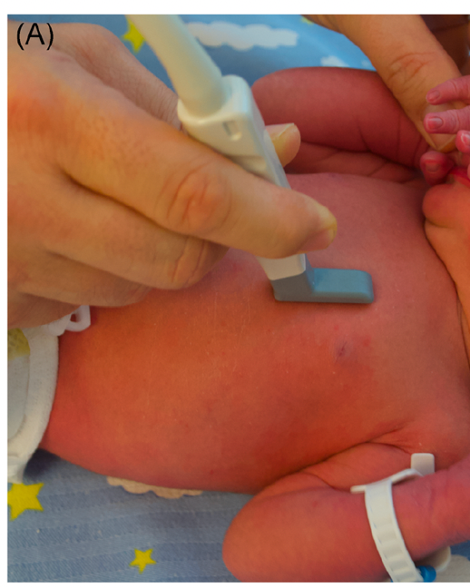

We will assess 5 lung zones in each side (Total of 10 lung zones): 30 points scoring system will be used based on 10 lung zones scanned with score ranging from zero to 3 in each zone.
- Upper Anterior at the level of mid-clavicular line (Figure A) arbitrarily defined line
- Lower Anterior at the level of mid-clavicular line (Figure A)
- Lateral at level of anterior axillary line (Figure B).
- Upper Posterior at level of posterior axillary line (Figure C).
- Lower posterior
For infants in supine position at the time of LU, we will tilt briefly to obtain LU images for the posterior region and vice versa for infants who are prone at the time of LU. Details of data collection form and study algorithm are provided below
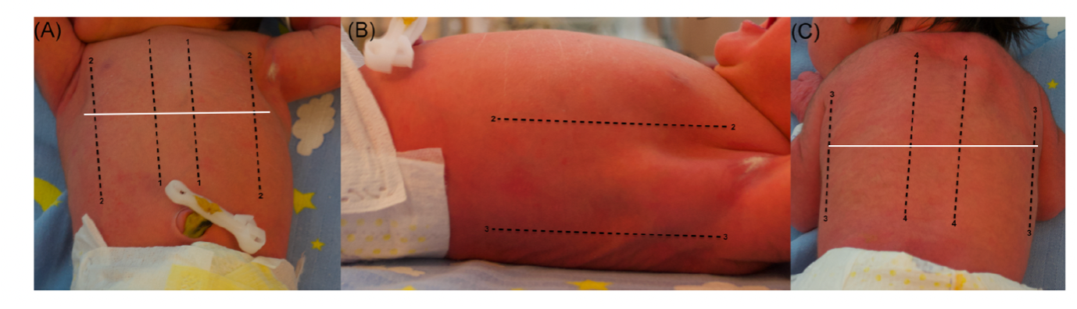

Lung USS diagnosis (adapted from Corsini et al¹⁸, originally developed by D Liechtenstein¹⁹)
- Presence of A lines: horizontal, equal distance from pleural surface and represent strong signal reflection of pleural interface through air filled lungs.
- Presence of B lines: vertical white dense lines that arising from pleura, usually more than 2 separate or could be dense coalescent lines. These lines originate at the pleural line and reach the bottom of the image representing fluid filled interstitium with or without alveolar space.
Scoring (Adapted from Brat ¹⁰): We will assess each area of interest (5areas in each lung) for a score of 0 to 3 based on the four different patterns. Images will be reviewed in the longitudinal scans.
- Score 0: defined only by presence of A lines (Figure A), indicating well aerated lungs.
- Score 1: defined by presence of ≥ 3 well-spaced B lines (alveolar-interstitial pattern) (Figure B).
- Score 2: defined by Coalescent-crowded B lines with or without sub pleural consolidation of size ≤1cm (Figure C).
- Score 3: defined by extensive consolidation with size >1cm (Figure D).
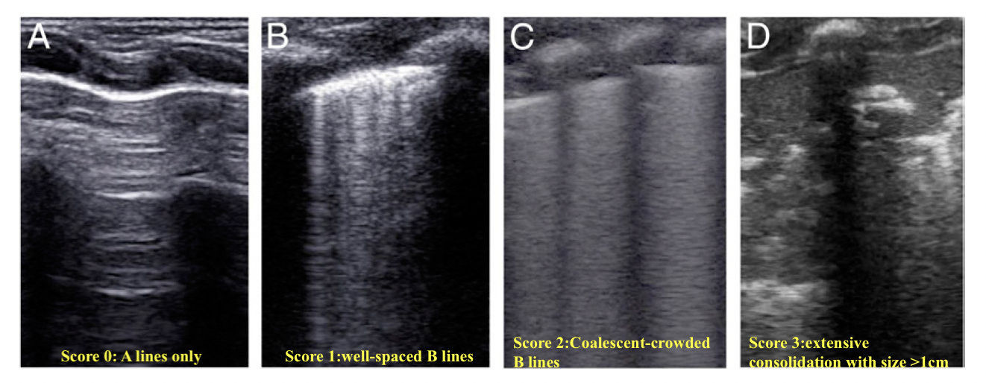

Study algorithm
- Preterm infants ≤34 weeks needing non-invasive respiratory support
- Any time less than 3hrs prior to first surfactant
Receives surfactant (ET/LISA/INSURE)
(Surfactant threshold based on local guidelines)
Continues to be on Non-invasive respiratory support
First Lung Ultrasound ≤3hrs
(Any time less than 3hrs prior to first surfactant)

Second LU 12 -24hrs after surfactant administration
Second LU at 12 -24hrs of life
Third LU on Day 2 (12-24hrs after the second LU)
Fourth LU on Day 3 (12-24hrs after the third LU)
Hospital discharge (Only clinical data collection)
Total of 4 LU
First Study end point
Final Study end point

Clinical and demographic factors collected after admission
Date and Time of birth
Birth gestational age
Birth weight
Sex
Maternal Antenatal steroids
Maternal infection/chorioamnionitis
Mode of delivery
Admission temperature
Worst BE in 12hrs
Respiratory support at ≤2 hrs (CPAP/HF/Low flow)
Maximum CPAP pressure (cm H₂O) /Maximum HF (L/Min)
Post admission PCO₂
Maximum FiO₂
S/F ratio
Oxygenation Index: PEEP*FiO₂/SpO₂
Silverman Anderson score
Chest X-ray score
Timing of 1st dose of surfactant (If applicable)
Timing of second dose surfactant (If applicable)
Total surfactant doses (If applicable)

Lung USS data collection-1st Score ≤3hrs, 3-6hrs after surfactant/6-12hrs LU for infants not requiring surfactant, Day-2, Day-3: Total of 4 LU
 | Pleural sliding (Yes/No) | Pleural line  - Normal  - Thickened  - Irregular with subpleural consolidation. | Lung parenchyma (scoring as above)  - A lines  - Non-coalescent B lines  - Coalescent B lines  - Consolidation | M mode in suspicion of pneumothorax | Pleural effusion (Y/N)
Right Upper Anterior
Right Lower Anterior
Right Lateral
Right Upper Posterior
Right Lower Posterior
Left Upper Anterior
Left Lower Anterior
Left Lateral
Left Upper Posterior
Left Lower Posterior
Date and time of LU:

Hospital outcomes
Duration of mechanical ventilation
Duration of CPAP
Duration of HF
Duration of Low flow
Duration of hospital stay
Respiratory support at 36 weeks
Home oxygen
Pneumothorax/PIE

Study center and unit practice: There would be two study centres-James Cook University Hospital, Middlesbrough, UK and University Hospital Wishaw, NHS Lanarkshire, Scotland.
Each unit is staffed by junior level trainees, senior trainees, neonatal nurse practitioners, neonatal nurses, neonatal midwives, and consultants.
In both units, CPAP is the primary mode of respiratory support using appropriately sized nasal masks/prongs. We will use CPAP ranging from 5 to7 cm H2O. We adjust FiO₂ to target oxygen saturation between 91-95% and PcO₂<7kPa. All preterm infants <30 weeks will routinely get caffeine citrate loading and maintenance caffeine. Our units’ practice is to intubate in the delivery room if the infant is persistently apnoeic/ bradycardic in spite of effective face mask ventilation. Infants in the neonatal unit will be intubated for surfactant if there is one or more than the following factors:

- Worsening Respiratory distress – As evidenced by increasing tachypnoea, recession, use of accessory muscles etc
- Poor respiratory drive – As evidenced by periods of hypoventilation despite caffeine therapy
- Recurrent apnoea - ≥6 apnoeas within last 6 hours requiring stimulation / increased oxygen or 1 episode requiring IPPV despite caffeine therapy
- Persistent Increase in FiO₂ requirement - Any infant with an FiO₂ >30-40% OR, in the first few hours, any persistent rise in FiO₂ associated with an increased work of breathing
- Worsening Respiratory acidosis - PCO₂ 8-8.5kPa with pH<7.2

For infants needing intubation for surfactant administration, we use 200 mg/kg of poractant α (Curosurf; Chiesi Farmaceutici, Parma, Italy). Based on the unit practice, surfactant could be administered by LISA/INSURE/ET/I-Gel technique. Under the discretion of the clinical team and based on local unit guidelines, we administer the second dose of surfactant if there is persistent need for higher oxygen (FiO₂ ≥ 30%) or needing higher mean airway pressure to maintain the oxygenation-ventilation. This will be done only after 6-12 hours of the first dose administration considering the median half-life of surfactant.
LU image storage and other data collection analysis: Clinical team would perform LU and calculate their own scores. All the stored LU images will be independently scored by study investigator (VMP) who will be blinded to the clinical history and LUS of the person who performed the LU.
Patient identification, data collection and storage: Potential participants will be identified from neonatal unit admissions. This will be performed both by the clinical staff and research investigators, on a daily basis. Study team will review only for the inclusion and exclusion clinical criteria, e.g., gestational age at birth, type of respiratory support. No personal information will be reviewed. All the demographic and clinical data would be obtained from neonatal database (Badger.Net http://www.clevermed.COm) and from patient notes. Written informed consent with patient name and hospital number will be filed in a research folder, which will be kept in a locked cabinet within the Neonatal Research Office. This office is locked when not occupied and is located in the Neonatal unit. All the clinical details, and the clinical course (without any patient identifiers) will be recorded in the REDCAP database (secure web-based database). Only the study numbers will be entered into the REDCAP database without patient identification. Patient hospital numbers and date of birth will be maintained in a separate password protected excel sheet. All the data will be stored in a separate research computer and the paper documents will be stored to the maximum period of 24 months. Study investigators will have complete access to all the data. All the data will be directly downloaded and stored into a research computer. Anonymous lung ultrasound images will be securely transferred to one of the expert study investigators for blinded assessment.
Training: All the investigators will undergo structured training course on LU.
Data analysis: Descriptive statistics were used for population characteristics. Categorical variables were presented as proportions, while numerical variables were presented as mean with standard deviation (SD) or median with inter-quartile range (IQR) as appropriate. For univariate analysis we used Chi-square/Fishers exact test for categorical variables and students T test/ Mann Whitney test for continuous variables. We will calculate sensitivity, specificity, likelihood ratio for LUS for the need for surfactant. We will also calculate Area under the curve for LUS predicting the need for surfactant.
We will perform subgroup analysis on two gestation strata of <30 weeks and ≥30 weeks.

Sample size: In our unit chest X-ray is the gold standard for imaging infants with respiratory distress. Providing the sensitivity of chest X-ray in predicting the need for surfactant was 38%¹², to improve this to approximately 60% by LUS, we will need 39 infants to show this difference with a power of 90% and alpha error of 5%²⁰. With expected loss of poor-quality image, we aim to recruit at least 50 infants. Since we have a wide range of gestation, we will obtain at least half of the population (25 babies) in the gestation <29 weeks.

End of the study: Study will be completed after completing the expected number of recruitment (n=50).

Research and Ethics: A Research and Ethics application will be prepared and submitted to the Integrated Research application system. This study does not involve any change in current practice, no intervention/change in intervention based on the LU images. Also, the study does not involve collection of any identifiable information; hence we would request for delayed (retrospective) consent.

Rationale for retrospective consent: consenting during antenatal period would not help, as it is difficult to predict preterm birth and their respiratory course. Since our aim is obtain the first LU images within first 3 hours it will be difficult to approach mothers immediately after the delivery. Validity of informed consent during stressful period is questionable. Each of the baby will be getting a maximum four LU scans with each scan taking a maximum of 5 minutes. In the previous studies mean duration of LU scan was 3 mins with SD of 2mins¹¹. The information from LU would not be used for clinical management. Based on the availability of LU trained physicians, LU is used in routine clinical practice.

Feasibility: Despite the limited research time, with the team of enthusiastic investigators, recruitment will not be difficult. All of the proposed investigators are competent in neonatal research and all of the investigators are GCP (Good clinical Practice) certified. We also have one research fellow who would be able to assist us in this project. We also have one full time research nurses in our unit to support our research. Progressive training of the investigators will be ensured by lectures, and group discussion. South Tees Hospitals NHS Trust has the necessary infrastructure and also the access to RedCap database to support this research project.

Study results and data dissemination: We feel sharing this knowledge, would enrich and benefit the wider neonatal community which will eventually improve patient care.
Conference and publication: Finding of this study will be presented in National and International Conferences. This study will also be published in international peer reviewed Journals.

References

1. Respiratory support in preterm infants at birth. Pediatrics 2014;133(1):171-4. doi: 10.1542/peds.2013-3442 [published Online First: 2014/01/01]
2. Sweet DG, Carnielli V, Greisen G, et al. European Consensus Guidelines on the Management of Respiratory Distress Syndrome - 2019 Update. Neonatology 2019;115(4):432-50. doi: 10.1159/000499361 [published Online First: 2019/04/12]
3. Schmölzer GM, Kumar M, Pichler G, et al. Non-invasive versus invasive respiratory support in preterm infants at birth: systematic review and meta-analysis. Bmj 2013;347:f5980. doi: 10.1136/bmj.f5980 [published Online First: 2013/10/19]
4. Finer NN, Carlo WA, Walsh MC, et al. Early CPAP versus surfactant in extremely preterm infants. The New England journal of medicine 2010;362(21):1970-9. doi: 10.1056/NEJMoa0911783 [published Online First: 2010/05/18]
5. Rojas-Reyes MX, Morley CJ, Soll R. Prophylactic versus selective use of surfactant in preventing morbidity and mortality in preterm infants. Cochrane Database Syst Rev 2012(3):Cd000510. doi: 10.1002/14651858.CD000510.pub2 [published Online First: 2012/03/16]
6. Bahadue FL, Soll R. Early versus delayed selective surfactant treatment for neonatal respiratory distress syndrome. Cochrane Database Syst Rev 2012;11(11):Cd001456. doi: 10.1002/14651858.CD001456.pub2 [published Online First: 2012/11/16]
7. Bahadue FL, Soll R. Early versus delayed selective surfactant treatment for neonatal respiratory distress syndrome. Cochrane Database Syst Rev 2012;11:CD001456. doi: 10.1002/14651858.CD001456.pub2 [published Online First: 2012/11/16]
8. Ramaswamy VV, Abiramalatha T, Roehr CC. Addressing the Lack of Clarity About Administering Surfactant in Preterm Infants With Respiratory Distress Syndrome Treated With Noninvasive Respiratory Support. JAMA Pediatr 2021 doi: 10.1001/jamapediatrics.2021.4098 [published Online First: 2021/10/26]
9. Aldecoa-Bilbao V, Balcells-Esponera C, Herranz Barbero A, et al. Lung ultrasound for early surfactant treatment: Development and validation of a predictive model. Pediatr Pulmonol 2021;56(2):433-41. doi: 10.1002/ppul.25216 [published Online First: 2020/12/29]
10. Brat R, Yousef N, Klifa R, et al. Lung Ultrasonography Score to Evaluate Oxygenation and Surfactant Need in Neonates Treated With Continuous Positive Airway Pressure. JAMA Pediatr 2015;169(8):e151797. doi: 10.1001/jamapediatrics.2015.1797 [published Online First: 2015/08/04]
11. De Martino L, Yousef N, Ben-Ammar R, et al. Lung Ultrasound Score Predicts Surfactant Need in Extremely Preterm Neonates. Pediatrics 2018;142(3) doi: 10.1542/peds.2018-0463 [published Online First: 2018/08/16]
12. Raimondi F, Migliaro F, Sodano A, et al. Use of neonatal chest ultrasound to predict noninvasive ventilation failure. Pediatrics 2014;134(4):e1089-94. doi: 10.1542/peds.2013-3924 [published Online First: 2014/09/03]
13. Raschetti R, Yousef N, Vigo G, et al. Echography-Guided Surfactant Therapy to Improve Timeliness of Surfactant Replacement: A Quality Improvement Project. J Pediatr 2019;212:137-43.e1. doi: 10.1016/j.jpeds.2019.04.020 [published Online First: 2019/05/14]
14. Rodriguez-Fanjul J, Jordan I, Balaguer M, et al. Early surfactant replacement guided by lung ultrasound in preterm newborns with RDS: the ULTRASURF randomised controlled trial. Eur J Pediatr 2020;179(12):1913-20. doi: 10.1007/s00431-020-03744-y [published Online First: 2020/07/28]
15. Khemani RG, Patel NR, Bart RD, 3rd, et al. Comparison of the pulse oximetric saturation/fraction of inspired oxygen ratio and the PaO2/fraction of inspired oxygen ratio in children. Chest 2009;135(3):662-68. doi: 10.1378/chest.08-2239 [published Online First: 2008/11/26]
16. Perri A, Riccardi R, Iannotta R, et al. Lung ultrasonography score versus chest X-ray score to predict surfactant administration in newborns with respiratory distress syndrome. Pediatr Pulmonol 2018;53(9):1231-36. doi: 10.1002/ppul.24076 [published Online First: 2018/06/06]
17. Hedstrom AB, Gove NE, Mayock DE, et al. Performance of the Silverman Andersen Respiratory Severity Score in predicting PCO(2) and respiratory support in newborns: a prospective cohort study. J Perinatol 2018;38(5):505-11. doi: 10.1038/s41372-018-0049-3 [published Online First: 2018/02/11]
18. Corsini I, Parri N, Ficial B, et al. Lung ultrasound in the neonatal intensive care unit: Review of the literature and future perspectives. Pediatr Pulmonol 2020;55(7):1550-62. doi: 10.1002/ppul.24792 [published Online First: 2020/04/28]
19. Lichtenstein DA. Lung ultrasound in the critically ill. Ann Intensive Care 2014;4(1):1. doi: 10.1186/2110-5820-4-1 [published Online First: 2014/01/10]
20. Flahault A, Cadilhac M, Thomas G. Sample size calculation should be performed for design accuracy in diagnostic test studies. J Clin Epidemiol 2005;58(8):859-62. doi: 10.1016/j.jclinepi.2004.12.009 [published Online First: 2005/07/16]

