Supplementary File
Five-Year Safety and Growth Response of Long-Acting PEGylated Recombinant Human Growth Hormone in Children with Growth Hormone Deficiency—Data from CGLS Database
Wei Wu¹, Haiyan Wei², Hongwei Du³, Liyang Liang⁴, Chunxiu Gong⁵, Yan Zhong⁶, Liyan Ma⁷，Feihong Luo⁸, Ruimin Chen⁹, Xiaoyan Huang¹⁰, Kan Ye¹¹, Yunpu Cui¹², Chunlin Wang¹³, Min Zhu¹⁴, Kundi Wang¹⁵, Yufang Zhao¹⁶, Huiwen Zhang¹⁷, Xu Xu¹⁸, Haiying Wu¹⁹，Yuan Li²⁰, Jin Cai²¹, Hongxiao Zhang²², Lirong Ying²³, Zhihong Chen²⁴, Wei Gu²⁵, Zheng Liu²⁶, Yuwen Li²⁷, Rongxiu Zheng²⁸, Naijun Wan²⁹, Guimei Li³⁰, Jingsi Luo³¹, Yaping Ma³², Yuqing Chen³³, Nan Li³⁴, Tingting Wang³⁵, Xiaoping Luo¹*
¹Department of Pediatrics, Tongji Hospital, Tongji Medical College, Huazhong University of Science and Technology, Wuhan 430030, China
²Department of Endocrinology, Genetics and Metabolism, Henan Children’s Hospital, Children′s Hospital Affiliated to Zhengzhou University, Zhenzhou 450000, China
³Department of Pediatrics, First Hospital of Jilin University, Changchun 130021, China
⁴Department of Pediatrics, Sun Yat-sen Memorial Hospital, Sun Yat-sen University, Guangzhou 510120, China
⁵Department of Endocrine and Genetics and Metabolism, Beijing Children’s Hospital, Capital Medical University, National Centre for Children’s Health, Beijing 100045, China
⁶Department of Child Health Care, Hunan Children's Hospital, Changsha 410007, China
⁷Department of Pediatrics, The General Hospital of Ningxia Medical University, Ningxia 750004, China
⁸Department of Pediatric Endocrinology and Inherited Metabolic Diseases, Children's Hospital of Fudan University, Shanghai, 201102, China
⁹Department of Pediatric Endocrinology, Genetics and Metabolism, Fuzhou First General Hospital Affiliated with Fujian Medical University, Fuzhou Children's Hospital of Fujian Medical University Fuzhou 350005, China¹⁰Department of Genetics, Metabolism and Endocrinology, Hainan Women and Children's Medical Center, Haikou, 570206 China¹¹Department of Child Health, The Affiliated Suzhou Hospital of Nanjing Medical University, Suzhou 215002, China
¹²Department of Pediatrics, Peking University Third Hospital, Beijing 100191, China
¹³Department of Pediatrics, The First Affiliated Hospital of Zhejiang University School of Medicine, Hangzhou 310003, Zhejiang, China¹⁴Department of Endocrinology, Genetics and Metabolism, Children′s Hospital of Chongqing Medical University, Chongqing 400014, China
¹⁵Department of Pediatrics, China-Japan Friendship Hospital, Beijing 100029, China
¹⁶Department of Pediatrics, Jinhua Hospital, Zhejiang University School of Medicine, Jinhua 321000, China
¹⁷Department of Pediatric Endocrinology and Genetic Metabolism, Xinhua Hospital, Shanghai Institute for Pediatric Research, School of Medicine, Shanghai Jiao Tong University, Shanghai 200092, China
¹⁸Department of Endocrinology, Wuxi Children′s Hospital, Affiliated Children's Hospital of Jiangnan University, Wuxi 214023, China
¹⁹Depatment of Endocrinology, Genetics and Metabolism, Children’s Hospital of Soochow University, Suzhou 215025, China
²⁰Department of Pediatrics, The First People's Hospital of Yunnan Province, Kunming 650032, China
²¹Department of Pediatrics, Affiliated Hospital of Nantong University, Nantong 226001, China
²²Department of Pediatrics, Second Hospital of Lanzhou University, Lanzhou 730030, China
²³Department of Pediatrics, Cixi People's Hospital, Cixi 315300, China
²⁴Department of Pediatric Endocrinology, Metabolism & Gastroenterology, The Affiliated Hospital of Qingdao University, Qingdao 266003, China
²⁵Department of Endocrinology, Genetics and Metabolism, Children's Hospital of Nanjing Medical University, Nanjing 210008, China
²⁶Department of Pediatrics, Tai'an Maternal and Child Health Care Hospital, Tai'an,271000, China
²⁷Department of Pediatrics, The First Affiliated Hospital of Nanjing Medical University, Nanjing, 210029, China
²⁸Department of Pediatrics, Tianjin Medical University General Hospital, Tianjin 300052, China
²⁹Department of Pediatrics, Beijing Jishuitan Hospital, Capital Medical University, Beijing, China
³⁰Department of Pediatrics, Shandong Provincial Hospital Affiliated to Shandong University, Jinan 250021, China
³¹Genetic and Metabolic Center, Maternal and Child Health Hospital of Guangxi Zhuang Autonomous Region, Nanning, China³²Department of Pediatrics, Affiliated Hospital of Jiangnan University, Wuxi 214122, China
³³Department of Endocrinology and Metabolism, Anhui Children's Hospital, Hefei, 230022, China
³⁴Research Center of Clinical Epidemiology, Peking University Third Hospital, Beijing 100191, China; Key Laboratory of Epidemiology of Major Diseases (Peking University), Ministry of Education, Beijing, China.
³⁵Medical Affairs Department, GeneScience Pharmaceuticals Co., Ltd., Changchun 130012, China

*Correspondence:
Dr. Xiaoping Luo, MD,
Department of Pediatrics,
Tongji Hospital, Tongji Medical College,
Huazhong University of Science and Technology,
Wuhan 430030, China Email: xpluo@tjh.tjmu.edu.cn
Figures

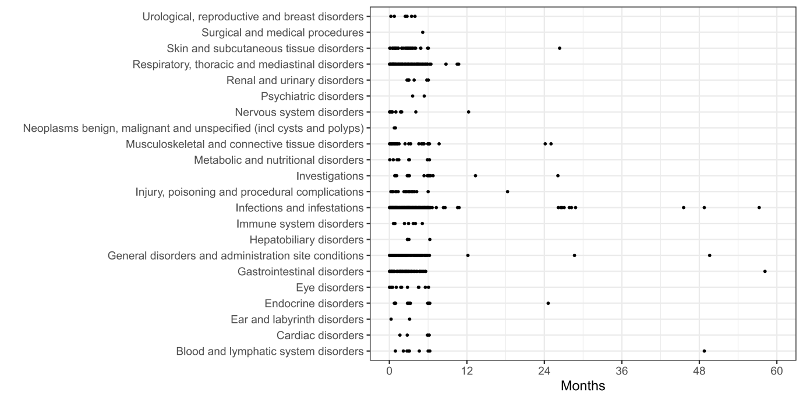Figure S1: Time distribution of adverse events based on system organ class

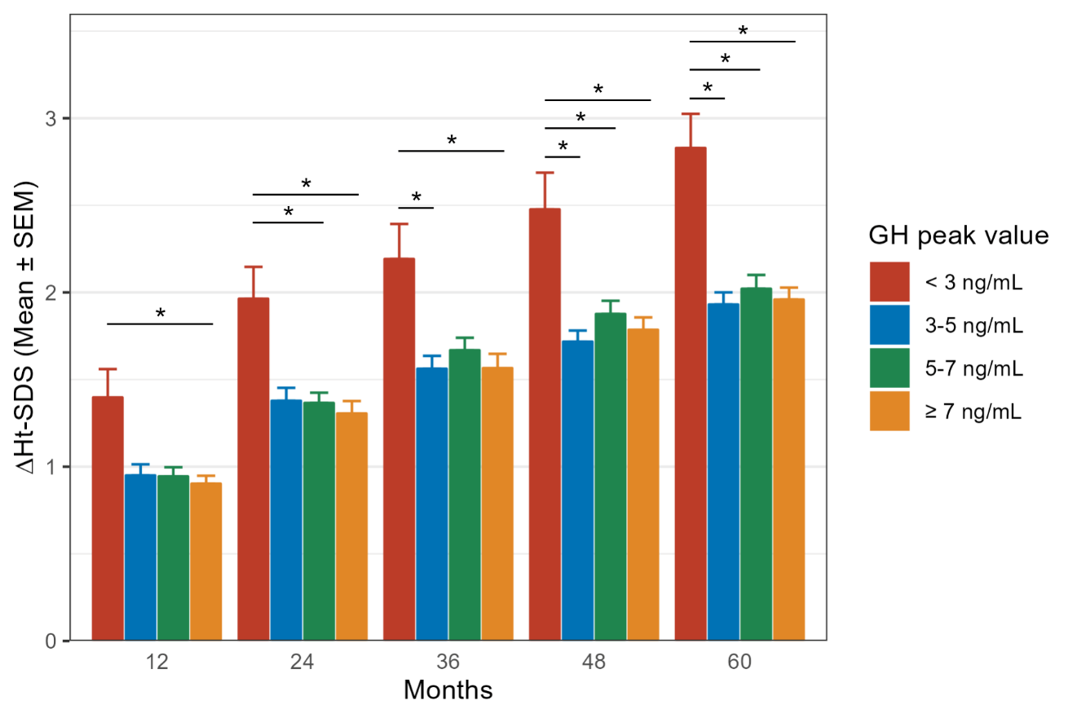
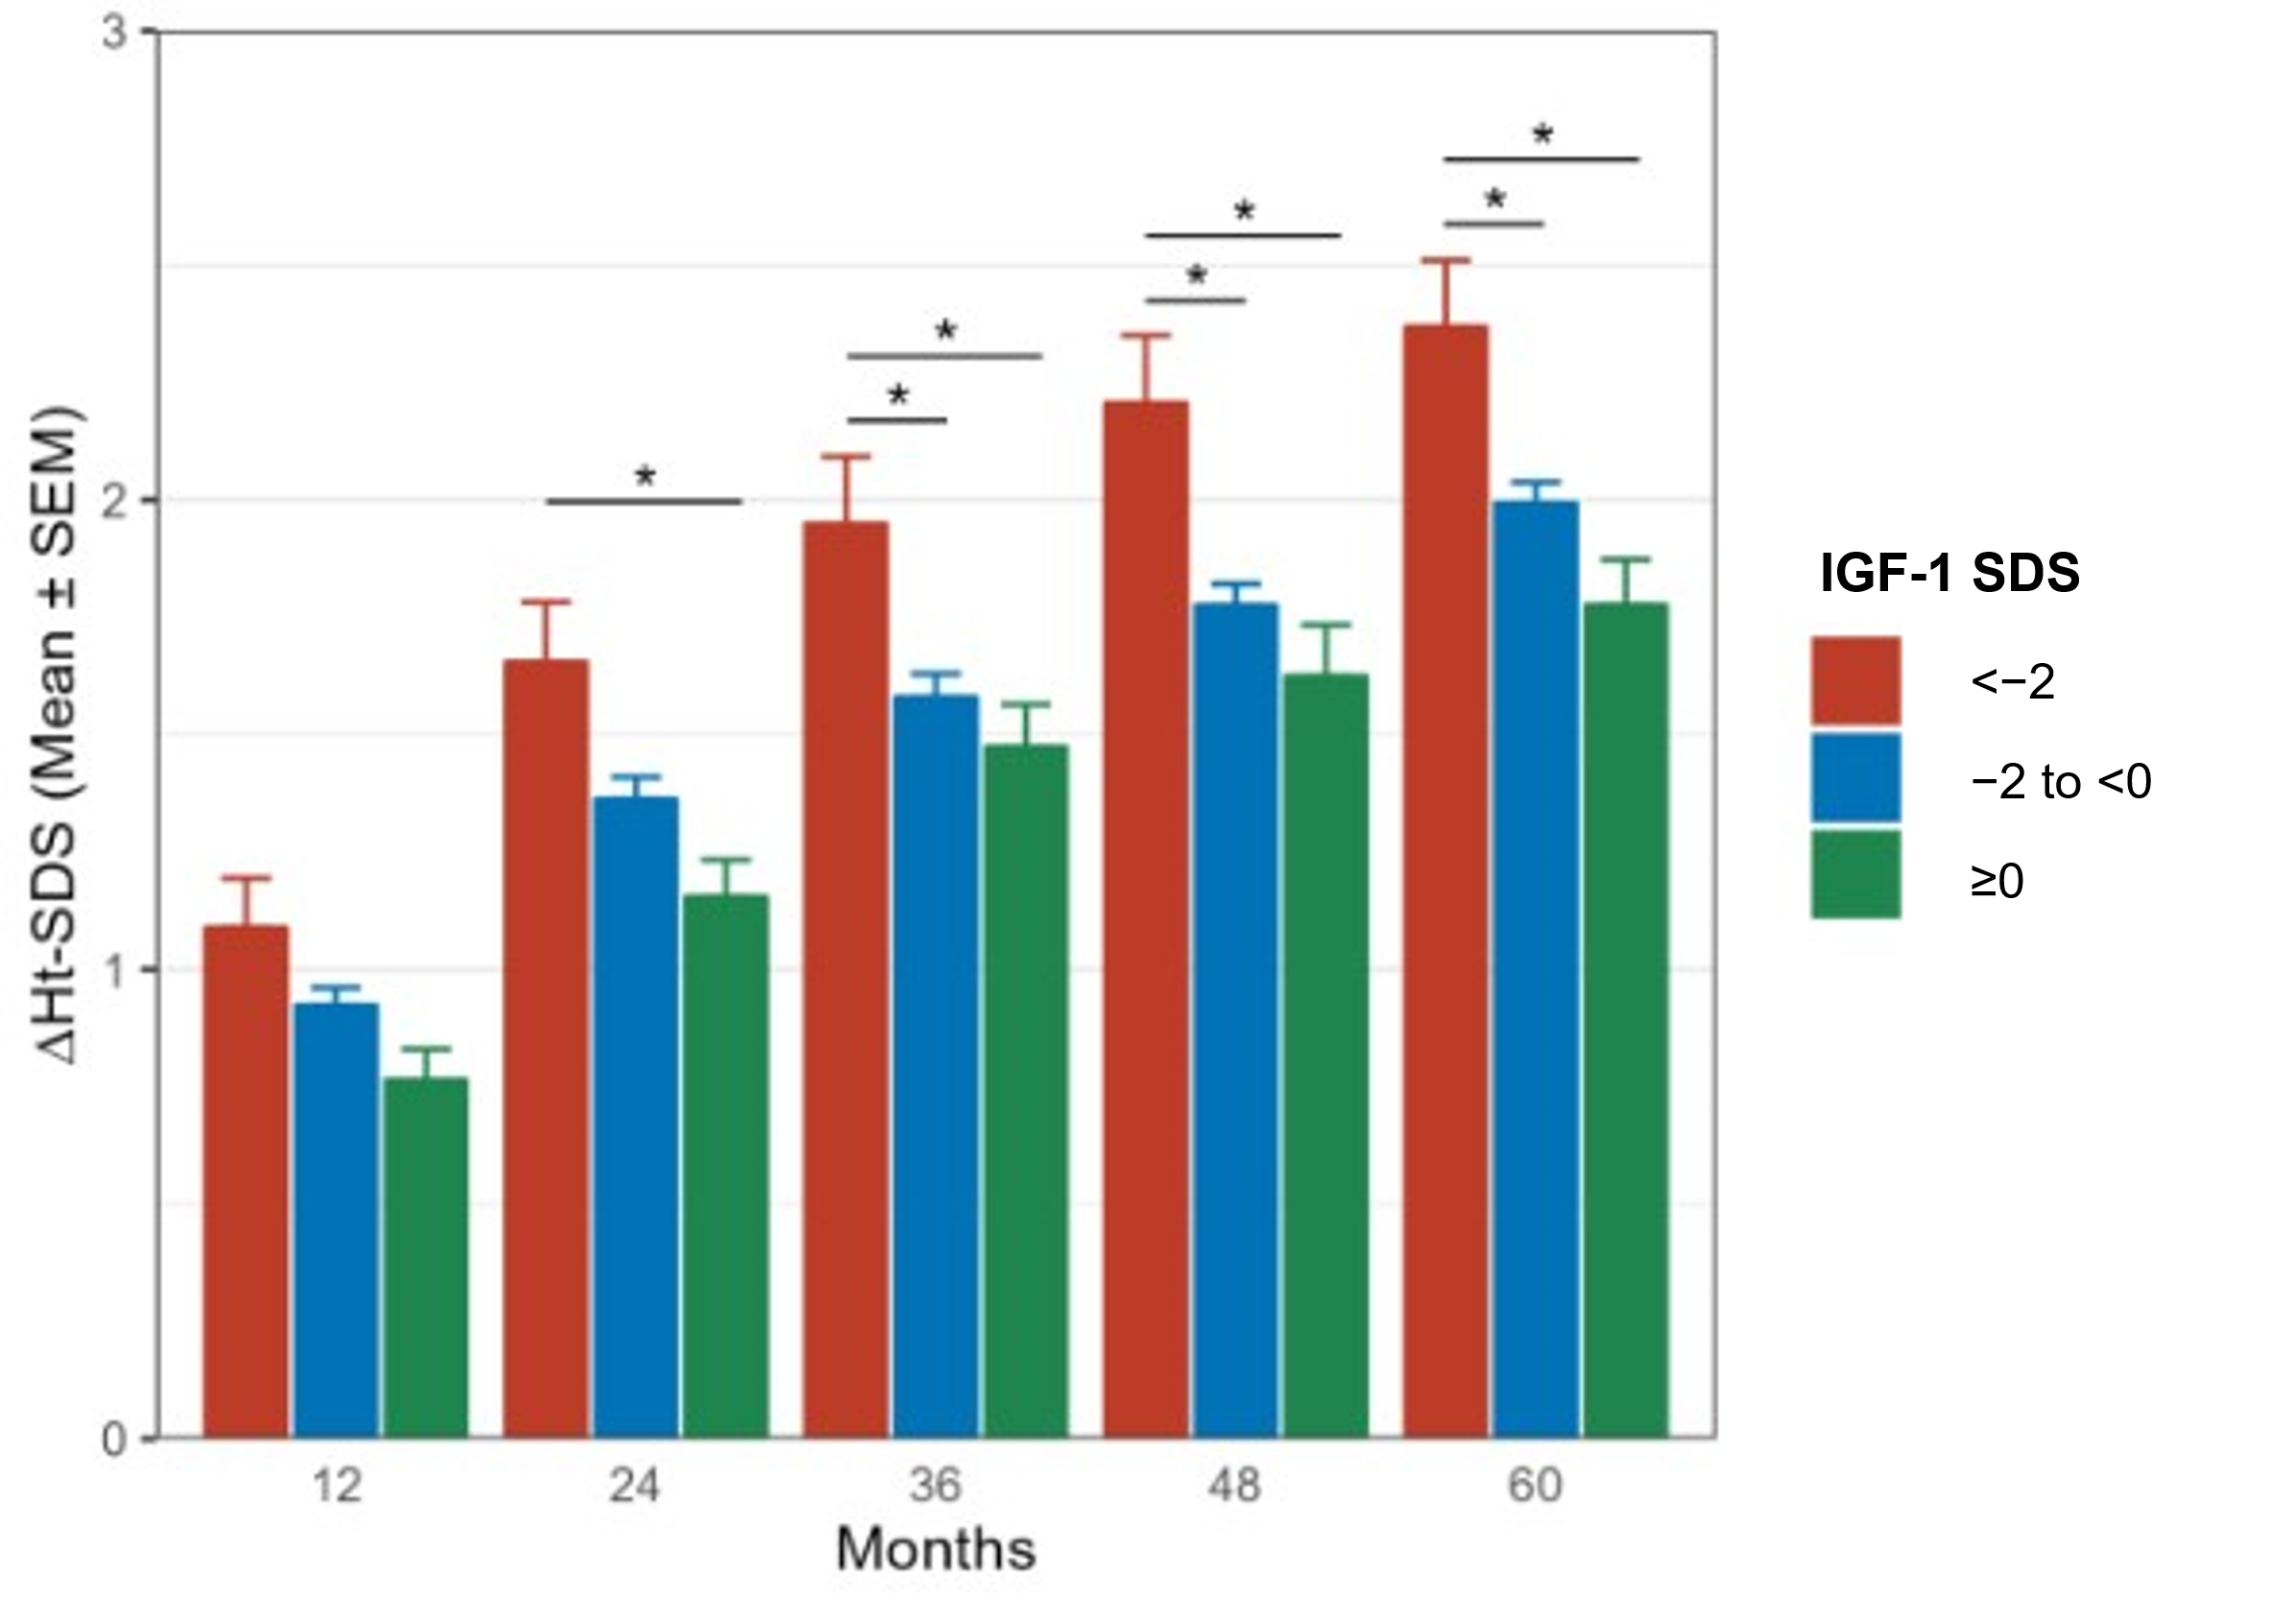
Figure S2: Subgroup analysis: A) ∆Ht-SDS from baseline by GH peak value
and B) ∆Ht-SDS from baseline by IGF-1 SDS.
*P<0.05
GH, growth hormone; ∆Ht-SDS, changes in height-standard deviation score; IGF-1, insulin-like growth factor-1; SEM, standard error of mean.
Figure S3: Gender-wise and Tanner stage-wise analysis of ΔHt-SDS, Ht-SDS and height velocity
∆Ht-SDS, changes in height-standard deviation score; Ht-SDS, height-standard deviation score; SEM, standard error of mean.

Table S1. Gender-wise and year-wise safety profile

Year | Male |  |  | Female
Year | Total AEs | TRAEs | SAE | Total AEs | TRAEs | SAE
Year 1 | 350/775 (45.6%) | 59/775 (7.6%) | 10/775 (1.3%) | 208/432 (48.1%) | 43/432 (1.0%) | 1/432 (0.2%)
Year 2 | 3/604 (0.5%) | 2/604 (0.3%) | 0/604 (0.0%) | 1/355 (0.3%) | 1/355 (0.3%) | 0/355 (0.0%)
Year 3 | 3/476 (0.6%) | 1/476 (0.2%) | 0/476 (0.0%) | 2/288 (0.7%) | 1/288 (0.3%) | 0/288 (0.0%)
Year 4 | 1/308 (0.3%) | 0/308 (0.0%) | 0/308 (0.0%) | 0/179 (0.0%) | 0/179 (0.0%) | 0/179 (0.0%)
Year 5 | 1/222 (0.4%) | 0/222 (0.0%) | 1/222 (0.4%) | 1/132 (0.7%) | 0/132 (0.0%) | 0/132 (0.0%)
Values in the table are presented as n/N (%)
n – no. of patients with AEs; N – total no. of assessed patients
AE, adverse event; SAE, safety adverse event; TRAE, treatment-related AE

Table S2. Gender-wise and year-wise treatment-related AEs observed during the five-year treatment period

Preferred term | Male |  |  |  | Female
Preferred term | Year 1 | Year 2 | Year 3 |  | Year 1 | Year 2 | Year 3
Hypothyroidism | 9 (1.2%) | - | - |  | 6 (1.4%) | - | -
Injection site reactions | 9 (1.2%) |  |  |  | 1 (0.2%)
Abnormal thyroid function testsª | 6 (0.8%) | - | - |  | 2 (0.5%) | - | -
Fever | 4 (0.5%) | - | - |  | 2 (0.5%) | - | -
Scoliosis | 4 (0.5%) | - | - |  | 4 (1.0%) | - | -
Arthralgia | 3 (0.4%) | - | - |  | 3 (0.7%) | - | -
Edema | 3 (0.4%) | - | - |  | 3 (0.7%) | - | -
Gastroenteritis | 3 (0.4%) | - | - |  | - | - | -
Elevated IGF-1 | 3 (0.4%) | 1 (0.2%) | 1 (0.2%) |  | 1 (0.2%) | - | -
Upper respiratory tract infection | 2 (0.3%) | - | - |  | - | - | -
Dizziness | 2 (0.3%) | - | - |  | 3 (0.7%) | - | -
Decreased thyroxine | 2 (0.3%) | - | - |  | 1 (0.2%) | - | -
Elevated fasting blood insulin | 1 (0.1%) | - | - |  | - | - | -
Cough | 1 (0.1%) | - | - |  | - | - | -
Headache | 1 (0.1%) | 1 (0.2%) | - |  | - | - | -
Urinary tract infection | 1 (0.1%) | - | - |  | - | - | -
Abnormal electrocardiogram | 1 (0.1%) | - | - |  | - | - | -
Rash | 1 (0.1%) | - | - |  | 1 (0.2%) | - | -
Periorbital edema | 1 (0.1%) | - | - |  | 1 (0.2%) | - | -
Eyelid edema | 2 (0.3%) | - | - |  | 1 (0.2%) | - | -
Body pain | 1 (0.1%) | - | - |  | - | 1 (0.3%) | 1 (0.4%)
Swelling | 1 (0.1%) | - | - |  | - | - | -
Urticaria | 1 (0.1%) | - | - |  | - | - | -
Elevated thyroid-stimulating hormone | 1 (0.1%) | - | - |  | 2 (0.5%) | - | -
Hypersensitivity reactions | 1 (0.1%) | - | - |  | 1 (0.2%) | - | -
Papular rash | - | - | - |  | 1 (0.2%) | - | -
Elevated glycated hemoglobin | - | - | - |  | 1 (0.2%) | - | -
Abnormal liver function | - | - | - |  | 1 (0.2%) | - | -
Hematuria | - | - | - |  | 1 (0.2%) | - | -
Anaphylactic rhinitis | - | - | - |  | 1 (0.2%) | - | -
Facial edema | - | - | - |  | 2 (0.5%) | - | -
AE, adverse events; IGF-1, insulin growth factor-1
ªThyroid function tests were abnormal: Documentation is not clear enough to be classified as a specific
diagnosis (e.g., hypothyroidism)
No treatment-related AEs occurred in the 4th and 5th years, so the table is not presented.

Table S3: Subgroup analysis of five-year height velocity by Tanner stage

Characteristics | Stage 1  N=149 | Stage 2  N=71 | Stage 3  N=59 | Stage 4  N=26 | Stage 5  N=7 | P  value
Height velocity (cm/y),  mean ± SD | 6.3 ± 1.4 | 7.2 ± 1.4 | 7.3 ± 2.1 | 6.7 ± 2.8 | 6.3 ± 2.0 | 0.001
Missing | 20 | 12 | 9 | 6 | 1
SD, standard deviation

Table S4. Gender-wise and Tanner stage-wise analysis of height parameters at 5th year

Characteristic | Female |  |  |  |  |  | Male
Characteristic | I  N = 41 | II  N = 34 | III  N = 25 | IV  N = 9 | V  N = 2 | p-value | I  N = 108 | II  N = 37 | III  N = 34 | IV  N = 17 | V  N = 5 | p-value
Height velocity at 60M | 6.6±1.4 | 7.3±1.0 | 6.3±1.6 | 4.5±2.0 | 5.2±3.1 | 0.004 | 6.2±1.4 | 7.1±1.7 | 8.0±2.1 | 7.9±2.5 | 7.0±1.5 | <0.001
Missing | 7 | 8 | 4 | 2 | 0 |  | 13 | 4 | 5 | 4 | 1
Height SDS at 60M | -0.3±1.0 | -0.4±1.0 | -0.3±1.0 | -0.5±0.6 | -0.1±1.7 | >0.9 | -0.3±0.9 | -0.4±0.8 | -0.3±0.7 | -0.3±0.7 | -0.9±0.5 | 0.7
Missing | 2 | 1 | 0 | 0 | 0 |  | 3 | 0 | 0 | 1 | 0
Height gain at 60M | 2.2±1.0 | 2.9±1.2 | 2.1±1.0 | 1.8±0.6 | 1.6±1.6 | 0.9 | 2.2±0.9 | 1.8±0.7 | 2.1±0.7 | 2.0±0.4 | 1.9±0.5 | 0.054
Missing | 2 | 1 | 0 | 0 | 0 |  | 3 | 0 | 0 | 1 | 0
The data is represented as Mean±SD ，Kruskal-Wallis rank sum test

Table S5: Subgroup analysis of ΔHt-SDS with time, with the GH peak values

Characteristic  (Mean±SD) | GH Peak Value (ng/mL)
Characteristic  (Mean±SD) | <3  N = 49 | 3,5  (N = 76) | 5,7  (N = 86) | 7,10  (N = 122) | P
Ht-SDS at 0M | -3.2±1.5 | -2.2±0.7 | -2.3±0.7 | -2.3±0.7
ΔHt-SDS at 12M | 1.4±0.9 | 0.9±0.4 | 0.9±0.4 | 0.9±0.4
ΔHt-SDS at 24M | 2.0±1.0 | 1.4±0.5 | 1.4±0.5 | 1.3±0.7
ΔHt-SDS at 36M | 2.2±1.3 | 1.6±0.5 | 1.7±0.6 | 1.6±0.7
ΔHt-SDS at 48M | 2.5±1.4 | 1.7±0.5 | 1.9±0.6 | 1.8±0.7
ΔHt-SDS at 60M | 2.8±1.3 | 1.9±0.6 | 2.0±0.70 | 2.0±0.7
Ht-SDS at 60M | -0.4±0.9 | -0.3±0.8 | -0.2±0.8 | -0.3±0.8 | 0.7
GH, growth hormone; ΔHt-SDS, changes in height-standard deviation score; M, Months; SD, standard deviation.

Table S6. Multivariate analysis of efficacy data

Variables | Coefficient (95% CI) | P-value
Female vs. Male | -0.132 (-0.292, 0.029) | 0.108
Age (years) | -0.105 (-0.145, -0.064) | <0.001
BA - CA (years) | 0.017 (-0.076, 0.111) | 0.712
Dose (mg/kg/week) | 3.034 (0.837, 5.230) | 0.007
Ht SDS | -0.468 (-0.559, -0.377) | <0.001
GH peak value (ng/mL) | -0.054 (-0.086, -0.021) | 0.001
BMI SDS | 0.094 (0.025, 0.163) | 0.008
IGF-1 SDS | -0.076 (-0.136, -0.016) | 0.014
BA, bone age; BMI, body mass index; CA, chronological age; GH, growth hormone; Ht, height; Ht SDS, Ht standard deviation score; IGF-1, insulin growth factor-1, SDS, standard deviation score

