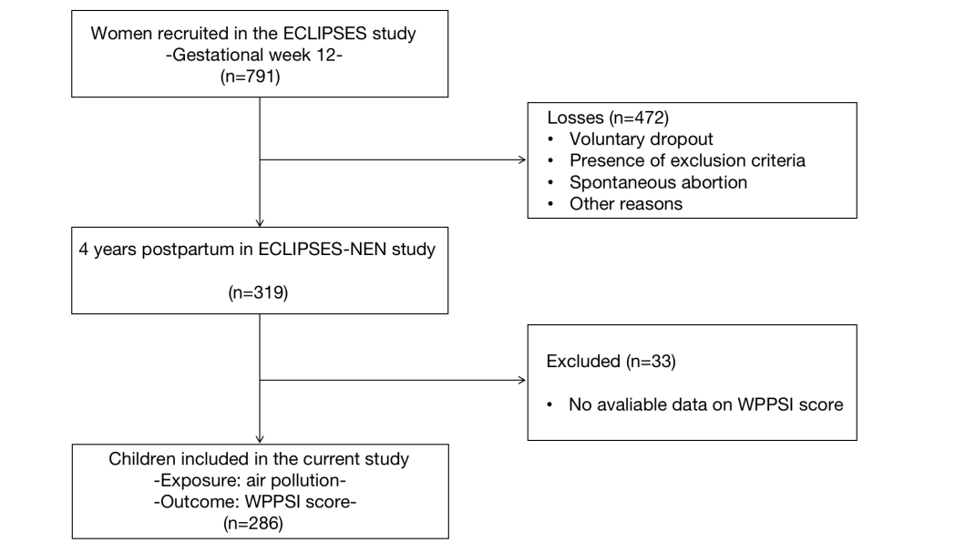

Fig. S1 Study flow diagram.

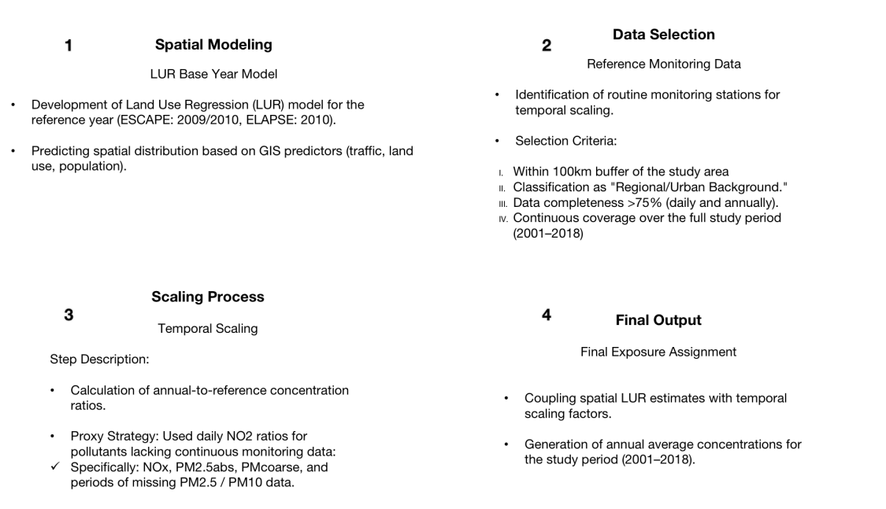
Fig. S2 Schematic of the LUR Temporal Adjustment and Exposure Assignment Process.

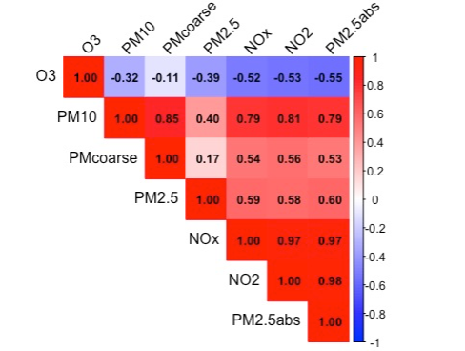
Fig. S3 Spearman correlations among air pollutants
Supplementary Table 1. Comparison of characteristics between included and excluded participants
Children characteristics | Excluded | Included | P
Gestational age (weeks), mean ± SD | 39.7 ± 1.4 | 39.8 ± 1.4 | 0.453
Sex, n (%) |  |  | 0.472
Male | 244 (48.3) | 146 (51.0)
Female | 261 (51.7) | 140 (49.0)
Type of feeding, n (%) |  |  | 0.940
Breastfeeding | 390 (77.2) | 222 (77.6)
Mixed feeding/infant formula | 115 (22.8) | 64 (22.4)
NDVI within 500 m of school | 0.3 ± 0.1 | 0.3 ± 0.1 | 0.681
Maternal and family characteristics
Age (years), mean ± SD | 31.0 ± 5.2 | 31.6 ± 4.7 | 0.090
BMI, mean ± SD | 24.7 ± 4.3 | 24.7 ± 4.3 | 0.870
Social class, n (%) |  |  | 0.260
Low | 66 (13.1%) | 29 (10.1)
Medium | 339 (67.1%) | 189 (66.1)
High | 100 (19.8%) | 68 (23.8)
Smoking status, n (%) |  |  | 0.450
Never smoker | 335 (66.3) | 198 (69.2)
Smoker or ex-smoker | 170 (33.7) | 88 (30.8)
Parent IQ (score), mean ± SD | 8.9 ± 2.7 | 9.1 ± 3.6 | 0.350
Abbreviations: BMI, Body Mass Index; MedDiet, Mediterranean diet; NDVI, Normalized Difference Vegetation Index.

Supplementary table 2. The interaction between sex and air pollution
 | VCI | FRI | WMI | PSI | FSIQ | VAI | NVI | GAI
Air pollution | b (95%CI) | b (95%CI) | b (95%CI) | b (95%CI) | b (95%CI) | b (95%CI) | b (95%CI) | b (95%CI)
NO2 | 1.02 (-1.81, 3.85) | 0.62 (-2.35, 3.59) | 1.77 (-1.04, 4.59) | 0.29 (-2.49, 3.06) | 1.43 (-1.14, 4.00) | 0.21 (-2.67, 3.10) | 1.07 (-1.72, 3.85) | 0.56 (-2.03, 3.14)
p | 0.480 | 0.681 | 0.217 | 0.839 | 0.273 | 0.884 | 0.453 | 0.672
NO_{x} | 0.29 (-2.55, 3.13) | 0.93 (-2.05, 3.91) | 1.35 (-1.52, 4.22) | 0.64 (-2.14, 3.43) | 1.37 (-1.22, 3.97) | 0.11 (-2.79, 3.01) | 0.93 (-1.90, 3.76) | 0.82 (-1.79, 3.43)
p | 0.843 | 0.538 | 0.356 | 0.649 | 0.298 | 0.940 | 0.516 | 0.538
O₃ | -0.74 (-3.58, 2.10) | -2.10 (-5.12, 0.92) | -0.43 (-3.30, 2.43) | 0.20 (-2.60, 3.00) | -0.63 (-3.23, 1.97) | 0.64 (-2.29, 3.58) | -1.01 (-3.88, 1.86) | -1.34 (-3.99, 1.31)
p | 0.608 | 0.173 | 0.767 | 0.889 | 0.636 | 0.666 | 0.488 | 0.321
PM₁₀ | 1.64 (-1.17, 4.46) | 2.63 (-0.33, 5.60) | 2.17 (-0.61, 4.95) | -0.56 (-3.34, 2.22) | 1.47 (-1.10, 4.04) | -0.18 (-3.07, 2.71) | 2.53 (-0.25, 5.31) | 1.51 (-1.08, 4.09)
p | 0.252 | 0.082 | 0.126 | 0.694 | 0.262 | 0.903 | 0.074 | 0.253
PM₂₅ | -2.12 (-5.08, 0.84) | -0.05 (-3.26, 3.15) | 0.78 (-2.44, 4.00) | 0.06 (-2.95, 3.07) | -0.53 (-3.39, 2.33) | -0.53 (-3.68, 2.63) | -0.94 (-4.13, 2.26) | -1.24 (-4.11, 1.63)
p | 0.160 | 0.975 | 0.635 | 0.967 | 0.714 | 0.742 | 0.565 | 0.397
PM_{2.5abs} | -1.27 (-4.19, 1.64) | 1.86 (-1.30, 5.03) | 1.17 (-2.17, 4.51) | 1.98 (-1.00, 4.95) | 1.37 (-1.41, 4.14) | 0.30 (-2.72, 3.33) | 1.08 (-2.09, 4.26) | 1.03 (-1.83, 3.88)
p | 0.390 | 0.247 | 0.492 | 0.192 | 0.333 | 0.844 | 0.503 | 0.479
PM_{coarse} | 0.32 (-2.52, 3.17) | 1.42 (-1.58, 4.41) | 0.87 (-1.90, 3.63) | -1.69 (-4.47, 1.08) | 0.15 (-2.45, 2.74) | -1.15 (-4.04, 1.73) | 0.97 (-1.84, 3.78) | -0.22 (-2.81, 2.38)
p | 0.823 | 0.353 | 0.537 | 0.231 | 0.912 | 0.433 | 0.496 | 0.869
Abbreviations: WPPSI, Wechsler Preschool and Primary Scale of Intelligence; VCI, Verbal Comprehension Index; FRI, Fluid Reasoning Index; WMI, Working Memory Index; PSI, Processing Speed Index; FSIQ, Full Scale IQ; VAI, Vocabulary Acquisition Index; NVI, Nonverbal Index; GAI, General Ability index; edf, effective degrees of freedom. NO₂, Nitrogen Dioxide; NOₓ, Nitrogen Oxides; PM_{2.5}, Particulate Matter ≤2.5 µm in diameter; PM_{2.5abs}, Absorbance of Particulate Matter ≤2.5 µm; PM₁₀, Particulate Matter ≤10 µm in diameter; PM_{coarse}, Coarse Particulate Matter (PM₁₀ − PM_{2.5}); O₃, Ozone.

Supplementary table 3. Associations between air pollutant exposures and cognitive function scores, including Raw and False Discovery Rate (FDR)-adjusted p-values.
Outcome | Exposure | Beta_95CI | Raw_P | FDR_P
FRI | no2 | 1.81 (-0.54, 4.15) | 0.132 | 0.674
FRI | nox | 2.06 (-0.23, 4.34) | 0.079 | 0.648
FRI | pm25 | 0.70 (-1.08, 2.48) | 0.441 | 0.674
FRI | pm25abs | 2.01 (-0.06, 4.09) | 0.059 | 0.648
FRI | pmcoarse | 0.61 (-0.95, 2.17) | 0.445 | 0.674
FRI | pm10 | 0.81 (-0.92, 2.54) | 0.358 | 0.674
FRI | o3 | 0.49 (-1.44, 2.41) | 0.621 | 0.787
FSIQ | no2 | 0.85 (-1.20, 2.91) | 0.416 | 0.674
FSIQ | nox | 0.83 (-1.18, 2.84) | 0.419 | 0.674
FSIQ | pm25 | 0.84 (-0.71, 2.39) | 0.292 | 0.674
FSIQ | pm25abs | 0.82 (-1.00, 2.65) | 0.378 | 0.674
FSIQ | pmcoarse | -0.59 (-1.95, 0.77) | 0.398 | 0.674
FSIQ | pm10 | -0.37 (-1.88, 1.14) | 0.634 | 0.787
FSIQ | o3 | -0.92 (-2.59, 0.74) | 0.279 | 0.674
GAI | no2 | 0.95 (-1.14, 3.03) | 0.375 | 0.674
GAI | nox | 0.88 (-1.16, 2.92) | 0.396 | 0.674
GAI | pm25 | 0.71 (-0.87, 2.29) | 0.378 | 0.674
GAI | pm25abs | 0.67 (-1.19, 2.52) | 0.482 | 0.710
GAI | pmcoarse | -0.34 (-1.73, 1.04) | 0.628 | 0.787
GAI | pm10 | -0.14 (-1.68, 1.40) | 0.859 | 0.859
GAI | o3 | -0.34 (-2.04, 1.36) | 0.696 | 0.787
NVI | no2 | 0.54 (-1.72, 2.79) | 0.641 | 0.787
NVI | nox | 0.56 (-1.64, 2.77) | 0.616 | 0.787
NVI | pm25 | 0.24 (-1.47, 1.95) | 0.781 | 0.825
NVI | pm25abs | 0.64 (-1.36, 2.65) | 0.529 | 0.760
NVI | pmcoarse | -0.68 (-2.18, 0.81) | 0.371 | 0.674
NVI | pm10 | -0.36 (-2.01, 1.30) | 0.674 | 0.787
NVI | o3 | -0.29 (-2.14, 1.56) | 0.759 | 0.817
PSI | no2 | 1.07 (-1.20, 3.35) | 0.355 | 0.674
PSI | nox | 1.03 (-1.19, 3.26) | 0.362 | 0.674
PSI | pm25 | 0.86 (-0.86, 2.58) | 0.328 | 0.674
PSI | pm25abs | 1.14 (-0.88, 3.16) | 0.268 | 0.674
PSI | pmcoarse | -0.89 (-2.40, 0.61) | 0.246 | 0.674
PSI | pm10 | -0.33 (-2.00, 1.35) | 0.703 | 0.787
PSI | o3 | -0.99 (-2.84, 0.86) | 0.296 | 0.674
VAI | no2 | 1.01 (-1.37, 3.39) | 0.405 | 0.674
VAI | nox | 1.08 (-1.24, 3.41) | 0.361 | 0.674
VAI | pm25 | 1.40 (-0.39, 3.20) | 0.127 | 0.674
VAI | pm25abs | 1.20 (-0.92, 3.31) | 0.269 | 0.674
VAI | pmcoarse | -0.74 (-2.32, 0.84) | 0.360 | 0.674
VAI | pm10 | -0.35 (-2.10, 1.41) | 0.699 | 0.787
VAI | o3 | 0.41 (-1.54, 2.35) | 0.683 | 0.787
VCI | no2 | 0.24 (-2.08, 2.57) | 0.838 | 0.859
VCI | nox | 0.21 (-2.07, 2.48) | 0.859 | 0.859
VCI | pm25 | 1.10 (-0.65, 2.85) | 0.220 | 0.674
VCI | pm25abs | 0.38 (-1.69, 2.44) | 0.722 | 0.793
VCI | pmcoarse | -1.37 (-2.90, 0.16) | 0.081 | 0.648
VCI | pm10 | -1.21 (-2.92, 0.49) | 0.164 | 0.674
VCI | o3 | -1.41 (-3.28, 0.47) | 0.143 | 0.674
WMI | no2 | -2.26 (-4.58, 0.07) | 0.059 | 0.648
WMI | nox | -2.05 (-4.32, 0.23) | 0.079 | 0.648
WMI | pm25 | -0.70 (-2.47, 1.08) | 0.442 | 0.674
WMI | pm25abs | -0.64 (-2.72, 1.44) | 0.549 | 0.768
WMI | pmcoarse | -2.71 (-4.23, -1.20) | 0.001* | 0.030*
WMI | pm10 | -2.39 (-4.09, -0.70) | 0.006* | 0.170
WMI | o3 | -1.01 (-2.93, 0.90) | 0.302 | 0.674
Abbreviations: FDR, False Discovery Rate; VCI, Verbal Comprehension Index; FRI, Fluid Reasoning Index; WMI, Working Memory Index; PSI, Processing Speed Index; FSIQ, Full Scale IQ; VAI, Vocabulary Acquisition Index; NVI, Nonverbal Index; GAI, General Ability index; edf, effective degrees of freedom. NO₂, Nitrogen Dioxide; NOₓ, Nitrogen Oxides; PM_{2.5}, Particulate Matter ≤2.5 µm in diameter; PM_{2.5abs}, Absorbance of Particulate Matter ≤2.5 µm; PM₁₀, Particulate Matter ≤10 µm in diameter; PM_{coarse}, Coarse Particulate Matter (PM₁₀ − PM_{2.5}); O₃, Ozone. Raw P represents the unadjusted p-value from the regression models. FDR P represents the p-value adjusted for multiple comparisons using the Benjamini-Hochberg procedure. *, statistical significant

Supplementary table 4. Sex-stratified Association Between Air Exposure on WPPSI score
 | VCI |  | FRI |  | WMI |  | PSI |  | FSIQ |  | VAI |  | NVI |  | GAI
Air pollution | b | 95%CI | b | 95%CI | b | 95%CI | b | 95%CI | b | 95%CI | b | 95%CI | b | 95%CI | b | 95%CI
NO₂
boys | 0.84 (-2.66, 4.34) |  | 1.65 (-1.69, 5.00) |  | -3.91 (-7.65, -0.16)* |  | 0.89 (-2.54, 4.31) |  | 0.15 (-2.96, 3.25) |  | 1.15 (-2.30, 4.59) |  | -1.23 (-4.54, 2.08) |  | 0.80 (-2.31, 3.91)
girls | -0.45 (-3.49, 2.60) |  | 0.89 (-2.40, 4.18) |  | -1.15 (-4.33, 2.02) |  | 1.09 (-2.18, 4.36) |  | 0.88 (-1.99, 3.75) |  | 0.21 (-3.17, 3.59) |  | 1.01 (-2.20, 4.21) |  | 0.43 (-2.39, 3.25)
NO_{x}
boys | 0.98 (-2.29, 4.26) |  | 2.09 (-1.03, 5.21) |  | -3.23 (-6.75, 0.29) |  | 0.75 (-2.46, 3.96) |  | 0.31 (-2.60, 3.22) |  | 1.31 (-1.91, 4.54) |  | -0.99 (-4.08, 2.11) |  | 0.86 (-2.05, 3.77)
girls | -0.63 (-3.74, 2.49) |  | 1.04 (-2.33, 4.41) |  | -1.11 (-4.36, 2.15) |  | 1.22 (-2.13, 4.57) |  | 0.81 (-2.13, 3.75) |  | 0.03 (-3.43, 3.50) |  | 1.08 (-2.21, 4.36) |  | 0.35 (-2.54, 3.24)
O₃
boys | -0.37 (-3.16, 2.41) |  | 1.95 (-0.69, 4.59) |  | -1.46 (-4.48, 1.56) |  | -1.41 (-4.13, 1.30) |  | -0.68 (-3.15, 1.78) |  | 0.09 (-2.66, 2.83) |  | 0.79 (-1.84, 3.42) |  | 0.26 (-2.21, 2.73)
girls | -1.30 (-3.88, 1.27) |  | -0.67 (-3.49, 2.15 |  | -0.82 (-3.52, 1.88) |  | -0.11 (-2.90, 2.67) |  | -0.84 (-3.28, 1.60) |  | 1.71 (-1.17, 4.59) |  | -1.30 (-4.02, 1.42 |  | -0.50 (-2.89, 1.90)
PM₁₀
boys | -2.54 (-5.07, -0.02)* |  | -1.14 (-3.59, 1.31) |  | -3.79 (-6.50, -1.09)* |  | -0.52 (-3.03, 1.99) |  | -2.04 (-4.29, 0.20) |  | -0.11 (-2.64, 2.42) |  | -2.64 (-5.02, -0.26)* |  | -1.83 (-4.08, 0.43)
girls | -0.98 (-3.17, 1.20) |  | 1.53 (-0.84, 3.90) |  | -1.50 (-3.78, 0.78) |  | -0.71 (-3.07, 1.65) |  | 0.19 (-1.88, 2.26) |  | -1.08 (-3.52, 1.36) |  | 0.58 (-1.73, 2.89) |  | 0.31 (-1.72, 2.34)
PM₂₅
boys | 1.92 (-0.32, 4.15) |  | 0.90 (-1.27, 3.07) |  | -0.84 (-3.30, 1.63) |  | 1.39 (-0.81, 3.60) |  | 1.53 (-0.46, 3.52) |  | 1.81 (-0.40, 4.02) |  | 0.20 (-1.95, 2.35) |  | 1.35 (-0.65, 3.35)
girls | -1.16 (-4.18, 1.85) |  | 0.15 (-3.15, 3.44) |  | -0.05 (-3.21, 3.11) |  | -0.12 (-3.37, 3.13) |  | -1.12 (-3.97, 1.72) |  | -1.05 (-4.43, 2.33) |  | -0.53 (-3.72, 2.66) |  | -1.02 (-3.82, 1.77)
PM_{2.5abs}
boys | 1.22 (-1.36, 3.81) |  | 1.94 (-0.52, 4.40) |  | -0.88 (-3.70, 1.94) |  | 0.79 (-1.75, 3.33) |  | 0.69 (-1.60, 2.99) |  | 1.27 (-1.28, 3.82) |  | -0.30 (-2.75, 2.16) |  | 0.83 (-1.47, 3.13)
girls | -0.75 (-4.36, 2.85) |  | 1.54 (-2.36, 5.44) |  | -0.07 (-3.84, 3.70) |  | 2.17 (-1.69, 6.03) |  | 0.96 (-2.45, 4.36) |  | -0.27 (-4.28, 3.75) |  | 1.76 (-2.03, 5.55) |  | 0.30 (-3.05, 3.64)
PM_{coarse}
boys | -2.00 (-4.29, 0.29) |  | -0.57 (-2.79, 1.66) |  | -3.32 (-5.77, -0.88)* |  | -0.84 (-3.11, 1.43) |  | -1.44 (-3.48, 0.60) |  | -0.11 (-2.40, 2.18) |  | -2.05 (-4.22, 0.11) |  | -1.20 (-3.25, 0.85)
girls | -1.66 (-3.62, 0.31) |  | 0.91 (-1.24, 3.07) |  | -2.53 (-4.56, -0.50)* |  | -1.50 (-3.62, 0.62) |  | -0.68 (-2.55, 1.19) |  | -1.74 (-3.94, 0.46) |  | -0.44 (-2.54, 1.66) |  | -0.45 (-2.29, 1.39)
Abbreviations: WPPSI, Wechsler Preschool and Primary Scale of Intelligence; VCI, Verbal Comprehension Index; FRI, Fluid Reasoning Index; WMI, Working Memory Index; PSI, Processing Speed Index; FSIQ, Full Scale IQ; VAI, Vocabulary Acquisition Index; NVI, Nonverbal Index; GAI, General Ability index; edf, effective degrees of freedom. NO₂, Nitrogen Dioxide; NOₓ, Nitrogen Oxides; PM_{2.5}, Particulate Matter ≤2.5 µm in diameter; PM_{2.5abs}, Absorbance of Particulate Matter ≤2.5 µm; PM₁₀, Particulate Matter ≤10 µm in diameter; PM_{coarse}, Coarse Particulate Matter (PM₁₀ − PM_{2.5}); O₃, Ozone. *, statistical significant

Supplementary table 5. The overall effect of air pollution mixture on WPPSI scores by WQS in positive direction
 | estimate | 95%CI
VCI | -1.69 | -4.21, 0.82
FRI | 1.40 | -1.88, 4.70
WMI | 1.86 | -4.11, 0.38
PSI | 1.98 | -1.57, 5.55
FSIQ | 0.59 | -1.79, 2.98
VAI | 2.41 | 0.01, 4.81*
NVI | 0.16 | -2.35, 2.68
GAI | -0.40 | -2.59, 1.77
Abbreviations: WPPSI, Wechsler Preschool and Primary Scale of Intelligence; VCI, Verbal Comprehension Index; FRI, Fluid Reasoning Index; WMI, Working Memory Index; PSI, Processing Speed Index; FSIQ, Full Scale IQ; VAI, Vocabulary Acquisition Index; NVI, Nonverbal Index; GAI, General Ability index. The Cognitive Proficiency Index (CPI) is not shown separately as it is derived from WMI and PSI. *, statistical significant

Supplementary table 6. Overall effect of air pollution mixture on WPPSI scores: sex-stratified WQS analysis in opposite direction
 |  | estimate | 95%CI
VCI | boys | 1.87 | -1.56, 5.30
 | girls | -1.40 | -4.14, 1.33
FRI | boys | 1.80 | -1.88, 5.50
 | girls | 1.10 | -2.50, 4.70
WMI | boys | -3.07 | -6.45, 0.29
 | girls | -1.85 | -5.10, 1.40
PSI | boys | 2.20 | -1.09, 5.50
 | girls | 2.16 | -0.73, 5.07
FSIQ | boys | -0.62 | -3.85, 2.60
 | girls | -0.58 | -5.32, 4.14
VAI | boys | 2.77 | -0.98, 6.52
 | girls | 2.21 | -2.63, 7.07
NVI | boys | -1.98 | -5.50, 1.52
 | girls | 1.67 | -2.88, 6.23
GAI | boys | 1.52 | -1.26, 5.90
 | girls | -0.25 | -3.46, 2.95
Abbreviations: WPPSI, Wechsler Preschool and Primary Scale of Intelligence; VCI, Verbal Comprehension Index; FRI, Fluid Reasoning Index; WMI, Working Memory Index; PSI, Processing Speed Index; FSIQ, Full Scale IQ; VAI, Vocabulary Acquisition Index; NVI, Nonverbal Index; GAI, General Ability index.

Supplementary table 7. The overall effect of air pollution mixture on WPPSI scores by two-indices WQS
 | estimate | 95%CI
VCI pwqs | 2.07 | -3.11, 7.26
nwqs | -1.44 | -6.27, 3.37
FRI pwqs | -0.01 | -3.64, 3.62
nwqs | 0.91 | -3.08, 4.92
WMI pwqs | 1.92 | -2.74, 6.59
nwqs | -1.62 | -6.78, 3.52
PSI pwqs | 4.15 | -0.60, 8.90
nwqs | -4.18 | -9.31, 0.94
FSIQ pwqs | 2.90 | -3.92, 9.73
nwqs | -2.10 | -8.33, 4.11
VAI pwqs | 0.95 | -3.54, 5.46
nwqs | -0.67 | -5.25, 3.91
NVI pwqs | 2.95 | 0.76, 5.14
nwqs | -2.65 | -5.45, 0.12
GAI pwqs | 2.20 | -3.46, 7.87
nwqs | -1.46 | -6.41, 3.48
Abbreviations: WPPSI, Wechsler Preschool and Primary Scale of Intelligence; VCI, Verbal Comprehension Index; FRI, Fluid Reasoning Index; WMI, Working Memory Index; PSI, Processing Speed Index; FSIQ, Full Scale IQ; VAI, Vocabulary Acquisition Index; NVI, Nonverbal Index; GAI, General Ability index. The Cognitive Proficiency Index (CPI) is not shown separately as it is derived from WMI and PSI.

