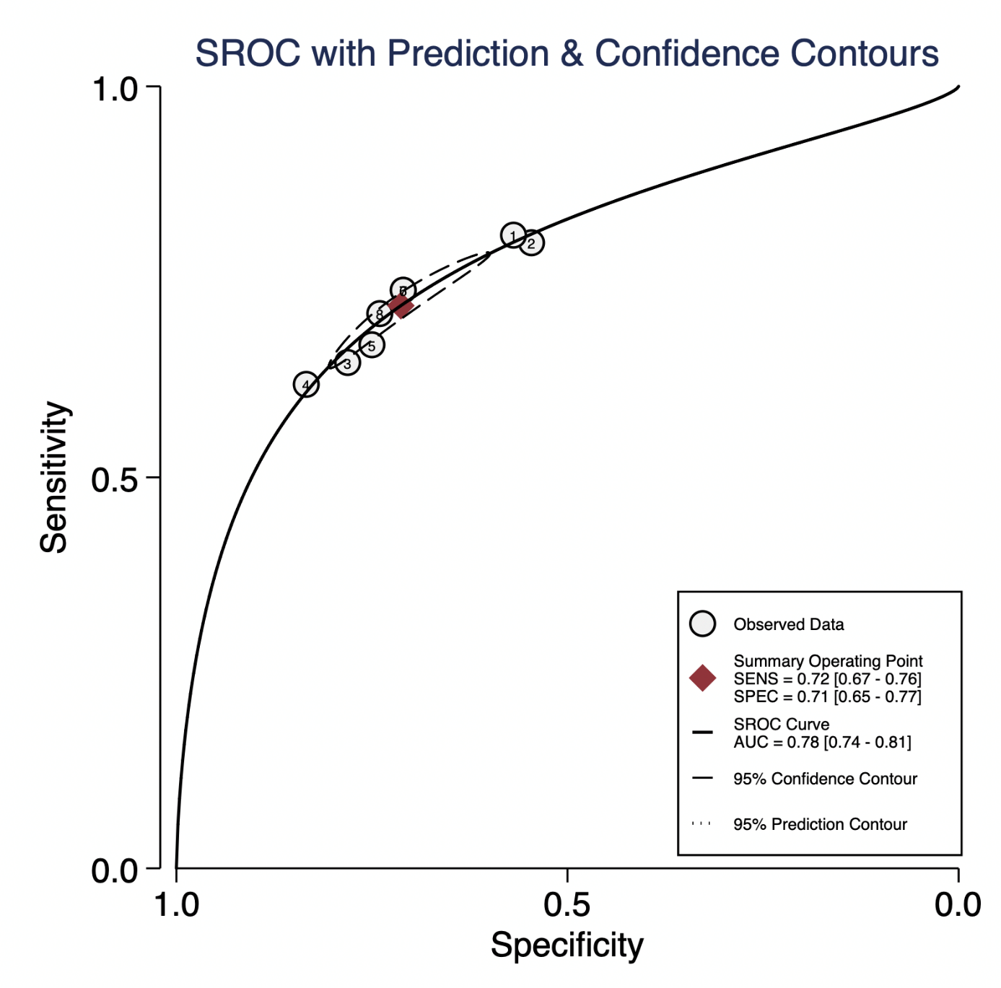
Supplementary Figure 2. SROC with Prediction & Confidence contours after excluding the studies with high risk of bias

