Figure S1. Forest Plot of Proportion of Respiratory Syncytial Virus (RSV) before COVID-19

Figure S2. Forest Plot of Proportion of Human Rhinovirus (HRV) before COVID-19
Figure S3. Forest Plot of Proportion of Influenza Virus (IV) before COVID-19

Figure S4. Forest Plot of Proportion of Adenovirus (ADV) before COVID-19

Figure S5. Forest Plot of Proportion of Bocavirus (BoV) before COVID-19

Figure S6. Forest Plot of Parainfluenzavirus (PIV) before COVID-19

Figure S7. Forest Plot of human Coronavirus (hCOV) before COVID-19
Figure S8. Forest Plot of Human Metapneumovirus (hMPV) before COVID-19
Figure S9. Bubble plots for prevalence of viral identifications in infants with respiratory tract infection in European countries prior to COVID-19 pandemic.

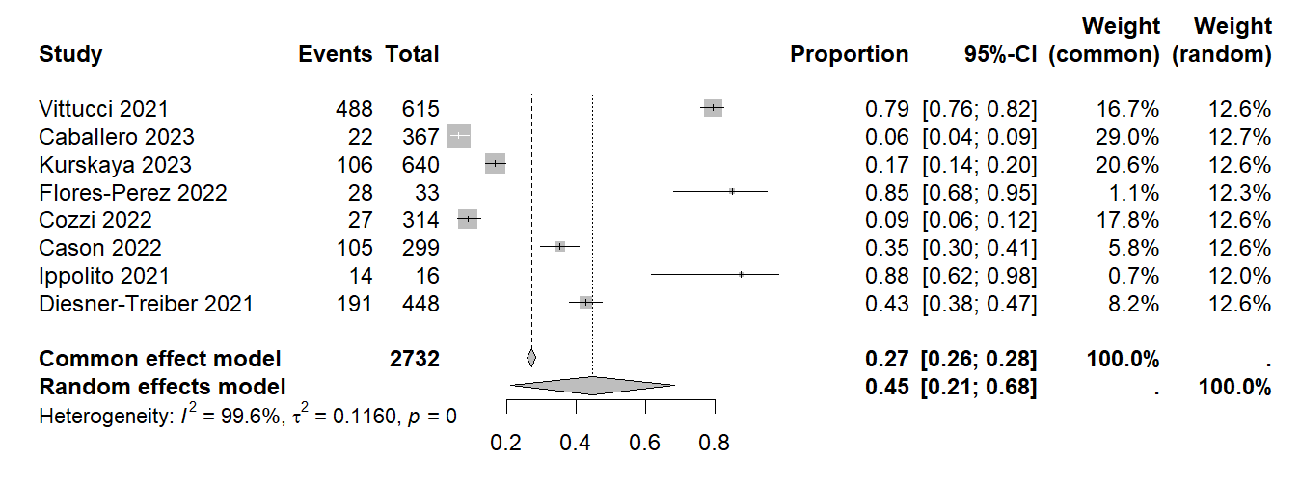
Figure S10. Forest Plot of Proportion of Human Rhinovirus (HRV) during COVID-19

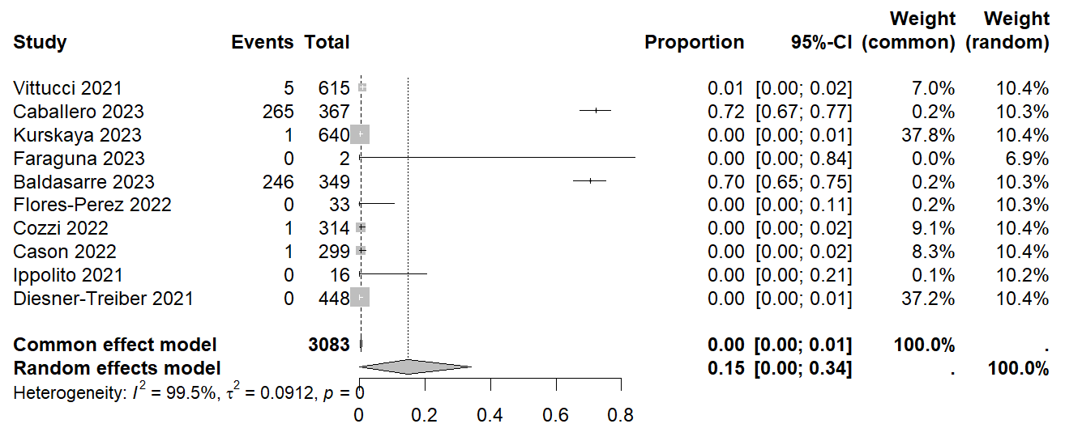
Figure S11. Forest Plot of Proportion of Respiratory Syncytial Virus (RSV) during COVID-19

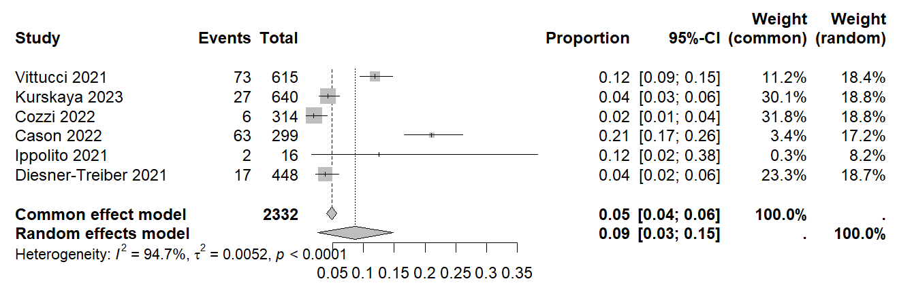
Figure S12. Forest Plot of Proportion of Adenovirus (ADV) during COVID-19

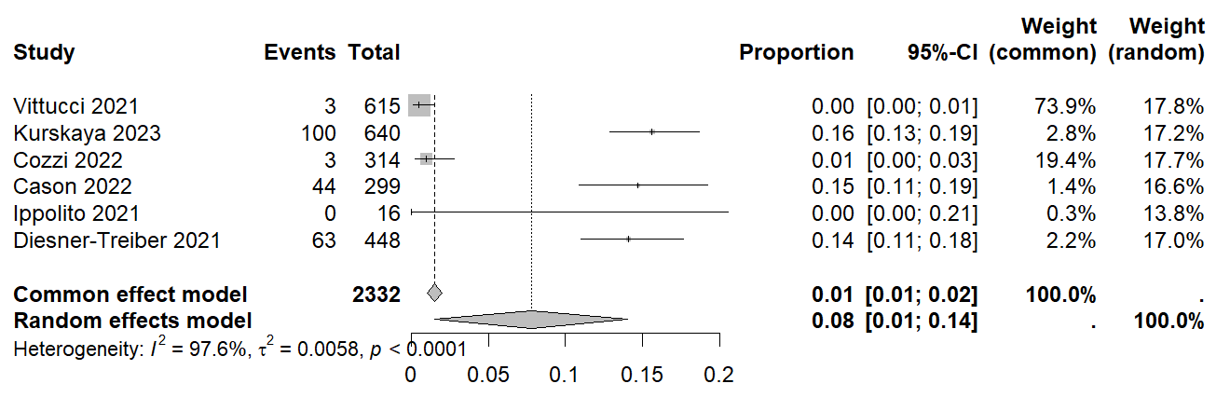
Figure S13. Forest Plot of human Coronavirus (hCOV) during COVID-19

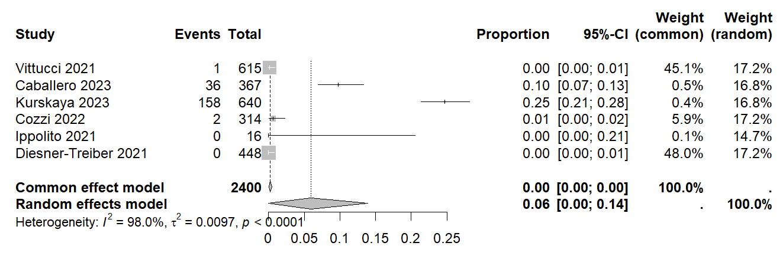
Figure S14. Forest Plot of Proportion of Human Metapneumovirus (hMPV) during COVID-19

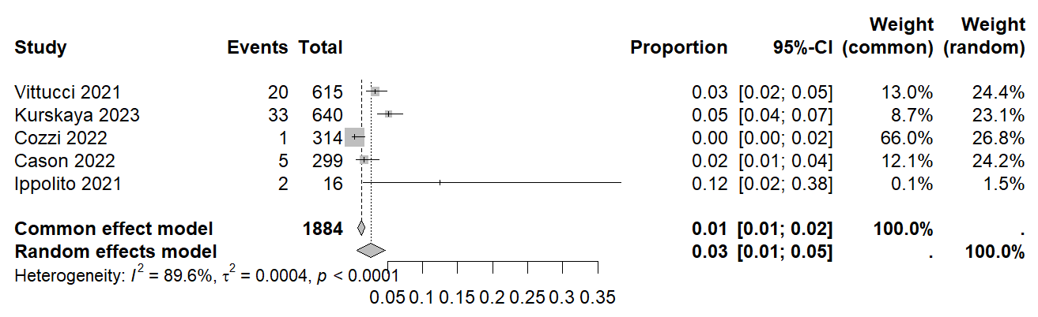
Figure S15. Forest Plot of Bocavirus (BoV) during COVID-19

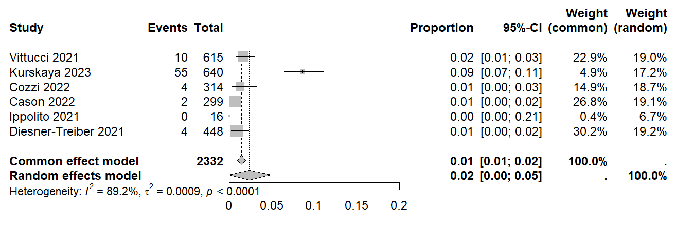
Figure S16. Forest Plot of Parainfluenzavirus (PIV) during COVID-19

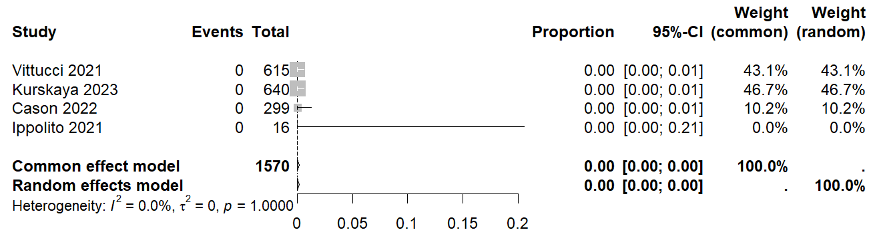
Figure S17. Forest Plot of Proportion of Influenza virus (IV) during COVID-19

Figure S18. Bubble plots for prevalence of viral identifications in infants with respiratory tract infection in European countries during COVID-19 pandemic.
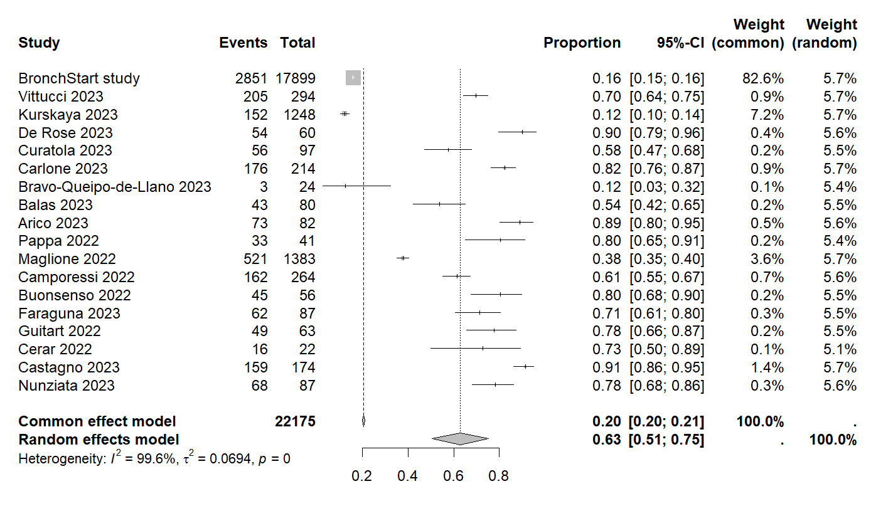
Figure S19. Forest Plot of Proportion of Respiratory Syncytial Virus (RSV) after COVID-19

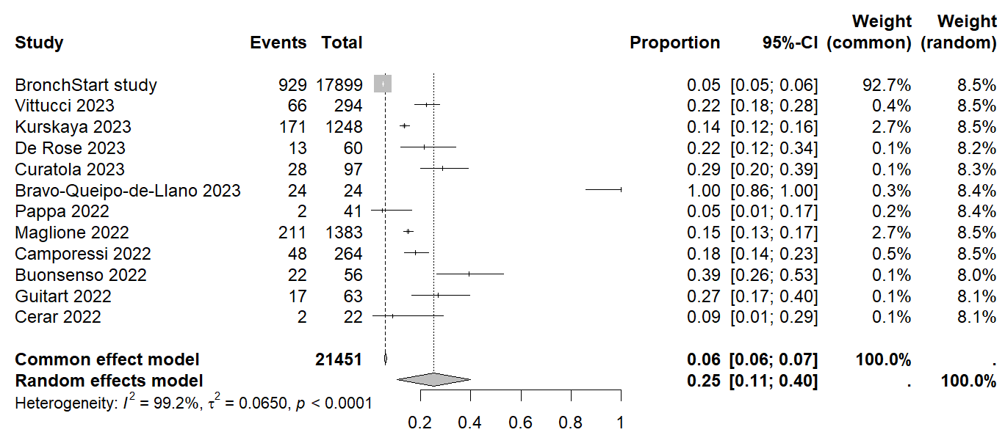
Figure S20. Forest Plot of Proportion of Human Rhinovirus (HRV) after COVID-19

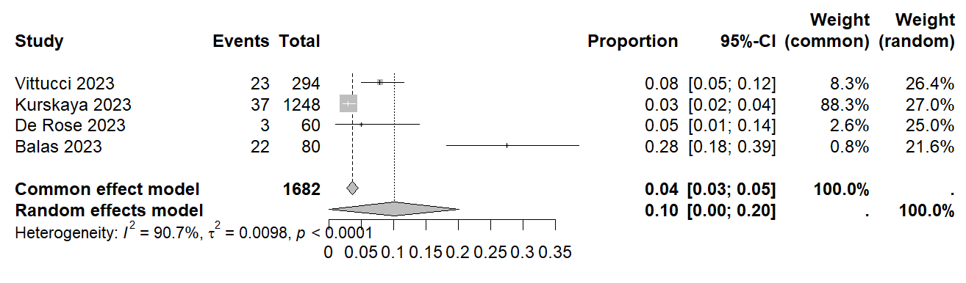
Figure S21. Forest Plot of Influenza Virus (IV) after COVID-19

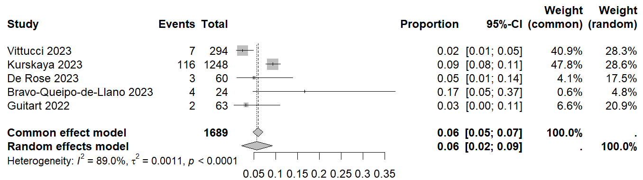
Figure S22. Forest Plot of human Coronavirus (hCOV) after COVID-19

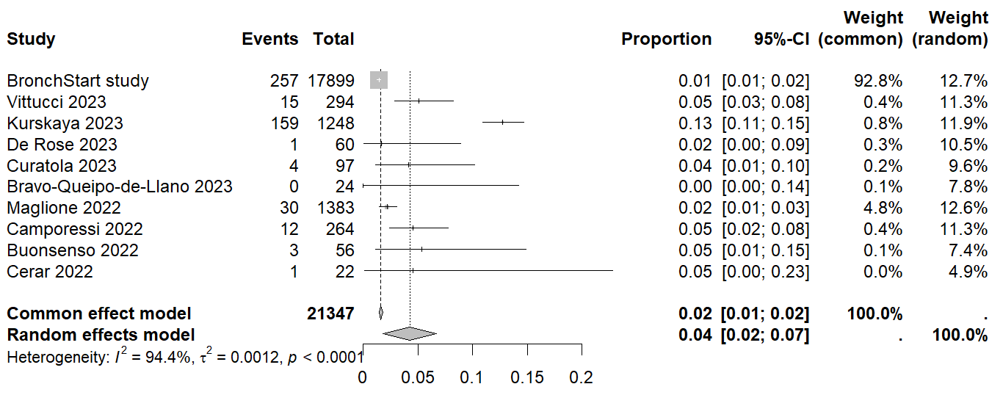
Figure S23. Forest Plot of Human Metapneumovirus (hMPV) after COVID-19

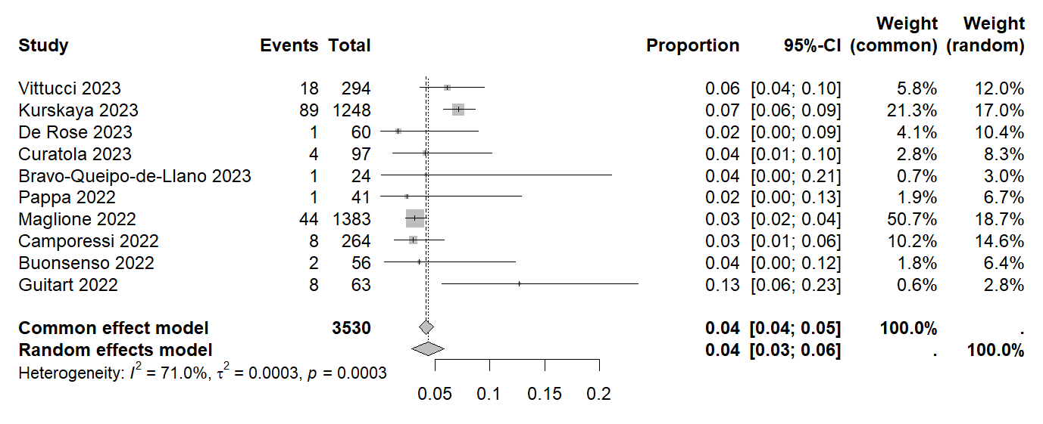
Figure S24. Forest Plot of Parainfluenzavirus (PIV) after COVID-19

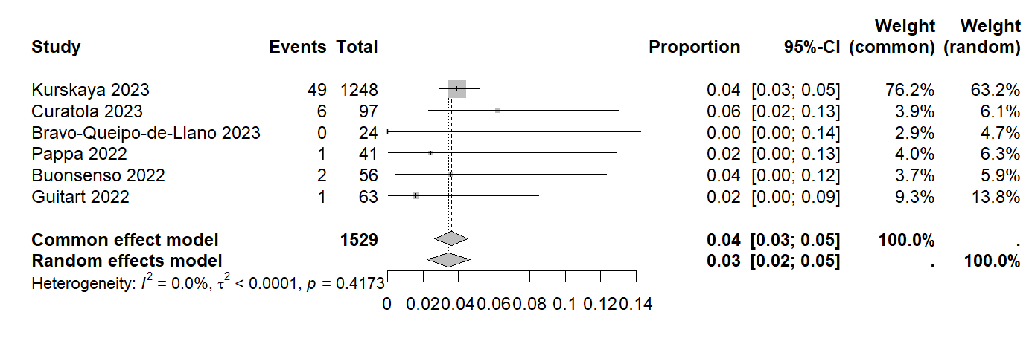
Figure S25. Forest Plot of Proportion of Bocavirus (BoV) after COVID-19

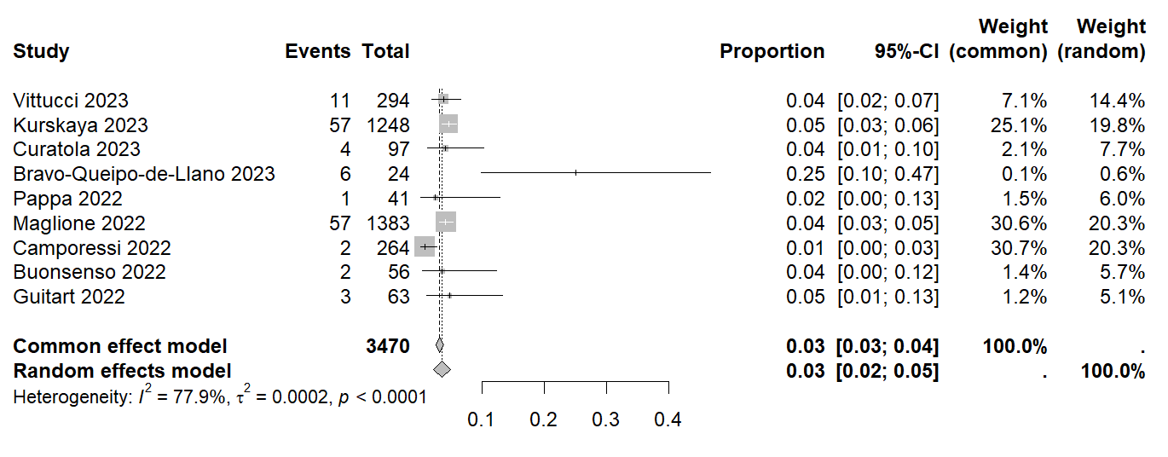
Figure S26. Forest Plot of Proportion of Adenovirus (ADV) after COVID-19

Figure S27. Bubble plots for prevalence of viral identifications in infants with respiratory tract infection in European countries after the COVID-19 pandemic.

