Supplementary materials
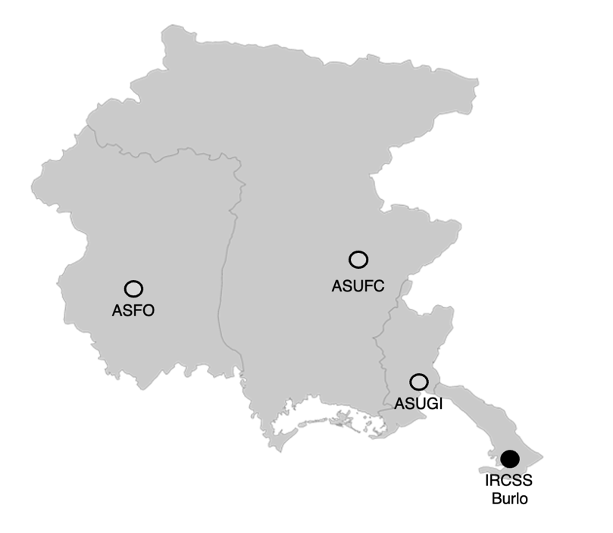
Figure S1: Regional Hub-and-Spoke model for pediatric palliative care in Friuli Venezia Giulia

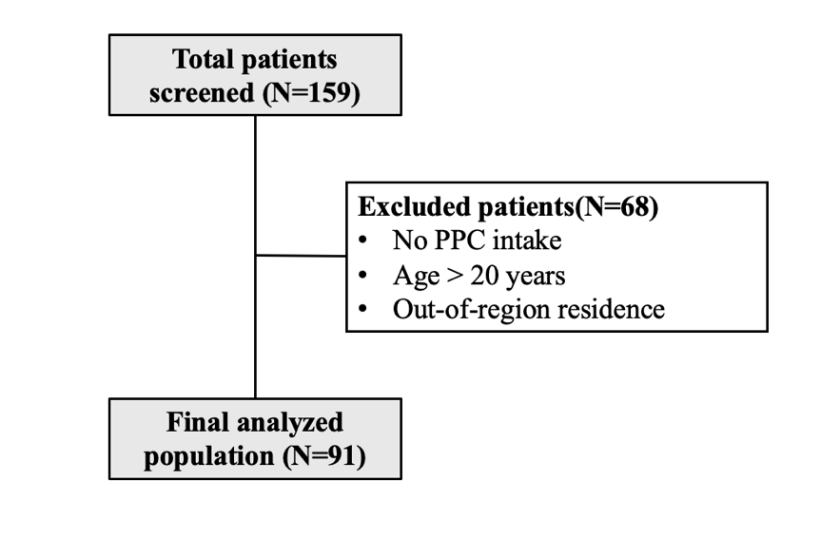
Figure S2: Flow chart of patient’s selection.
Figure S3: Interactive Sankey diagram available at the following link: https://giuliazamagni.shinyapps.io/Sankey_services/.

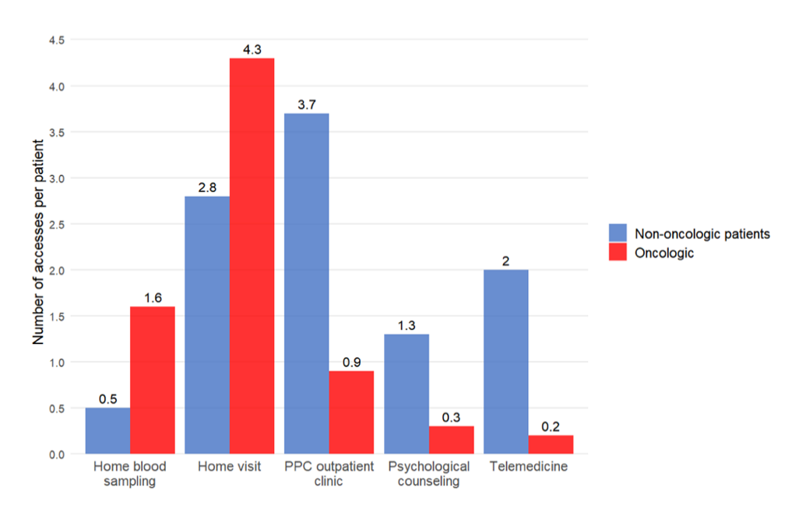
Figure S4: Mean number of PPC accesses per patient in oncologic versus non-oncologic patients, stratified by type of PPC activity.

