This sensitivity analysis includes 57 patients:
- SW - 45 (21 males, 24 females)
- SV - 12 (7 males, 5 females)

Descriptive statistics:

Variable | SW (n = 45) | SV (n = 12) | p - value
Sex | Male (n = 21) | Male (n = 7)
Sex | Female (n = 24) | Female (n = 5)
Outcomes
Age at diagnosis (months) | 0.6 (0.4–1.2) | 58.9 (30.9–84.9) | p < 0.001
Follow up duration (years) | 17.7 (16.4 – 18.0) | 11.15 (8.53–14.79) | p = 0.0044
TH (cm) | M: 177.95 ± 4.88 | 178.50 ± 8.25 | NS
TH (cm) | F: 162.19 ± 4.82 | 162.20 ± 5.54 | NS
TH SDS | −0.35 ± 0.80 | -0.23 ± 1.17 | NS
Age at nFH (years) | All: 16.3 (15.1–17.2) | 15.5 (15.1–17.0) | NS
Age at nFH (years) | M: 16.5 ± 1.4 | 16.64 ± 1.4 | NS
Age at nFH (years) | F: 15.7 ± 1.7 | 14.86 ± 1.7 | NS
nFH (cm) | All: 162.88 ± 8.80 | 167.67 ± 10.44 | NS
nFH (cm) | M: 169.32 ± 6.74 | 171.80 ± 10.97 | NS
nFH (cm) | F: 159.05 (154.62-161.53) | 164.00 (163.00–164.50) | p = 0.046
c-nFH (cm) | All: -6.66 ± 5.42 | -4.03 ± 6.71 | NS
c-nFH (cm) | M: -8.40 (-12.50--5.50) | -6.70 ± 7.08 | NS
c-nFH (cm) | F: -4.94 ± 5.28 | -0.30 ± 4.34 | NS
nFH SDS | −1.35 ± 1.02 | -0.76 ± 1.18 | NS
c-nFH SDS | −0.99 ± 0.87 | -0.52 ± 0.83 | NS
Treatment
Age at start of HC treatment (years) | 0.17 (0.09–0.28) | 4.66 (2.17–7.09) | p < 0.001
Age at first clinic visit (years) | 0.06 (0.02–0.17) | 4.55 (1.97–6.93) | p < 0.001
HC treatment | 45/45 | 12/12
MC treatment | 45/45 | 2/13
HC BSA mean (mg/(m2*day)) | 17.15 ± 3.15 | 13.94 ± 4.90 | p = 0.0496
Growth
Max BAA (years) | 1.4 (0.5–2.3) | 3.59 (2.2–5.3) | p = 0.0161
Age at max BAA (years) | 9.9 ± 3.7 | 8.5 ± 4.3 | NS
Peak ΔBAA | 0.02 (−0.45–0.99) | 2.51 (0.34–4.08) | p = 0.0128
Age at peak ΔBAA (years) | 7.1 ± 2.6 | 6.9 ± 2.5 | NS
Peak HV (cm/year) | 7.5 ± 1.0 | 7.1 ± 0.9 | NS
Age at peak HV (years) | 10.7 ± 2.2 | 10.7 ± 1.2 | NS
Puberty
Age at first puberty sign (years) | All: 9.4 ± 2.2 | 8.3 ± 2.6 | NS
Age at first puberty sign (years) | M: 10.3 (9.3-11.5) | 9.0 (7.0–10.1) | NS
Age at first puberty sign (years) | F: 8.9 ± 2.2 | 8.6 ± 2.8 | NS
Premature occurrence of puberty signs | 13/44 (28.9%) | 5/12 (41.7%) | NS
Pubarche as first puberty sign | 20/44 (44.4%) | 7/12 (58.3%) | NS
Pubarche as first premature puberty sign | 8/13 (61.5%) | 4/5 (80%) | NS
Weight
BMI AUC final (kg/m2) | All: 18.11 ± 2.85 | 18.82 (16.74–22.69) | NS
BMI AUC final (kg/m2) | M: 17.42 (16.54-18.65) | 20.64 (17.98–22.79) | NS
BMI AUC final (kg/m2) | F: 17.20 ± 2.70 | 18.00 ± 3.23 | NS
BMI SDS final | 0.22 ± 1.59 | 0.53 ± 1.34 | NS
Age at AR (years) | 3.42 (3.36–3.48) | 3.39 (3.33–3.40) | NS
BMI at AR (kg/m2) | 16.14 (15.27–17.69) | 15.58 (14.16–16.33) | NS

Supplementary File 4 - Table 1 – Population characteristics at nFH visit.
Central tendency for each variable is shown as mean ± SD (for variables with normal distribution) or median with IRQ (for variables without normal distribution).
Abbreviations: AR – adiposity rebound, AUC – area under curve, BAA – bone age advancement, BSA – body surface area, c-nFH – corrected near final height, HC – hydrocortisone, HV – height velocity, IQR – interquartile range, MC – mineralocorticoid, nFH – near final height, NS – not significant, SDS – standard deviation score, SV – simple virilizing, SW – salt wasting, SD – standard deviation, TH – target height
p < 0.001

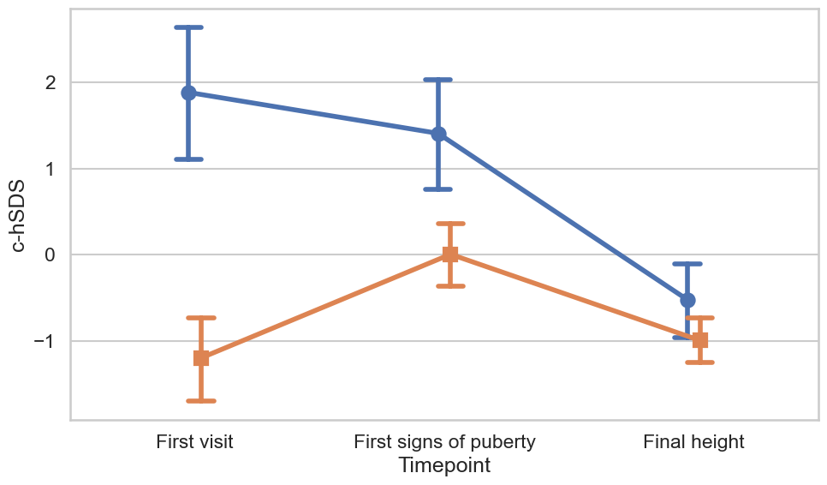
p < 0.001
p < 0.001
p < 0.001
p < 0.001
p < 0.001
TYPE | Timepoint | N | Mean ± SD
SV | Final height | 12 | -0.52 ± 0.83
SV | First signs of puberty | 12 | 1.41 ± 1.13
SV | First visit | 12 | 1.88 ± 1.42
SW | Final height | 43 | -0.99 ± 0.88
SW | First signs of puberty | 43 | 0.01 ± 1.22
SW | First visit | 43 | -1.2 ± 1.62

Supplementary File 4 - Figure 1. c-hSDS in pivotal time-points by type of CAH. Blue line indicates SV-CAH, orange line indicates SW-CAH.
Below c-hSDS results by CAH type for three time points. * - p<0.05
Abbreviations: c-hSDS – corrected height standard deviation score, SV – simple virilizing, SW – salt wasting

Longitudinal analysis
SV | First visit  (4.77 ± 3.39 years) | First visit → First puberty sign | First puberty sign  (8.34 ± 2.63 years) | First puberty sign → Near final height | Near final height  (15.90 ± 1.72 years)
hSDS | 1.65 ± 2.02 | 0.96 ± 1.70 | 1.17 ± 1.51 | 0.54 ± 1.10 | -0.39 ± 1.41
c- hSDS | 1.88 ± 1.42 | 1.20 ± 1.44 | 1.41 ± 1.13 | 0.78 ± 0.90 | -0.16 ± 1.11
Height velocity  [cm/year] | 6.08 ± 3.59 | 6.76 ± 1.71 | ND | 4.82 ± 1.80 | 1.09 (0.39–1.36)
HC BSA [mg/m2/day] | 14.24 ± 6.43 | 13.76 ± 5.66 | 13.55 ± 5.85 | 14.11 ± 5.61 | 14.50 ± 6.78
BAA [years] | 3.00 ± 2.81 | 2.21 ± 2.88 | 4.11 ± 1.97 | 2.21 ± 1.53 | 1.36 ± 1.65
BMI AUC [kg/m^2] | 16.32 ± 4.49 | 14.88 ± 2.99* | 15.34 (14.28–16.61) | 17.94 ± 3.01* | 19.49 ± 3.27

Supplementary File 4 - Table 2. Longitudinal auxological and clinical data in SV CAH group.
* - p<0.001 between consecutive time periods
Abbreviations: AUC – area under curve, BAA – bone age advancement, BSA – body surface area, CAH – congenital adrenal hyperplasia, c-hSDS – corrected height standard deviation score, HC – hydrocortisone, hSDS – height standard deviation score, SV – simple virilizing

Longitudinal model

 | Beta (95% CI) | SE | p
Intercept | 0.578 (-0.074, 1.23) | 0.332584473 | 0.082
TYPE = SW | -0.299 (-0.871, 0.272) | 0.291668522 | 0.305
Age | -0.096 (-0.128, -0.064) | 0.016119711 | <0.001
lagHC | -0.262 (-0.311, -0.212) | 0.02516923 | <0.001
HC BSA mean | -0.211 (-0.414, -0.007) | 0.103815426 | 0.042
BMI AUC | -0.005 (-0.053, 0.044) | 0.024666689 | 0.849
Puberty status | 0.122 (0.063, 0.181) | 0.030014589 | <0.001

Supplementary File 4 - Table 3. Results of the longitudinal model.
Abbreviations: AUC – area under curve, BSA – body surface area, CI – confidence interval, HC – hydrocortisone, lagHC – lagged hydrocortisone dose, NC – non classic, NS – not significant, SE – standard error, SW – salt wasting

Final height model

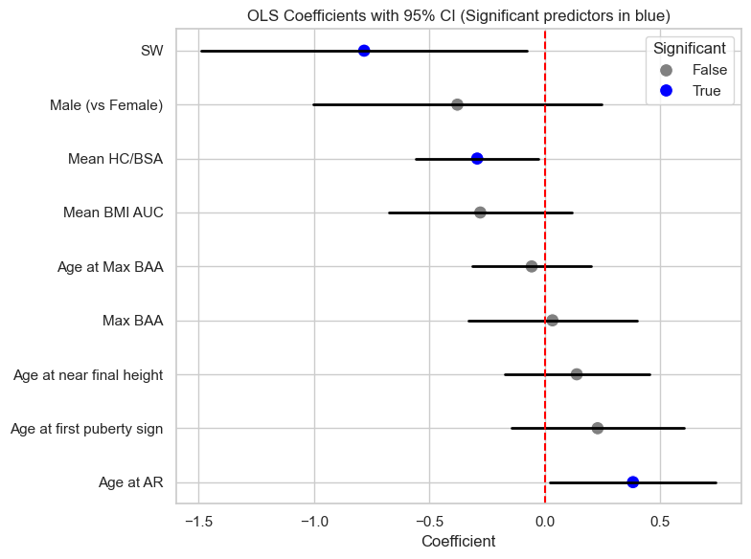
Supplementary File 4 - Figure 2. Corrected nFH model coefficients with 95% confidence intervals. Statistically significant interactions are marked in blue.
The model included: sex, CAH type, mean HC BSA, age at AR, maximum BAA, age at maximum BAA, BMI AUC, age at first puberty sign, and age at final height as predictors. Female sex and SV CAH were used as reference categories
Abbreviations: AR – adiposity rebound, BAA – bone age advancement, BMI AUC – body mass index area under curve, BSA – body surface area, CI – confidence interval, HC – hydrocortisone, NC – non-classic, OLS – ordinary least squares, SV – simple virilizing, SW – salt wasting

